**ITC606 Lab. Week 13**

Student Number 2021006498

Name Kauê Reis de Assis Pereira

**Upload to Black Board Labxx**

**File name: ITC606Labxx_*YourFirstName***

1. **Screenshot of Solution 1**

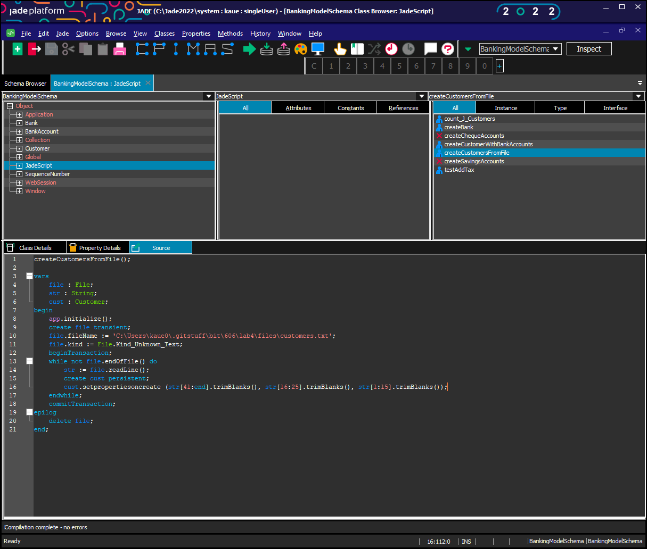

1. **Screenshot of Solution 2**

1. **Screenshot of Solution 3**

1. **Screenshot of Solution 4**

1. **Screenshot of Solution 5**

