Full paper Template: Author Guidelines

First Author¹, Second Author ², Third Author ²*

¹ Department/Unit (if applicable), Organization, City, Brazil, author1@email.com.br*
² Department/Unit (if applicable), Organization, City, Brazil, {author2, author3}@email.com.br *
*Those information should be filled only after the work has been approved

Abstract
The abstract must be limited to 200-400 words. Use Times New Roman, 12pt, italics, with line spacing of 1,5. Indent the first line of the paragraph with 0.5cm. Justify the text in a paragraph on the left- and right-hand side. The abstract should briefly describe the research problem, the approach or methodology, and explicitly highlight the main contribution and key findings of the work. Abstracts that do not clearly state the main contribution and results of the paper may not be considered for review. Separate sections with a single line.

Keywords: Include 3 to 5 keywords, separated by “;”; using lower case (except names), and Times New Roman 12. At least one of them must be selected from the following core areas: Cadastre, Cartography, Geodesy, Photogrammetry or Remote Sensing.

Introduction
The XIV Brazilian Colloquium on Geodetic Sciences (CBCG) is an event promoted by the Graduate Program in Geodetic Sciences (PPGCG), linked to the Department of Geomatics within the Sector of Earth Sciences at the Federal University of Paraná (UFPR). Since its inception in 1999, colloquium has established itself as a vital space for meeting, dialogue, and the dissemination of scientific, technological, and innovative knowledge in the field of Geodetic Sciences.
Throughout its previous editions, the CBCG has met the demand for academic and scientific events focused on Geodesy, Cartography, and Remote Sensing, bringing together researchers, professionals, faculty, and students from various regions of Brazil and abroad. In its fourteenth edition, the event reaffirms its commitment to the exchange of ideas and the strengthening of the scientific community.
This document provides formatting instructions for authors preparing full-length research papers for the XIV CBCG. Authors are requested to strictly follow these guidelines. The present MS Word document may be used as a template.
Submitted papers must be original and must not have been previously published, nor be under consideration for publication elsewhere. References should be comprehensive and must adequately cover relevant prior research in the field.
Please consider that the manuscript must clearly include: the problem or research question, the methodology or approach, the main contribution of the paper, and the principal results or implications.

Manuscript Submission
Manuscripts must be submitted electronically as a Portable Document Format (.PDF format) via the event website (https://cbcg.ufpr.br). The manuscript must not exceed twelve pages, and the file size must be limited to 6 MB, including figures, tables, references, and appendices. Each paper will be reviewed by at least two anonymous reviewers. Their evaluations will be used to determine acceptance and, when applicable, will be forwarded to the author(s) with suggested revisions.
Once the manuscript has been accepted, a final version (page proof) in PDF format will be sent to the author(s) for approval prior to publication. To avoid delays in the publication process, authors are strongly encouraged to follow the style guidelines carefully.
Note: To ensure a double-blind review process, authors must remove all identifying information from the initial submission. This includes author names and affiliations (typically listed below the title), as well as any identifying information in the document properties. After the review process and any required revisions, authors should restore this information in the final version.

Copyright and Disclosure

Copyright
By submitting a paper to this event, authors agree to the following terms:
- Authors retain copyright of their work while granting the event the right to publish and make it available on its website under a Creative Commons Attribution License. This license allows others to access, use, and share the work, provided that proper acknowledgment is given to the original authors and to its initial publication in the event.
- Authors are encouraged to post and share their work online (e.g., in institutional repositories or personal websites) at any time after publication on the event website.

Disclosure
If the submission requires approval by an institution, company, or government agency prior to publication, the author(s) must ensure that such permission has been obtained in writing, confirming that the information contained in the paper may be made publicly available on the event website.
Author(s) and/or their organizations retain the right to reuse the work, in whole or in part. The event organizers do not control the commercial use of published material. However, it is assumed that all submissions have been properly authorized and that the author(s) have the necessary rights to disclose the information contained therein.

Paper Formatting Guidelines (Times New Roman, 14pt, bold)

General (Times New Roman, 12pt, Bold)
The table below summarizes the most important aspects of the desired layout of the paper.

Table 1. Formatting summary
Item | Description
Page size & margins | A4 Portrait; all margins 2cm
Page numbers | Yes, starting at 1
Footer / Headers | None (NB: footnotes are not permitted)
Title | Times New Roman, 16pt, bold, first letter in capitals, centered, followed by a single blank line, 12pt.
Author and co-authors | Times New Roman, 12pt, centered - author and co-author names in one line, followed by a single blank line, 12pt.
Author affiliations | Times New Roman, 12pt, centered – each author’s full affiliation (i.e. company / organization), full contact details of the corresponding author only, followed by a single blank line, 12pt.
Key-words | Times New Roman, 12pt, left-justified, separated by semicolon, followed by a single blank line,12pt.
Abstract | Times New Roman, 12pt, Italics, with line spacing of 1,5. Indent the first line of the paragraph with 0.5cm. Justify the text in a paragraph on the left- and right-hand side.  Separate sections with a single line. 200 - 400 words
Headings | Times New Roman, 14pt, bold, left-justified, first letter in capitals, one blank line above.
Sub-headings | Times New Roman, 12pt, bold, left-justified, in proper case, one blank line above.
Sub-sub-headings | Times New Roman, 12pt, italic, left-justified, in proper case, one blank line above.
Heading numbering | Use the decimal system of heading numbering, with no more than three levels.
Source: Author and year (if necessary)

Body Text
Body Text should be Times New Roman, 12pt, with line spacing of at least 18pt. Indent the first line of the paragraph with 0.5cm. Justify the text in a paragraph on the left- and right-hand side. Use a spacing of 6pt before each paragraph.

Symbols and units
SI units should be used. Where abbreviations for units are used, there should be space between the value and the unit - i.e., ‘10 km’, not ‘10km’ – and angles should be ‘25°30'S’, not ‘25° 30' S’. Use italics for Greek or Roman text or abbreviations (e.g., et al.).

Equations
Equations should be numbered consecutively throughout the text with Arabic numerals in parentheses (not brackets), right-justified, as in (1). When referring to an equation in the text, use "Equation (1)" or "Eq. (1)". The equation should be indented by 7,5cm, with the equation number right justified. Equation Editor (MSWord97-2003) or MathType should be used to create the equations. Either plain or italics style may be used for the variables, as long as there is consistency in style. Use boldface for vectors and matrices.

$N= γ+\frac{\overline{α}}{\sum_{i=1}^{n}{b_{i}}}$ (1)

Figures, photographs and illustrations
Figures should be provided in a standard format (e.g. jpeg, tiff, bmp) and should be of high resolution (450dpi). Figures shall be numbered consecutively with a brief caption, which should be in Times New Roman, 12pt, above the figure, centered, and not bold, the source/authorship of the figure should be in Times New Roman, 12pt, below the figure, centered, and not bold. The figure, photograph or illustration should also be centered. Authors are encouraged to make use of color in all graphics, figures and photographs. The figure should be in the document, as close as practicable to the first reference to it. Refer to the example below.

Figure 1. South African Geoid Model 2010
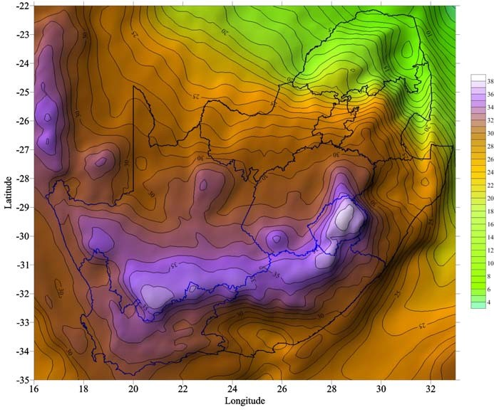
Source: Author and year (if necessary)

Tables
Tables should be numbered consecutively and should have captions. The table caption should be in Times New Roman, 12pt, positioned above the table, centered, and not in bold. Text inside the table should preferably be Times New Roman, 10pt, centered, with the headings in bold, the source/authorship of the table should be in Times New Roman, 12pt, below the table, centered, and not bold. Each table shall be in the document as close as practicable to the first reference to it. Refer to the example below.

Table 2. Differences with GPS/Levelling - Western Cape Province
Model | Min. (cm) | Max. (cm) | Mean (cm) | Std. Dev. (cm)
AGP2003 | - 76 | - 38 | - 63 | 9
EGM96 | - 97 | - 62 | - 55 | 20
Source: Author and year (if necessary)

References
In-text citations must use numerical identifiers enclosed in brackets, such as [1]. The reference list at the end of the document must be organized in alphabetical order by the first author's last name and numbered accordingly, ensuring a direct correlation between the in-text citations and the final list. Please note that in-text citation numbers correspond strictly to the item's position in the alphabetical reference list, and not to their order of appearance in the text. For references, use Times New Roman, 11pt, first line hanging by 0.5cm. Use a line spacing of at least 15pt. Use the ABNT style for reference. References should be listed in alphabetical order and presented as shown in the examples at the end of this document. References should follow one another, with no blank lines in between.

Book
Author, Book Title, Edition, Place of Publication, Publisher, Year. Example:
Czinkota, M. R.; Ronkainen, A. I. International marketing. 7. ed. Mason, Ohio: Thomson/South-Western, 2004.

Chapter in Book
Author, ‘Chapter title’, in Editors (eds.), Book Title, Place of publication, Publisher, Year. Example:
North, D. ‘Energy use at home’. In: Scott, S.; Peel, N. (org.). Energy conservation. London: Academic Press, 1980.

Full-text journal article
Author, ‘Article title’, Journal Title, Volume (Issue), Pages, Year. Example:
Rasid, Z. M.; Parish, T. S., ‘The effects of two types of relaxation training on students' levels of anxiety’, Adolescence, 33(129), 99–110, 1998.

Conference Proceedings
Author Year, Article title, in Editors (eds.), Proceedings Title, Place and date of conference, Place of publication, Publisher, Date of publication, Pages. Example:
Merry, C. L. Recent variations in mean sea level. In: Sünkel, H.; Baker, T. (org.). Sea Surface Topography and the Geoid. Edinburgh, July 1989. New York: Springer-Verlag, 1990. p. 149-157.

Journal article on the WWW
Author Year, Article title, Journal Title, Volume (Issue), Available at: URL, Accessed Day Month Year. Example:
Griffith, A. I. Coordinating family and school: mothering for schooling. Education Policy Analysis Archives, v. 3, n. 1, 1995. Available at: http://olam.ed.asu.edu/epaa/. Accessed: 12 feb. 1997.

Web document
Author Year, Document title, Place, Institution/Publisher, Available at: URL, Accessed Day Month Year. Example:
Anderson, J. CASA approves Avgas Contamination Test. Canberra: Department of Transport and Regional Services, 2000. Available at: http://www.dotrs.gov.au/media/anders/archive/2000/jan_00/al6_2000.htm. Accessed: 7 feb. 2000.

Web document (no author)
Document title, Year, Institution/Publisher, Available at: URL, Accessed Day Month Year. Example:
Educating America for the 21st century: developing a strategic plan for educational leadership. Columbia University, 1994. Available at: http://ariel.adgrp.com/~ghb/trips/940717_ICT/policy/ILT/EdPlan.html. Accessed: 16 may 1995.

Web document (no publication date)
Author [s.d.], Document title, Place, Institution/Publisher, Available at: URL, Accessed Day Month Year. Example:
Sherman, C. The invisible web. UK: Free Pint Limited, [s.d.]. Available at: http://www.freepint.co.uk/issues/080600.htm#feature. Accessed: 27 nov. 2000.

Web site
Organization Year, Website title, Place, Available at: URL, Accessed Day Month Year. Example:
THE BODY SHOP AUSTRALIA. The Body Shop Australia. Mulgrave, Victoria, 2003. Available at: http://www.thebodyshop.com.au/. Accessed: 31 jan. 2003.

May 1, 2026

