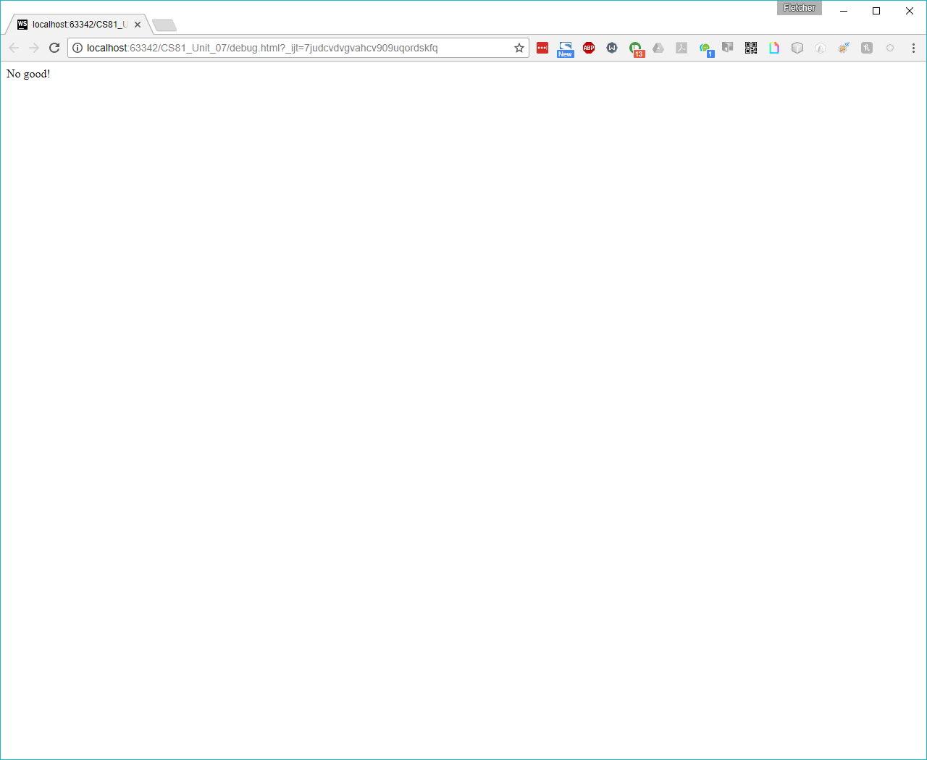

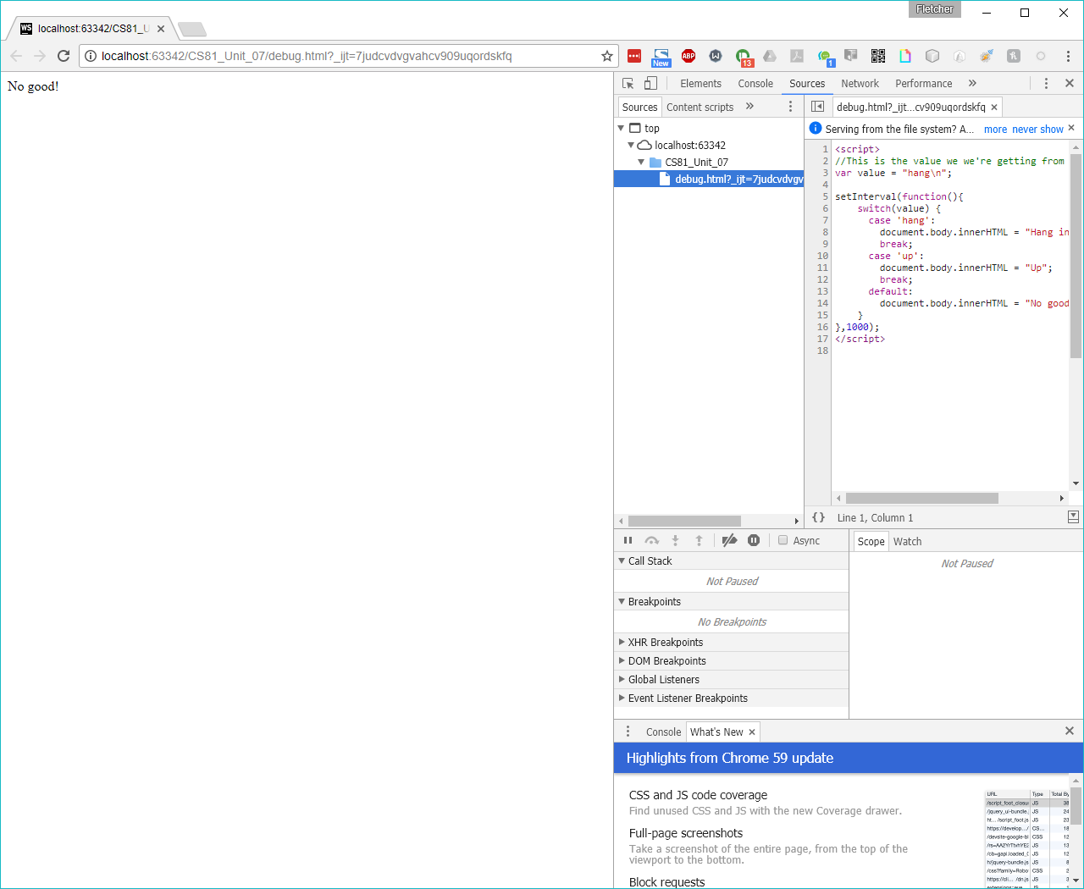

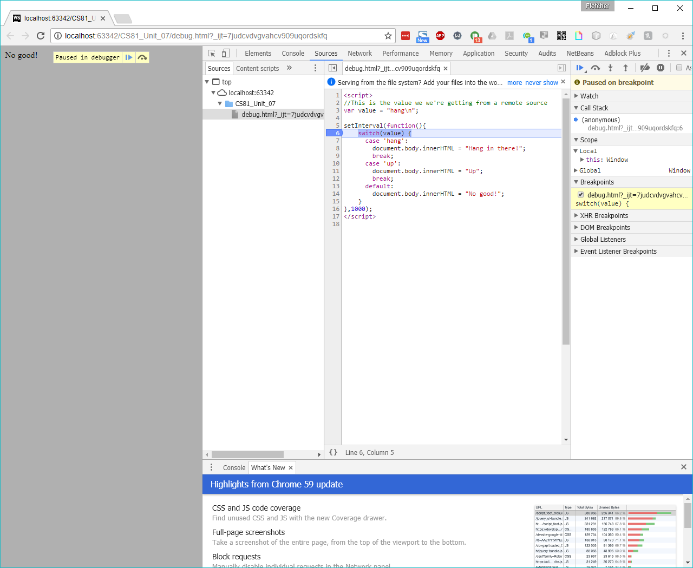

NOTE: In my version (on Windows), I do not get the red dot when the program is stopped. Also, right-clicking on the word “value” does not give the option to create a Watch, by itself. You have to highlight the word, THEN right-click it, and you can “Add selected text to Watches”.

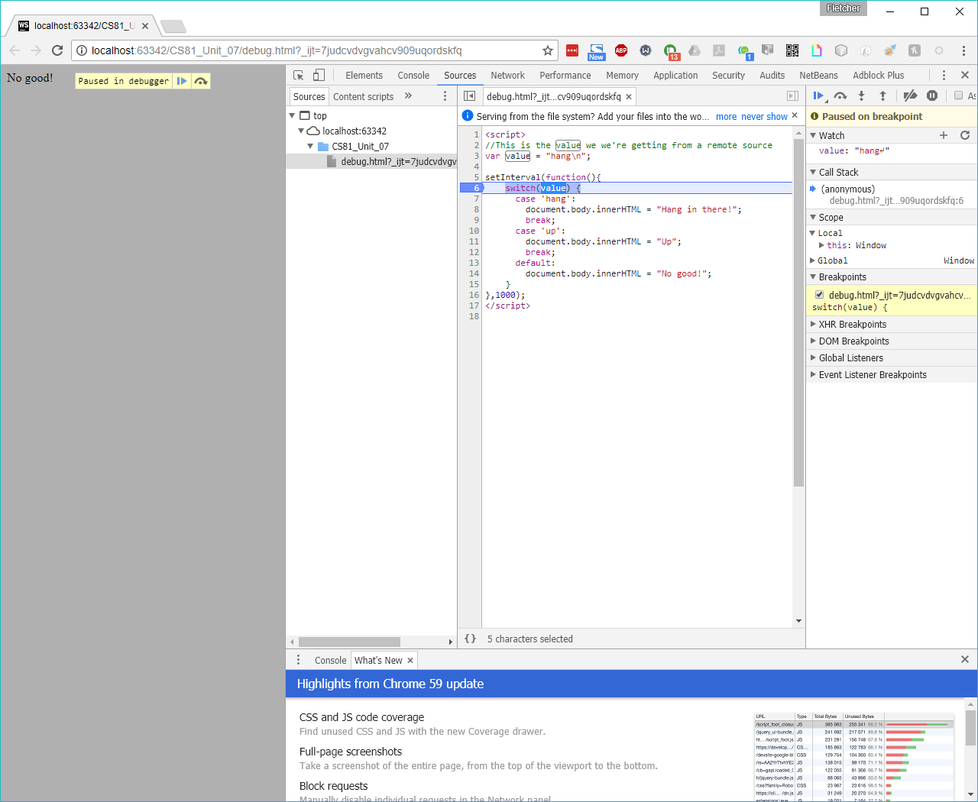

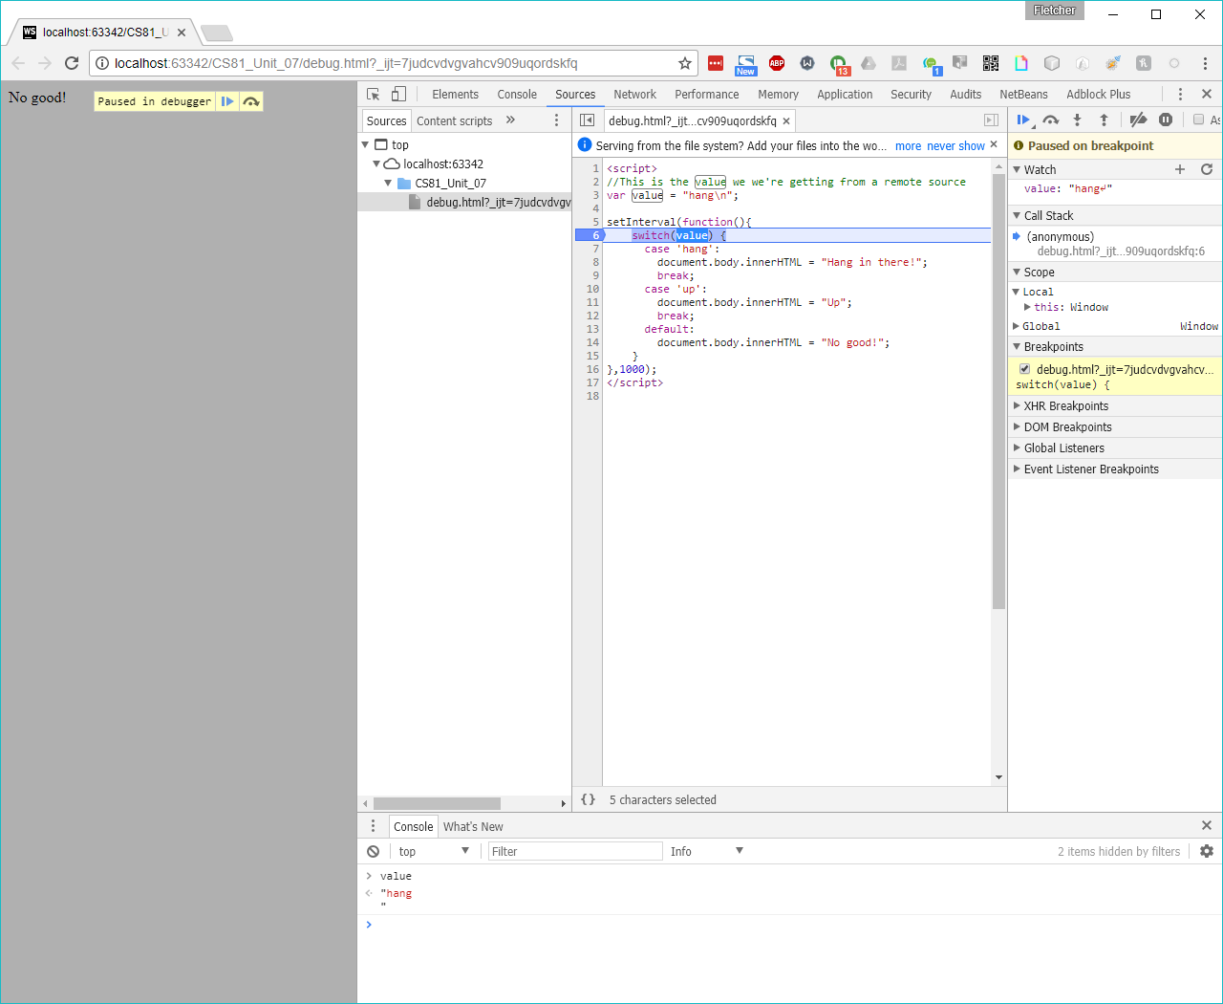

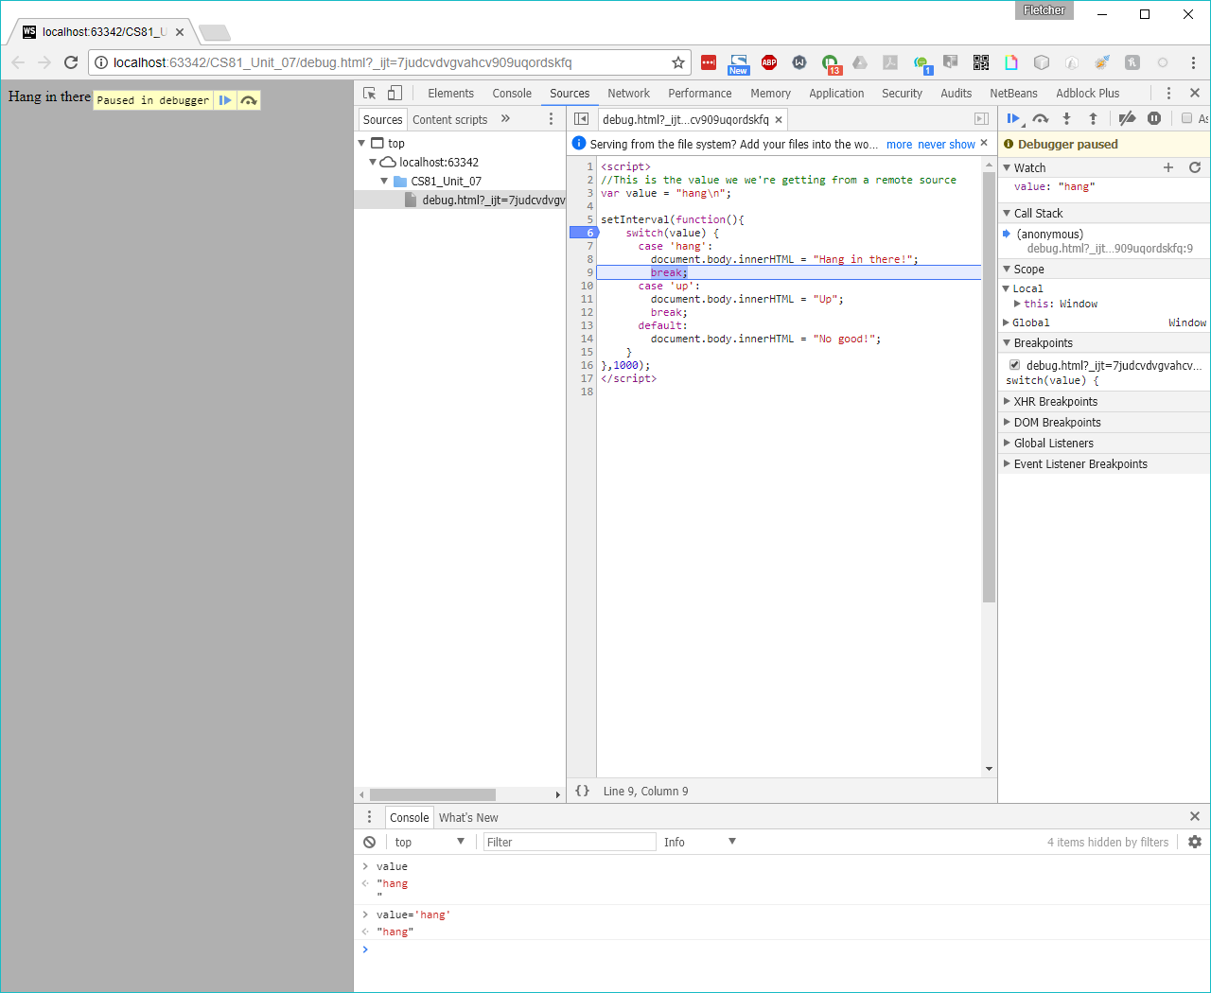

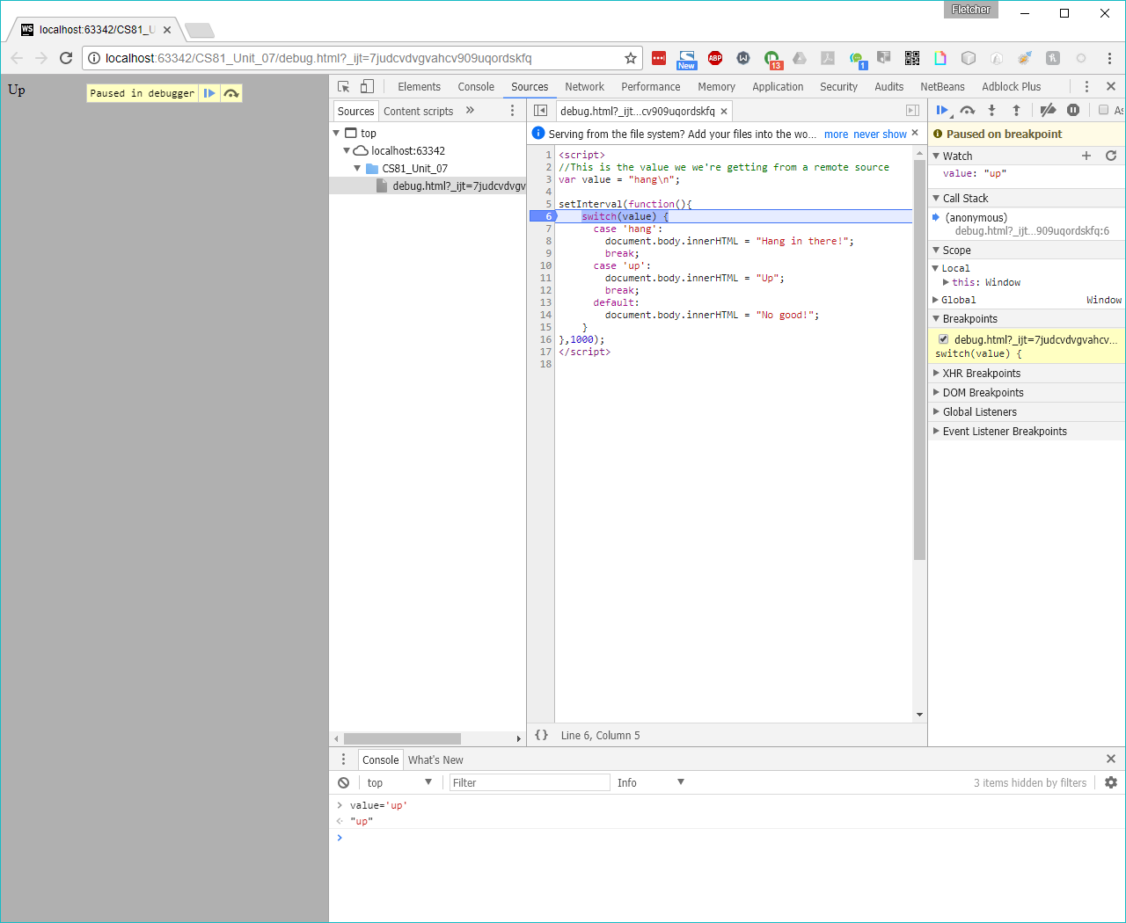

NOTE: For whatever reason, to get the value to be evaluated correctly, you have to hit the resume button TWICE, even though that doesn’t make any sense.