Lab2 Emily Kauffman (emk103@pitt.edu)

INFSCI 2150 Jeffrey James (jaj63@pitt.edu)

Spring 2018

University of Pittsburgh

**Exercise 1:**

1. Add Patients
2. Add Orders
3. Add Users
4. Edit Patients

**Exercise 2:**

1. System Developer
2. Application: Has Super User Privileges
3. System Administrator
4. Hospital Administrator

**Exercise 3:**

**Role Management:**

Macintosh HD:Users:jjames:Desktop:Screen Shot 2018-03-26 at 8.45.20 PM.pngMacintosh HD:Users:jjames:Desktop:Screen Shot 2018-03-26 at 8.46.32 PM.png

Macintosh HD:Users:jjames:Desktop:Screen Shot 2018-03-26 at 8.44.55 PM.pngMacintosh HD:Users:jjames:Desktop:Screen Shot 2018-03-26 at 8.46.18 PM.png

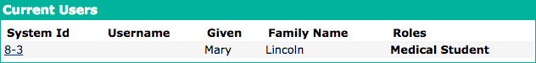

Macintosh HD:Users:jjames:Desktop:Screen Shot 2018-03-26 at 5.11.23 PM.png

Macintosh HD:Users:jjames:Desktop:Screen Shot 2018-03-26 at 5.11.41 PM.png

**Exercise 4:**

|  |  |  |
| --- | --- | --- |
| Role | Inherit Privilege(s) from Role(s) | Additional Privilege(s) |
| Encounter Manager |  | Add/ Edit/ View Encounters |
| Patient Manager |  | Add/ Edit/ View Patients |
| Laboratory Manager |  | Add/ Edit/ View Laboratory Orders |
| User Administrator |  | Add/ Edit/ View Users |
| Ambulance Personnel |  | View Patients  Add Reports |
| Nurse | Ambulance Personnel, Patient Manager, Laboratory Manager | Add/ Edit/ View Observations  Edit/ View Reports |
| Doctor | Patient Manager, Laboratory Manager, Encounter Manager | Add/ Edit/ View Visits |
| Health Secretary | Encounter Manager | Add/ Edit/ View Diet Orders |
| Physiotherapist | Encounter Manager | Add/ Edit/ View Physiotherapy Orders |
| Psychologist | Encounter Manager | Add/ Edit/ View Psychology Orders |
| Radiologist | Laboratory Manager | Add/ Edit/ View Radiology Orders |
| Dentist | Encounter Manager | Add/ Edit/ View Diet Orders |
| System Administrator | User Administrator | Add/ Edit User Passwords  Add/ Edit/ View Roles |
| Registration Clerk | User Administrator, Patient Manager | Add/ Edit/ View Appointments |

**Exercise 5:**

**Role Management:**

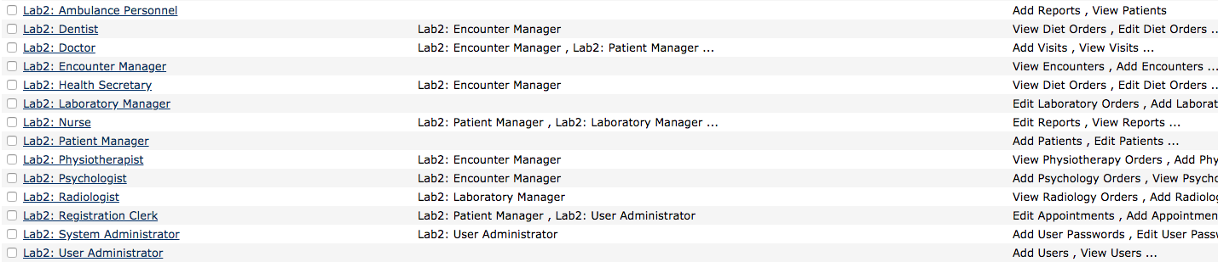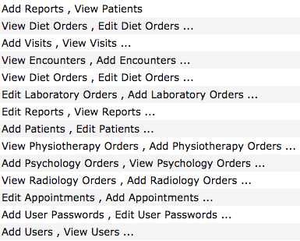

**Exercise 6:**

**Anonymous:** People who don’t sign-in to OpenMRS are given the privileges of this role, they are usually given very restricted access and view-only

**Authenticated:** Anyone that signs-in to Open-MRS is given the privileges of this role, they are common to all users

**Provider:** This is the basic medical provider role. It can be used to build more specialized medical provider roles.

**System Developer:** This role has access to everything (all privileges) in Open-MRS. Should only be granted to system administrators.

In our Open-MRS system, those with an *Anonymous* role and *Provider* have no privileges by default, those with an *Authenticated* role have many “Get” and “View” privileges (basically read only access), and those with a *System Developer* role have all privileges available in the system.

**Exercise 7:**

The system did not appear to have any way of resizing columns in the Role Management page. We were not able to see all of the information we had wanted due to this issue. It would be great if this function would be added to the system.

It was difficult searching through the various privileges to find the ones we wanted to select. It would good to be able to sort, filter, and search through these to make selections more quickly.

We found it hard to navigate through the users. It would be nice if the system had a single page view of all users and their roles or the users could be added on the “Role Management” page under each role.

**Exercise 8:**

**Functional Roles:** These roles consist of all the permissions needed to perform a task. They reflect the essential business functions that need to be performed. They are defined by a set of standard healthcare tasks (e.g. Neurologist).

**Structural Roles:** These roles place people in the organizational hierarchy. Such a role is a type of healthcare personnel warranting differing levels of access control.

**Exercise 9:**

|  |  |
| --- | --- |
| Roles | Privileges |
| Functional: Anesthesiologist | Add/ Edit/ View Allergies  Add/ Edit/ View Reports  Add/ Edit/ View Observations |
| Functional: Neurologist | Add/ Edit/ View Laboratory Orders  Add/ Edit/ View Reports  Add/ Edit/ View Radiology Orders |
| Structural: Attending Physician | Add/ Edit/ View Patients  Add/ Edit/ View Laboratory Orders  Add/ Edit/ View Reports |
| Structural: Attending Registered Nurse | Add/ Edit/ View Patients  Add/ Edit/ View Observations  View Appointments  View Orders |

**Exercise 10:**

