Very brief summary:

1. RLINE Input files
2. Source Input File (Traffic data)

The best we could model is probably AADT x hourly allocation.

1. Receptor location
2. Surface Meteorology File

RLINE uses surface meteorology provided by the AERMET model (the meteorological

preprocessor for AERMOD). Thus, we need to use AERMET to process the meteorological data and use that as an input for RLINE.

1. AERMET model input
2. ISHD surface met data (Integrated Surface Hourly Database)

available at <ftp://ftp.ncdc.noaa.gov/pub/data/noaa/>

1. Upper air data

available from NOAA/ESRL Radiosonde Database at <http://esrl.noaa.gov/raobs/> in FSL format. Specific downloading parameters need to be determined.

1. 1-minute Automated Surface Observing Systems (ASOS) data (Wind)

available at <ftp://ftp.ncdc.noaa.gov/pub/data/asosonemin/>

*Need to use AERMINUTE preprocess the data*

1. Monthly Surface Characteristics

Surface characteristics (Bowen ratio, albedo, and surface roughness length) *need to be calculated beforehand using AERSURFACE. Further investigation is needed*, *about source data, etc.*

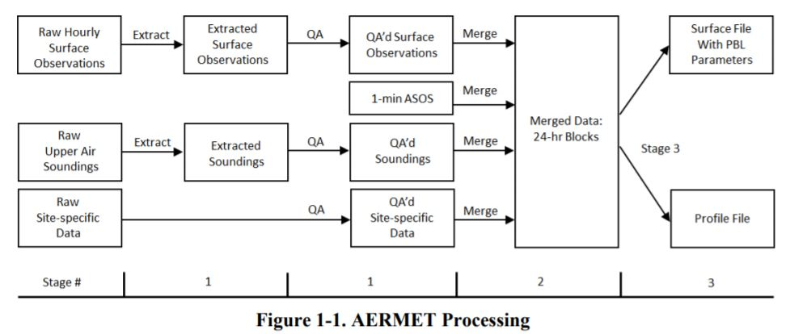

Reference:

AERMET User Guide: <https://gaftp.epa.gov/Air/aqmg/SCRAM/models/met/aermet/aermet_userguide.pdf>

RLINE User Guide:

<https://www.cmascenter.org/r-line/documentation/1.2/RLINE_UserGuide_11-13-2013.pdf>

South Carolina Department of Health and Environmental Control 2015 – 2019 Meteorological Data Processing Using AERMET Version 19191 April 2021:

<https://scdhec.gov/sites/default/files/media/document/BAQ_DHECAERMETProcessingOverview_April2021_0.pdf>