Final Fit with R Markdown

KK

2024-06-11

# R Markdown

**R Markdown** uses *markdown* language to render your reports and manuscripts. One click is all is need to write up your desire document types:

* **Writer documents**
  + *Microsoft word file*
  + *PDF file*
    - require Tex and a little bit annoying
  + *HTML file*
* **Presentation**
  + *PowerPoint*
* **Interactive document**
  + *Shiny dashboard*

## How to write R Markdown cheaply

Three essential components:

1. **YAML Header**
   * At the start of the file
   * Write between two “—”
   * Use indentations for options
2. **Text**

### Header is hashtags followed by one space

* + *italic* **bold** ***italic bold*** superscript subscript
  + Tap two space and Enter to separate paragraphs  
     or backlash for new line
  + Tab plus dash plus Tab for un-ordered list items
    1. Number plus Tab is ordered list
  + $equation=formuala$ to insert equation
 $$E=mc^{2}$$

 + to insert equation block
  + to insert ***URL***: <https://www.facebook.com/>
  + [Attached link](https://www.facebook.com/)
  + 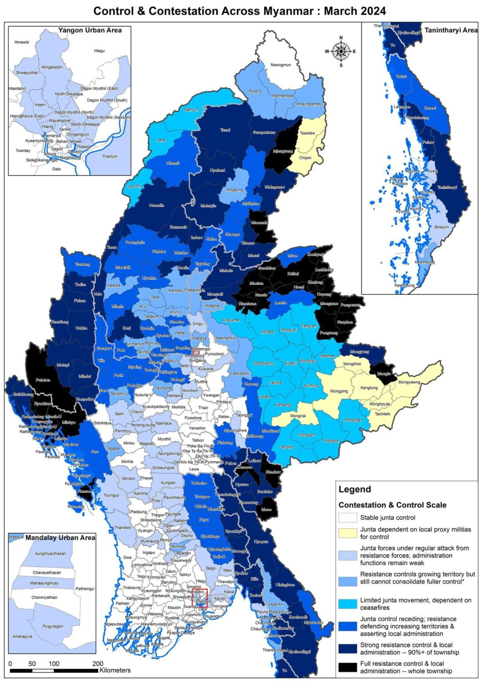
  + image
  + Image file must be in **same folder** as ***Rmd file***.  
    Online image can also be used but permission denial may encounter

1. **Code Chunk**
   * write between two verbatim mark as follow:

* [1] "Write the code here"
 $shortcut=ctrl+alt+i$

 + {r codename, include = TRUE or FALSE} to include the code in your report
  + It’s better use the **finalfit** code together with **dplyr/magrittr**, and **knitr** packages

### Example

1. **Load the packages and set up**

We don’t want the package attaching here, so include = F.  
Also for the following sections, include=F.

1. **Import the data set**
2. **Transform data**
3. Set up your final fitted outcomes and explanatory

From now on, we want our output in the file. So, include=T.

1. **Exploratory data analysis**

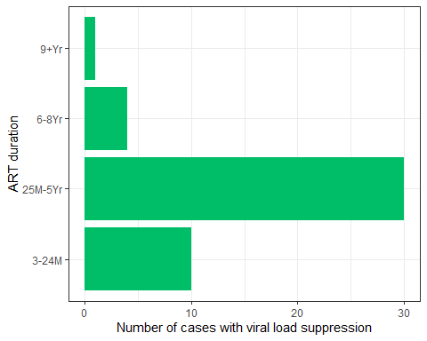

Figure 1. Viral laod suppression by duration of ART

1. Tables  
   **Table 1. Background characteristics of patients taking ART**

| Variables | Values | No | Yes | Total |
| --- | --- | --- | --- | --- |
| Total N (%) |  | 27 (37.50) | 45 (62.50) | 72 |
| Gender | Female | 14 (51.85) | 25 (55.56) | 39 (54.17) |
|  | Male | 13 (48.15) | 20 (44.44) | 33 (45.83) |
| History of TB | Negative | 23 (85.19) | 41 (91.11) | 64 (88.89) |
|  | Positive | 4 (14.81) | 4 (8.89) | 8 (11.11) |
| District: 1=Misungwi,2=others | Misungwi | 25 (92.59) | 31 (68.89) | 56 (77.78) |
|  | others | 2 (7.41) | 14 (31.11) | 16 (22.22) |
| WHO Clinical Staging | I | 3 (11.11) | 3 (6.67) | 6 (8.33) |
|  | II | 9 (33.33) | 13 (28.89) | 22 (30.56) |
|  | III | 13 (48.15) | 25 (55.56) | 38 (52.78) |
|  | IV | 2 (7.41) | 4 (8.89) | 6 (8.33) |
| ART PI-NonPI | Non-PI | 18 (66.67) | 37 (82.22) | 55 (76.39) |
|  | PI | 9 (33.33) | 8 (17.78) | 17 (23.61) |
| ARV regimens | 3TC+AZT+EFV | 1 (3.70) | 5 (11.11) | 6 (8.33) |
|  | 3TC+AZT+NVP | 12 (44.44) | 22 (48.89) | 34 (47.22) |
|  | ABC+3CT+EFV | 5 (18.52) | 10 (22.22) | 15 (20.83) |
|  | ABC+3TC+ATV/r | 3 (11.11) |  | 3 (4.17) |
|  | ABC+3TC+LPV/r | 5 (18.52) | 8 (17.78) | 13 (18.06) |
|  | TDF+FDC+ATV/r | 1 (3.70) |  | 1 (1.39) |
| Time on ART Category | 3-24M | 2 (7.41) | 10 (22.22) | 12 (16.67) |
|  | 25M-5Yr | 16 (59.26) | 30 (66.67) | 46 (63.89) |
|  | 6-8Yr | 6 (22.22) | 4 (8.89) | 10 (13.89) |
|  | 9+Yr | 3 (11.11) | 1 (2.22) | 4 (5.56) |
| number of ARV tablet/day | <=2.4 | 11 (40.74) | 19 (42.22) | 30 (41.67) |
|  | 2.5-4.4 | 4 (14.81) | 6 (13.33) | 10 (13.89) |
|  | 4.5-5.9 | 3 (11.11) | 10 (22.22) | 13 (18.06) |
|  | 6+ | 9 (33.33) | 10 (22.22) | 19 (26.39) |
| Nutritional Status | Moderate | 6 (22.22) | 13 (28.89) | 19 (26.39) |
|  | Normal | 18 (66.67) | 27 (60.00) | 45 (62.50) |
|  | Severe | 3 (11.11) | 5 (11.11) | 8 (11.11) |
| CD4 group: 350 | <=350 | 5 (18.52) | 2 (4.44) | 7 (9.72) |
|  | 351+ | 22 (81.48) | 43 (95.56) | 65 (90.28) |
| Relation with Caregiver | Father | 4 (14.81) | 5 (11.11) | 9 (12.50) |
|  | Mother | 11 (40.74) | 26 (57.78) | 37 (51.39) |
|  | Others | 2 (7.41) | 3 (6.67) | 5 (6.94) |
|  | Relative | 10 (37.04) | 11 (24.44) | 21 (29.17) |
| HIV+ Caregiver | No | 12 (44.44) | 15 (33.33) | 27 (37.50) |
|  | Yes | 15 (55.56) | 30 (66.67) | 45 (62.50) |
| HIV+ Siblings | No | 21 (77.78) | 38 (84.44) | 59 (81.94) |
|  | Yes | 6 (22.22) | 7 (15.56) | 13 (18.06) |
| Literacy of caregiver | No | 11 (40.74) | 18 (40.00) | 29 (40.28) |
|  | Yes | 16 (59.26) | 27 (60.00) | 43 (59.72) |
| Time on ART Years | Mean (SD) | 5.15 (2.57) | 3.81 (2.32) | 4.31 (2.49) |
| Previous Regimens | 1 | 11 (40.74) | 34 (75.56) | 45 (62.50) |
|  | 2 | 11 (40.74) | 8 (17.78) | 19 (26.39) |
|  | 3 | 3 (11.11) | 2 (4.44) | 5 (6.94) |
|  | 4 | 2 (7.41) | 1 (2.22) | 3 (4.17) |
| CD4 group: 500 | <=500 | 9 (33.33) | 3 (6.67) | 12 (16.67) |
|  | 501+ | 18 (66.67) | 42 (93.33) | 60 (83.33) |

**Table 2. Comparing characteristics of patients taking ART with viral load suppression status**

| Variables | Values | No | Yes | P value |
| --- | --- | --- | --- | --- |
| Gender | Female | 14 (51.85) | 25 (55.56) | 0.810 |
|  | Male | 13 (48.15) | 20 (44.44) |  |
| History of TB | Negative | 23 (85.19) | 41 (91.11) | 0.463 |
|  | Positive | 4 (14.81) | 4 (8.89) |  |
| District: 1=Misungwi,2=others | Misungwi | 25 (92.59) | 31 (68.89) | 0.021 |
|  | others | 2 (7.41) | 14 (31.11) |  |
| WHO Clinical Staging | I | 3 (11.11) | 3 (6.67) | 0.896 |
|  | II | 9 (33.33) | 13 (28.89) |  |
|  | III | 13 (48.15) | 25 (55.56) |  |
|  | IV | 2 (7.41) | 4 (8.89) |  |
| ART PI-NonPI | Non-PI | 18 (66.67) | 37 (82.22) | 0.159 |
|  | PI | 9 (33.33) | 8 (17.78) |  |
| ARV regimens | 3TC+AZT+EFV | 1 (3.70) | 5 (11.11) | 0.178 |
|  | 3TC+AZT+NVP | 12 (44.44) | 22 (48.89) |  |
|  | ABC+3CT+EFV | 5 (18.52) | 10 (22.22) |  |
|  | ABC+3TC+ATV/r | 3 (11.11) |  |  |
|  | ABC+3TC+LPV/r | 5 (18.52) | 8 (17.78) |  |
|  | TDF+FDC+ATV/r | 1 (3.70) |  |  |
| Time on ART Category | 3-24M | 2 (7.41) | 10 (22.22) | 0.070 |
|  | 25M-5Yr | 16 (59.26) | 30 (66.67) |  |
|  | 6-8Yr | 6 (22.22) | 4 (8.89) |  |
|  | 9+Yr | 3 (11.11) | 1 (2.22) |  |
| number of ARV tablet/day | <=2.4 | 11 (40.74) | 19 (42.22) | 0.588 |
|  | 2.5-4.4 | 4 (14.81) | 6 (13.33) |  |
|  | 4.5-5.9 | 3 (11.11) | 10 (22.22) |  |
|  | 6+ | 9 (33.33) | 10 (22.22) |  |
| Nutritional Status | Moderate | 6 (22.22) | 13 (28.89) | 0.876 |
|  | Normal | 18 (66.67) | 27 (60.00) |  |
|  | Severe | 3 (11.11) | 5 (11.11) |  |
| CD4 group: 350 | <=350 | 5 (18.52) | 2 (4.44) | 0.095 |
|  | 351+ | 22 (81.48) | 43 (95.56) |  |
| Relation with Caregiver | Father | 4 (14.81) | 5 (11.11) | 0.508 |
|  | Mother | 11 (40.74) | 26 (57.78) |  |
|  | Others | 2 (7.41) | 3 (6.67) |  |
|  | Relative | 10 (37.04) | 11 (24.44) |  |
| HIV+ Caregiver | No | 12 (44.44) | 15 (33.33) | 0.452 |
|  | Yes | 15 (55.56) | 30 (66.67) |  |
| HIV+ Siblings | No | 21 (77.78) | 38 (84.44) | 0.535 |
|  | Yes | 6 (22.22) | 7 (15.56) |  |
| Literacy of caregiver | No | 11 (40.74) | 18 (40.00) | 1.000 |
|  | Yes | 16 (59.26) | 27 (60.00) |  |
| Time on ART Years | Median (IQR) | 4.84 (3.27 to 6.56) | 3.29 (2.31 to 5.36) | 0.014 |
| Previous Regimens | 1 | 11 (40.74) | 34 (75.56) | 0.019 |
|  | 2 | 11 (40.74) | 8 (17.78) |  |
|  | 3 | 3 (11.11) | 2 (4.44) |  |
|  | 4 | 2 (7.41) | 1 (2.22) |  |
| CD4 group: 500 | <=500 | 9 (33.33) | 3 (6.67) | 0.007 |
|  | 501+ | 18 (66.67) | 42 (93.33) |  |

**Table 3. Binary logistic regression**

|  | Dependent: vlSuppress |  | No | Yes | OR (univariable) | OR (multivariable) |
| --- | --- | --- | --- | --- | --- | --- |
| 7 | Time on ART Category | 3-24M | 2 (16.7) | 10 (83.3) | - | - |
| 6 |  | 25M-5Yr | 16 (34.8) | 30 (65.2) | 0.37 (0.05-1.65, p=0.240) | 0.40 (0.06-1.84, p=0.282) |
| 8 |  | 6-8Yr | 6 (60.0) | 4 (40.0) | 0.13 (0.01-0.85, p=0.046) | 0.14 (0.02-0.93, p=0.056) |
| 9 |  | 9+Yr | 3 (75.0) | 1 (25.0) | 0.07 (0.00-0.81, p=0.051) | 0.07 (0.00-0.89, p=0.060) |
| 4 | Gender | Female | 14 (35.9) | 25 (64.1) | - | - |
| 5 |  | Male | 13 (39.4) | 20 (60.6) | 0.86 (0.33-2.26, p=0.760) | 0.94 (0.32-2.81, p=0.912) |
| 1 | Nutritional Status | Moderate | 6 (31.6) | 13 (68.4) | - | - |
| 2 |  | Normal | 18 (40.0) | 27 (60.0) | 0.69 (0.21-2.10, p=0.526) | 0.78 (0.22-2.62, p=0.691) |
| 3 |  | Severe | 3 (37.5) | 5 (62.5) | 0.77 (0.14-4.75, p=0.766) | 0.91 (0.14-6.69, p=0.921) |