Task 2

Database Query for admins

Successfully Admins Query

Admins Table Structure

Database Query for Customers

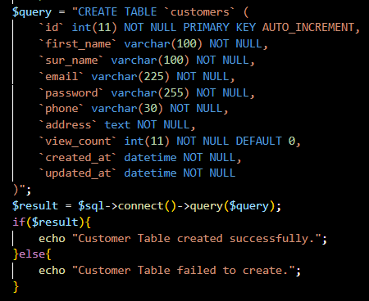

Successfully Customers Query

Customers Table Structure

Database Query for Campsites

Successfully Campsites Query

Campsites Table Structure

Database Query for Pitch_Types

Successfully Pitch_Types Query

Pitch_Types Table Structure

Database Query For Contacts

Successfully Contacts Query

Contacts Table Structure

Database Query For Packages

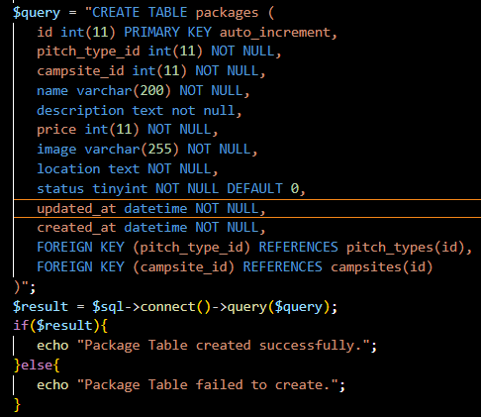

Successfully Packages Query

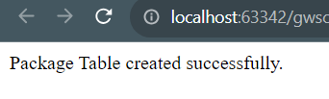

Packages Table Structure

Database Query For Bookings

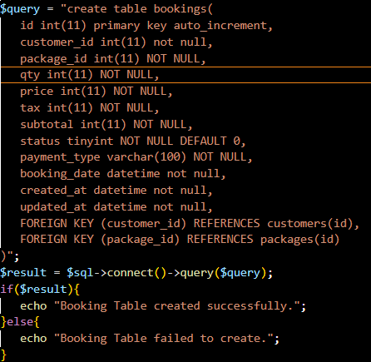

Successfully Bookings Query

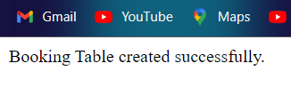

Bookings Table Structure

Database Query For Features

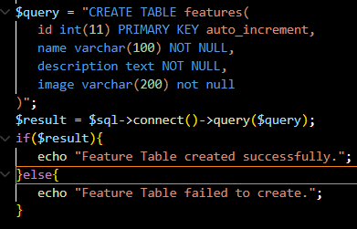

Successfully Features Query

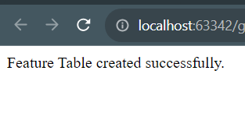

Features Table Structure

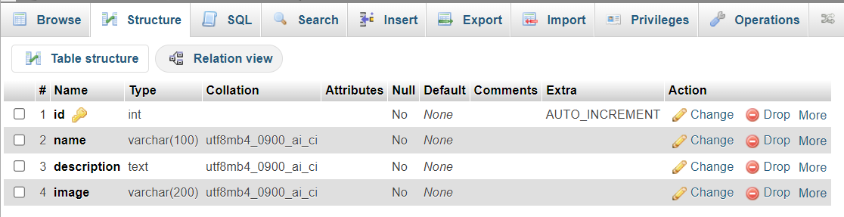

Database Query For Attractions

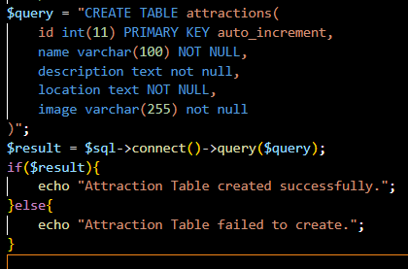

Successfully Attraction Query

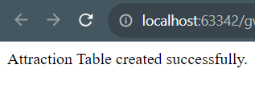

Attractions Table Structure

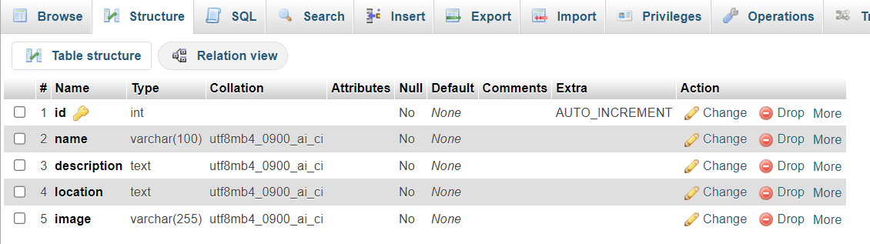

Database Query For Reviews

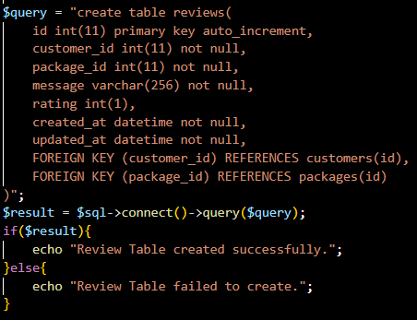

Successfully Reviews Query

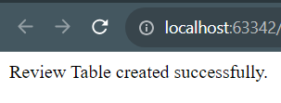

Reviews Table Structure

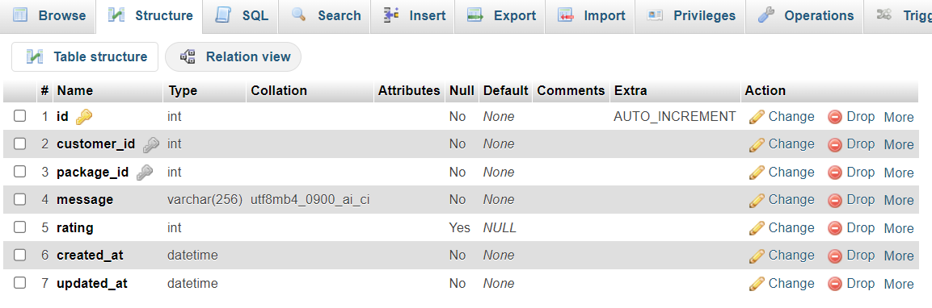

Database Query For Package_Feature

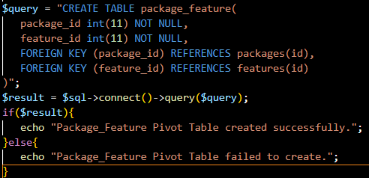

Successfully Package_Feature Query

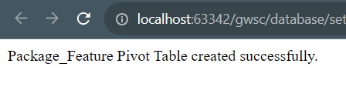

Package_Feature Table Structure

Database Query For Package_Attraction

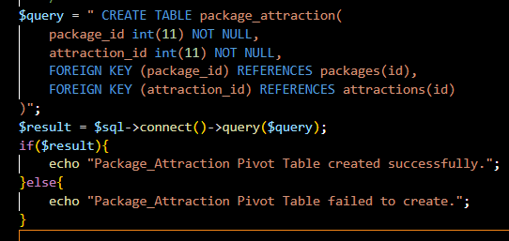

Successfully Package_Attraction Query

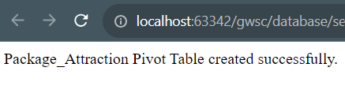

Package_Attraction Table Structure

