Register

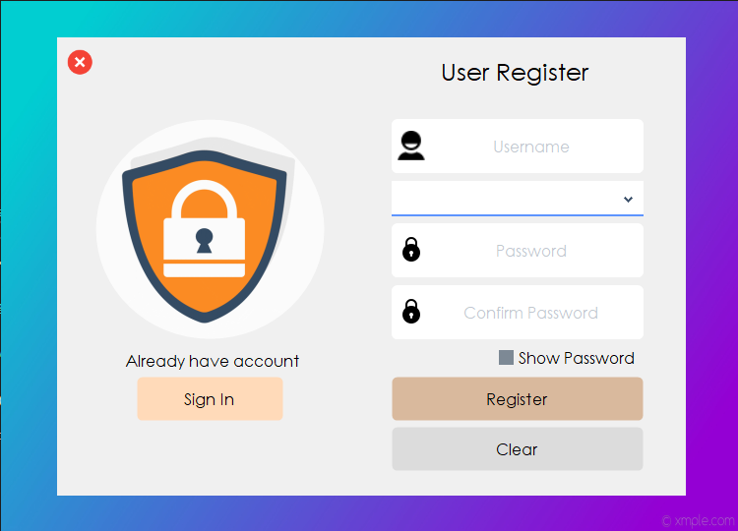

1. First user needs to register account to use software. So, need to click the “Sign Up” button.
2. When user account creates, need to fill the following form all fields.
3. Account registration process will be successful only after completing all the information.
4. If the account registration process is successful, clicking the “Sign In” button will take you to the login page.

Login

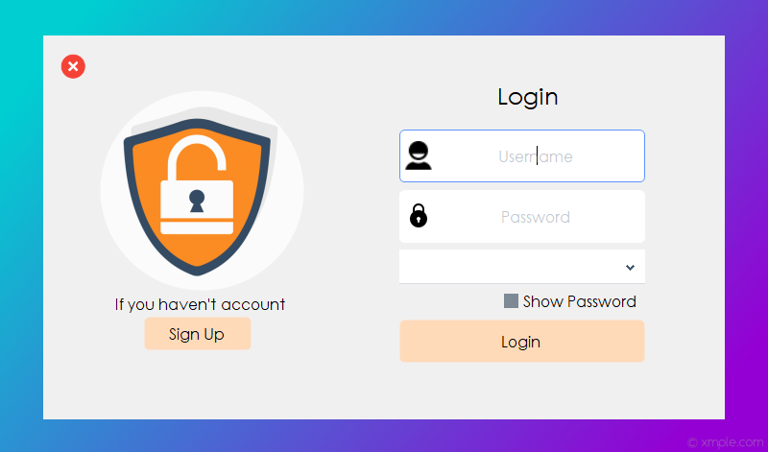

1. Only users who have registered an account will be able to login if they have chosen the correct username, password and role they created.
2. If the login process is successful, you’ll be taken to view as shown in the image below (For “Manager” role).

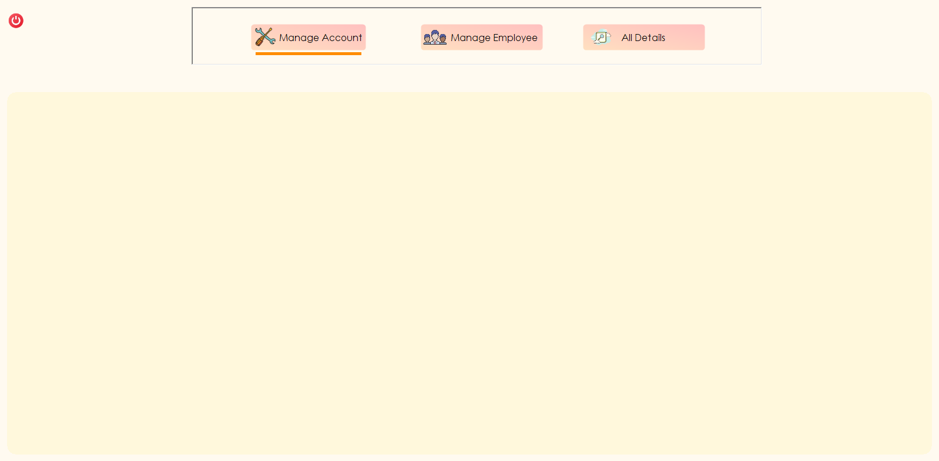

Manage Account

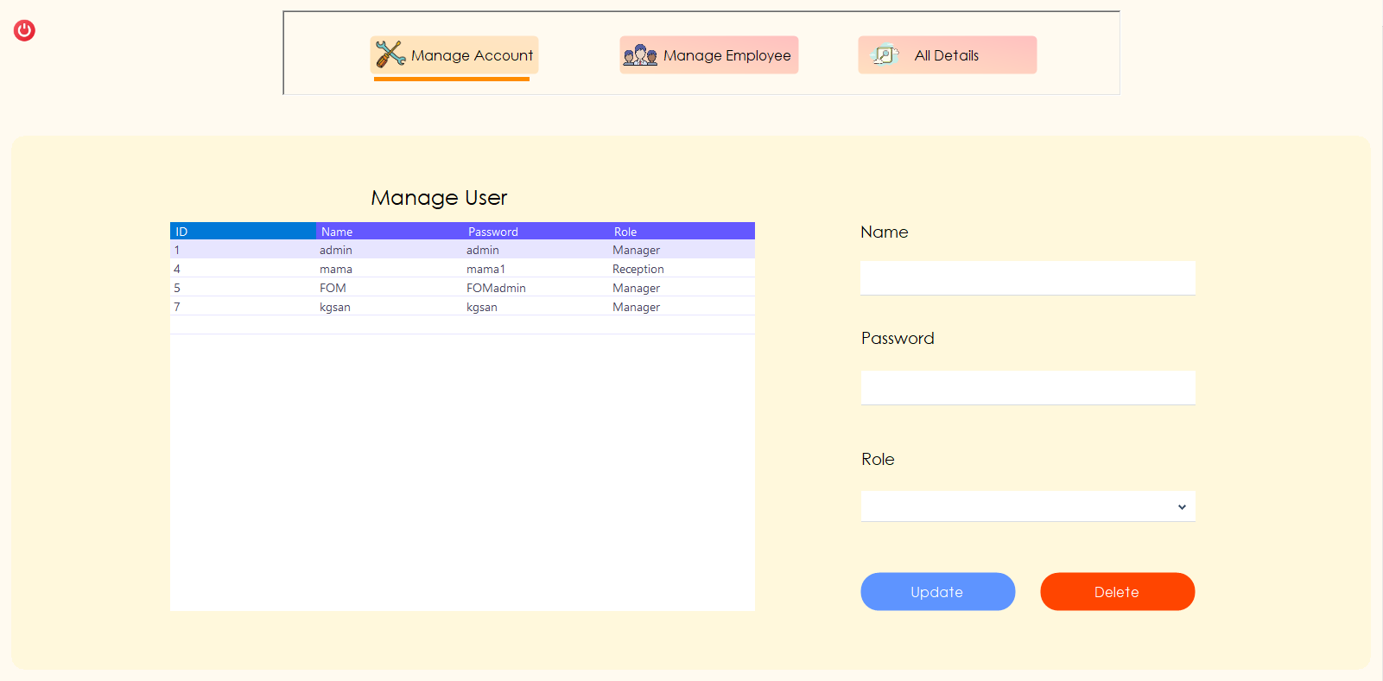

Only “Manager” role, can update and delete registered account. Read below on how to update and delete for account.

1. In the data that appears in the table, double-click what you want to do.
2. Data will automatically fill in the above fields.
3. Can now edit the data, manager want to edit.
4. After changes are completed, click “Update” button to update the data.
5. If you want to delete it, you can do so by clicking the “Delete” button.

Manage Employee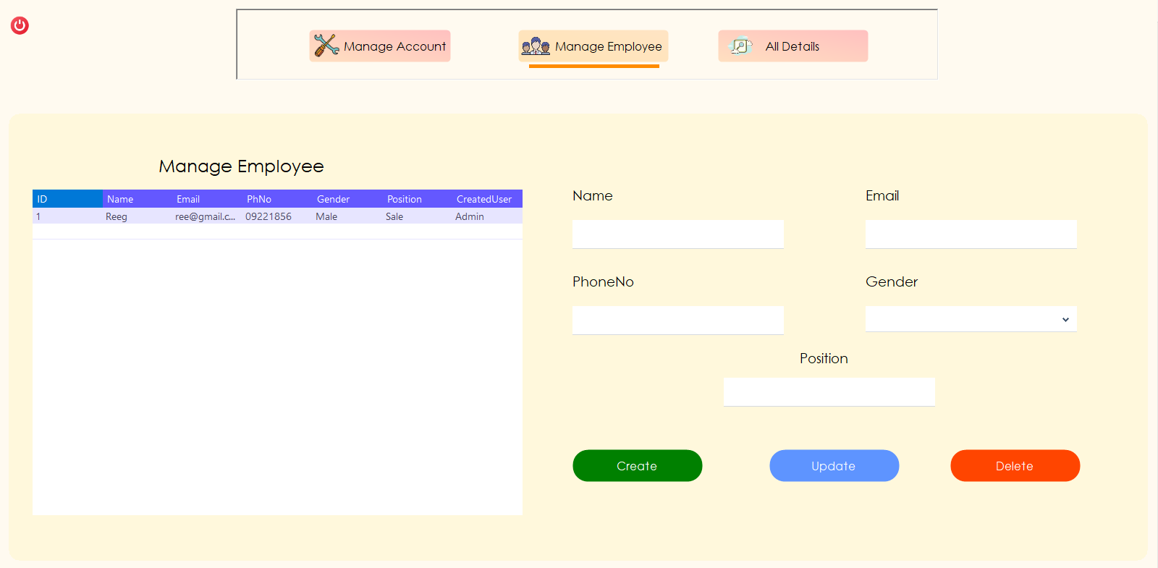

Only the “Manager” role can control the employee create, update and delete processes. Read below on how to create, update and delete for employee.

**How to create employee**

1. Name – Write the employee’s name
2. Email – Enter the email address used by the employee
3. Phone No - Enter the employee’s phone number.
4. Gender – Select the gender of the employee.
5. Position – Enter the employee position.
6. All the required fields are filled in, the employee create process is successful by clicking the create button.

**How to update and delete employee**

1. The data that appears in the table, double-click what you want to do.
2. Data will automatically fill in the above fields.
3. Can now edit the data, manager want to edit.
4. After changes are completed, click “Update” button to update the data.
5. If you want to delete it, you can do so by clicking the “Delete” button.

All Details (or) Reporting Section

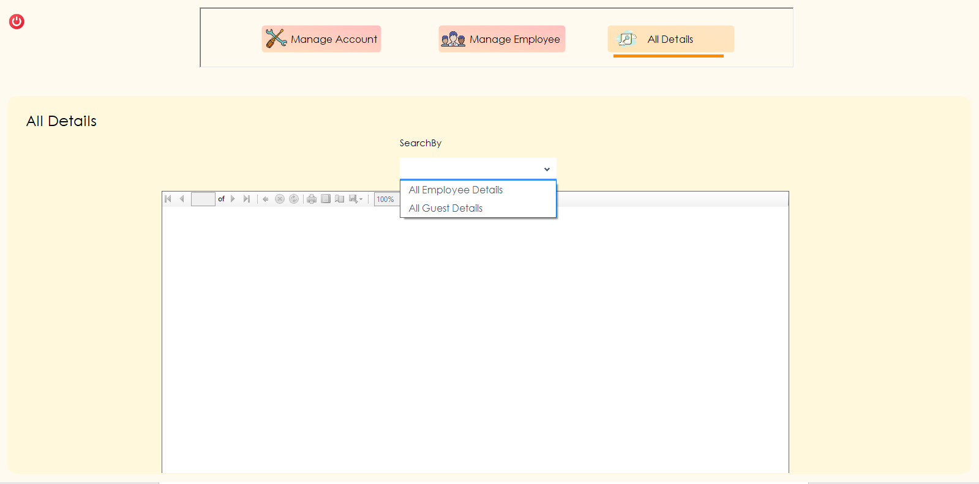

1. This is the report section. Which sections can be reported are the information of the staff and the list of the guests staying at the hotel.

All Employee Details

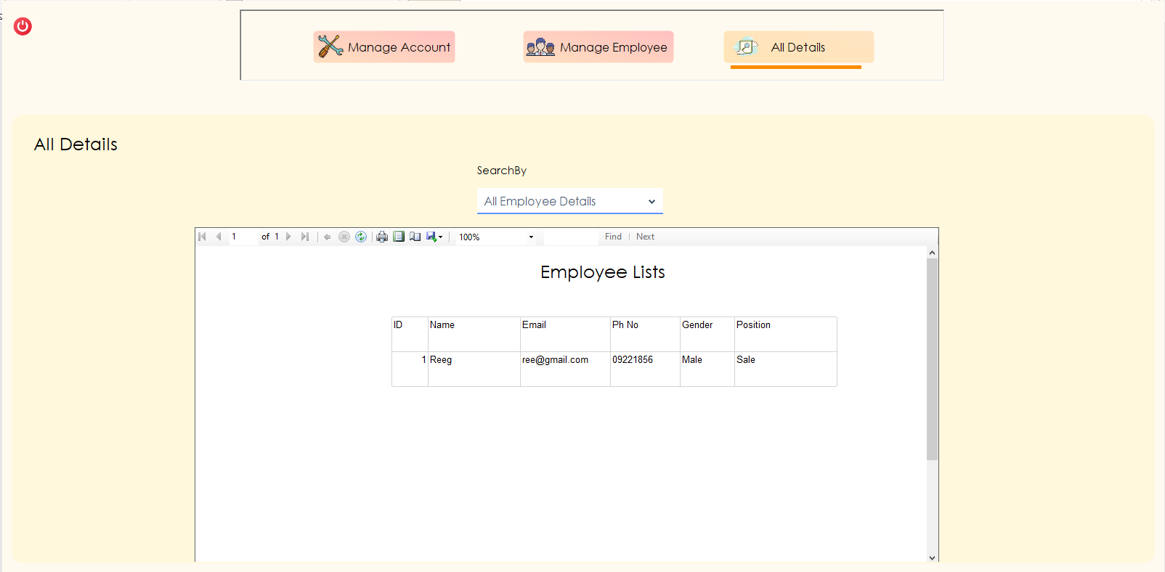

All Guest Details

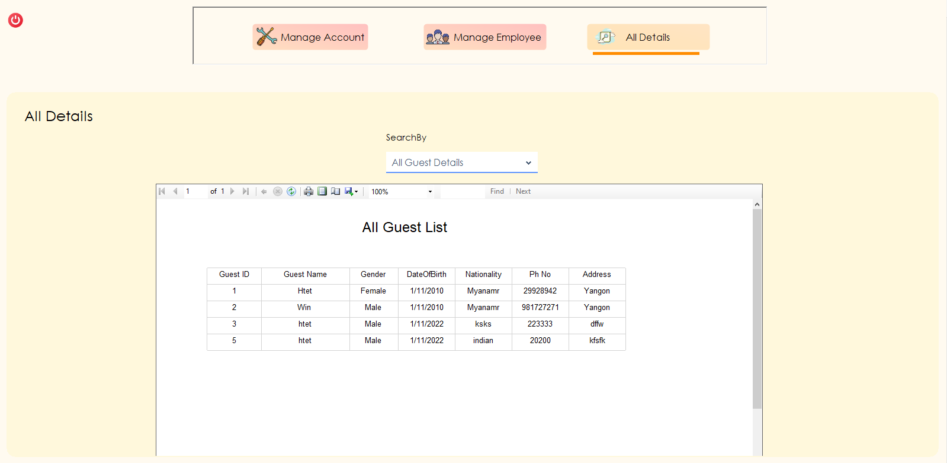

Logout

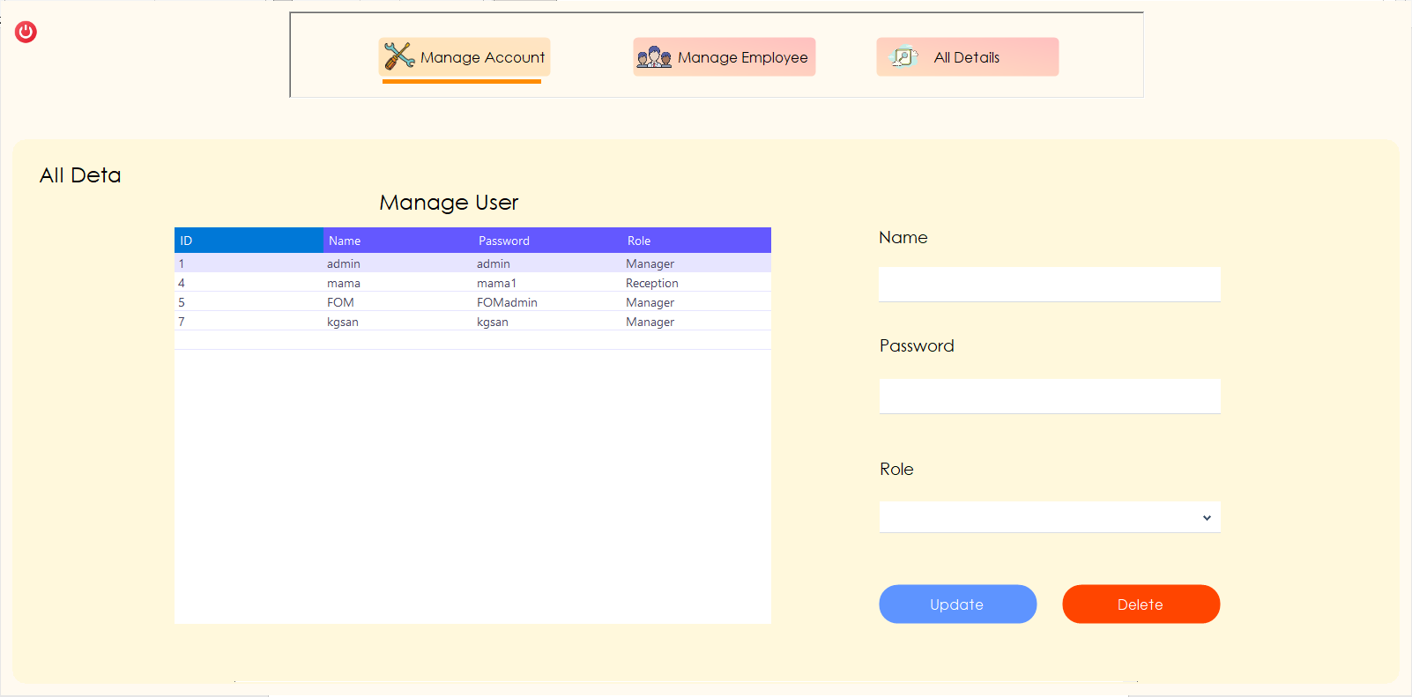

Logout Button

If you want to logout of your account after completing all your works, you can click the button shown in the picture. Clicked the logout button and you will be taken back to the login form.

Application Stop

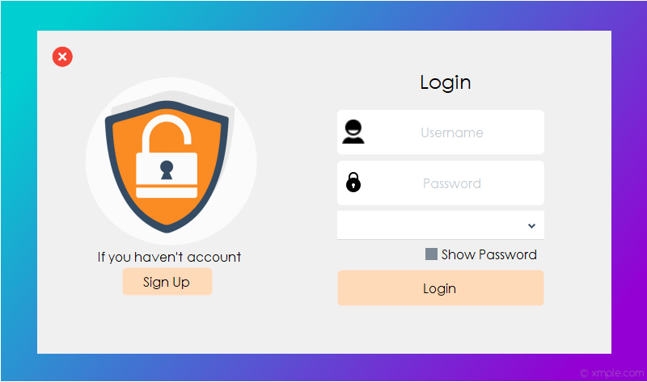

Application

Stop

If the user has finished using the software, by clicking the button shown in the picture you can stop the application.