RAVLEEN KAUR

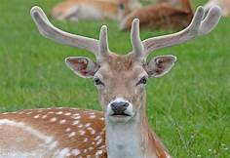

EDUCATION

* Swami Sant Dass Public School

<https://www.ssdpsphg.com/>

“Research Interests”