Major Project Report File
on
Customer Churn Prediction

Submitted in Partial fulfillment of the requirement for the award of degree of

BACHELOR OF TECHNOLOGY
in
Computer Science and Artificial Intelligence
Batch (2022-2026)


Submitted to: Submitted by:
Dr.Ridhi Kapoor Parveen Kaur
12200525

DEPARTMENT OF COMPUTER SCIENCE AND ENGINEERING
DAV UNIVERSITY
JALANDHAR-PATHANKOT NATIONAL HIGHWAY, NH 44,
SARMASTPUR- PUNJAB 144012

ACKNOWLEDGMENT

I would like to express my sincere gratitude to my project guide, Dr. Ridhi Kapoor, for their valuable guidance, constructive feedback, and continuous support throughout the duration of this project. I am also thankful to Dr. Rahul Hans and the Department of Computer Science and Artificial Intelligance for providing the necessary resources and an encouraging academic environment.

My appreciation extends to all faculty members and classmates whose suggestions and cooperation helped strengthen the quality of this work. Lastly, I am deeply grateful to my family for their constant encouragement and support, which motivated me to complete this project successfully.

DECLARATION

I, Parveen Kaur, hereby declare that the work which is being presented in this project titled “Customer Churn Prediction” by me, in partial fulfilment of the requirements for the award of Bachelor of Technology (B. Tech) Degree in “Computer Science and Artificial Intelligence’’ is an authentic record of my own work carried out under the guidance of Dr. Ridhi Kapoor.

To the best of my knowledge, the matter embodied in this report has not been submitted to any other University/ Institute for the award of any degree or diploma.

Parveen Kaur
12200525

Abstract

Customer churn is a major challenge for subscription-based businesses, as losing customers directly affects revenue and long-term growth. This project focuses on predicting customer churn using machine learning techniques to help organizations identify at-risk customers before they leave. The dataset contains customer demographics, account information, service usage patterns, and billing details. After cleaning and preprocessing the data, various classification models such as Logistic Regression, Decision Tree, and Random Forest were trained and evaluated. Among them, the Random Forest model achieved the highest accuracy in identifying churn patterns. The project also includes exploratory data analysis and visualizations to understand key factors influencing churn, such as contract type, tenure, payment method, and monthly charges. The results demonstrate how machine learning can support proactive retention strategies by helping businesses target customers likely to churn and improve overall customer satisfaction.

TABLE OF CONTENTS

S.NO | TOPICS | P. NO
1. | Introduction | 6-14.
2. | Project Title | 15-17.
3. | Objectives | 18.
4. | Code and Implementation | 19-20.
5. | Conclusion | 21.
6. | References | 22.

Chapter1

INTRODUCTION
1.1 INTRODUCTION TO PROJECT – Customer Churn Prediction:
Customer churn is one of the most critical challenges faced by subscription-based businesses, telecom operators, financial institutions, and service-driven companies. Churn occurs when a customer stops using a product or service, leading to revenue loss and increased acquisition cost for replacing that customer. Understanding and predicting churn allows organizations to retain valuable clients and improve long-term business performance.
This project focuses on developing a Customer Churn Prediction System using data analytics and machine learning techniques. The goal is to identify customers who are at high risk of leaving by analyzing their demographic information, service usage patterns, billing behavior, complaints, past interactions, and contract details. By leveraging historical datasets and applying advanced predictive algorithms, the system can classify customers as “churn” or “non-churn” with high accuracy.
The project involves several key stages, including data collection, preprocessing, feature engineering, exploratory data analysis (EDA), and model development. Various machine learning models—such as Logistic Regression, Random Forest, Gradient Boosting, and Neural Networks—are evaluated to determine the most effective algorithm for churn prediction. Visualization tools and dashboards are incorporated to interpret customer behavior and highlight important churn indicators

1.2 ADVANTAGES OF PROJECT:

1. Early Identification of At-Risk Customers
The model helps identify customers who are likely to churn, allowing businesses to take timely and targeted retention actions before they leave.

2. Improved Customer Retention
By predicting churn, companies can implement personalized strategies—such as offers, discounts, upgraded services, and improved support—to retain valuable customers.

3. Increased Revenue and Profitability
Reducing customer churn directly lowers revenue loss and boosts overall profitability, since retaining an existing customer is far more cost-effective than acquiring a new one.

4. Data-Driven Business Decisions
The system provides clear insights based on customer behavior and patterns, enabling organizations to make accurate, data-backed strategic decisions.

5. Enhanced Customer Experience
Understanding customer needs and issues enables companies to improve service quality, reduce complaints, and deliver a more satisfying customer journey.

6. Optimized Marketing and Resource Allocation
Instead of spending on broad marketing campaigns, businesses can focus efforts specifically on high-risk customers, resulting in better use of resources and higher ROI.

7. Competitive Advantage
Organizations that can predict churn and retain customers more effectively gain an edge over competitors in highly saturated markets.

8. Automation and Scalability
The machine learning model automates churn detection and can scale easily as new customers, services, or business data are added.
1.3 FEATURES OF PROJECT:

1. Data Collection & Integration: Collects customer demographic details, service usage, billing history, complaints, and contract information from multiple sources.

2. Data Preprocessing & Cleaning: Handles missing values, removes duplicates, deals with outliers, and transforms raw data into a usable format.

3. Feature Engineering: Creates meaningful features such as tenure groups, usage patterns, payment behavior, and customer segments to improve model accuracy.

4. Exploratory Data Analysis (EDA): Provides insightful visualizations to understand customer behavior, correlation between features, and churn trends.

5. Machine Learning Model Development: Uses ML algorithms like Logistic Regression, Random Forest, XGBoost, and Neural Networks to predict customer churn.

6. Model Evaluation Metrics: Evaluates model performance using accuracy, precision, recall, F1-score, confusion matrix, and ROC-AUC.

7. Prediction System: Classifies customers into “Churn” and “Non-Churn” categories based on their behavioral and service attributes.

8. Interactive Dashboard / UI: Includes visual dashboards (Streamlit/Power BI/Tableau) displaying churn rates, top influencing factors, and customer insights.

9. Real-Time Insights (Optional): Can integrate with live data sources to generate up-to-date churn predictions and alerts.

10. Scalable & Deployable Architecture: Supports deployment through Streamlit, cloud platforms, or local applications, making it easy for businesses to use.

  - TECHNOLOGIES USED:
  - PYTHON:
- Python is a high-level, interpreted programming language known for its simplicity, readability, and versatility. Created by Guido van Rossum and first released in 1991, Python emphasizes code readability with its use of indentation, making it easier for developers to write clean and maintainable code. It supports multiple programming paradigms, including procedural, object-oriented, and functional programming, making it a flexible tool for various types of software development.
- Python has a large standard library that includes modules for handling tasks such as file I/O, system operations, and even web development. It also has a rich ecosystem of third-party libraries and frameworks, which extend its functionality in areas like data science (e.g., NumPy, Pandas), web development (e.g., Django, Flask), machine learning (e.g., TensorFlow, Scikit-learn), and automation (e.g., Selenium).

Key Features of Python:
- Simple Syntax: Python's syntax is designed to be clear and intuitive, making it accessible to beginners and experienced programmers alike. The language emphasizes readability, which helps in writing clean and maintainable code.
- Versatility: Python supports multiple programming paradigms, including procedural, object-oriented, and functional programming. This flexibility allows developers to use Python for a wide range of applications, from scripting and automation to complex data analysis.
- Extensive Standard Library: Python comes with a comprehensive standard library that provides modules and functions for various tasks, including file handling, networking, and data manipulation. This library reduces the need for external dependencies and accelerates development.
- Cross-Platform Compatibility: Python is cross-platform, meaning it can run on different operating systems, such as Windows, macOS, and Linux. This compatibility ensures that Python code can be executed on various devices and environments without modification.

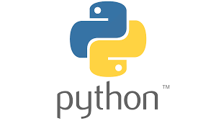

2. STREAMLIT:

Streamlit is an open-source Python library that enables developers to create interactive, web-based applications quickly and with minimal code. Designed specifically for data scientists and machine learning engineers, Streamlit allows users to build dynamic dashboards, visualizations, and tools in a straightforward, Pythonic way without needing front-end development skills.
Streamlit simplifies the process of turning data-driven Python scripts into deployable web applications. With just a few lines of code, developers can create fully interactive interfaces with components like sliders, buttons, charts, and tables. The framework automatically updates the app in real-time as users interact with it, ensuring a responsive and engaging user experience.
One of Streamlit’s key strengths is its integration with popular Python libraries, such as NumPy, Pandas, Matplotlib, Plotly, and TensorFlow, making it ideal for showcasing data visualizations, machine learning models, and data analysis results. The platform also supports easy deployment, allowing users to share their apps online via platforms like Streamlit Cloud or deploy them locally or on cloud servers.

Key Features of Streamlit :
- Easy to Use:
Streamlit allows you to create web applications with minimal lines of code. It is designed for simplicity, so you don’t need extensive knowledge of web development technologies like HTML, CSS, or JavaScript to build applications.
- Real-Time Interactivity:
Streamlit automatically updates the application in real-time as the user interacts with widgets like sliders, buttons, and inputs. This makes it ideal for building interactive data visualizations and dashboards.
- Integration with Popular Python Libraries:
Streamlit seamlessly integrates with popular Python libraries such as Pandas, NumPy, Matplotlib, Plotly, TensorFlow, and Scikit-learn. This allows users to leverage existing Python scripts and build interactive visualizations and machine learning models.


3. NUMPY:
NumPy (Numerical Python) is a cornerstone of scientific computing in Python, created by Travis Oliphant in 2005. It evolved from earlier packages like Numeric and Numarray and is now integral to the Python scientific computing stack. NumPy provides efficient tools for handling large, multi-dimensional arrays and matrices, along with a comprehensive suite of high-level mathematical functions.
The core feature of NumPy is the ndarray (n-dimensional array) object, which is a fast, flexible container for large datasets. Unlike Python's built-in lists, NumPy arrays are homogeneous, meaning all elements must be of the same type, which enhances performance. This efficiency is due to NumPy's use of contiguous memory blocks and optimized C code for many operations.
NumPy's array operations are vectorized, allowing computations to be applied to entire arrays without explicit loops. This vectorization improves both code readability and execution speed, significantly reducing the time required for large-scale numerical operations compared to traditional Python code.
The library offers a wide range of mathematical functions, including basic arithmetic, trigonometric functions, exponential and logarithmic operations, and statistical methods. It also supports linear algebra operations, such as matrix manipulations and eigenvalue computations. NumPy's broadcasting feature further enhances performance by allowing operations on arrays of different shapes, automatically aligning smaller arrays with larger ones.
In addition to mathematical operations, NumPy includes robust random number generation capabilities, essential for simulations and statistical analyses. It supports various probability distributions and can handle large datasets through memory-mapped file arrays.
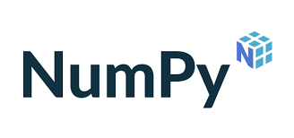

4. PANDAS:
Pandas is a powerful, open-source Python library designed for data manipulation and analysis. Created by Wes McKinney and released in 2009, it has become an essential tool in the data science ecosystem, bridging the gap between the numerical computing capabilities of NumPy and the flexible data manipulation requirements of analysis tasks. Pandas provides two primary data structures: Series and DataFrame. The Series is a one-dimensional array-like object, while the DataFrame is a two-dimensional, tabular data structure with labeled axes (rows and columns), akin to a SQL table or an Excel spreadsheet. This structure allows for efficient handling of heterogeneous data and simplifies the manipulation of data with complex, real-world requirements.
Pandas is known for its ability to work with various data formats, including CSV, Excel, JSON, and SQL databases, making it invaluable for data ingestion and preparation. It offers an extensive array of functions for data manipulation, such as filtering, sorting, grouping, merging, and reshaping. Its indexing capabilities, including the loc and iloc indexers, provide powerful tools for data selection and transformation.
One of pandas' standout features is its time series functionality. It supports date range generation, frequency conversion, and moving window statistics, which are critical for financial and scientific analysis. Pandas integrates seamlessly with other Python libraries such as NumPy for numerical operations, Matplotlib and Seaborn for visualization, and scikit-learn for machine learning, facilitating a comprehensive data science workflow.
Handling missing data is another strength of pandas. It provides methods for filling, dropping, and interpolating NaN (Not a Number) values, which is crucial for preparing datasets for analysis. Pandas' performance is optimized through Cython and C, making it efficient for large-scale data processing. Recent developments include enhanced support for categorical data and improved string handling. Overall, pandas is a versatile tool widely used across various industries for tasks ranging from data cleaning to complex statistical analysis and machine learning.



5. SCIKIT-LEARN (SKLEARN):
Scikit-Learn, commonly known as sklearn, is one of the most widely used open-source machine learning libraries in Python. Released in 2007 and built on top of NumPy, SciPy, and Matplotlib, it provides a comprehensive suite of tools for building, evaluating, and deploying machine learning models. The library is designed with a consistent and user-friendly API, which makes it accessible for both beginners and advanced practitioners. Scikit-Learn offers a wide range of supervised and unsupervised learning algorithms, including Logistic Regression, Decision Trees, Random Forest, Support Vector Machines, K-Means Clustering, and more.
Sklearn is structured around core functionalities such as model training, data preprocessing, feature selection, and model evaluation. It provides built-in methods for splitting datasets, standardizing features, encoding categorical variables, and validating model performance through techniques like cross-validation. The library’s estimator interface—based on the fit(), predict(), and transform() methods—ensures consistency across all algorithms, making it easy to experiment with multiple models and compare their results efficiently.
One of the major strengths of scikit-learn is its capability to integrate seamlessly with other tools in the Python ecosystem. It works smoothly with Pandas (for data manipulation), NumPy (for numerical operations), and Matplotlib/Seaborn (for visualization). Sklearn also offers powerful utilities for building pipelines, which automate the entire machine learning workflow—from preprocessing to model prediction—ensuring cleaner, more reproducible code.
Scikit-Learn includes efficient implementations of metric functions such as accuracy, precision, recall, F1-score, and ROC-AUC, making it a complete toolkit for evaluating model performance. It also supports hyperparameter tuning through GridSearchCV and RandomizedSearchCV, enabling users to optimize model parameters for better accuracy. Despite being a high-level library, sklearn is optimized for performance through underlying C/C++ integrations, making it suitable for medium to large-scale datasets. Overall, Scikit-Learn is an essential library for machine learning development, widely used in academia, industry, and real-world applications like customer churn prediction, fraud detection, healthcare analytics, and recommendation systems.



- SEABORN:
Seaborn is a powerful, open-source Python data visualization library built on top of Matplotlib. Developed by Michael Waskom, Seaborn was designed with the goal of making statistical graphics more visually appealing, informative, and easier to create. It provides a high-level interface for drawing attractive and meaningful statistical plots, making it an essential tool in the field of data science and exploratory data analysis (EDA).
Seaborn simplifies the process of creating complex visualizations by offering a wide range of built-in themes, color palettes, and plot types. It works seamlessly with Pandas DataFrames, allowing users to visualize patterns, trends, and relationships in structured datasets effortlessly. Rather than writing long code, Seaborn enables the creation of rich visualizations in just a few lines, making it highly efficient for data exploration.
One of Seaborn’s standout strengths is its ability to handle statistical relationships between multiple variables. It supports advanced visualization techniques such as pair plots, joint plots, heatmaps, violin plots, swarm plots, and categorical plots. These tools help analysts understand distributions, correlations, and comparisons across features. Seaborn also includes built-in support for confidence intervals, regression plots, and kernel density estimation, making it ideal for statistical modeling.
Seaborn integrates naturally with NumPy, Pandas, Matplotlib, and SciPy, allowing analysts to move seamlessly between data processing and visualization. Its aesthetic defaults—such as improved color schemes and layouts—significantly enhance the clarity and presentation of visual output. Whether for research, reports, dashboards, or model evaluation, Seaborn helps users transform raw data into compelling visual stories.
Overall, Seaborn is a versatile and highly efficient visualization library that plays a crucial role in modern data science workflows. Its ability to generate attractive, statistically-rich visualizations with minimal code makes it a preferred choice for analysts, researchers, and machine learning practitioners.



CHAPTER-2
2.1) PROJECT PROBLEM STATEMENT:
- Problem:
- Businesses struggle to identify which customers are likely to leave due to the complex and diverse nature of customer behavior patterns.
- Traditional churn detection methods rely on manual analysis or delayed feedback, resulting in late interventions and lost customers.
·3. Large volumes of customer data remain underutilized because organizations lack automated systems to analyze patterns and predict churn accurately.
4.· Companies face high financial losses because they fail to implement timely retention strategies due to the absence of reliable churn prediction models.
- Objectives:
- To develop a machine learning model that accurately predicts customers likely to churn.
2. To identify the key factors and behavioral patterns that contribute to customer churn.
3. To enable businesses to take proactive measures through data-driven insights and predictions.
4. To help organizations reduce churn rates, improve customer retention, and increase overall profitability.
- Scope:
- Data Collection & Preprocessing:
The project involves gathering customer-related data, cleaning it, handling missing values, encoding categorical variables, and preparing the dataset for analysis and model training.
- Model Development & Evaluation:
The scope includes applying machine learning algorithms, training predictive models, evaluating their performance using metrics such as accuracy, precision, recall, and selecting the best model for churn prediction.
- Deployment & User Interface:
The project covers building an interactive Streamlit-based web application that allows users to input customer details, view predictions, and analyze churn-related insights in real time.
- Challenges:
- Imbalanced Dataset: In churn prediction, the number of customers who churn is usually much smaller than those who stay. This imbalance makes it difficult for machine learning models to learn meaningful patterns and often leads to biased predictions.
- Data Quality & Missing Information: Customer data may contain inaccuracies, missing fields, inconsistent entries, or noise. Ensuring proper data cleaning and preprocessing is challenging but essential for building a reliable model.
- Dynamic Customer Behavior: Customer preferences and behavior change over time due to market trends, service quality, competitor offers, and personal choices. Building a model that generalizes well over time and adapts to evolving patterns is a major challenge.

2.2) PROJECT TITLE – :CUSTOMER CHURN PREDICTION:
Customer churn is a significant challenge faced by businesses, especially in highly competitive sectors like telecommunications, banking, and subscription-based services. Churn refers to the phenomenon where customers stop using a company’s products or services, often switching to competitors. Predicting customer churn is critical because retaining existing customers is often more cost-effective than acquiring new ones. This project, Customer Churn Prediction, focuses on leveraging historical customer data and machine learning techniques to identify patterns and factors that contribute to customer attrition. By understanding these patterns, businesses can take proactive measures to retain valuable customers, improve customer satisfaction, and enhance profitability.
The primary aim of this project is to develop a predictive model capable of accurately identifying customers who are likely to churn. This involves analyzing various customer attributes, such as tenure, usage patterns, service subscriptions, billing preferences, and demographic information. Using this data, the project employs machine learning algorithms to create a model that not only predicts churn but also provides insights into the key factors influencing customer behavior. By doing so, the project transforms raw data into actionable insights that businesses can use to implement targeted retention strategies and personalized interventions.
Overall, the Customer Churn Prediction project addresses a real-world business problem by combining data analytics, machine learning, and domain knowledge. The outcomes of this project can help organizations reduce customer attrition, optimize marketing efforts, and maintain a competitive edge in the market. Furthermore, it highlights the growing importance of data-driven decision-making in understanding customer behavior and improving long-term business sustainability.

2.3) PROJECT HIERARCHY:

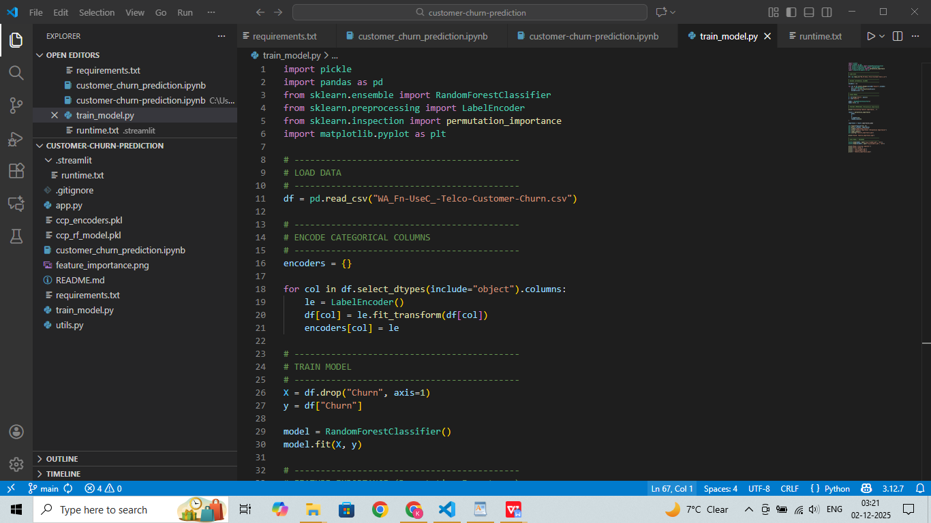

CHAPTER 3:
OBJECTIVES:
The primary objective of the Customer Churn Prediction System is to build an automated and intelligent platform that uses advanced machine learning (ML) and data analytics techniques to identify customers who are likely to discontinue a service. The project aims to help businesses reduce revenue loss by recognizing early signs of churn and enabling companies to take proactive steps to retain customers. By analyzing customer behavior and service usage patterns in real-time, the system contributes to effective decision-making and customer relationship management.

Key objectives of the project include:
- Real-Time Churn Prediction:
The system will analyze live or frequently updated customer data—such as usage patterns, payment history, and service interactions—to automatically predict which customers are at high risk of churning. This ensures timely identification and allows businesses to take quick preventive actions.
- Advanced ML and Analytics Integration:
Leveraging statistical analysis and machine learning algorithms, the system will detect patterns, trends, and behavioral indicators that contribute to customer churn. This integration ensures high accuracy in identifying risk factors and supports data-driven retention strategies.
- Support for Multiple Customer Segments:
The platform will be capable of analyzing diverse customer groups across various demographics and service types. This ensures that churn prediction is accurate and applicable to different customer profiles, improving targeting and personalization.
- Interactive and User-Friendly Dashboard:
A major goal is to provide an intuitive interface where users can visualize churn probabilities, explore customer insights, and monitor key performance indicators (KPIs). The dashboard will allow businesses to filter customer groups, track churn trends, and access detailed reports easily.

- Real-Time Alerts and Notifications:
The system will generate immediate alerts when a customer shows signs of potential churn, enabling businesses to respond with timely offers, support, or personalized interventions to reduce attrition.
- Mobile and Desktop Accessibility:
To ensure convenience and flexibility, the platform will be accessible from both mobile devices and desktops. This allows business teams to monitor churn statistics and customer behavior anytime and anywhere.
- Educating Teams on Customer Behavior:
By providing explanations behind churn predictions and highlighting critical factors, the system helps organizations understand why customers are leaving. This supports better decision-making and strengthens customer retention strategies.

CHAPTER 4:
CODING AND IMPLEMENTATION:
4.1)CODE:

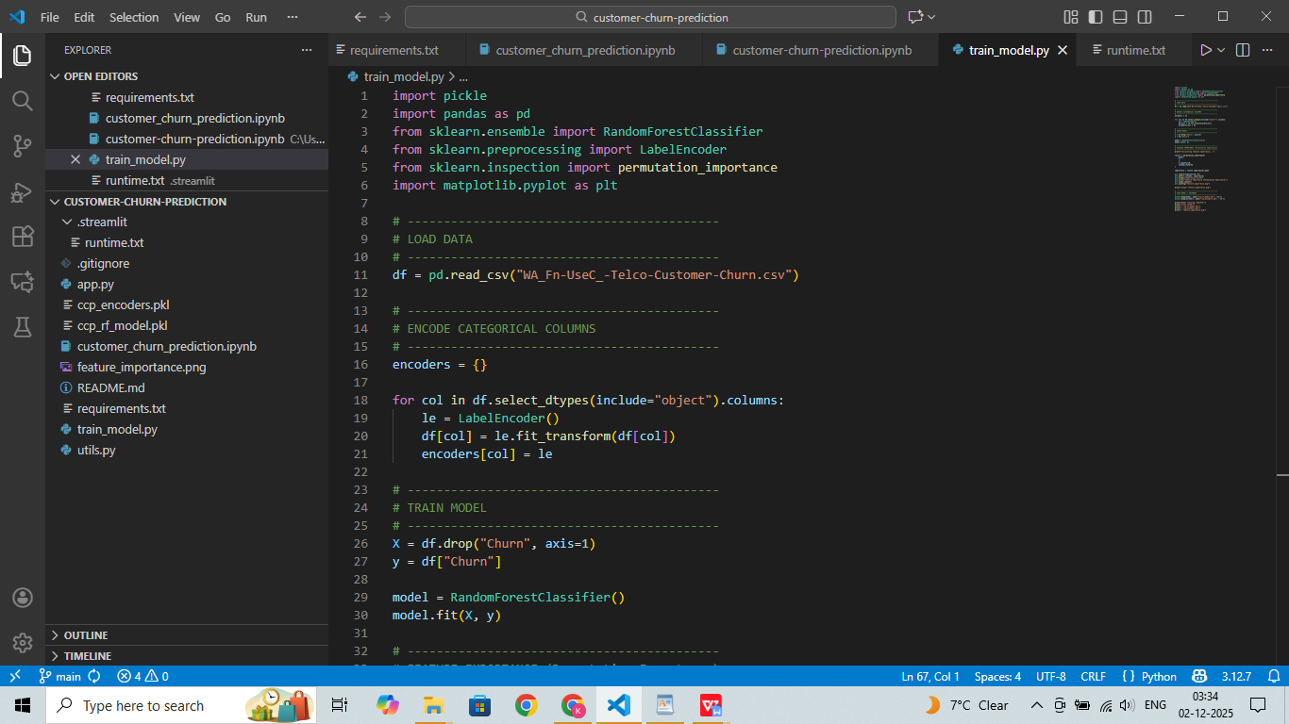

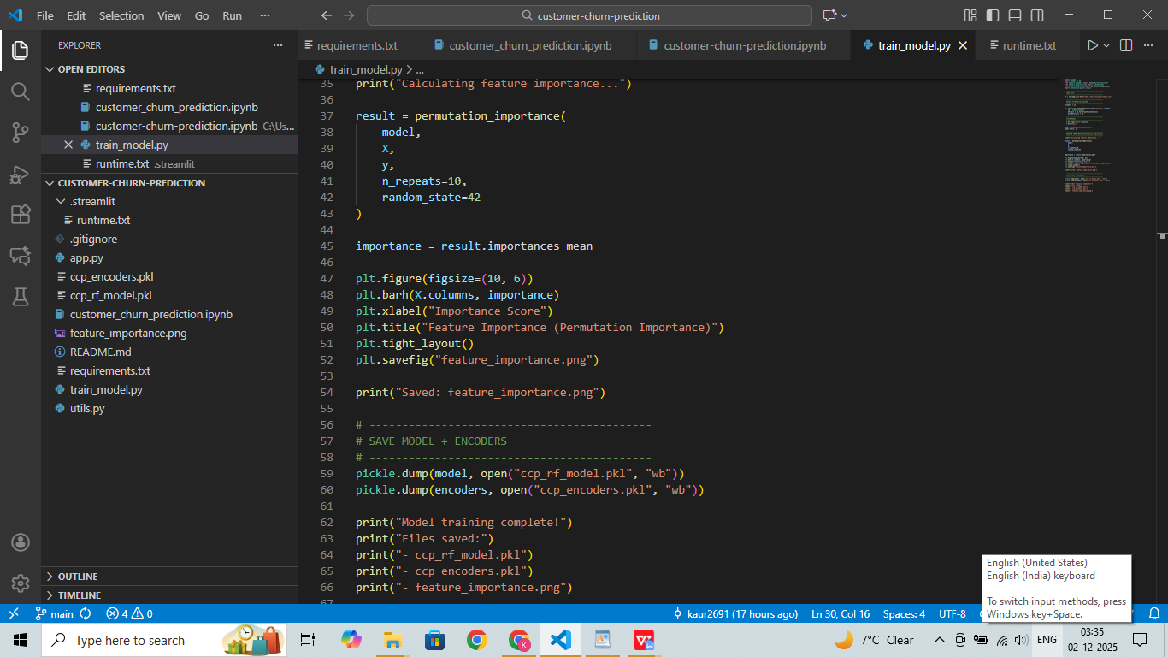
4.2) IMPLEMENTATION:

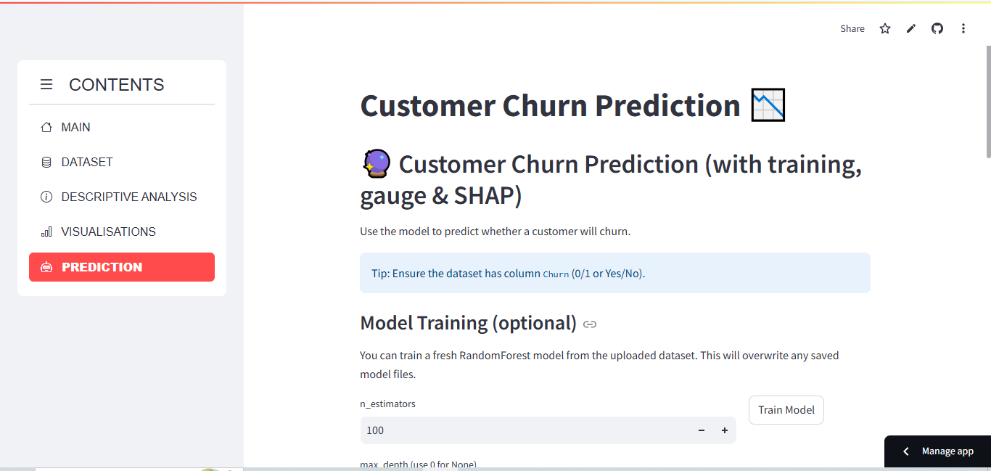

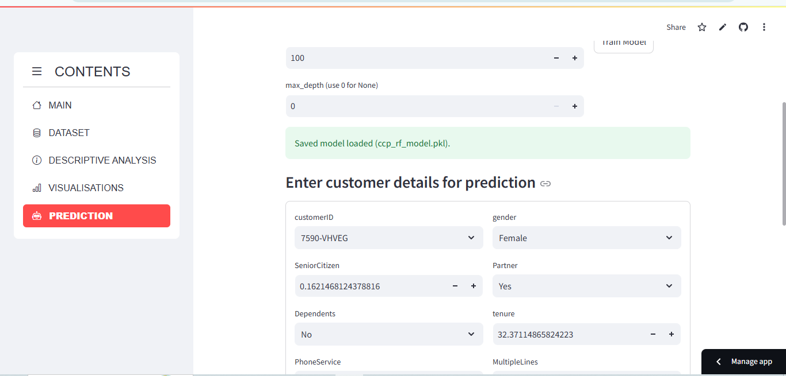

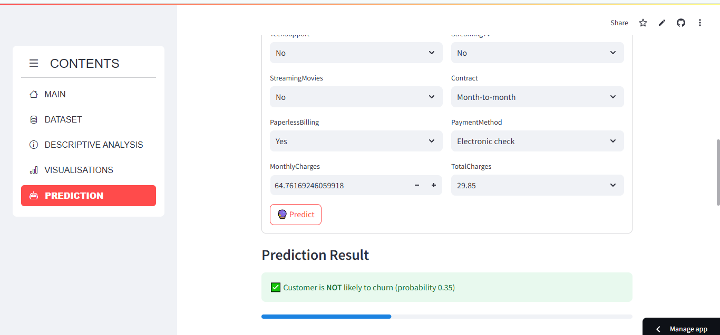

CHAPTER-5:
CONCLUSION:

The Customer Churn Prediction System demonstrates the power of modern technology in addressing one of the most significant challenges faced by businesses today—the loss of customers to competitors. By utilizing advanced machine learning techniques and data analytics, the system accurately identifies customers who are at risk of leaving, offering a scalable and automated solution for improving customer retention and reducing revenue loss.
Through the integration of predictive algorithms, real-time customer data analysis, and an intuitive user interface, the system ensures both accuracy and ease of use. Key processes such as data preprocessing, feature engineering, and predictive modeling enable the detection of subtle behavioral patterns and service-related factors that contribute to churn. This not only strengthens the model’s prediction capability but also improves transparency by helping businesses understand why customers are likely to leave.
The implementation of such a system has far-reaching benefits—ranging from supporting customer service teams in designing personalized retention strategies to helping organizations optimize their marketing and operational decisions. While challenges such as evolving customer expectations and diverse behavioral patterns persist, the project provides a strong foundation for future advancements in churn analytics and customer-focused technologies.
In conclusion, the Customer Churn Prediction System plays a vital role in helping businesses build stronger relationships with customers, minimize churn rates, and foster long-term loyalty. By turning raw data into actionable insights, the system empowers organizations to make informed decisions and create a more stable, customer-centric business environment.

Chapter-6
REFERENCES:
https://www.geeksforgeeks.org/customer-churn-prediction-using-machine-learning/
https://www.kaggle.com/blastchar/telco-customer-churn
https://scikit-learn.org/stable/
https://pandas.pydata.org/

