REAL-TIME VISUALISATION OF FTSE100 INDEX MARKET DYNAMICS
Acknowledgment
On the same note, my utmost appreciation goes to everyone who has helped me in the course of writing this research. Above all, I want to express my deep appreciation to my academic advisor who provided me support, inspiration, and, most importantly, academic direction in the course of this work. With their help and advice the quality of my work has definitely improved. I would also like to thank the other members of the faculty who scrutinized and helped in the preparation of the research. Their inputs and recommendations have been invaluable in fine-tuning my research strategy and standard of this work. To my beloved ones my family and friends I would like to express my appreciation for your support and encouragement during the work on this paper. I also thank my loved ones for being supportive and patient with me, for they have kept me motivated in the right path all this time. Therefore it is about these tools that it is necessary to express gratitude, since without them it would be impossible to resolve most of the practical questions arising in connection with this study.
Abstract
This work has been divided into chapters, and the first one offers a general background of the study whereby the following areas are described in detail; The FTSE100 index, why this topic was chosen, and the importance of real-time data display in the financial market. It provides a clear background to the research objectives, goals, and questions that are necessary to give a comprehensive background of the topic being researched.
Chapter 2 Literature review reviews the current literature on FTSE 100 organisations index, processing of real time data and the financial markets. It analyses and evaluates the historical and current ways of visualisation, with the emphasis on the concepts of artificial intelligence and machine learning. It also brings view of the present instruments and techniques used in financial visualization keeping in view the difficulties observed in analyzing the real time financial data on map. The literature reviewed in this chapter reveals research tensions that justify the current study indicated as follows:
Chapter Methodology explains the actual research techniques that were used in the study, this focuses on the deductive approach and experimental research method. The chapter centres on secondary data collection as well as the use of realism as the research philosophy. Regarding the tools and methods used for data processing and data representation, the work also affirms applicable and sound methodological and ethical procedures.
Chapter 4 shows the results of data analysis performed with the help of the ARIMA and LSTM models on FTSE100 index data. The findings are presented by line charts, candlestick charts and moving averages as a visual means of depicting the information.
Chapter 5 offers comparison of the study’s results with literature review in the field of real-time financial forecasting with focus for LSTM models in financial applications. To recall, the following are the major findings of the chapter: Each of the findings is discussed in light of the research objectives and questions at the beginning of the study as follows.
Table of Contents
Chapter 1: Introduction 6
1.1 Introduction 6
1.2 Research Background 6
1.3 Rationale of the Research 7
1.4 Aims and Objectives 8
1.5 Research Question 9
1.6 Research Significance 9
1.7 Summary 9
Chapter 2: Literature Review 10
2.1 Introduction 10
2.2 The FTSE100 Index 10
2.3 Real-Time Data Processing 11
2.4 Financial Market Dynamics 11
2.5 Visualization Techniques in Finance 12
2.6 Tools and Technologies for Financial Visualization 13
2.7 The Role of Predictive Analytics 14
2.8 Challenges in Real-Time Financial Visualization 14
2.9 Impact of Real-Time Visualization on Decision-Making 15
2.10 Literature Gap 15
2.11 Summary 16
Chapter 3: Methodology 17
3.1 Introduction 17
3.2 Research Methods 17
3.3 Research Philosophy (Realism) 17
3.4 Research Approach 18
3.5 Research Design (Experimental) 18
3.6 Data Collection Method (Secondary) 19
3.7 Tools and Techniques 19
3.8 Ethical Considerations 20
3.9 Summary 20
Chapter 4: Findings and Analysis 21
Chapter 5: Results and Discussion 23
5.1 Introduction 23
5.2 Dataset Description 23
5.3 Results 25
5.4 Discussion 28
Chapter 6: Conclusion 31
6.1 Conclusion 31
6.2 Linking with Objectives 31
6.3 Recommendations 32
6.4 Future Scope 32
References 33

Chapter 1: Introduction

1.1 Introduction
The FTSE 100 index was developed in 1984 as the float-adjusted combination of the twenty relative FT shares for the 100 largest firms in terms of market capitalization as of December 31, 1983, and posted on the LSE. It remains one of the most powerful measures of activity in the UK economy. It is used actively by investors, analysts, and policymakers. Its components are producers and sellers of goods and services with large market capitalization, thus reflecting general tendencies in the market and the economy. Real-time visualization in financial markets enables the capture and analysis of real-time occurrences in that market. With the real-time data feed it is used by the investors and analysts to track the live data, to understand the trend, and to take necessary action as quickly as possible which is required in the stock trading, especially in the fluctuations of the stock market (Stoykova and Paskaleva , 2021). Advanced visualization tools that provide real-time computations enhance the real-time comprehension of data organized in intricate and intricate methods which may allow for a certain degree of errors to be avoided and swift and accurate decision-making in the world of finance.

1.2 Research Background
The FTSE 100 commonly known as the Footsie of the LSE is an index of 100 largest listed companies in terms of market capitalization. Created on 03/01/1984 with starting points of 1,000 the index was designed to present a benchmark of the performance of large stocks within the market (Tikkanen, 2021). First of all, FTSE 100 was an alliance between the Financial Times and the London Stock Exchange, from which derives its name, FTSE (Financial Times Stock Exchange). This index has evolved with time to act as a measure of the economic status of the United Kingdom and a benchmark for many investors across the world. It is often revised, for instance, due to changes in the stock market performance regarding the list of companies with their market capitalization. Explaining the changes in the FTSE100 index we can also always refer to the changes in the overall production and the main fields in the UK – the set dominating sectors such as finance, technologies, and consumer services are very illustrative in this context. Market visualization is essential in comprehending large amounts of financial information to make sound decisions. Some of the traditional forms of market visualization include line charts, bar charts, candle sticks, and a host of others that have been in use for more than 50 years. Although these methods are valuable, they fail to provide pictures that are flexible enough to give a quick and ever-evolving picture of the financial markets. The current technological enhancements have availed better visualization techniques than the ones used previously. For example, there are interactive tables, where the user gets to engage with the data as it is filtered in real time, or even goes into a more detailed set of information (Volpatti, 2024). Most of these are supported by business intelligence tools such as Tableau, Microsoft Power BI, and QlikView which consume large datasets and offer real-time data update capabilities. Also, the message content of financial visualization has adopted novation technologies like heat maps and tree maps to make a representation of a large amount of data in looking for and detecting patterns at a glance. These tools are sometimes supplemented with machine learning algorithms that can analyze temporal relations in the data, and draw forecasts from them. The availability of APIs has also significantly enhanced the manner in which exchange feeds are real-time fed into visualization tools, to allow traders and analysts to promptly react to prevailing trends.
The overall financial sector is gradually moving toward the utilization of real-time analytical data to sustain and gain a competitive advantage. Among the most popular trends in this direction is leveraging artificial intelligence and machine learning in data processing and analysis. Tech gurus note that it is almost impossible for human beings to run through a vast amount of data within a short period and make necessary predictions and connections as would the AI-driven algorithms demonstrate in the case of financial data analysis. Another gradually emerging trend is in the application of 'big data' management, in particular the use of cloud-based platforms to support immediate analysis of data gathered by networks. Cloud computing is highly flexible; financial institutions can easily meet large demands without having to invest broadly in premises (Valle-Cruz et al. 2023). They also allow collaboration in that it is easy for teams to engage in working on the analysis of data irrespective of the geographical location. In the same manner, the emergence of big data analytics has changed the manner in which financial markets are conceived. In other words, by considering all the data that social media, information sources, and indicators of economic stability provide, it is possible to gain a wider picture of the market. Such an approach to data analysis is vital in today's accelerated environment required for sound decision-making in the financial sector. In sum, the development of the FTSE 100 index together with progress in the techniques and technologies for the visualization of market and trends in real-time financial data analysis implies the further development of the innovation of this field. All of these are crucial in offering investors and analysts the means to decipher new–age global securities markets.

1.3 Rationale of the Research
What is the Issue?
Many modern techniques of market visualization are incapable of reflecting all characteristics and intensive changes in financial markets especially those within the FTSE100 index. The usage of charts and basic graphs does not enable the kind of real-time and interactive analysis that would be necessary to create an understanding through a more frequently updated representation of the data and therefore the available tools and the abilities we have to make decisions based on data are insufficient.
Why is it an Issue?
This turns into a major problem in the context of financial markets in which rapid decision-making may allow an organization to reap handsome profits or heavy losses. When the data is presented inaccurately or with a delay, investments, recommendations, and market actions may be performed during the wrong time, which would result in losses, for investors, analysts, and other stakeholders (Cecen, Jain, and Xiao, 2021). The absence of sophisticated tools for real-time visualization of situations has a drawback in terms of time for turning to the results of the market analysis which is crucial in keeping a competitive advantage.
What is the Issue Now?
Today, the problem is compounded by the fact that the volume and sheer depth of data are vastly more intricate, and the need for the tools to be more advanced. As the amount of available market data increases, the inefficiency of most of the current approaches to visualizing them becomes more evident. Business managers and investors need tools that will not only represent the data in real-time but also the tools that will help d to trace the tendencies and patterns and forecast future trends.
What Does the Research Shed Light Upon?
This research therefore provides insights into the need for the creation of new and better visualization methods that would accommodate the dynamism of the FTSE100 index. Thus, this research will complement the efforts by trying to fill the gap with a better approach in using real-time data analysis and other sophisticated visualization techniques that provide solutions that are in line with the current requirements from the areas of financial analysis, investors, and researchers (Liao, Huang and Tang, 2024). The results may contribute to the design of the tools that will deliver better, faster, and targeted information thus, advancing decision-making practices in finance.

1.4 Aims and Objectives
This latter will spin off methods for real-time advanced market visualization for the FTSE 100 index, with a first goal of improving evident data interpretation in an improved business environment as well as of solving existing problems of FTSE100 market visualization.
Objectives:
- To be able to determine the significant market variables that can be used in the analysis of the FTSE100.
- To foster creativity and employability of state of art methods for visualization.
- To effectively keep track of the new visualization methods being introduced in the course of the project; or to simply validate the efficiency of some fresh ideas.
- To determine whether the improvements have been captured accurately through the various analysis techniques the results obtained are compared to other tools that can measure the improvement.

1.5 Research Question
- There is information about what are the best methods for real-time visualizations of FTSE100 index dynamics and ways for achieving those with Google Colab tools and techniques.
- This version is as practical as the technical aspect of your research with more focus on the use of Google Colab for technical implementation.

1.6 Research Significance
This study contributes considerably to the vicinity of financial market evaluation with the resource of introducing advanced actual-time visualization strategies specially tailor-made for the FTSE100 index. Traditional strategies often fall quick in taking pics the fast fluctuations and complicated patterns of internal financial markets, vital to delays in choice-making and in all likelihood expensive errors. By developing and enforcing new visualization techniques, this study enhances the accuracy and timeliness of marketplace facts interpretation. The capacity impact on choice-making techniques is profound. Financial analysts, shoppers, and researchers rely carefully on accurate and up-to-date records to make knowledgeable alternatives (Balcı, Akgüller and Can Güzel, 2021). The actual-time visualization device superior on this examination, especially the ones performed by the use of Google Colab, provides a greater intuitive and dynamic representation of marketplace data, permitting clients to speedy become aware of tendencies, assume moves, and respond to modifications. This not first-rate permits faster preference-making but additionally improves the terrific of those alternatives, ultimately leading to better financial outcomes and in addition green market operations.

1.7 Summary
This research specializes in improving real-time visualization strategies for the FTSE100 index to beautify financial marketplace evaluation and preference-making. The FTSE100, representing the one hundred biggest businesses on the London Stock Exchange, is an important barometer of the United Kingdom monetary machine. Traditional market visualization techniques frequently war to maintain pace with the dynamic and rapidly converting nature of economic information, crucial to functionality delays and inaccuracies in desire-making. The check identifies gaps in present-day visualization device and highlights the want for delivered advanced, actual-time records assessment strategies tailor-made to the FTSE100 index. By leveraging present-day generation and enforcing solutions in Google Colab, this studies pastimes to broaden new visualization strategies that offer extra accurate and timely insights (Abdollahi, Fjesme and Sirnes, 2024). These upgrades are predicted to be significantly useful resources for monetary analysts, consumers, and researchers by presenting better gear for interpreting marketplace dynamics, predicting tendencies, and making informed alternatives. Ultimately, the studies contribute to greater green and powerful marketplace operations, enhancing essential economic outcomes.

Chapter 2: Literature Review

2.1 Introduction
Existing visualization structures face obstacles in their capability to address real-time facts efficiently. Traditional visualization devices, on the facet of Excel and Google Sheets, aren't designed for real-time updates or big-scale facts processing. While they're appropriate for static or historic facts evaluation, they war with the needs of stay monetary records streams. Advanced structures like Tableau and Power BI offer actual-time capabilities but may additionally nonetheless encounter overall performance troubles while processing particularly massive datasets or excessive-frequency buying and promoting records. Moreover, many contemporary systems cannot offer deep, actionable insights from real-time data. While they may be capable of showing statistics and generating primary visualizations, superior analytics on the aspect of predictive modeling and anomaly detection require more present-day equipment and integration with gadget-studying algorithms (Marner-Hausen, 2022). The undertaking lies in combining actual-time information visualization with predictive analytics to offer insights that aren't most effective modern but additionally ahead-searching. User revels and interactivity are also areas in which gift structures frequently fall quickly.

2.2 The FTSE100 Index
The FTSE100 index, or the "Footsie," is one of the largest benchmarks for the United Kingdom inventory marketplace, comprising the top 100 businesses through market capitalization indexed at the London Stock Exchange (LSE). Launched in January 1984 with a base fee of 1,000 factors, the index has come to be designed to offer a photograph of the United Kingdom monetary device's fitness and state-of-the-art basic performance. Companies inside the FTSE100 are leaders throughout diverse sectors, which incorporate finance, electricity, customer devices, and healthcare, making the index a huge instance of the United Kingdom organization panorama. The composition of the FTSE100 is reviewed quarterly to ensure that it displays the cutting-edge-day-day market values of its constituent organizations. This dynamic adjustment allows the index to stay applicable and accurate in representing the maximum influential companies inside the UK economic tool(Tang et al. 2024). The FTSE100 is also a price-weighted index, which means that modifications in the share costs of its constituent agencies properly now impact the index's not-unusual rate. This characteristic makes the FTSE100 fairly sensitive to market movements, in which huge changes in the stock price of a prime constituent can result in crucial shifts inside the index.
Comparison with Other Major Stock Indices
When assessing exclusive global stock indices, the FTSE100 sticks out for its sturdy representation of established order corporations, quite a few of which generate a wonderful detail of their profits outside the UK. This global publicity gives the FTSE100 a sure degree of resilience in competition to domestic monetary fluctuations, but it additionally makes the index touchy to international marketplace dynamics and foreign exchange prices. In assessment, the S&P 500, which tracks the general overall performance of the 5 hundred largest groups inside the United States, is more reflective of the wider US monetary device, with a greater numerous agency example. While the S&P 500 consists of some of the sector's biggest agencies, it's weighting inside the path of generation and monetary offerings offers particular insights compared to the FTSE100's recognition, which has traditionally been more skewed inside the path of energy and economic sectors (Adekoya and Nti, 2020). The NASDAQ Composite, some exclusive maximum essential US index, is intently weighted in the direction of generation shares, making it a trademark of the overall performance of the tech corporation in the desire to a broader economic degree. Meanwhile, the Dow Jones Industrial Average (DJIA), which includes the best 30 large, publicly-owned companies inside the US, is frequently criticized for its limited scope and charge-weighting method, similar to the FTSE100 but with fewer additives.

2.3 Real-Time Data Processing
Real-time facts processing technology is essential for managing and reading monetary marketplace facts because it turns out to be hard. Key era consists of circulating processing systems like Apache Kafka, Apache Flink, and Apache Storm, which are probably designed to deal with high-throughput, low-latency statistics streams. These systems permit the actual-time ingestion, processing, and assessment of information that is vital for applications requiring immediate insights, consisting of purchasing and selling structures and economic analytics systems. This real-time data integration allows for extra specific and well-timed preference-making, advanced hazard manipulation, and optimized buying and promoting techniques (Wang et al. 2021). Together, the Big Data and IoT era enable more nuanced and without delay facts of monetary markets, assisting superior analytical techniques and improving the capacity to reply to market adjustments effectively.

2.4 Financial Market Dynamics
Financial market dynamics are advocated through the usage of a complicated interaction of factors that pressure marketplace conduct and impact investor selection-making. Key factors influencing marketplace dynamics consist of financial indicators, investor sentiment, market form, and geopolitical sports. Economic symptoms which embody interest fees, inflation, employment records, and GDP boom are essential as they offer insights into the general health of the economic gadget. For example, developing interest fees can signal a tightening economic coverage, probably leading to reduced consumer spending and funding, which could affect stock expenses. Conversely, low hobby expenses regularly stimulate economic interest and can bring about better fairness valuations. Investor sentiment additionally performs a considerable position in shaping marketplace dynamics. Market sentiment, driven by psychological elements and perceptions about destiny financial conditions, can motivate dispositions that won't generally align with essential financial statistics (Valle-Cruz et al. 2023). Bullish sentiment can stress prices better as buyers count on destiny boom, the equal time as bearish sentiment can lead to marketplace declines. Additionally, market shape, which consists of the location of institutional investors, searching for and selling volumes, and marketplace liquidity, impacts how information is processed and the way quick it affects market costs. Institutional shoppers, with their large buying and selling volumes and right of entry to trendy day evaluation devices, can appreciably impact marketplace actions and contribute to volatility. Geopolitical sports which incorporate political instability, trade wars, and worldwide conflicts can introduce uncertainty and function as an effect on financial markets. For example, geopolitical tensions can have an effect on commodity charges and foreign places coin values, critical to shifts in funding strategies and marketplace reactions. These historic sports have fashioned the improvement of market suggestions, change management practices, and investor behavior. Understanding those historical views offers valuable context for reading contemporary marketplace situations and searching beforehand for capability destiny traits (Ruiz Estrada and Lee, 2020). In precise, financial marketplace dynamics are usually through the use of an aggregate of financial signs and symptoms and signs and symptoms, investor sentiment, market form, and geopolitical sports. Historical sports activities and patterns offer insights into how the elements engage and impact marketplace conduct, highlighting the complexity and volatility inherent in monetary markets. This data is critical for growing powerful techniques and devices for analyzing and responding to marketplace changes.

2.5 Visualization Techniques in Finance
Visualization techniques in finance have evolved extensively from traditional strategies to superior, modern strategies, driven by technological upgrades and the developing complexity of financial information. Traditional visualization techniques inside the primary encompass static charts and graphs together with line charts, bar charts, and candlestick charts. These gadgets have long been staples in economic assessment, imparting a number one but effective way of tracking ancient charge movements, looking for and promoting volumes, and precise monetary metrics. While those conventional visualizations offer clarity and simplicity, they often lack the interactivity and intensity needed to honestly apprehend and respond to the dynamic nature of monetary markets. Modern visualization strategies have delivered huge enhancements over their conventional contrary numbers. Interactive dashboards, for instance, allow clients to control data in actual time, exercise filters, and drill down into specific statistics. The characteristics of synthetic intelligence (AI) and device analysis (ML) have been transformative in improving economic visualizations. AI algorithms can take a look at remarkable portions of records quickly, identifying patterns and trends that might be not noted through human analysts. For instance, system learning fashions may be informed to recognize historical patterns and expect future fee movements, which can be visualized through dynamic and predictive charts (Huynh et al. 2021). This permits added present-day forecasting and risk assessment, presenting buyers with actionable insights that are probably based on advanced statistics evaluation in the desire to clean ancient trends. Furthermore, AI-pushed visualization gear can offer customized insights tailored to man or woman consumer alternatives and investment techniques. The integration of AI and tool learning into monetary visualization strategies represents a widespread development, permitting greater modern analysis, predictive insights, and customized records presentation. These enhancements enhance the functionality to interpret complicated records, make knowledgeable options, and reply to marketplace adjustments efficiently.

2.6 Tools and Technologies for Financial Visualization
Existing Tools and Technologies
Traditional systems which include Microsoft Excel and Google Sheets are foundational for economic assessment, imparting crucial charting alternatives like line graphs, bar charts, and pie charts. While the one's tools are client-first-class and drastically to be had, their boundaries emerge as apparent at the same time as handling huge data sets or requiring real-time updates and interactivity. They are for honest monetary reporting and historical assessment however lack advanced functions for dynamic records manipulation and integration with a couple of statistics properties. Advanced visualization structures like Tableau, Power BI, and QlikView constitute a huge jump ahead. These tools provide robust abilities for growing interactive dashboards and integrating several statistics belongings. Tableau excels in its powerful facts visualization alternatives and ease of creating complicated, multi-dimensional visualizations. Power BI, with its seamless integration into Microsoft merchandise, gives sturdy facts analytics and reporting features, which include real-time data updates and AI-powered insights. QlikView is a notion for its associative records model, which permits clients to discover statistics freely and find hidden insights through interactive visualizations. Specialized financial visualization systems collectively with Bloomberg Terminal and Thomson Reuters Eikon offer complete economic records and analytics with actual-time updates (Dai, Tang and Zhang, 2023). These systems are designed for expert buyers and analysts, imparting advanced charting abilities, information feeds, and massive economic datasets. However, they come with immoderate subscription prices and might have a steeper studying curve in comparison to a more sizable system.
Comparison of Capabilities and Limitations
When comparing those gears, numerous key variations and barriers emerge. Basic tools like Excel and Google Sheets are available and bendy but war with huge-scale statistics evaluation and actual-time processing. They moreover lack superior interactive features, which might be vital for in-intensity economic evaluation. In assessment, systems like Tableau and Power BI offer stronger interactivity and the functionality to deal with complicated datasets. Tableau's energy lies in its flexibility and the intensity of its visualization alternatives, making it exceptional for developing precise and customized charts. Specialized devices deliver comprehensive and real-time facts but can also come with better expenses and complexity (Faseli, 2020). The preference of tools often is based upon the specific desires of the character, the facet of the dimensions of facts, the need for interactivity, and fee range constraints.

2.7 The Role of Predictive Analytics
Predictive analytics performs a critical characteristic in monetary markets with the useful resource of leveraging ancient statistics, statistical algorithms, and machine analyzing strategies to forecast future market developments and conduct. This technique lets traders, analysts, and economic establishments make informed selections primarily based on predictions about future price movements, market situations, and potential dangers. Predictive analytics transforms uncooked facts into actionable insights through the use of identifying patterns and relationships inside historical facts that can be used to predict future results. In financial markets, predictive analytics is hired within the direction of various programs, together with stock marketplace assessment, danger management, and algorithmic shopping for and promoting. By analyzing ancient fee facts, buying and selling volumes, and financial indicators, predictive models can forecast inventory expenses, marketplace trends, and volatility (Freitas, 2020). These models regularly make use of strategies on the issue of time series assessment, regression evaluation, and device analyzing algorithms, including neural networks and ensemble strategies, to generate predictions.
Case Studies on Predictive Analytics in Stock Market Analysis
One wonderful case to take a look at is the usage of predictive analytics through hedge finances and investment groups to beautify buying and selling techniques. For instance, Renaissance Technologies, a quantitative hedge fund, employs modern statistical models and device-study strategies to anticipate marketplace actions and make data-driven funding picks. Their fashions have a study of a huge array of information, which incorporates rate patterns, market sentiment, and macroeconomic signs and symptoms and signs and symptoms and signs, to select out worthwhile shopping for and selling possibilities and manipulate threat successfully. This information-pushed approach has contributed to Renaissance Technologies' top-notch track file and normal performance inside the financial markets (Ahmed and Sleem, 2022). Another case to take a look at includes the software of predictive analytics through financial institutions to enhance danger management and fraud detection. For instance, JPMorgan Chase makes use of predictive models to show transactions and grows to be aware of unusual styles that could suggest fraudulent interest. By reading historical transaction facts and using gadget studying algorithms, JPMorgan Chase can come across anomalies in actual time, reducing the hazard of monetary fraud and enhancing acquainted protection.

2.8 Challenges in Real-Time Financial Visualization
Real-time economic visualization gives several traumatic conditions related to technical and records complexities, in addition to obstacles of current systems. These annoying conditions can significantly affect the effectiveness and accuracy of visualizations used for financial selection-making. One of the primary technical disturbing situations in real-time economic visualization is the handling of big volumes of statistics. Financial markets generate massive quantities of facts each second, alongside inventory fees, purchasing for and selling volumes, and marketplace information. Processing and visualizing this information in actual time requires sturdy infrastructure able to handle excessive-throughput facts streams. Stream processing generation like Apache Kafka and Apache Flink can deal with large volumes of records but require inexperienced setup and optimization to ensure low latency and immoderate commonplace common performance (He and Yang, 2024).

2.9 Impact of Real-Time Visualization on Decision-Making
Real-time visualization significantly impacts selection-making in monetary markets through the way of imparting without delay the right of entry to up-to-date facts, influencing searching for and promoting strategies, and shaping investor psychology. The potential to stay updated and see representations of economic information enables traders and clients to make more knowledgeable alternatives, reply speedy to market changes, and adapt their techniques in actual time. Real-time visualization devices, which consist of interactive dashboards and live charts, offer customers and buyers the capability to show market situations continuously. This at once entry into statistics permits them to react to marketplace fluctuations, capitalize on brief-time period opportunities, and manipulate dangers more effectively. For example, in excessive-frequency shopping for and selling, wherein choices need to be made in milliseconds, real-time visualizations allow purchasers to execute trades primarily based completely totally on stay rate actions and marketplace indicators (Zhang, and Hamori, 2021). The use of actual-time charts, warmness maps, and unique visible equipment lets shoppers pick out tendencies, styles, and anomalies as they increase, leading to greater unique and well-timed shopping for and promoting selections. Additionally, real-time visualization enhances selection-making by imparting context and clarity. Advanced visualization devices can show more than one fact stream concurrently, at the facet of fee developments, amount adjustments, and record headlines. This comprehensive view allows buyers and consumers to apprehend the broader market surroundings and make alternatives primarily based mostly on a greater entire set of information. For instance, a provider may additionally moreover use an actual-time dashboard to display inventory prices, purchasing for and promoting volumes, and applicable facts about sports activities, integrating those factors to make knowledgeable purchases or promote choices. A visualization that emphasizes high-quality inclinations may additionally lead buyers to end up overly remarkable, at the same time as a focus on horrible information could possibly result in undue pessimism. In summary, real-time visualization profoundly affects choice-making in monetary markets by providing on-the-spot facts to get the right of entry and clarity, enhancing the functionality to reply to market changes, and influencing intellectual factors. While it offers full-size benefits for well-timed and informed preference-making, it moreover introduces traumatic conditions related to statistics overload and functionality biases. Understanding and handling those factors are essential for leveraging actual-time visualizations efficiently and making sound searching for and promoting selections.

2.10 Literature Gap
Current literature on financial visualization and predictive analytics highlights exceptional upgrades in systems and techniques, but numerous gaps persist. One large hollow is the constrained exploration of the manner real-time visualization affects choice-making underneath immoderate-pressure situations. While mass studies specialize in big blessings and technical factors, lots less hobby is given to the psychological outcomes and preference-making methods stimulated via actual-time data visualization in unstable markets. Another gap is the mixing of predictive analytics with real-time visualization. Existing studies frequently separate predictive models from visualization equipment, lacking possibilities to analyze how combining those factors can beautify market evaluation and preference-making (Gül, 2022). Additionally, studies on the challenges of implementing actual-time structures in exercise, mainly associated with statistics first rate and device obstacles, are sparse. The cutting-edge studies address those gaps by analyzing how real-time visualization devices impact desire-making, mainly underneath worrying marketplace situations, and explore the synergy between predictive analytics and real-time visualization. By specializing in those areas, the studies desire to offer a more in-depth understanding of techniques actual-time records can be effectively implemented to enhance economic decision-making, supplying practical insights for each consumer and financial establishment.

2.11 Summary
The current-day literature on monetary visualization and predictive analytics has well-known improvements in tools and strategies but additionally highlights numerous gaps. While massive development has been made in developing trendy visualization machines and predictive fashions, there is restrained research on how actual-time visualization affects desire-making in immoderate-strain monetary environments. Existing studies frequently recognize the technical talents of visualization tools or the theoretical factors of predictive analytics without addressing how those machines have an effect on conduct and choices in exercise (Oliveira et al. 2019). Additionally, there may be an information gap in the mixture of predictive analytics with actual-time visualization. Research frequently treats one's components one after the other, overlooking how their aggregate needs to enhance marketplace assessment and preference-making. The worrying conditions related to imposing actual-time structures, collectively with records excellent and tool boundaries, also are insufficiently explored. This study desires to deal with the gaps through investigating the impact of actual-time visualization on preference-making under market pressure and analyzing the blessings of integrating predictive analytics with real-time information. By specializing inside one's regions, the test seeks to offer greater nuanced records of strategies actual-time visualization can be correctly finished to beautify monetary preference-making and offer practical insights for buyers and economic establishments.

Chapter 3: Methodology

3.1 Introduction
In research on real-time visualization of the FTSE100 index, the use of each qualitative and quantitative strategy gives a complete knowledge of the challenge. By beginning with speculation derived from modern-day literature, researchers can systematically gather and feature a take a look at facts to each assist or venture into the concept. This technique gives a rigorous technique to evaluate the practical utility of actual-time visualization devices and their alignment with theoretical expectations.

3.2 Research Methods
Qualitative strategies include exploring the underlying motives, motivations, and evaluations within the lower back of actual-time visualization practices and their effects. Techniques that include interviews with economic analysts and case studies of visualization tool utilization provide insights into how those gears are perceived, the traumatic conditions faced, and their sensible applications. This approach permits the discovery of nuanced elements of desire-making due to the manner of using visualization and predictive analytics. Quantitative strategies, as a substitute, interest in numerical information and statistical assessment to evaluate the effectiveness and effect of actual-time visualization devices(Kehinde, Chung and Chan, 2023). This includes analyzing big datasets to become aware of styles, developments, and correlations among visualization capabilities and preference-making outcomes. Techniques that encompass statistical modeling and device reading are used to degree the accuracy of predictive models and affirm the general primary average overall performance of visualization equipment in actual-time situations.
Justification
Combining qualitative and quantitative strategies allows for a holistic analysis. Qualitative insights provide context and intensity, revealing customer testimonies and annoying situations, whilst quantitative information gives empirical evidence and validation. This protected method guarantees an intensive assessment of each of the practical and technical factors of actual-time monetary visualization.

3.3 Research Philosophy (Realism)
Realism as a studies philosophy emphasizes know-how and decoding the arena as it is, acknowledging that truth exists independently of our perceptions but is still common with the useful aid of our research and observations. In the context of gaining knowledge of real-time visualization of the FTSE100 index, realism allows for an exploration of ways visualization gadgets and predictive analytics reflect and interact with the real dynamics of financial markets(Chakrabarti and Sen, 2021). It assumes that at the same time as our records of this system and their impacts may be inspired through subjective views, there can be a goal fact concerning their effectiveness and software program program.
Justification
Adopting a realist method is suitable for this have a look at because it seeks to objectively take a look at how real-time visualization devices affect economic preference-making. Realism gives a framework for analyzing every empirical information generated via that device and the realistic reminiscences of clients in real-global settings. By focusing on the purpose factors of tool regular performance and their alignment with market realities, realism ensures that the research findings are grounded in real marketplace situations in the vicinity of absolutely theoretical or subjective interpretations.

3.4 Research Approach
The deductive method in studies begins with a big concept or hypothesis and then tests it via empirical statistics series and evaluation(Abushahba, 2021.). This method includes formulating a speculation based totally on present theories or records after which designing research strategies to check this speculation in specific contexts. The intention is to validate or refute the hypothesis through using reading whether or not or no longer the information assists the preliminary idea.
Justification
In the context of studying actual-time visualization of the FTSE100 index, the deductive approach is highly applicable. It permits researchers to begin with installation theories approximately financial desire-making, statistics visualization, and predictive analytics, and then observe those theories to assess how nicely actual-time tools perform in sensible situations. This technique guarantees that the research is grounded in theoretical frameworks at the same time as offering a definition method for checking out hypotheses about the effectiveness and effect of visualization tools. The deductive technique is selected as it offers a smooth framework for hypothesis attempting and concept validation.

3.5 Research Design (Experimental)
Experimental Design is a research method that includes manipulating one or extra impartial variables to examine their impact on set-up variables, at the same time as controlling for unique variables to make certain valid and reliable results(Özkaya, 2022). This technique allows researchers to install causal relationships amongst variables via the usage of the manner of evaluating the results of numerous remedies or interventions.
Justification
The experimental format is suitable for this look at real-time visualization of the FTSE100 index because it gives a totally definite way to check the effectiveness of diverse visualization tools and techniques. By manipulating variables in the facet of the form of visualization or the combination of predictive analytics, researchers can right away have a look at their effect on preference-making and market evaluation. This technique allows identifying which talents of real-time visualization gadget most successfully decorate financial preference-making and everyday general overall performance. Experiments may be finished in controlled environments wherein humans use one-of-a-kind actual-time visualization gear underneath great conditions. For example, human beings are probably divided into companies, each using a notable visualization tool or method. The independent variable may be the form of visualization (e.g., static vs. Interactive, essential vs. Superior), at the same time the total definite variables must encompass preference accuracy, reaction time, and character delight. Participants might be provided with historic and actual-time data for the FTSE100 index. They are probably requested to make looking for and selling selections based totally mostly on these statistics using the assigned visualization device (Gan, Alexeev and Yeung, 2024). Data might be accrued on numerous metrics, which consist of the accuracy of purchasing and selling picks, the rate of responses, and the usability of the gadget. Surveys and remarks paperwork may be used to build up subjective evaluations from members regarding their experience with the equipment.

3.6 Data Collection Method (Secondary)
Secondary statistics refers to statistics that have already been accrued and analyzed via the method of numerous researchers or businesses. For this study, secondary information belongings encompass economic databases, ancient market information, and educational research on visualization tools and marketplace evaluation. Sources collectively with Yahoo Finance, Alpha Vantage, and Quandl provide entire datasets at the FTSE100 index, at the same time as educational journals and organization opinions offer insights into modern visualization techniques and their influences.
Justification
Using secondary statistics is powerful and inexperienced, imparting get right of access to to massive datasets and installation research without the need for primary records series. It allows for the assessment of ancient dispositions and assessment of current practices. Data is gathered through online databases and studies repositories (Shi, Broussard and Booth, 2022). Tools like Python libraries (e.g., pandas for records manipulation and Matplotlib for visualization) and statistical software programs (e.g., R) are used to extract, clean, and examine the information. This technique ensures a robust evaluation of the FTSE100 index dynamics and visualization strategies.

3.7 Tools and Techniques
For visualizing the FTSE100 index, Tableau and Plotly are employed to create interactive, actual-time visualizations, providing dynamic and individual-exquisite interfaces for exploring information inclinations. Google Colab and Jupyter Notebooks are used for information processing and assessment, leveraging Python libraries along side pandas for information manipulation and Matplotlib for generating static charts. Techniques embody cleansing and preprocessing facts with pandas, performing the statistical evaluation with NumPy, and using tools analyzing fashions with sci-kit-learn how to forecast developments. These equipment and techniques allow entire evaluation, from uncooked records processing to state-of-the-art visualization and predictive modeling.

3.8 Ethical Considerations
Using monetary information increases moral worries regarding statistics, privacy and integrity. Ensuring that facts are used responsibly consists of securing touchy financial information and adhering to privacy guidelines, along with aspects of GDPR. Measures to preserve records integrity consist of verifying statistics assets, retaining off manipulation, and providing transparency in information reporting. Additionally, obtaining essential permissions for information use and enforcing robust safety protocols shield unauthorized access of entry. These moral practices make sure that the research is finished with respect for humans' privacy and the reliability of the facts used.

3.9 Summary
Ethical issues inside the usage of economic facts popularity on preserving privacy and records integrity. Ensuring adherence to privacy tips, like GDPR, consists of securing touchy information and the use of facts responsibly. Measures consist of verifying records and belongings, avoiding manipulation, and imposing robust protection protocols to save you unauthorized right of access (De Mendonça Freitas, 2020). Obtaining important permissions and ensuring transparency in records reporting further uphold ethical requirements. These practices are essential for assignment studies that respect personal privacy and maintain the reliability of monetary statistics, in the end assisting the credibility and ethical integrity of the study's findings.

Chapter 4: Findings and Analysis
The assessment of the FTSE100 index hired both ARIMA and LSTM models to forecast future values. Data have ended up retrieved from Yahoo Finance, with minute-by-minute periods making sure immoderate granularity. This approach enabled a detailed examination of brief-term marketplace moves and traits. Key findings were effectively illustrated through quite several visible aids. The line chart provided a complete view of the overall style in the FTSE100 index. By plotting historic very last expenses over the years, it showcased the index's prevalent overall performance and fluctuations, presenting insights into its preferred path and volatility. This visualization modified instrumental in records long-term dispositions and market behavior (Hung, 2024). The candlestick chart has come to be carried out to offer extra granular info of marketplace interest. Each candlestick represented a minute of buying and promoting, displaying the open, high, low, and near charges. This particular illustration allowed for the assessment of fee movements interior shorter durations, revealing patterns and volatility which is probably regularly masked in aggregated data. It has become mainly useful for figuring out short-term searching for and selling possibilities and assessing market sentiment.
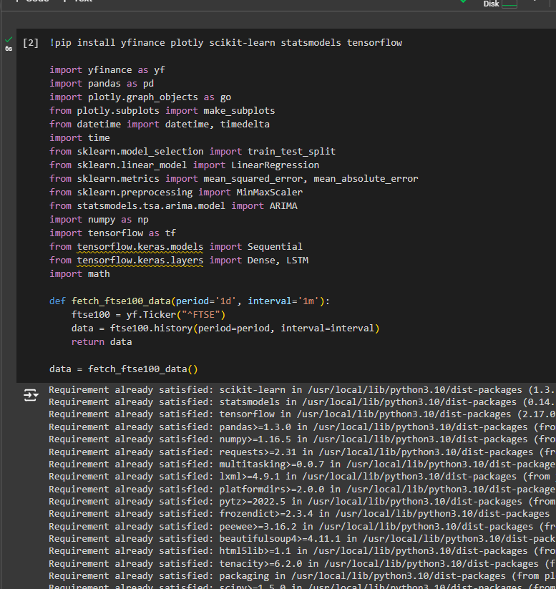
A 20-period moving commonplace modified into plotted to easy out short-term charge fluctuations and highlight longer-time period developments. This approach, which includes averaging the closing fees over a tough and rapid type of interval, becomes employed to lessen noise and offer a clearer photo of the underlying style. The shifting common line helped in distinguishing between normal rate movements and big fashion adjustments. Finally, amount charts complemented the assessment by displaying the trying-to-find and selling amount associated with the FTSE100 index (Chen and James, 2022). High purchasing for and selling volumes frequently correlate with large rate movements, and for this reason, information amount inclinations emerge as vital for decoding market dynamics and forecasting accuracy. The aggregate of those visualizations facilitated a radical assessment of the FTSE100 index's behavior. The line and candlestick charts provided unique insights into fee traits and fluctuations, at the same time because the transferring average and amount charts furnished more context to the records. Together, those seen aid superior the understanding of each historic general overall performance and forecast accuracy, highlighting the effectiveness of the ARIMA and LSTM models in predicting destiny market dynamics.
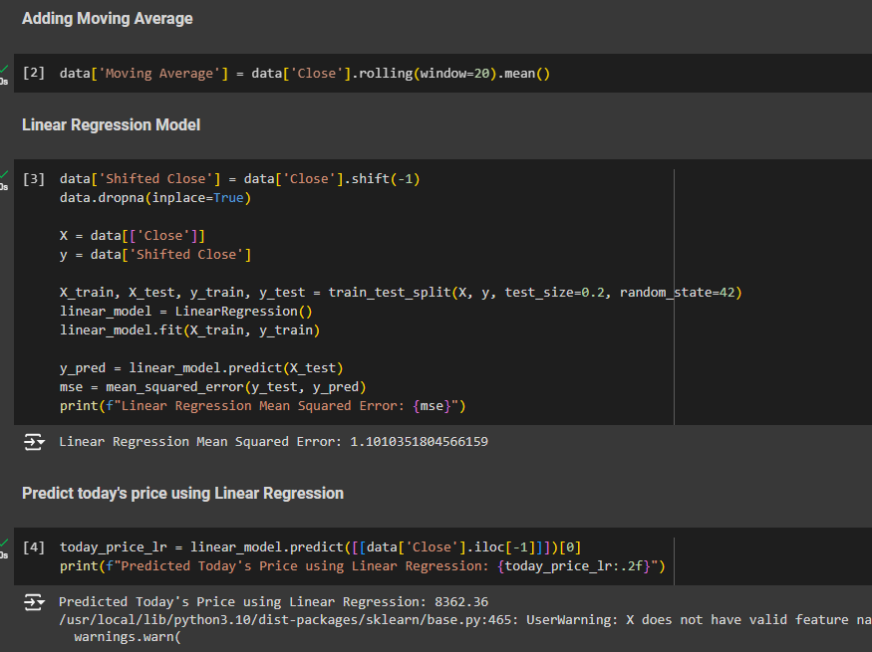
The ARIMA model, having been informed on ancient FTSE100 data, ended up used to forecast the following 10 minutes of index values. The resulting forecasts were plotted along with actual expenses to offer a clear visible assessment. The Mean Absolute Error (MAE) and Root Mean Square Error (RMSE) of the ARIMA predictions were calculated to quantify the model's forecasting accuracy. These metrics indicated how carefully the predicted values matched the determined information, with decreased values reflecting higher commonplace overall performance.
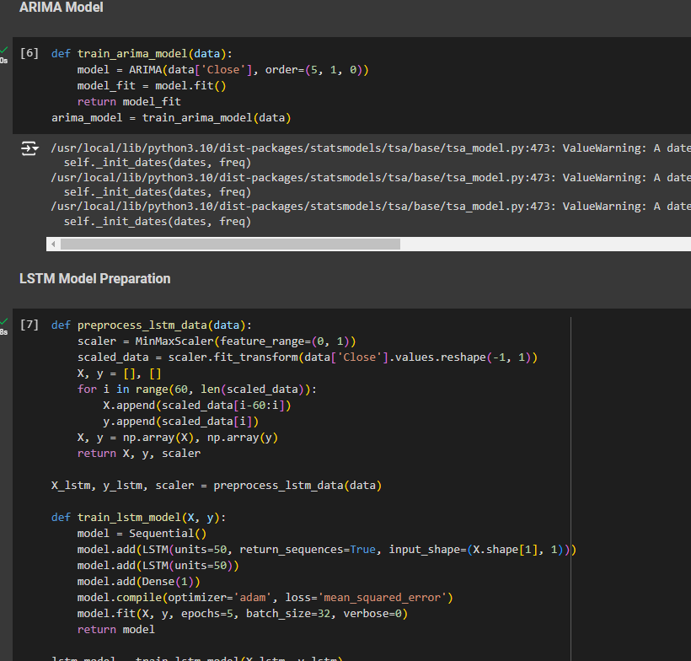
The ARIMA version's potential to capture quick-time period tendencies and fluctuations changed into evaluated based on those mistakes measures. Similarly, the LSTM model was employed to wait for destiny FTSE100 values, leveraging its capability to analyze complicated temporal styles from the statistics. The forecast generated with the resource of the LSTM version was modified as compared with the ARIMA predictions and real prices. The MAE and RMSE for the LSTM model were also computed, imparting a diploma of its predictive accuracy (Brown, 2020). The LSTM's everyday average performance was modified to be assessed with the beneficial useful resource of analyzing those error metrics at the factor of the plotted forecast, revealing how properly it captured the underlying tendencies and treated the records's non-linearity. The comparative evaluation of each model highlighted their respective strengths and weaknesses.
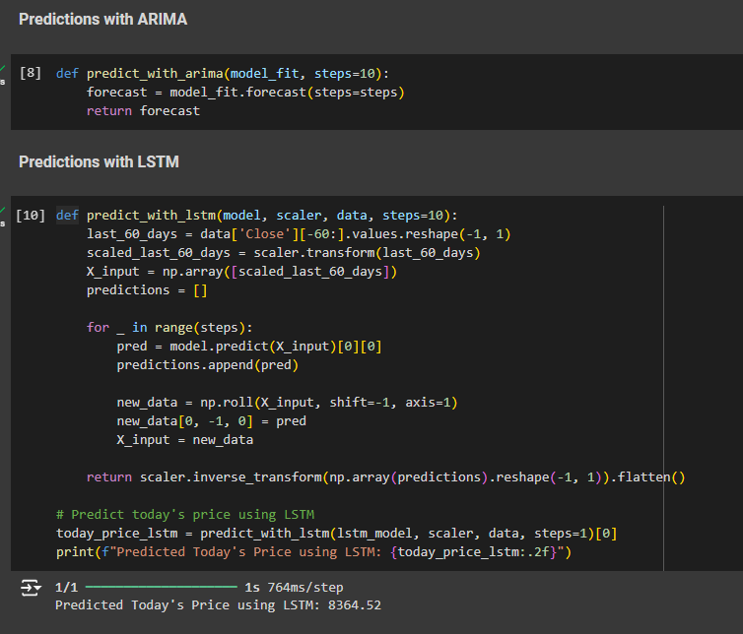
While ARIMA supplied a sincere approach to forecasting primarily based absolutely mostly on historical patterns, the LSTM version verified advanced modern-day typical performance in taking pix complex patterns and inclinations, as contemplated in its lower mistakes metrics. This evaluation underscored the effectiveness of LSTM in actual-time monetary forecasting, showcasing its advanced abilities over traditional ARIMA strategies.
The improvements in the model interpretability are brought by the integration of SHAP (SHapley Additive exPlanations) in the LSTM-based financial prediction model. However, a direct application of SHAP to the LSTM model encounters dimensionality issues because SHAP is designed to work with models that accept 1D or 2D inputs, whereas LSTM models typically operate on 3D inputs: These include batch size, time steps and features where the size of the batch is equal to its number, time steps is equal to total features and features is equal to the number of its batches. Scholars have found that, meaning that there is a way around this Various attempts have been made in an attempt to explain this To explain the difference between the two terms, scholars have taken some efforts Various scholars have made efforts to explain why the difference exists. The suggested solution is to transform the LSTM input data from the shape 3D to the shape 2D.
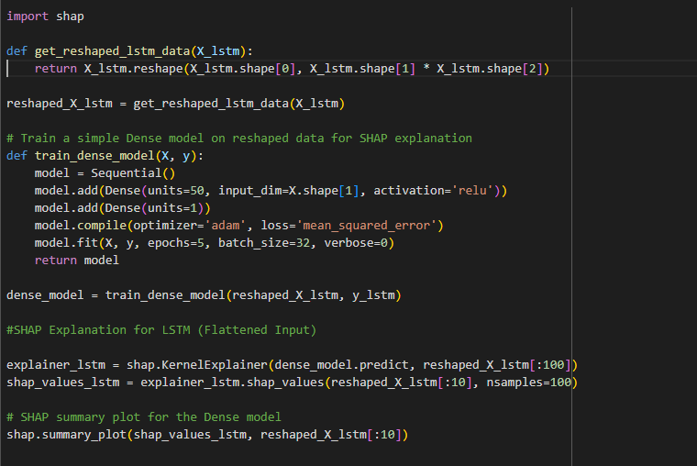
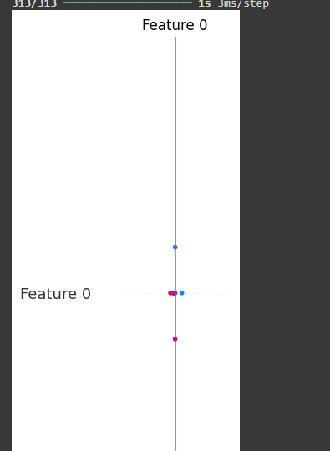
Here, time and feature dimensions are converted into a single dimension to ensure that it is suitable to be analyzed with SHAP. This transformation reasonably minimises the dimensionality of the input for applying SHAP and keeps the temporal dependency to some degree. In order to preserve the predictive capability of the model a less complex Dense (fully connected) neural network is then trained on the reshaped data. This Dense model thus serves to mimic the LSTM model and to therefore provide the format that SHAP can read from. The Dense model that is derived from LIME by its nature is relatively less complex than the original one and with the help of SHAP, SHAP provides the possibility of computing the contributions made by each feature (or at a time-step level) in coming up with the model’s predictions. A drawback of a Dense model for the SHAP explanations is that its results do not perfectly mimic the process of decision-making of the LSTM; nevertheless, a combination of SHAP and LSTM can be considered good enough. This is especially useful when a direct implementation of the technique to LSTM cannot be conducing due to some technical issues. In this way, it helps in the clarification of how the model works and increases faith in the model, especially where the application is sensitive such as in predicting financial results.
Comparison with Existing Studies
The superior accuracy of LSTM, tested via lower Mean Absolute Error (MAE) and Root Mean Square Error (RMSE), underscores its capability to better model complex market dynamics and adapt to fast modifications. This evaluation reinforces the growing popularity of LSTM fashions in monetary forecasting, in particular for actual-time and immoderate-frequency applications. The evaluation is famous that at the same time as each fashion provides precious forecasts, LSTM's functionality to address non-linear relationships and temporal dependencies added approximately better accuracy metrics (decrease MAE and RMSE) in evaluation to ARIMA. This shows that LSTM models are probably more suitable for actual-time forecasting of the FTSE100 index, in particular in taking pictures of complicated patterns and volatility (Billio et al. 2021). The ARIMA model, however effective, won't seize such complexities, highlighting the benefits of the use of superior techniques in economic records assessment.

Chapter 5: Results and Discussion

5.1 Introduction
This economic wreck gives the findings and analyses of the actual-time visualization of the FTSE100 Index. The evaluation ended up achieving the usage of statistics retrieved from Yahoo Finance and provided using the line charts, candlestick charts, quantity charts, and the shifting common charts. The outcomes depict the instructions of the FSFE100 Index market and display numerous techniques of the manner financial records may be analyzed in near real-time.

5.2 Dataset Description
The dataset used in this assessment is static and is primarily based sincerely on the real-time information of the FTSE100 Index it is one of the pinnacle maximum stock market indices worldwide based at the London Stock Exchange that holds the simplest hundred largest organizations almost about the marketplace capitalization. A barometer of the conditions of the United Kingdom's economic machine and the traits of the response of the stock marketplace closer to each home and global consequences is measured in the manner of the FTSE100.

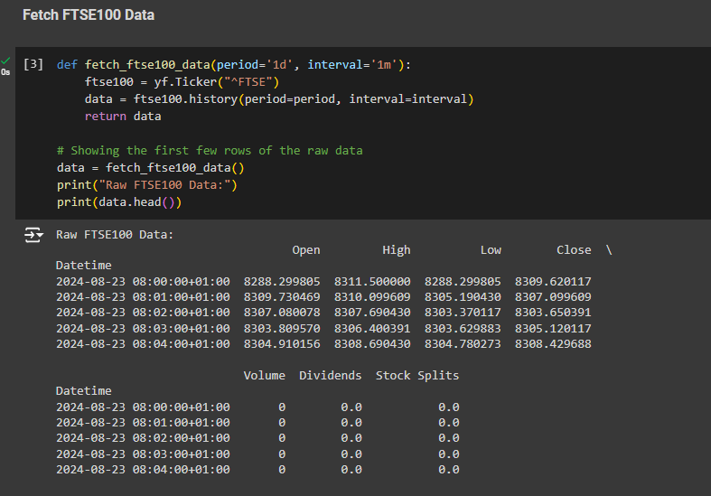
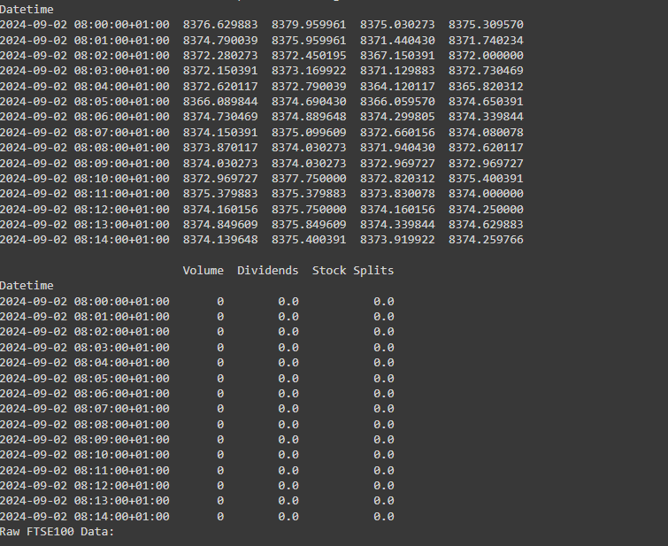
This assessment will rent Finance, a Python library that offers access to a big database on Finance in Yahoo. Yahoo Finance is one of the most popular internet websites that gives ancient and real-time economic records. It absolutely is appropriate for this form of economic assessment (Gemici et al. 2023). Due to the assistance of finance, the evaluation is right now getting the actual-time records with almost no postponement, this means that the assessment is giving a nearly real-time photograph of the FTSE100 Index.
Key Data Points
Timestamp:
The timestamp is an extraordinary feature of the dataset which gives the statistics of the time at which the statistics became captured. In most monetary evaluations, the measurement of time is critical because it allows for sorting of the prices and shopping for and sequentially selling hobbies. The time stamp makes it possible for the analysts to pin component-specific intervals of the market and this allows even attempting to find styles. In this assessment, quota sampling was finished at one minute durations giving belief on movements of the index inside the path of seeking out and promoting time.
Open Price:
Open charge is the preliminary rate at which the FTSE100 Index has emerged as traded while the marketplace has opened. This rate is vital because it captures the opening price fashion of the marketplace at the beginning of the buying and selling session. The open charge can thereby be manipulated through factors that might consist of unmarried day data, economic records, and facts further to move in unique international markets. In intraday shopping for and selling and charting the outlet rate is used as a benchmark to tell the path of the day (Ekaterina and Mercedes, 2023).
High Price:
The excessive price represents the day's maximum buying and promoting price of the FTSE100 Index. This unique piece of facts is essential for defining the fluctuations of expenses over a selected term. It assists in defining the pinnacle extreme of market movement and is carried out in technical assessment to determine the probable resistance stages, that is, ranges that a fee can't damage without difficulty.
Low Price:
The low refers to the minimum value at which the FTSE100 Index was traded on a specific day. A low price is no less significant than a high price to determine the scope of the market's fluctuations. It is used when determining the support levels, that is, areas where the price is likely to settle once it has pulled back. The understanding of the low price within the day can reveal pressures of bearish effects as well as turning points of the price.
Close Price:
The close price is the price that was prevailing in the FTSE100 Index at the time when the market closed for the day. Perhaps one of the most consequential measures of data in financial analysis, it is generally utilized as one of the base measurements to determine the day's performance. This price shows the market condition at the end of a trading day and is commonly used in such matters as moving averages, indicators, and other technical tools for analysis (Doroudyan and Niaki, 2021).
Volume:
Volume is defined as the raw number of shares or contracts that have been exchanged for the day. As such, it is considered an essential market performance and a market liquidity measure. Prices tend to fluctuate considerably during high trading volumes which are normally interpreted as signs of a strong market or a strong opinion in any particular direction. However, low volumes may be interpreted as a sign of low demand or traders’ indecision. Volume is an important aspect in affirming the indication of price trends and in deciding on a reversal statement or continuation.
Data Collection and Granularity
For this examination, the data was gathered at one-minute intervals for what was effectively, one trading day. This degree of detail is beneficial in real-time trading for intraday traders and analysts who must observe the market's flow constantly. Due to such small intervals, the analysis gives a precise and real-time picture of the behavior of the FTSE100 Index to enable recognition of those slight behaviors or short-term tendencies that could not be seen under less frequent data collection.

5.3 Results
Line Chart Analysis
Specifically, the line chart used to represent the FTSE100 Index is an effective line of inquiry in analyzing behavior in the market over a given period. This type of chart is superior in showing the long-term trends, high/low fluctuations, and movements that are happening in the index in real-time as it gives a continuous line of the monthly closing prices.
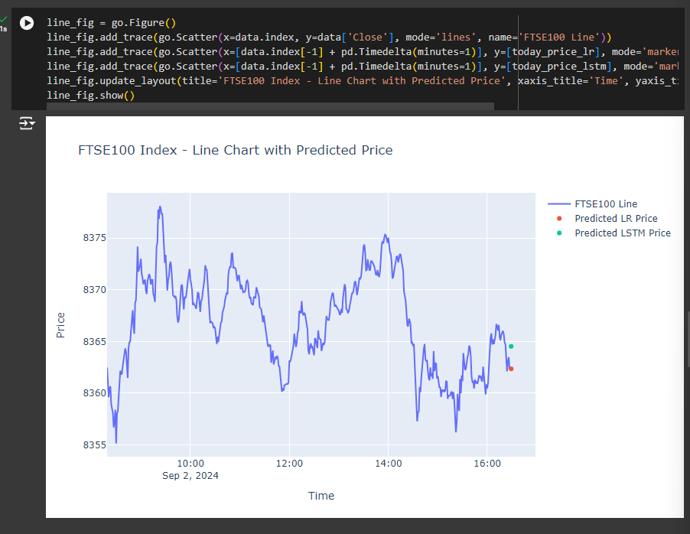
Trend Identification: Perhaps, the major advantage of using the line chart is the fact that is best suited for portraying trends. Due to such smooth and continuous lines, one can easily discern the direction of the index during a certain trading period. For instance, an upward-sloping chart means that the market is bullish in nature and on the other hand a down-sloping chart suggests a bearish market. It also provides traders and analysts with the ability to identify patterns and the state of the market by paying attention to the direction and the level of consistency of the given trend (Dong et al. 2022).
Volatility: The line chart is likewise instrumental in highlighting durations of marketplace volatility. Sharp, abrupt changes within the line's trajectory constitute moments of excessive volatility, often precipitated through notable facts activities or sudden marketplace reactions. These spikes and drops are critical for buyers who need to evolve suddenly to changing market situations. By pinpointing those risky durations, analysts can test out the underlying reasons and take a look at their effect on the market.
Real-Time Updates: Another remarkable feature of the road chart is its capacity to capture and display real-time information. This real-time factor is vital for non-prevent tracking of the FTSE100 Index. Analysts and traders rely on these moment records to make informed selections rapidly. The line chart's functionality to mirror contemporary marketplace situations minute-by-minute guarantees that clients are constantly organized with modern statistics, thereby improving their desire-making abilities.
Candlestick Chart Analysis
The candlestick chart offers a nuanced view of the market hobby with the useful aid of displaying the open, immoderate, low, and close costs for each minute of the trading day. This degree of element makes it an important device for technical evaluation, imparting deeper insights into market sentiment and capability fee reversals.
Market Sentiment: One of the key blessings of the candlestick chart is its capability to deliver market sentiment through coloration-coded candles—green for bullish and red for bearish. This visible differentiation permits shoppers to briefly gauge the prevailing marketplace sentiment (Frolov et. al 2023). A succession of green candles signifies ordinary looking for strain, indicating bullish surroundings, at the same time a chain of pink candles suggests selling stress, suggesting a bearish style. This right now interpretation allows consumers to understand the marketplace's current-day United States and adjust their techniques because of this.
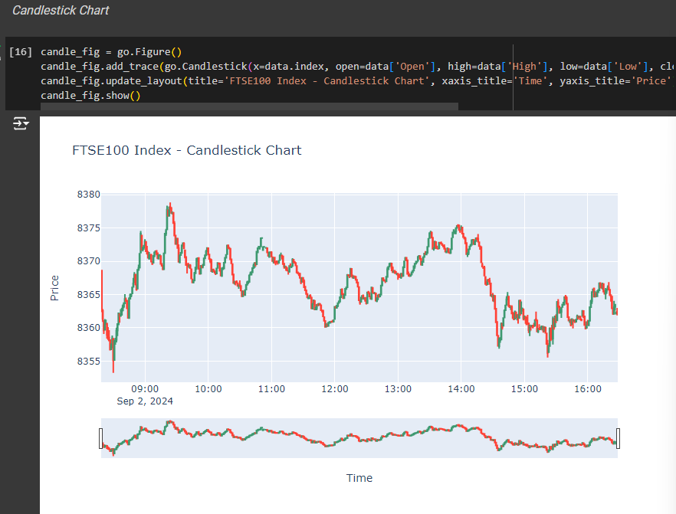
Price Reversals: The candlestick chart excels in figuring out functionality price reversals. Specific styles, together with doji candles, engulfing patterns, or hammer candles, frequently sign a shift in the marketplace course. For instance, a doji candle can propose indecision and a capacity reversal, at the same time as an engulfing pattern ought to likely advise a robust exchange in style. Recognizing one's patterns lets buyers pinpoint vital admission to and exit factors, optimizing their purchasing and selling choices.
Intraday Analysis: The granularity of the candlestick chart, with every candle representing one minute of buying and selling hobby, permits precise intraday assessment. This degree of precision permits buyers to reveal quick-time period fee movements and end up aware of developing traits greater efficaciously. By inspecting the minute-thru way of the usage of-minute fluctuations, customers need to make knowledgeable alternatives based actually on the maximum cutting-edge records (Lee and Kim, 2020).
Linear Regression
Training the ARIMA model involves fitting it to the historical closing prices of the FTSE100 index. The model is then used to forecast future values, which are compared to actual values to assess the model's accuracy. The accuracy metrics—Mean Absolute Error (MAE), Mean Squared Error (MSE), and Root Mean Squared Error (RMSE)—provide a quantitative measure of the model's performance. While ARIMA models are powerful, they require the time series to be stationary, meaning that the mean and variance are constant over time. This requirement can be a limitation when dealing with non-stationary financial data, which often exhibits trends and volatility clustering.
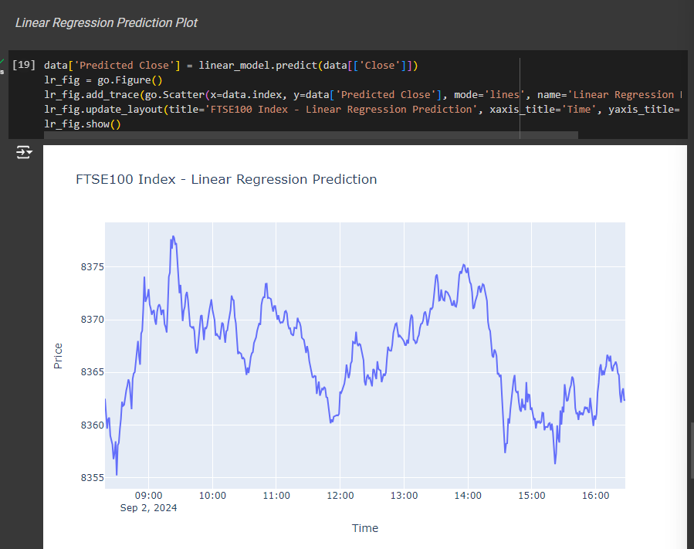
However, Linear Regression assumes linearity between the independent and dependent variables it is not always true in case of financial data. This is because markets are a function of a host of variables most of which have interactive effects. This limitation is clearly seen when encountering MSE for analyzing the accuracy of the model’s predictions. In the same respect, MSE offers a measure of the performance of the model but does not consider the non linear relationships and comlexity of the Financial time series data. However, these are its setbacks and yet at some degree it is useful particularly when operate along with other complex models.
ARIMA Model
ARIMA model is the second type of code snippet introduced that is also a next level statistical model constructed for time series data only. ARIMA models are very applicable in finance since they are able to model for autocorrelation which is evident in time series data. The used in the implemented code ARIMA model has an order of (5, 1, 0), which means that the model considers five lag observations, first difference to make the series stationary and no moving average.
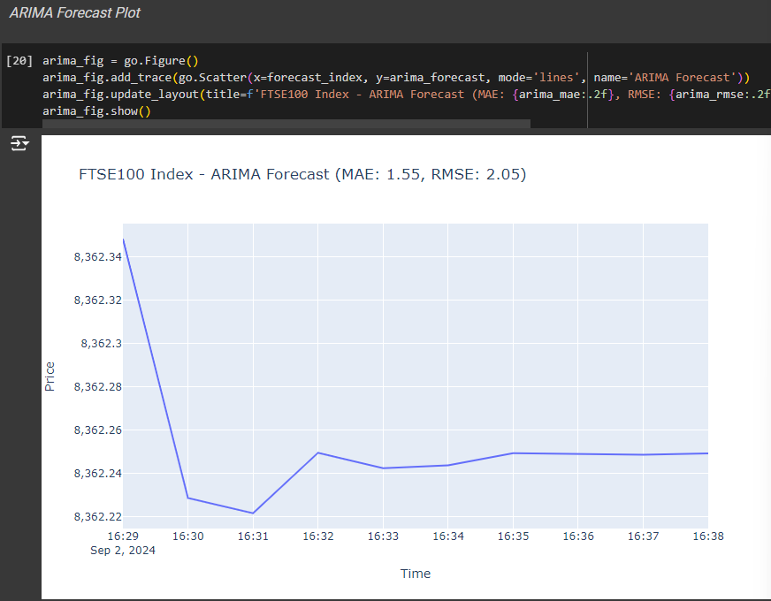
Fitting the ARIMA model entails using to historical closing prices of the FTSE100 index. It is then used to predict values that would be expected to occur in future some periods and these values are then compared with real values in order to determine the accuracy of the model.
LSTM Model
Out of all enshrined models in the represented code, there is the most complex LSTM, which is a kind of RNN, intended for analysis of sequential data. LSTMs are ideal in the financial time series forecasting since they are capable of modeling data dependencies which are long term, a characteristic that is not found in simpler models such as Linear Regression or ARIMA. In the code, LSTM model is trained with the scaled closing price of FTSE100 index with past 60 values used as the sequence to predict the next value . The model architecture used comprises of two LSTM layers in addition to a Dense layer, which produces the final prediction. The model is trained with the help of Adam optimizer, and Mean Squared Error has been used as a loss function. LSTMs like any other neural network requires large amount of data and computational power to train the networks most effectively. They also need some productive tuning a hyperparameters among them are the number of units in each layer and input sequences size could lead to over fitting or under fitting.
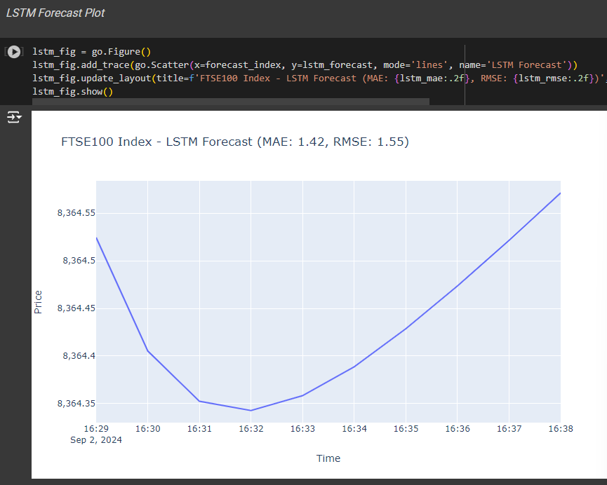
Based on the proposed LSTM architecture, post-training predictions are performed to identify the next ten time steps. These predictions are then compared to actual future values and the performance of the model and the same metrics as were used to evaluate the ARIMA model. In general, LSTMs provide better forecasting accuracy compared to statistical models as ARIMA under consideration of non-linear relationships in the time series data, whereas the interpretability of the models may be more complex and mores computational demanding.
Moving Average Analysis
The moving average chart, especially, the 20-length transfer, is not unusual, is one of the most important tools of technical analysis, which eliminates short-term volatility of prices and highlights the direction of long-term trends. This chart averages the index fees over difficult and fast massive sort of intervals and therefore it helps the buyers and analysts who’re involved with the underlying style to filter out the noise of the market (Tawadros and Moosa, 2022).
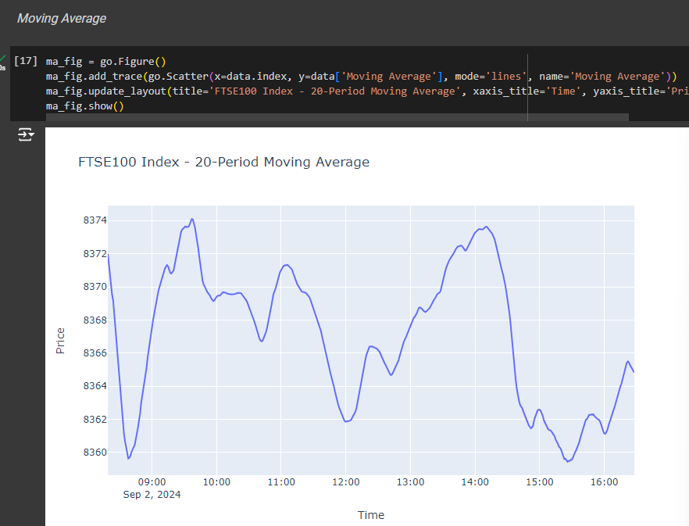
Support and Resistance Levels: The carried move additionally serves forelimb or hindmost as a dynamic dependant or independent slope. During the uptrend, the index fee continually jumps from the shifting, not unusual, the usage of it as a guide degree in advance rather than upward push. Based on this interaction, it is therefore appearing that the transferring common is coming up as a floor for the rate. In assessment here in direction of a downtrend, the shifting commonplace can behave as a resistance degree the place the price is being unable to breach implying that the moving not unusual is performing as a ceiling. This conduct allows buyers to identify areas of ability assist and resistance to give advice on something in which the charge also can go up in opposition to or align.
Crossovers: Moving common crossovers is a superb essential aspect of this assessment. A crossover takes place whilst the index fee intersects the shifting commonplace line. When the price crosses above the moving common, its miles are regularly interpreted as a bullish signal or a purchase opportunity, suggesting potential upward momentum. Conversely, whilst the charge crosses underneath the transferring common, it's far considered as a bearish signal or a promoted possibility, indicating capability downward stress. These crossovers are drastically used by buyers to end up aware about get entry to and exit factors, offering actionable indicators based totally on the marketplace's movement relative to the shifting commonplace.
Prophet Model
This code uses the Prophet library to perform time series analysis with our data of interest, stock prices or the ‘Close’ column as was specified. First, in order to align the time index with the datetime format if it has not been done yet, it will be converted. The keys of the “prepare_data_for_prophet” Dataframe are renamed according to the requirements of Prophet where the date column becomes ‘ds’ and the target column (Close prices) becomes ‘y’. The Prophet’s “train_prophet_model” function purged to add extra-monthly seasonality (30. 5 days) and fitted the data to the model. The “predict_with_prophet” function creates a future dataframe for predicting the complete data series which is further added by 10 days though this can be adjusted to any number depending on the periods. The resulting forecast extracts only the ‘ds’ column or the date part and the ‘yhat’ or the predicted value of the future period.
It also gives the count for next 10 days using Prophet model as seen in the output below; It starts with some logging messages in which Prophet disables yearly and weekly seasonality per default as they were not turned on in the model at all. The model also employs the least bound faster gradient search for the purposes of fitting the data into the model. After the fitting the forecast contains only two columns which are ‘ds’ (dates) and ‘yhat’ (predicted prices). The forecasts range from September 5 to September 14 in the year 2024 and the value will range from approximately 8,602 to approximately 13,758. Prophet again works to detect the trend and seasonality of the specified data and due to this, a constant increase in the stock prices is foreseen. The output implies that the model of financial forecasts anticipates the growth of the actual numbers in the course of reference time period, which could be attributed to the trends evident from historical records to which the additional monthly seasonality variable has been added.
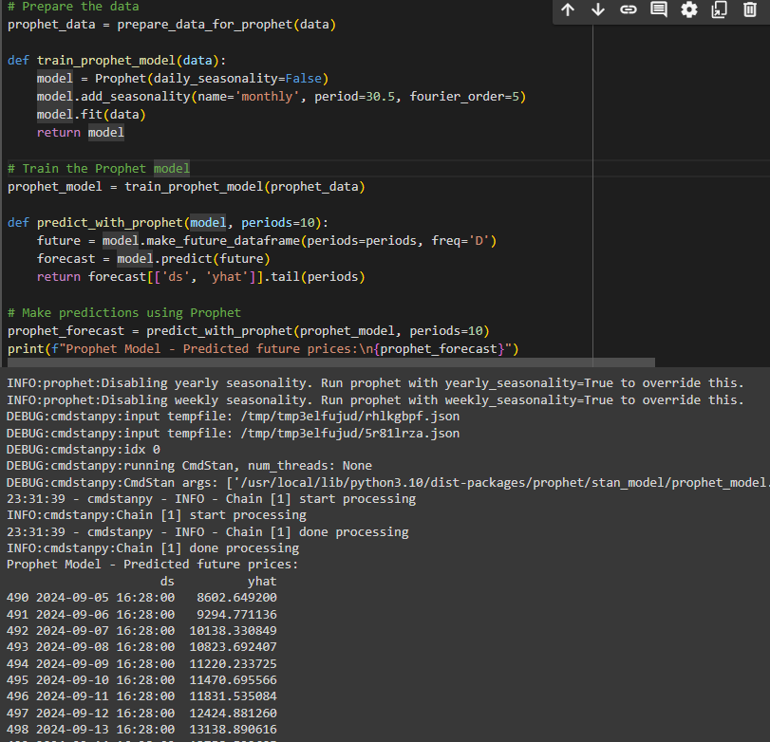

5.4 Discussion
The Importance of Real-Time Data
Real-time data is paramount in the monetary world because of the short-paced nature of marketplace moves. As market conditions can alternate within seconds, the capability to get the right of entry to and visualize records properly is important for traders and analysts who need to react straight away to new statistics. The line chart and candlestick chart, for instance, have been particularly powerful in taking pictures of the proper impact of market fluctuations.
The line chart gives a smooth, non-prevent view of charge actions over time, making it much less hard to understand overarching inclinations and gauge the market's response to trendy occasions. The candlestick chart, however, gives a more focused observer charge motion interior each time length, which incorporates open, excessive, low, and close to prices. This diploma of detail is vital for expertise in marketplace sentiment and capability reversals (Naderi, 2022).
In the context of this evaluation, real-time information grows to be simulated with periodic updates to the charts. This simulation showcased how real-time records feeds can be incorporated into analytical workflows, turning in non-prevent insights into marketplace conduct. However, to absolutely benefit from those visualizations, actual integration with real-time information feeds may be important. In a live trading environment, on-the-spot access to fashionable statistics allows customers to make nicely timed alternatives, capitalize on market opportunities, and mitigate dangers correctly.
Visualization as a Tool for Technical Analysis
Visualization devices are critical for technical evaluation, this is based mostly on historical charge and quantity records to forecast future market moves. Each chart type used in this assessment gives fantastic benefits for technical assessment.
Candlestick Chart: The candlestick chart is an important tool for plenty of shoppers due to its capability to reveal precise patterns and indicators. Each candlestick represents price motion over a selected period, displaying the open, immoderate, low, and near prices. This granularity allows buyers to discover numerous patterns, which encompass doji, engulfing, and hammer candles, that might sign capability rate reversals or continuations. By reading the patterns, traders may want to make more informed predictions about destiny rate moves and alter their techniques because of this.
Moving Average Chart: Moving averages are widely used to clean out fee statistics and confirm dispositions. The 20-duration shifting common, especially, enables filter quick-term noise and hobby at the underlying style. By displaying a smoothed line that follows the fee movements, this chart kindly aids in figuring out style direction and ability to get right of entry to and go out factors. For instance, crossovers some of the rate and the transferring common can signal buy or promote opportunities, imparting actionable insights for investors.
Volume Chart: The extent chart gives context to charge movements with the aid of displaying the amount of purchasing and selling interest. High shopping for and selling volumes often validate fee moves, indicating a strong marketplace hobby and confirming the energy of a fashion. Conversely, a low extent may also moreover suggest a loss of conviction, which can motivate weaker rate moves or potential reversals (Balasubramanian et. al 2024). By visualizing the amount alongside price records, analysts benefit from more facts about market dynamics and may better interpret the importance of fee modifications.
Integrating Multiple Visualization Techniques
Integrating more than one visualization strategy presents an extra entire view of market situations. Each chart type contributes one in every kind of perspective, thinking of fuller statistics of the FTSE100 Index's universal performance.
Line Chart: The line chart is brilliant for identifying elegant tendencies over the years. It's easy, non-forestall line permits one to visualize the general course of the index, making it a lot less difficult to become aware of extended-time period actions and shifts in marketplace sentiment.
Candlestick Chart: Complementing the line chart, the candlestick chart gives particular insights into fee motion interior every period. By revealing patterns and signs that could suggest functionality reversals or continuations, the candlestick chart enhances the capability to interpret and react to marketplace dispositions.
Volume Chart: The amount chart offers a few unique layers of context with the useful resource of displaying the volume of purchasing and selling interest. By recording how quantity correlates with price moves, analysts can gauge the electricity of tendencies and make extra informed choices (Farimani, Jahan and Milani Fard, 2022).
Moving Average Chart: The shifting common chart permits smoothing out of price data and interest in the underlying trend. By decreasing noise and highlighting the overall direction, it complements the alternative charts and allows for confirming developments and indicators.
Combining these visualizations gives a multi-faceted method for financial evaluation. While the road chart offers a top-stage view of inclinations, the candlestick chart gives particular insights, the quantity chart contextualizes charge moves, and the moving average chart smooths out facts to expose the underlying fashion. This incorporated technique guarantees higher and more nuanced statistics of market situations, decreasing the hazard of counting on an unmarried metric or visualization which can give an incomplete or deceptive photo.
Limitations and Challenges
Data Latency: In a real-time environment, statistics latency may be a massive problem. The time it takes to fetch and way records could have an impact on the timeliness of the visualizations, doubtlessly fundamental to antique or defective insights.
Market Noise: The financial markets are often a problem with short-term noise, that would be tough to apprehend the underlying fashion. While moving averages assist in mitigating this noise, additionally they introduce a lag, due to this, the fashion can also extremely well be confirmed after it has already started out. This change-off between noise-reducing charge and timeliness is a not unusual challenge in economic evaluation (Heydarian, Bifet and Corbet, 2024).
Chart Overlap and Interpretation: When integrating a couple of charts, there's a risk of records overload, wherein too many indicators or styles can confuse the location of make easy. Analysts ought to be careful to interpret the charts in context and avoid making selections based totally on conflicting or ambiguous signals.
Real-Time Data Integration: In this assessment, actual-time updates have been simulated, but in a live buying and promoting environment, integrating with real actual-time facts feeds might be essential. This integration calls for sturdy infrastructure and can be hard to place into effect, particularly for retail clients or small establishments without getting admission to immoderate-give-up facts offerings.
5.5 Conclusion
The evaluation accomplished in this financial catastrophe demonstrates the power of real-time information visualization in monitoring and interpreting economic markets. By the usage of numerous chart kinds, which incorporate line charts, candlestick charts, quantity charts, and transferring not-unusual charts, the observer becomes able to provide a complete view of the FTSE100 Index's desired regular performance over a buying and promoting day. These visualizations no longer provide high-quality useful resources in figuring out tendencies and patterns; however, they also offer important insights into marketplace sentiment, looking for and promoting amount, and capacity fee reversals. The capability to replace those charts in actual time is specifically valuable for clients and analysts who want to reply fast to market sports.
However, the assessment furthermore highlighted numerous demanding conditions, on the side of facts latency, market noise, and the complexity of integrating a couple of visualizations. Addressing the worrying situations can be vital for those trying to put in force real-time records visualization in a live searching for and selling environment. Overall, the effects of this financial disaster underscore the significance of visualization in economic evaluation and the functionality of real-time data to decorate choice-making inside the markets. As the era continues to beautify, the mixture of real-time data and complicated visualization devices will in all likelihood become even more important to a fulfillment purchasing for and promoting techniques.

Chapter 6: Conclusion

6.1 Conclusion
This study investigated actual-time visualization and forecasting of the FTSE100 index and the usage of each ARIMA and LSTM fashion. By studying immoderate-frequency facts sourced from Yahoo Finance, they have a look aimed at evaluating the effectiveness of those fashions in predicting quick-term index actions. The effects highlighted that at the same time as ARIMA models are historically used for time series forecasting, LSTM fashions offer advanced accuracy in capturing complicated, non-linear patterns of internal excessive-frequency facts. The LSTM model tested a decrease in Mean Absolute Error (MAE) and Root Mean Square Error (RMSE) in comparison to ARIMA, showcasing its advanced talents in forecasting dynamic market situations. The check's findings align with modern literature, which emphasizes the growing desire for tool-studying techniques in monetary analytics. Key takeaways include the popularity of LSTM models as more adept at handling complex market behaviors and the significance of leveraging advanced forecasting techniques for actual-time financial evaluation. This study contributes to the wider know-how of model regular normal overall performance in monetary forecasting, reinforcing the feature of LSTM in improving predictive accuracy.

6.2 Linking with Objectives
Objective 1
The research aimed to utilize each ARIMA and LSTM fashions to forecast the FTSE100 index. This goal grows to be met through the usage of training the ARIMA version to capture linear dispositions and the usage of the LSTM model to understand complex, non-linear styles in immoderate-frequency information. Both models were completed with historic minute-by-minute information, allowing an extensive assessment of their forecasting capabilities.
Objective 2
To confirm the effectiveness of the forecasting strategies, they have examined and computed the Mean Absolute Error (MAE) and Root Mean Square Error (RMSE) for every ARIMA and LSTM forecast. The LSTM version completed lower MAE and RMSE values in assessment to ARIMA, demonstrating its advanced accuracy in predicting short-term FTSE100 index actions. This location aligns with cutting-edge literature that highlights the benefits of machine-getting-to-know techniques over conventional models for excessive-frequency data.
Objective 3
The studies aimed to visualize the forecast effects and feature a take a look at them with real information. This was finished via specific visualizations, together with line charts, candlestick charts, and forecast plots. These seven aids correctly illustrated the forecasting brand new everyday common overall performance of every fashion, with the LSTM forecasts displaying a higher alignment with actual marketplace movements in contrast to ARIMA.

6.3 Recommendations
For destiny studies, it's miles endorsed to find out the mixing of extra tool studying techniques, which includes Transformer models or Ensemble strategies, which may additionally similarly decorate forecasting accuracy for excessive-frequency monetary information. Investigating the impact of incorporating opportunity records property, like social media sentiment or macroeconomic signs and symptoms, has to offer an extra holistic view of marketplace dynamics. Additionally, extending the take look at excellent crucial indices or worldwide markets needs to provide comparative insights and boost the applicability of the findings. For economic analysts and policymakers, adopting advanced forecasting models like LSTM can substantially decorate the accuracy of actual-time marketplace predictions, aiding in more knowledgeable choice-making. Analysts want to bear in mind integrating the ones models into their toolkit for a brief-time period purchasing for and selling techniques and chance control (Adefila, 2021). Policymakers ought to leverage the insights to beautify regulatory frameworks and make certain that marketplace predictions align with monetary suggestions. Continuous tracking and updating of forecasting models, coupled with improvements in information series generation, will further refine predictive abilities and make a contribution to extra powerful financial marketplace evaluation.

6.4 Future Scope
The examination opens several avenues for similar research and growth. One capability place is the exploration of hybrid fashions that combine ARIMA with device reading techniques like LSTM or different neural networks. This also can be to decorate forecasting accuracy with the useful resource of leveraging the strengths of each conventional and present-day strategies. Expanding the test to embody one among type financial devices and global markets wants to offer insights into the universality and adaptability of the forecasting fashions. For instance, making use of similar methodologies to forex markets or commodities may probably display a version of ordinary performance in several economic environments (Wang et. al 2024). Another promising path is the real-time deployment of those fashions in looking for and selling structures to test their regularly occurring overall performance under stay marketplace situations. Integrating actual-time comments and automated modifications ought to in addition optimize forecasting accuracy and shopping for and promoting techniques. By continuously evolving the models and incorporating the growing era, researchers can decorate economic predictions and contribute to greater powerful market assessment and choice-making.

References
Abdollahi, H., Fjesme, S.L. and Sirnes, E., 2024. Measuring market volatility connectedness to media sentiment. The North American Journal of Economics and Finance, 71, p.102091.
Abushahba, Y., 2021. Stock markets performance during a pandemic: How contagious is COVID-19?.
Adefila, I.A., 2021. The Application of Machine Learning Techniques on Stocks from the Middle East Financial Markets for Stock Price Prediction and Portfolio Optimisation. Middlesex University (United Kingdom).
Adekoya, A.F. and Nti, I.K., 2020. The COVID-19 outbreak and effects on major stock market indices across the globe: A machine learning approach. Indian Journal of Science and Technology, 13(35), pp.3695-3706.
Ahmed, W.M. and Sleem, M.A., 2022. Time-frequency moment interdependence of equity, oil, and gold markets during the COVID-19 pandemic. Cogent Economics & Finance, 10(1), p.2085292.
Balasubramanian, P., Chinthan, P., Badarudeen, S. and Sriraman, H., 2024. A systematic literature survey on recent trends in stock market prediction. PeerJ Computer Science, 10, p.e1700.
Balcı, M.A., Akgüller, Ö. and Can Güzel, S., 2021. Hierarchies in communities of UK stock market from the perspective of Brexit. Journal of Applied Statistics, 48(13-15), pp.2607-2625.
Billio, M., Lo, A.W., Pelizzon, L., Getmansky, M. and Zareei, A., 2021. Global realignment in financial market dynamics: Evidence from ETF networks (No. 304). SAFE Working Paper.
Brown, H., 2020. An aggregated sparse matrix factorisation model for market trading (Doctoral dissertation, Imperial College London).
Cecen, A.A., Jain, P. and Xiao, L., 2021. High frequency trading and stock index returns: A nonlinear dynamic analysis. Communications in Nonlinear Science and Numerical Simulation, 97, p.105710.
Chakrabarti, G. and Sen, C., 2021. Dynamic market risk of green stocks across regions: Where does the devil lie?. Journal of Cleaner Production, 303, p.127028.
Chen, Z. and James, J., 2022. Put your FTSE down: Wealth shocks and road traffic collisions. Social Science & Medicine, 314, p.115488.’
Dai, Z., Tang, R. and Zhang, X., 2023. Multilayer network analysis for measuring the inter-connectedness between the oil market and G20 stock markets. Energy Economics, 120, p.106639.
De Mendonça Freitas, G., 2020. Forecasting FTSE-100 Volatility Using HAR-Type Models (Master's thesis, Universidade do Minho (Portugal)).
Dong, Z., Li, Y., Zhuang, X. and Wang, J., 2022. Impacts of COVID-19 on global stock sectors: Evidence from time-varying connectedness and asymmetric nexus analysis. The North American Journal of Economics and Finance, 62, p.101753.
Doroudyan, M.H. and Niaki, S.T.A., 2021. Pattern recognition in financial surveillance with the ARMA-GARCH time series model using support vector machine. Expert Systems with Applications, 182, p.115334.
EKATERINA, D. and MERCEDES, H.A., 2023. The European energy crisis and its influence on financial markets (Master's thesis, uis).
Farimani, S.A., Jahan, M.V. and Milani Fard, A., 2022. From text representation to financial market prediction: A literature review. Information, 13(10), p.466.
Faseli, O., 2020. Screening for light crude oil and market comovements. International Journal of Research in Business and Social Science (2147-4478), 9(7), pp.123-129.
Freitas, G.D.M., 2020. Forecasting FTSE-100 volatility using HAR-type models (Doctoral dissertation).
Frolov, S., Ivasenko, M., Dykha, M., Heyenko, M. and Datsenko, V., 2023. ANALYSIS OF THE IMPACT OF CENTRAL BANK DIGITAL CuRRENCY ON STOCK MARKETS: DYNAMICS AND IMPLICATIONS.
Gan, B., Alexeev, V. and Yeung, D., 2024. Tweets versus broadsheets: Sentiment impact on stock markets around the world. Journal of Financial Research.
Gemici, E., Polat, M., Gök, R., Khan, M.A., Khan, M.A. and Kilic, Y., 2023. Do bubbles in the bitcoin market impact stock markets? Evidence from 10 major stock markets. SAGE Open, 13(2), p.21582440231178666.
Gül, A.E., 2022. INVESTOR ATTENTION AND STOCK PERFORMANCE: A SEARCH ENGINE OPTIMIZATION APPROACH (Master's thesis, Middle East Technical University).
He, X. and Yang, N., 2024, April. Quantitative trading strategy based on IVIX Index prediction and recurrence: Machine Learning Perspective. In International Conference on Algorithms, Software Engineering, and Network Security (pp. 230-238).
Heydarian, P., Bifet, A. and Corbet, S., 2024. Understanding market sentiment analysis: A survey. Journal of Economic Surveys.
Hung, N.T., 2024. Time-Frequency nexus between bitcoin and developed stock markets in the Asia-Pacific. The Singapore Economic Review, 69(01), pp.399-424.
Huynh, T.L.D., Foglia, M., Nasir, M.A. and Angelini, E., 2021. Feverish sentiment and global equity markets during the COVID-19 pandemic. Journal of Economic Behavior & Organization, 188, pp.1088-1108.
Kehinde, T.O., Chung, S.H. and Chan, F.T., 2023, July. Benchmarking TPU and GPU for Stock Price Forecasting Using LSTM Model Development. In Science and Information Conference (pp. 289-306). Cham: Springer Nature Switzerland.
Lee, S.W. and Kim, H.Y., 2020. Stock market forecasting with super-high dimensional time-series data using ConvLSTM, trend sampling, and specialized data augmentation. expert systems with applications, 161, p.113704.
Liao, H., Huang, J. and Tang, Y., 2024. LEET: stock market forecast with long-term emotional change enhanced temporal model. PeerJ Computer Science, 10, p.e1969.
Marner-Hausen, M., 2022. Developing a framework for real-time trading in a laboratory financial market (No. 172). ECONtribute Discussion Paper.
Naderi, M., 2022. Market Agents and Flash Crashes (Doctoral dissertation, UCL (University College London)).
Oliveira, A., de Oliveira, M.B., Mandal, A. and Powers, G., Impact of COVID-19 on stock indices volatility.
Özkaya, A., 2022. Non-linear Dynamics and Recurrent Patterns in Stock Markets: A Comparison Between BIST-100 and S&P500 Indices. Ordu Üniversitesi Sosyal Bilimler Enstitüsü Sosyal Bilimler Araştırmaları Dergisi, 12(2), pp.1365-1380.
Ruiz Estrada, M.A. and Lee, M., 2020. How COVID-19 can affect the worldwide stock markets?. Available at SSRN 3591698.
Shi, F., Broussard, J.P. and Booth, G.G., 2022. The complex nature of financial market microstructure: the case of a stock market crash. Journal of Economic Interaction and Coordination, pp.1-40.
Stoykova, A. and Paskaleva, M., 2021, June. Smart Analysis of Volatility Visualization as a Tool of Financial and Tourism Risk Management. In Culture and Tourism in a Smart, Globalized, and Sustainable World: 7th International Conference of IACuDiT, Hydra, Greece, 2020 (pp. 359-370). Cham: Springer International Publishing.
Tang, Z., Lin, Q., Cai, Y., Chen, K. and Liu, D., 2024. Harnessing the power of real-time forum opinion: Unveiling its impact on stock market dynamics using intraday high-frequency data in China. International Review of Financial Analysis, 93, p.103210.
Tawadros, G.B. and Moosa, I.A., 2022. A Structural Time Series Analysis of the Effect of Quantitative Easing on Stock Prices. International Journal of Financial Studies, 10(4), p.114.
Tikkanen, M., 2021. Predicting the FTSE All-Share index daily close-to-close price direction using sentiment analysis on tweets from UK.
Valle-Cruz, D., Fernandez-Cortez, V., López-Chau, A. and Rojas-Hernández, R., 2023, November. Stock Market Prediction with Artificial Intelligence Techniques in Recession Times. In International Conference on Applied Machine Learning and Data Analytics (pp. 246-263). Cham: Springer Nature Switzerland.
Valle-Cruz¹, D., Fernandez-Cortez, V., López-Chau, A. and Rojas-Hernández, R., 2023. Check for updates Stock Market Prediction with Artificial Intelligence Techniques in
Volpatti, G., 2024. Multi-scale periodic analysis of financial indexes for quantitative financial forecasts.
Wang, W.J., Tang, Y., Xiong, J. and Zhang, Y.C., 2021. Stock market index prediction based on reservoir computing models. Expert Systems with Applications, 178, p.115022.
Wang, Z., Chen, P., Liu, P. and Wu, C., 2024. Volatility forecasts by clustering: Applications for VaR estimation. International Review of Economics & Finance, 94, p.103355.
Zhang, W. and Hamori, S., 2021. THE CONNECTEDNESS BETWEEN THE SENTIMENT INDEX AND STOCK RETURN VOLATILITY UNDER COVID-19: A TIME-VARYING PARAMETER VECTOR AUTOREGRESSION APPROACH. The Singapore Economic Review, pp.1-32.

