

|  |  |
| --- | --- |
| Course Number | ESE 1444 |
|  |  |
| Course Title | MATHEMATICS FOR EMBEDDED SYSTEMS |
| Semester/Year | Summer/2019 |
|  |  |

**Lab 8- Ordinary Differential Equations**

**SUBMITTED BY:**

**Student Name                              Student Number           Signature**

Jasmine C0748300 JK

Gurvinder Singh C0748418 GS

Diksha Shah C0748229 DS

**a) Write a general application based on RK4 method and then use it for the following problem:**

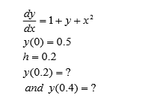

**Answer:**

#include<iostream>

using namespace std;

float diff(float, float);

int main()

{

float xo, yo,h,x1;

float k,k1,k2,k3,k4,ka,kb,kc,kd;

cout<<"\n Enter value of xo and yo and h and x "<<endl;

cin>>xo>>yo>>h;

int i=1;

double y1;

double y2;

// R.K method begins.

x1= i*h;

k1 = diff(xo,yo);

cout<<"K1 = "<<k1<<endl;

k2 = diff(xo +(h/2), yo + ((k1*h)/2));

cout<<"K2 ="<<k2<<endl;

k3 = diff(xo +(h/2), yo + ((k2*h)/2));

cout<<"K3 ="<<k3<<endl;

k4 = diff(xo + h , yo + k3*h);

cout<<"K4 ="<<k4<<endl;

y1= yo+h*(k1+2*k2+2*k3+k4)/6 ;

cout<<"The value of y1 is : "<<y1<<endl;

ka = diff(x1,y1);

cout<<" Ka = "<<ka<<endl;

kb = diff(x1 +(h/2), y1 + ((ka*h)/2));

cout<<" Kb="<<kb<<endl;

kc = diff(x1 +(h/2), y1 + ((kb*h)/2));

cout<<" kc="<<kc<<endl;

kd = diff(x1 + h , y1 + kc*h);

cout<<" Kd="<<kd<<endl;

y2= y1+h*(ka+2*kb+2*kc+kd)/6;

cout<<"The value of y2 is :"<<y2<<endl;

}

float diff(float x, float y)

{

float ans = 1+y+x*x;

cout<<"";

return ans;

}

**Output:**

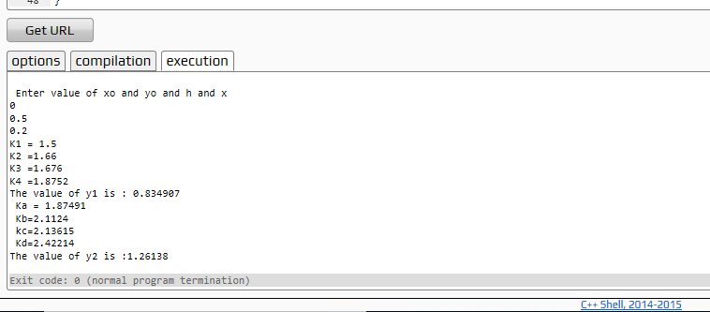

**b) Write a general application based on Bulirsch-Stoer method and then use it for the following problem:**

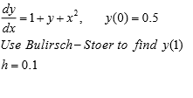

**Answer:**

#include<iostream>

using namespace std;

float diff(float, float);

int main()

{

float xo, yo,h;

yo=0.5;

xo=0;

h=0.1;

cout<<"Enter the value of yo = ";

cin>>yo;

cout<<"Enter the value of xo = ";

cin>>xo;

cout<<"Enter the value of h = ";

cin>>h;

cout<<endl;

float y1;

float y2;

float y3;

float funxoyo=1+yo+xo;

y1= yo+h*funxoyo;

cout<<"The value of y1 => "<<y1<<endl;

float n=1;

float x1=n*h;

float funx1y1=1+y1+x1*x1;

y2=yo+ 2*h*funx1y1;

cout<<"The value of y2 =>"<<y2<<endl;

float n1=2;

float x2=n1*h;

float fucx3y3=1+y1+2*h*x2;

y3=y1+2*h*fucx3y3;

cout<<"The value of y3 =>"<<y3<<endl;

}

float diff(float x, float y)

{

float ans = 1+y+x*x;

cout<<"";

return ans;

}

**Output:**

