Lab Report 05

Digital Signal Processing and Storage

Submitted By:

Gurvinder Singh(C0748418)
Jasmine Kaur(C0748300)

Determine analytically the convolution y (n) = x (n) ∗ h (n) of the following sequences, and verify your answers using the con m function.

1. x(n) = {2,-4,5,3,-1,-2,6}, h(n) = {1,-1,1,-1,1}

Solution:

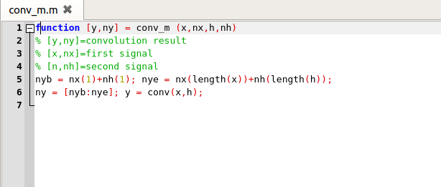
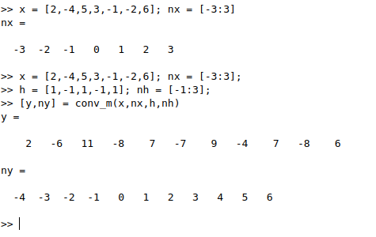

2. x(n) = {1,1,0,1,1}, h(n) = {1,-2,-3,4}

Solution:

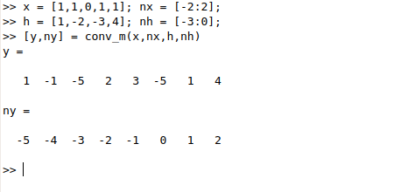

3. x(n) = (1/4)^{-n} [u(n+1)-u(n-4)], h(n) = u(n)-u(n-5)

Solution:

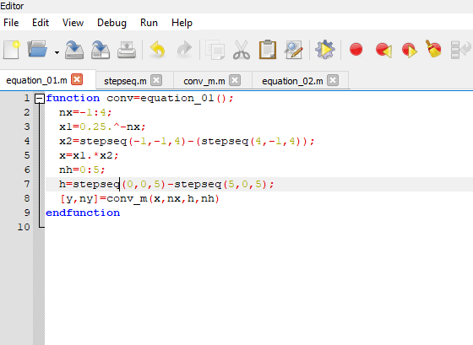

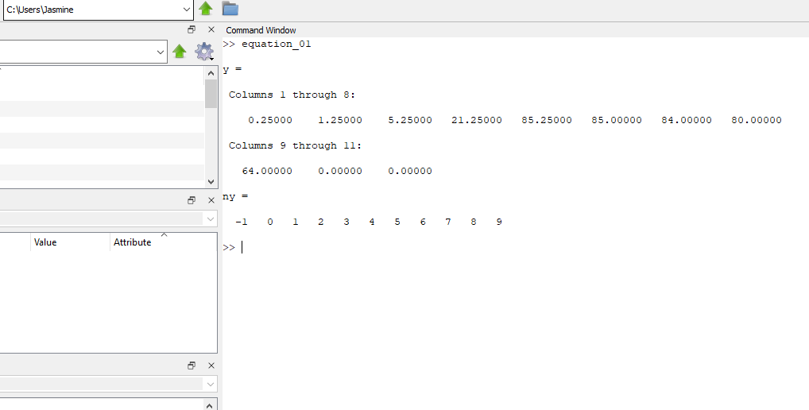

4. x(n) = n/4[u(n)-u(n-6)], h(n) = 2[u(n+2)-u(n-3)]

Solution:

