**LAB REPORT-2**

**(Submitted By : Gurvinder Singh(****C0748418), Jasmine(C0748300))**

1. **Create a 2D plot of the sine function between 0 and 2π.**

Solution:

a = 0:pi/100:2*pi;

b = sin(a);

plot(a,b)

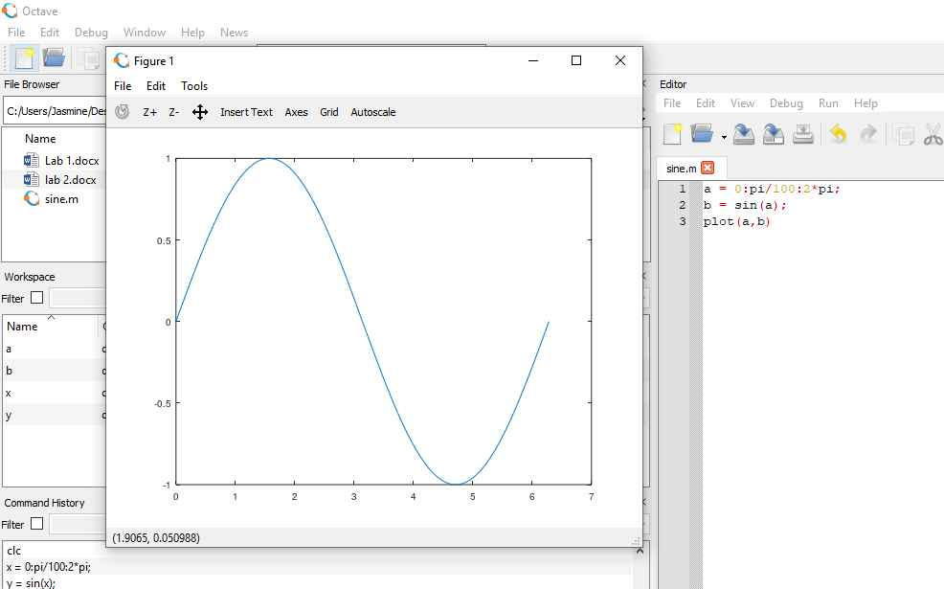

1. **Create a 3D plot of a surface by creating a grid along the X and Y axes and plotting the Z-coordinate according to the exponential function.**

Solution: [A,B] = meshgrid(-4:.4:4);

C = A .* exp(-A.^4 - B.^4);

surf(A,B,C)

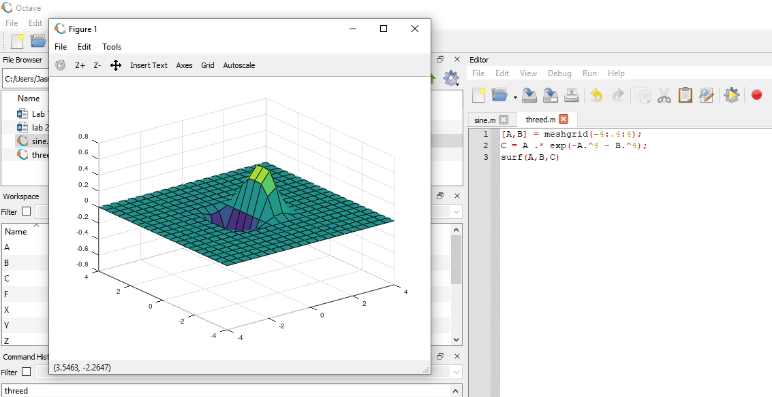

1. **Write a script to apply if and if-else statements.**

Solution: Number = input('Enter a number: ');

if Number < 0

disp('Negative')

elseif Number > 0

disp('Positive')

else

disp('Zero')

end

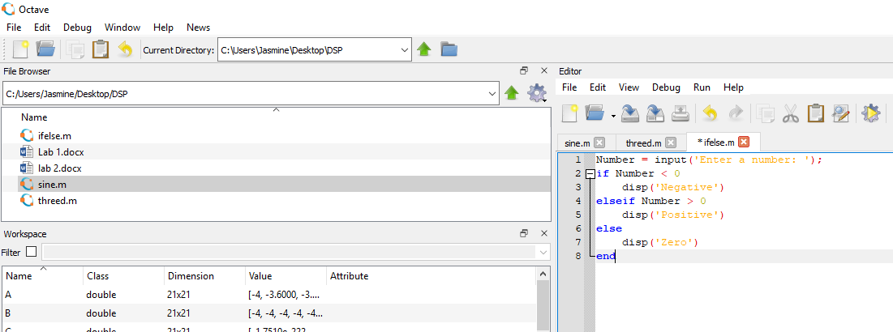

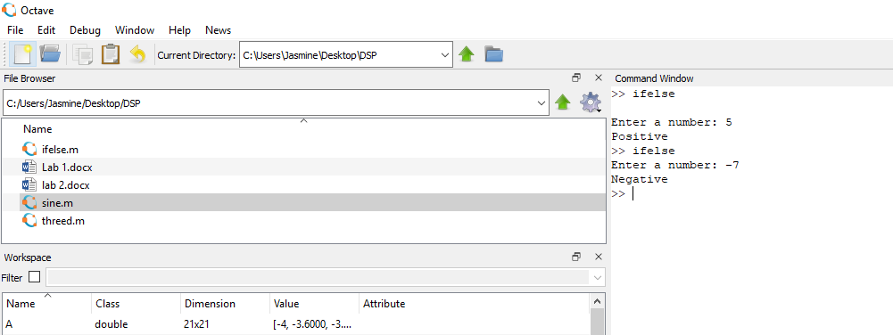

1. **Write a script to apply conditional logic switch.**

Solution:

grade = 'F';

switch(grade)

case 'A'

disp('Excellent!' );

case 'B'

disp('Well done' );

case 'C'

disp('Well done' );

case 'D'

disp('You passed' );

case 'F'

disp('Better try again' );

otherwise

disp('Invalid grade' );

end

Output:

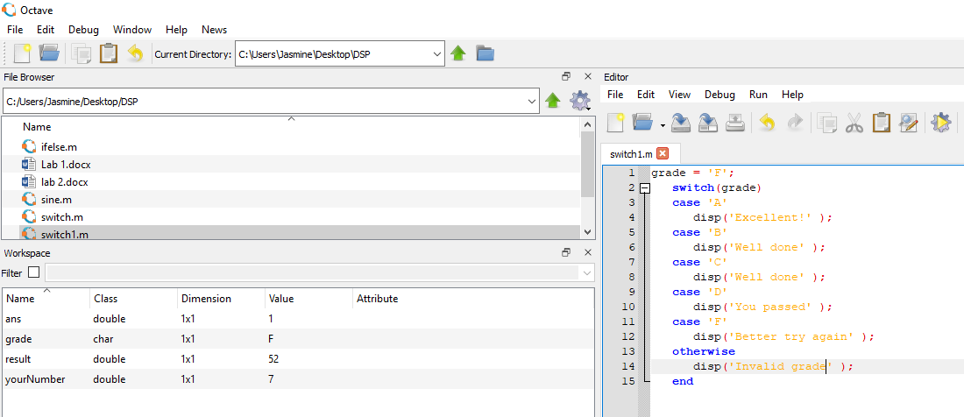

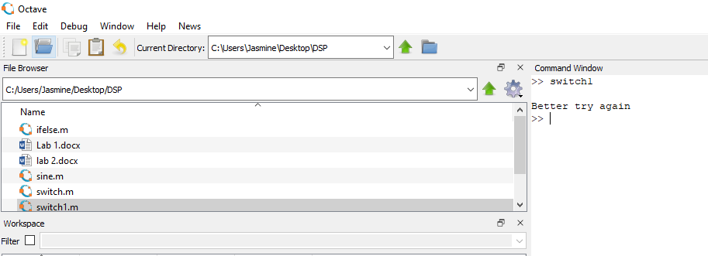

1. **Write a script to perform loop with a while condition.**

Solution:

n = 21;

f = n;

while n > 1

n = n-1;

f = f*n;

end

disp(['Factorial of n = ' num2str(f)])

Output:

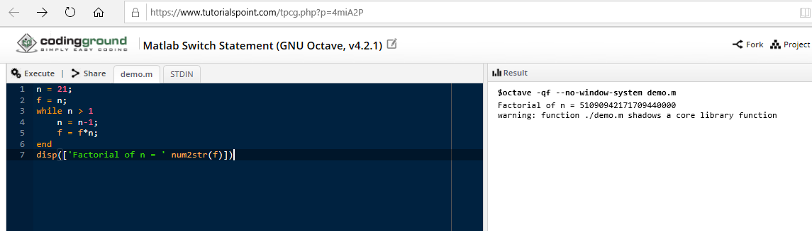

**6. Write a script to plot a vector of random data. Draw a horizontal line at the mean. Save the script and run it from the command line.**

**Solution:**

x=[0:1:10]

y=[2 2 2 2 2 2 2 2 2 2 2]

plot(x,y);

**Output:**

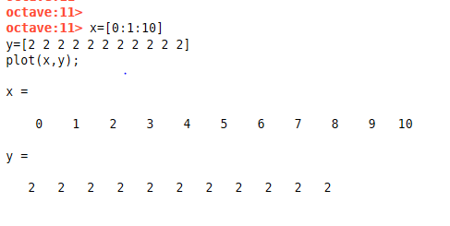

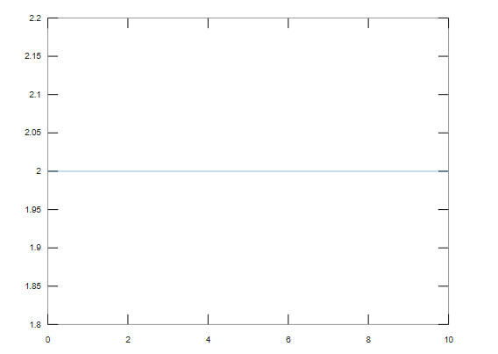

1. **Write a script that calculates the mean of ﬁve samples of data from a vector of random data. Calculate the overall mean. Use a for loop to perform the calculations. For each iteration of the loop print out the intermediate results. Use an if..else control block to display the results depending on whether the mean of the samples is less than, greater than or equal to the overall mean.**

**Solution:**

function m = mean()

disp('Random vector of five value:')

vec = randi(10,5,1)

disp('vector sum is:');

vec1 = sum(vec)

mean = vec1/5;

disp('overall mean value:')

disp(mean);

y=0;

x=1;

for n = 1;length(vec)

y=y+vec(n);

disp('intermediate sum of elements');

disp(y);

disp('intermediate mean of the elements');

intermediate=y/x

x=x+1;

if intermediate>6.2000

disp('Note- mean is greater than overall mean')

else

disp('Note-mean is less than overall mean')

endif

endfor

endfunction

**Output:**

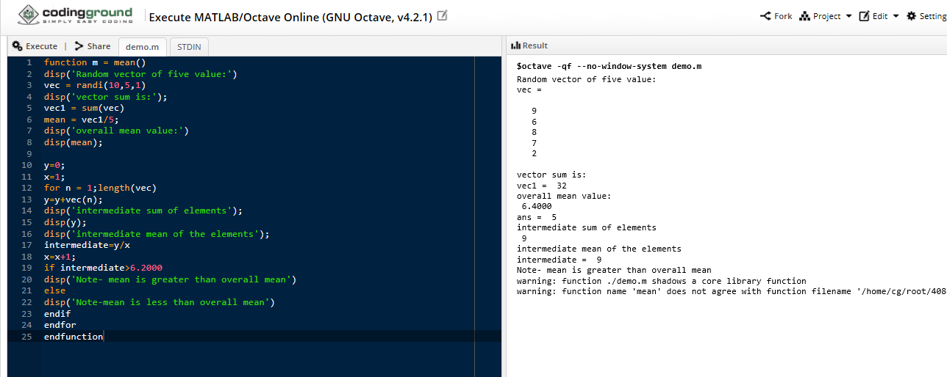

**8. Create a function that calculates the area of a circle with the radius as input in command window. Call this function from the MATLAB command line or in a MATLAB script (.m).**

Solution:

function area = areacircle(r)

r = input('Enter the radius to calculate the area:');

area = pi*r*r;

end

Output:

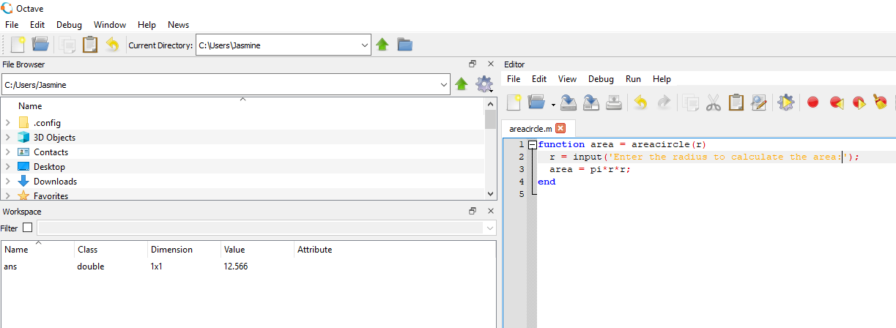

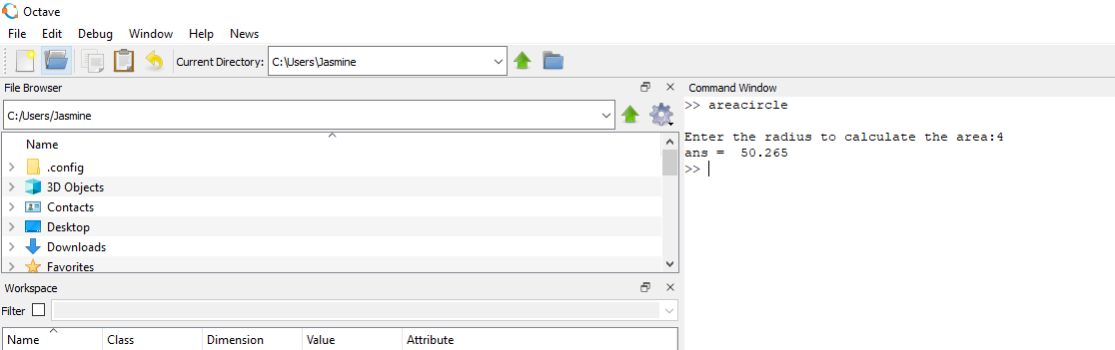

1. **Create a function that calculates the sum of an arbitrary number of sinusoidal terms. Call this function from the MATLAB command line or in a MATLAB script (.m).**

**Solution:**

Function Y = SUM()

Y = 10*sin(20)+30*sin(40)+50*sin(60);

end

**Output:**

