**ESE-2014 Lab3 - Discrete Time Signal and Systems**

**Submitted By: Jasmine(C0748300), Gurvinder Singh(C0748418)**

1. Generate the following sequence using the basic octave signal functions and the basic octave signal operations. Plot signal samples using the stem function.
2. x1(n)= 3delta(n+2)+2delta(n)-delta(n-3)+5delta(n-7), -5<=n<=15

**Solution:**

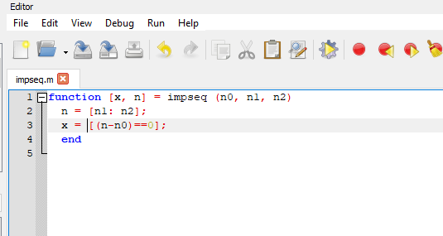

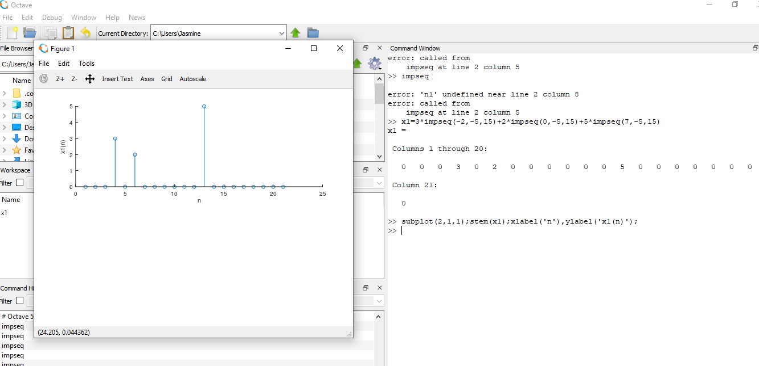

1. x2(n)=sigma(k= -5 to 5) e^(-|k|)delta(n-2k), -10<=n<=10

**Solution:**

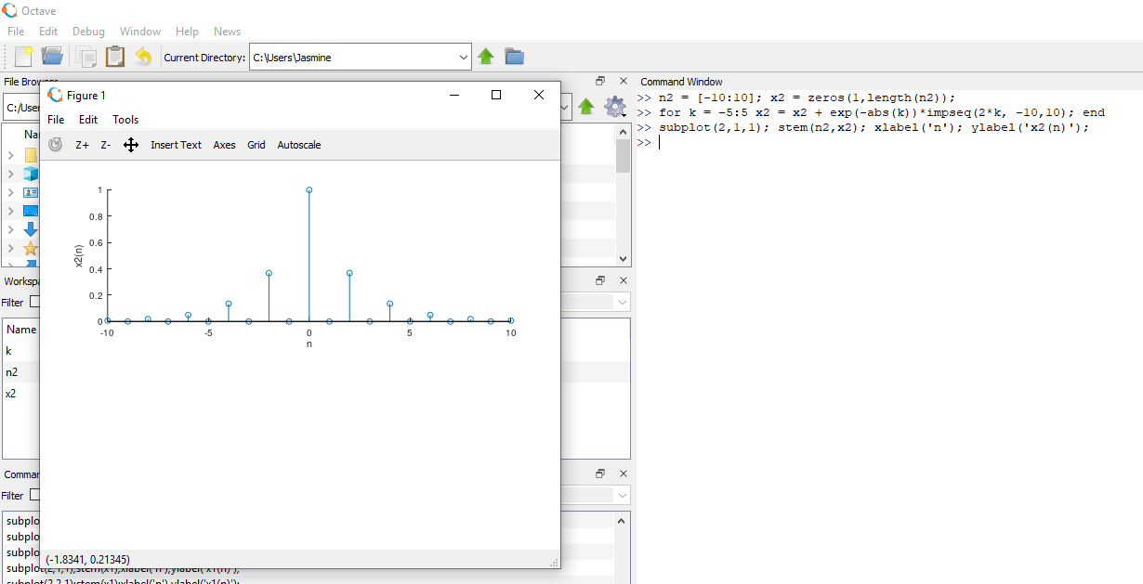

c) x3(n)= 10u(n)-5u(n-5)-10u(n-10+5u(n-15)

**Solution:**

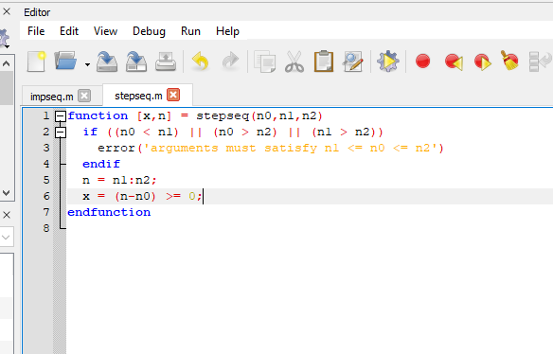

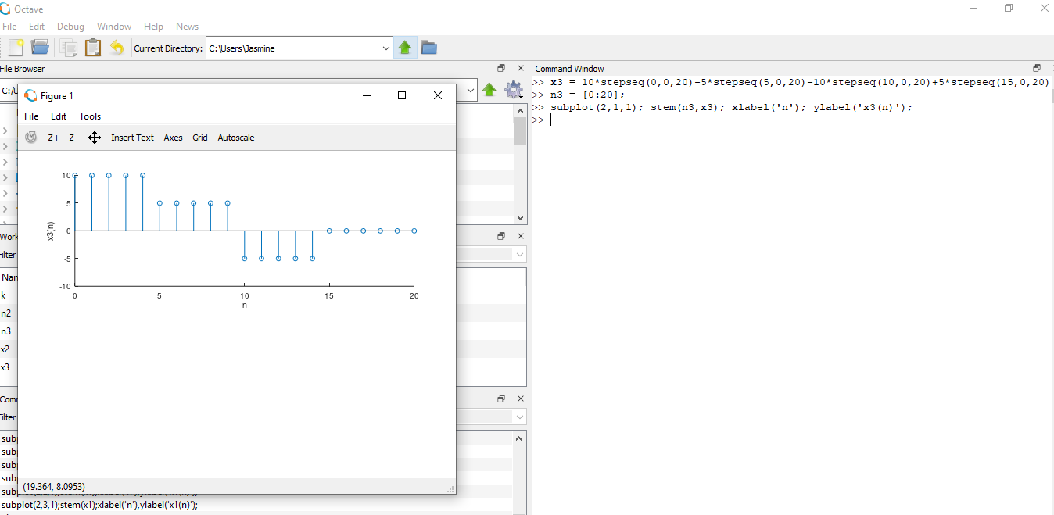

d) x4(n)= e^(0.1n)[u(n+20)-u(n-10)]

**Solution:**

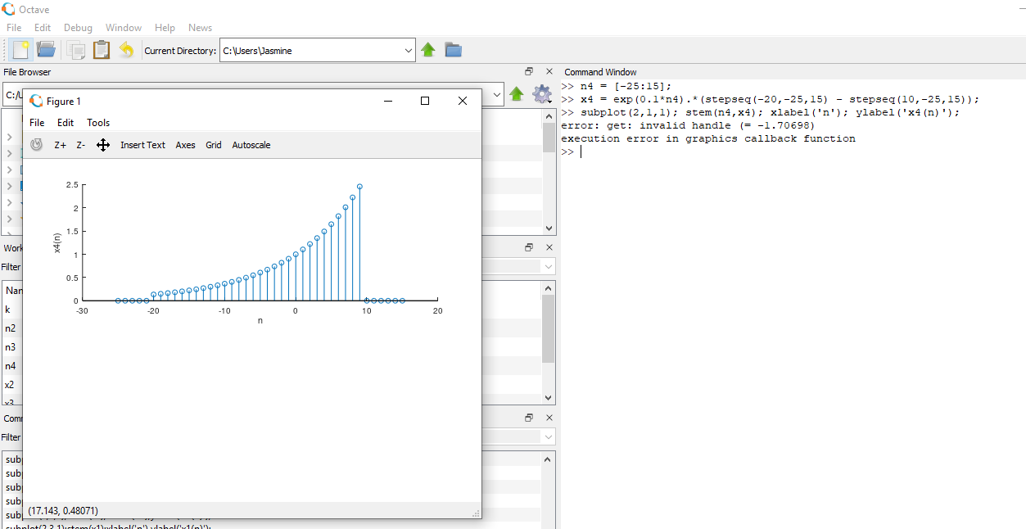

2. Let x(n)={2, 4, -3, 1, -5, 4, 7}. Generate and plot the samples (use the stem function) of the following sequences.

a) x1(n)= 2x(n-3) + 3x(n+4) – x(n)

**Solution:**

First step is to create function showing shifting of signal.

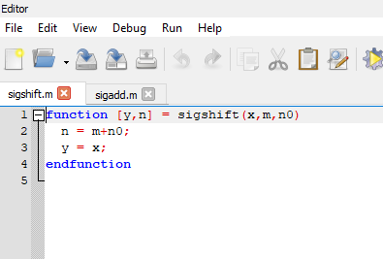

Second step is to create signal adding function

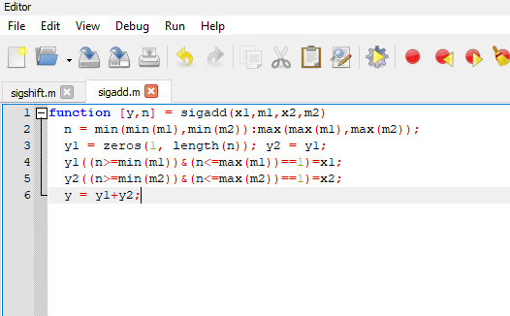

Operation on sequence:

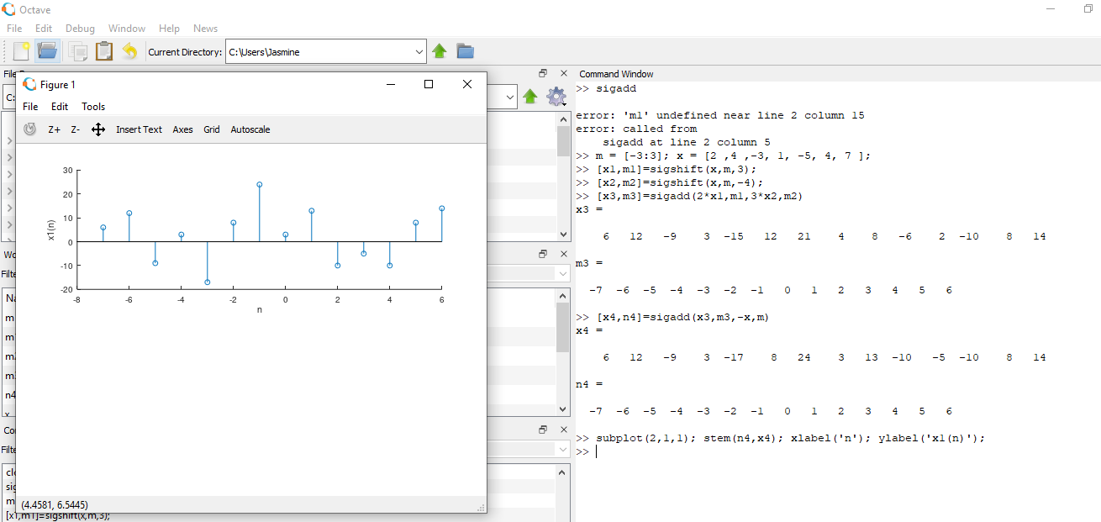

b) x2(n)= 4x(4+n) + 5x(n+5) + 2x(n)

**Solution:**

Creating folding signal function

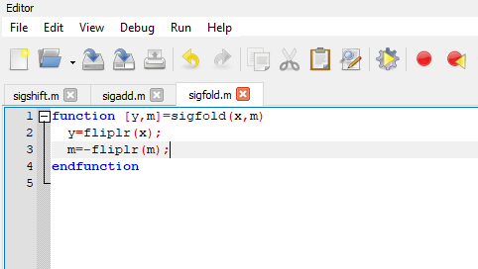

Operation on Sequence:

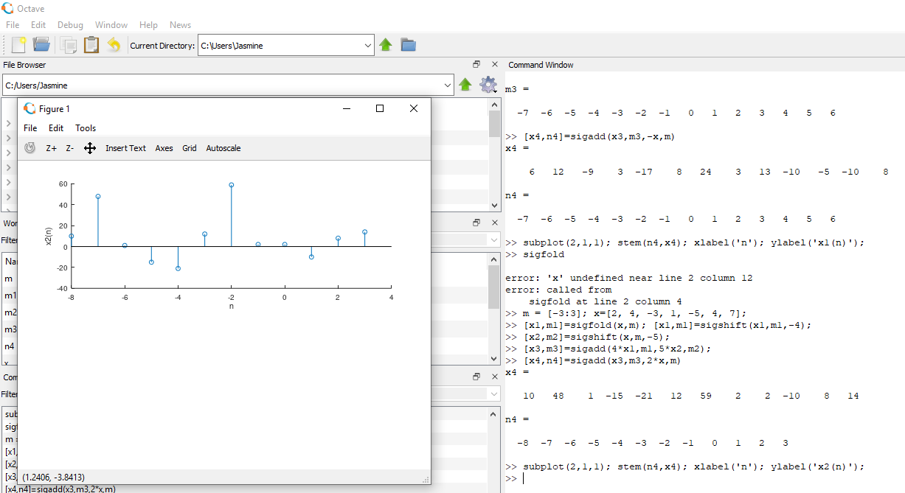

c) x3(n)= x(n+3)x(n-2) + x(1-n)x(n+1)

**Solution**: Creating signal multiplying function

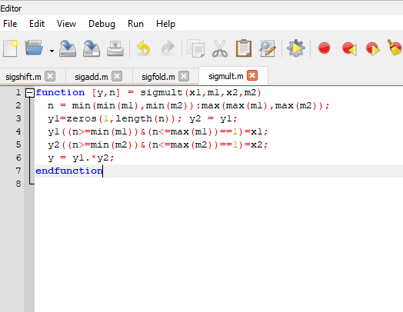

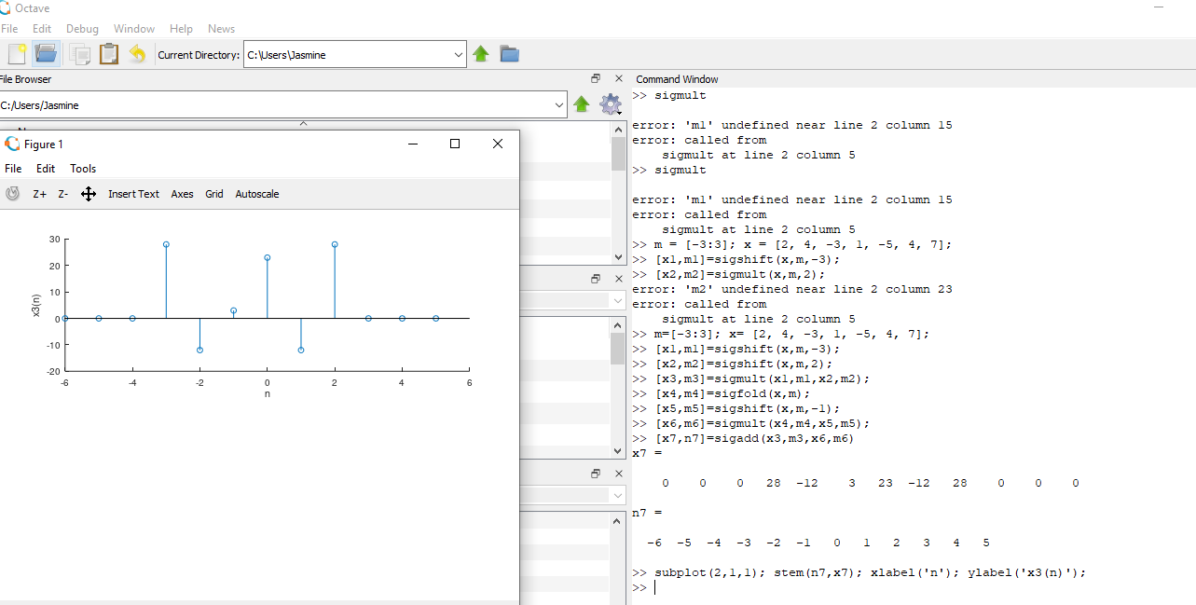

d) 2e^(0.5n)x(n) + cos(0.1*pi*n)x(n+2), -10<=n<=10

**Solution:**

