**Lab Manual 06**

**Subject: -Digital Signal Processing and Storage**

**Group Members: -**

**Student Name:** - Jasmine

**Student ID: -** C0748300

**Student Name: -** Gurvinder Singh

**Student ID: -** C0748418

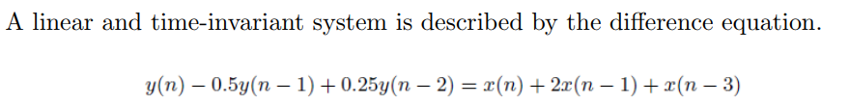

**Impulse Response using filter: -**



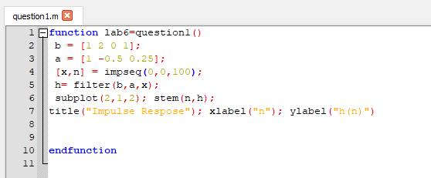

**PLOT: -**

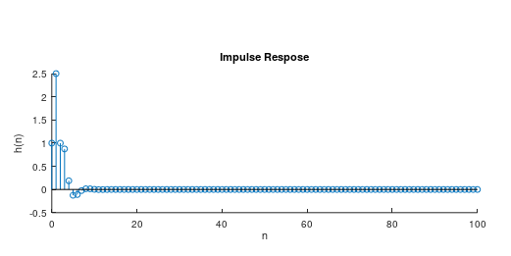



It is observed from the output plot that the system is stable because the plot of output became stable after some time., which is clearly identified in below shown plot and marks.

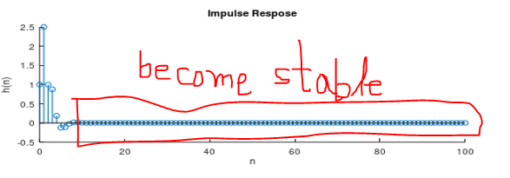

**Output Response Using filter: -**

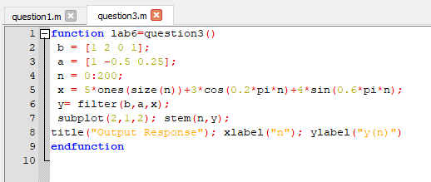

**PLOT: -**

