ESE 2014 Digital Signal Processing and Storage

Assignment 3

Name: Jasmine

Student #: C0748300

1. Draw a diagram of a basic analog to digital converter, and a digital to analog converter.

Answer:

**Analog to Digital Converter**

**Low Pass Filter:** It is a filter that passes the signals with frequency lower than cutoff frequency and attenuates the signal higher than the cutoff frequency.

**Sampler:** Conversion of discrete time signal into sampled data signal is done by sampler.

**Quantizer:** It converts the sampled data signal into the discrete time amplitude signal.

**Encoder**: It converts the quantized signal into binary form that is converts discrete time amplitude signal into digital signal.

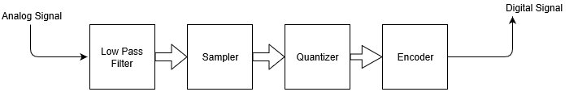

**Digital to Analog Converter**

**Regeneration Circuit:** Function of regeneration circuit is to amplify the desired signals so that it become suitable for the further transmission.

**Decoder:** It performs the reverse action of the encoder. Decoder is a circuit that converts codes into set of digital signals.

**Reconstruction Filter:** After getting the desired analog signal, some modifications are needed in terms of amplitude of the signal for which reconstruction filter is used.

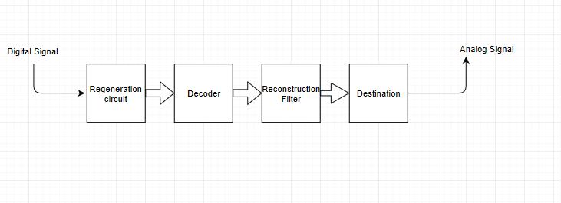

1. **Describe the basic meaning of sampling, quantization, and digitizing of a continuous signal.**

Answer:- **Sampling** is the initial process to be performed during digital signal processing. It is the process that allow analog signal (Continuous in both time and amplitude) to be converted into sampled data signal (Discrete in time and continuous in amplitude). Nyquist theorem states that sampling rate must be atleast twice the maximum frequency.

**Quantization** is the process of converting sampled data signal into discrete time discrete amplitude signal. This represents the function of analog-to-digital converters which helps in defining a series, consisting of digital values to represent the original analog signal.

**Digitizing** has crucial importance in data processing, transmission. It is the process of converting transmitted signal into diital format, in which information is stored in form of bits.