**ESE-2014 LAB REPORT-7**

**(Submitted By : Gurvinder Bhullar(C0748418), Jasmine(C0748300))**

**QUESTION 1 (a).**

X(2)=x1(n)+x1(n-4).so express in terms of x(2)

X2(e jw)=x1(e jw)+x1(ejw)(e-j4w)=2(e-2jw)cos (2w)x1(ejw)

The magnitude is scaled by 2 and phase is changed by 2w

**Question 1(b)**

DTFT function

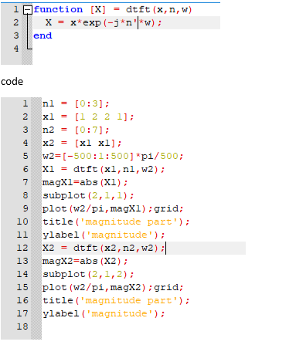

Output:

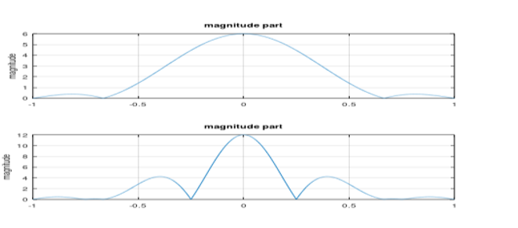

**Question-2**

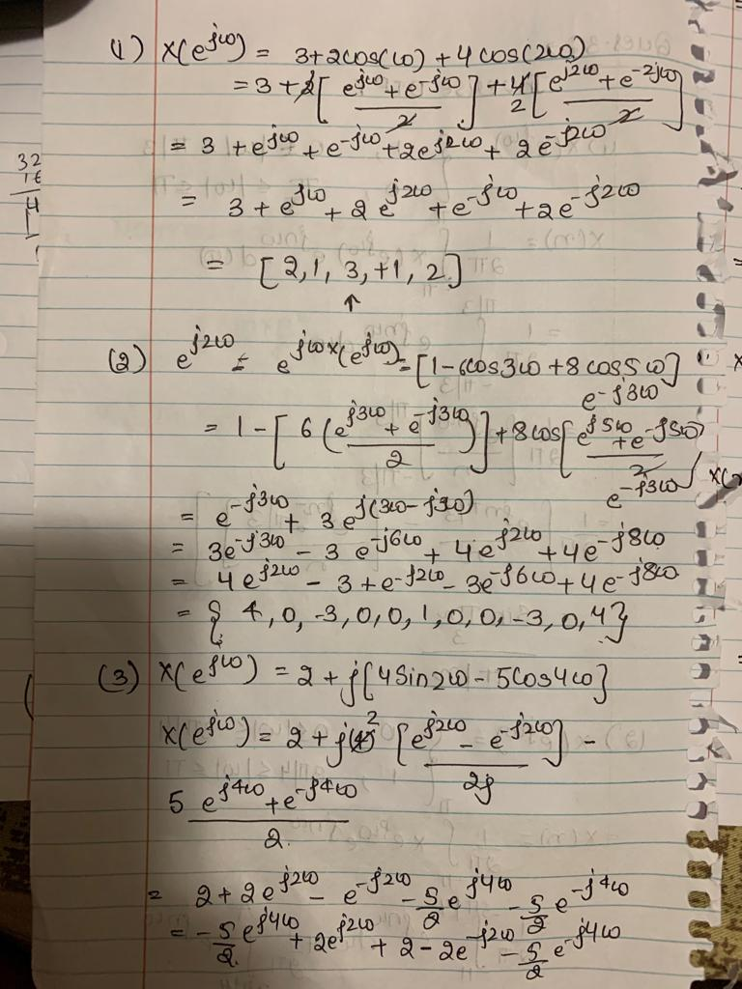

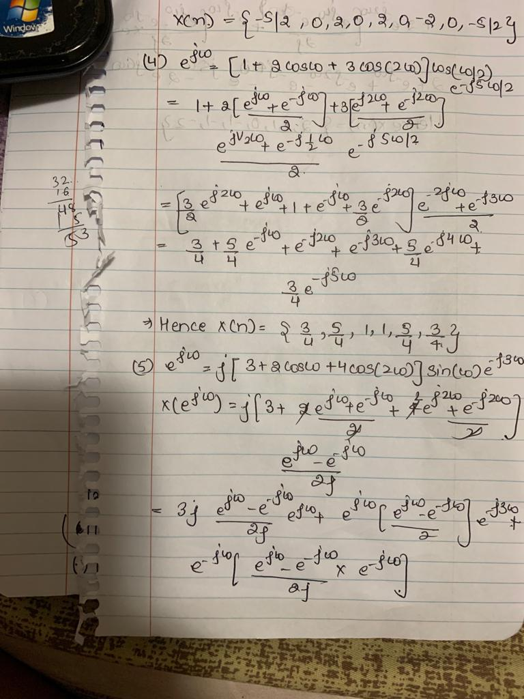

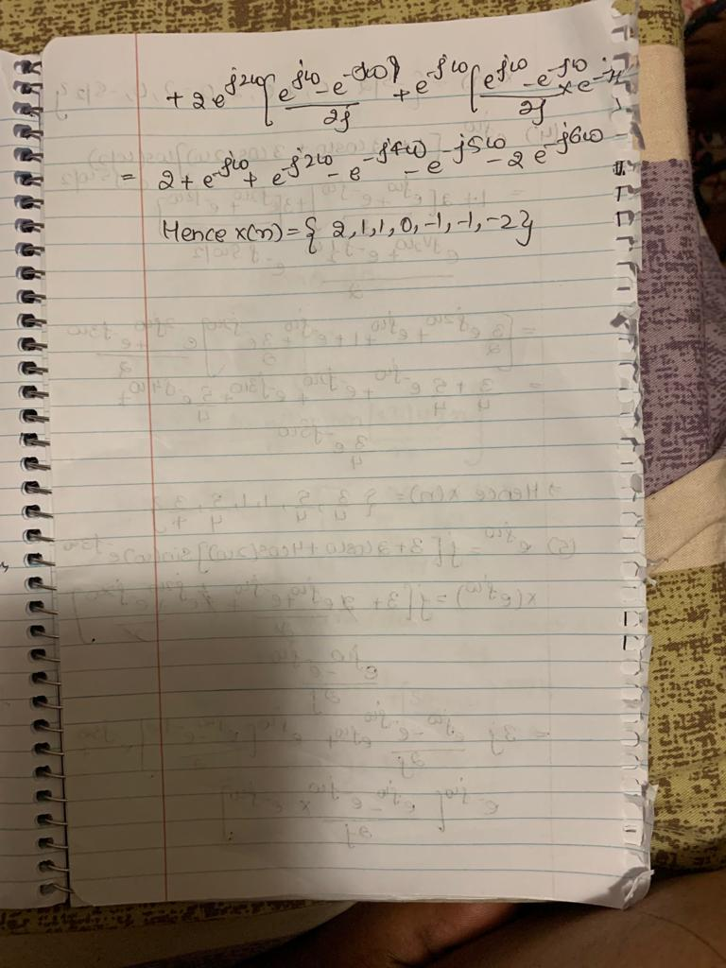

**Question-3**

