**LAB REPORT-1**

**(Submitted By : Gurvinder Bhullar(C0748418), Jasmine(C0748300))**

1. **Create an vector.**

Solution: vec = [1:9]

Output:

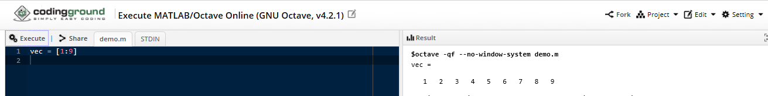

1. **Create a matrix**

Solution: The given matrix has 3 rows and 3 columns.

mat1 = [10,4,20; 1,4,15; 12,2,18]

Output:

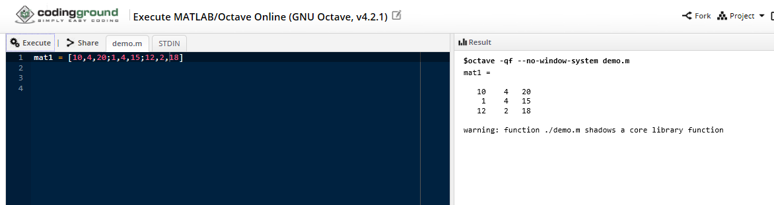

1. **Create a 5x1 vector of zeros. Create a 1x5 vector of random numbers.**

Solution: The given matrix has 5 rows.

Zeros (5,1)

Output:

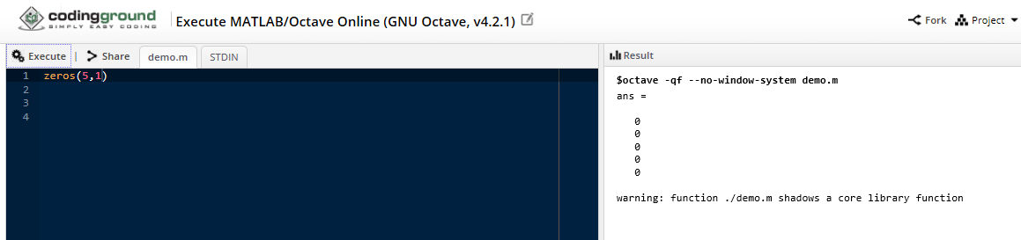

Solution: rand (1,5)

Output:

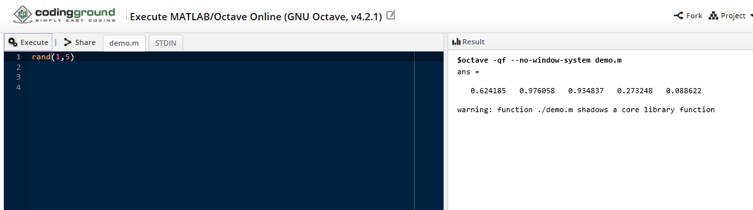

1. **Transpose the matrix you create in no.2.**

Solution: Transpose of a matrix is defined as the matrix in which position of rows and columns are interchanged.

mat1 = [10,4,20; 1,4,15; 12,2,18]

mat2 = mat1’

Output:

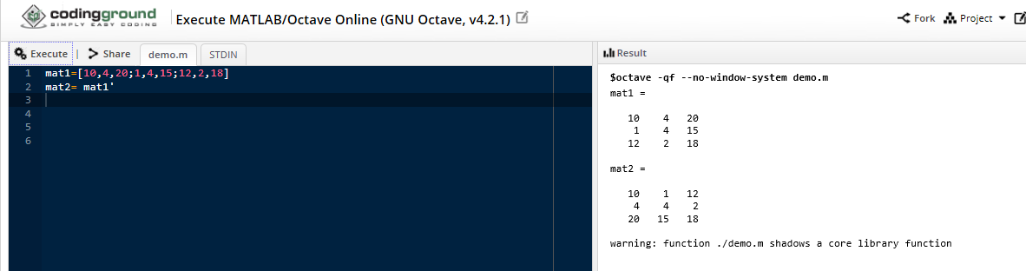

1. **Compute the inner product of two matrices. Compute the cross product of two matrices. Compute the inverse of a matrix.**

Solution1: The inner product of matrices is also known as dot product. The dot product of two square matrices called A1 and A2 is A3 which multiply each element of columns and added them.

A1 = [2,3,4;4,5,6;7,6,8]

A2 = [9,8,7;6,5,4;4,3,2]

A3 = dot (A1, A2)

Output1:

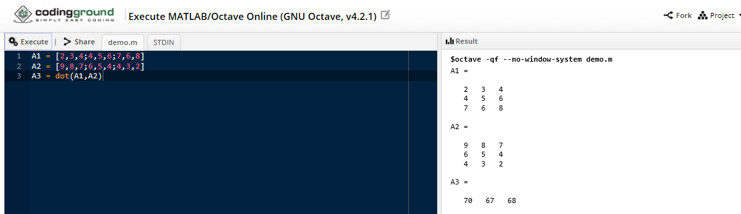

Solution2: The essential condition of cross product is that matrices should of same size. The given cross product of A1 and A2 is A3 matrix.

A1 = [2,3,4;4,5,6;7,6,8]

A2 = [9,8,7;6,5,4;4,3,2]

A3 = cross (A1, A2)

Output2:

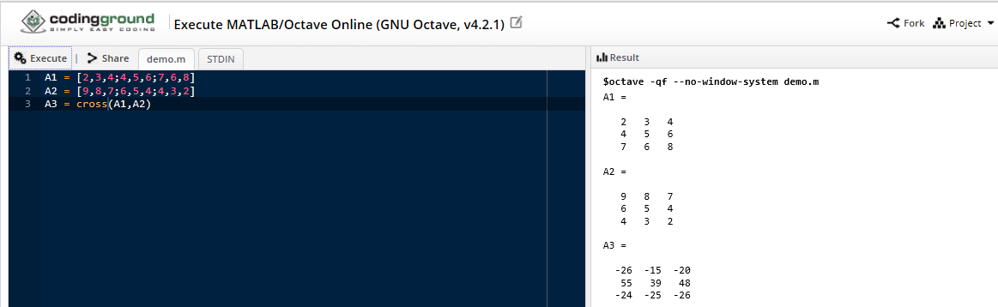

Solution3: B = [4,7;2,6]

C = Inverse(B)

Output:

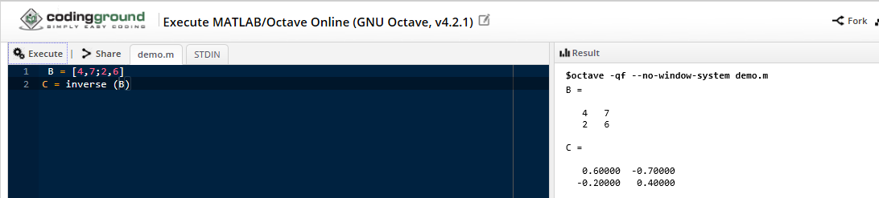

1. **Compute the element wise multiplication of a matrix and a scalar.**

Solution: C1 = [12,11,13;22,23,21;13,12,14]

C2 = [5,0,0;0,5,0;0,0,5] // Scalar Matrix

C = C1 * C2

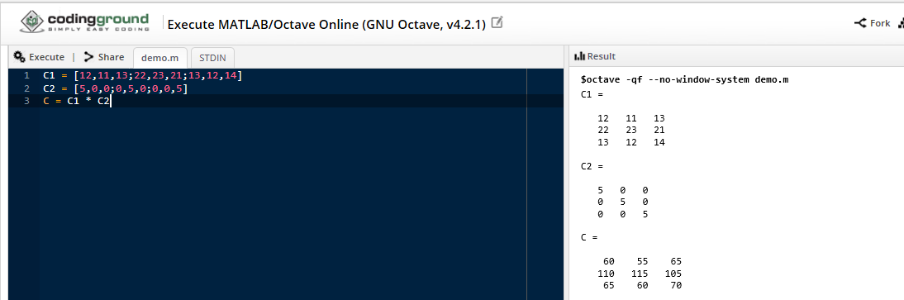

1. **Concatenate two matrices.**

Solution: Combination two matrices is known as concatenation. There are two type of concatenation horizontal and vertical.

A = [12,10,23 ; 8,14,6 ; 27,8,9]

B = [31,12,34 ; 2,0,8 ; 34,22,54]

C = [A, B] // Horizontal concatenation

D = [A; B] // Vertical concatenation

Output:

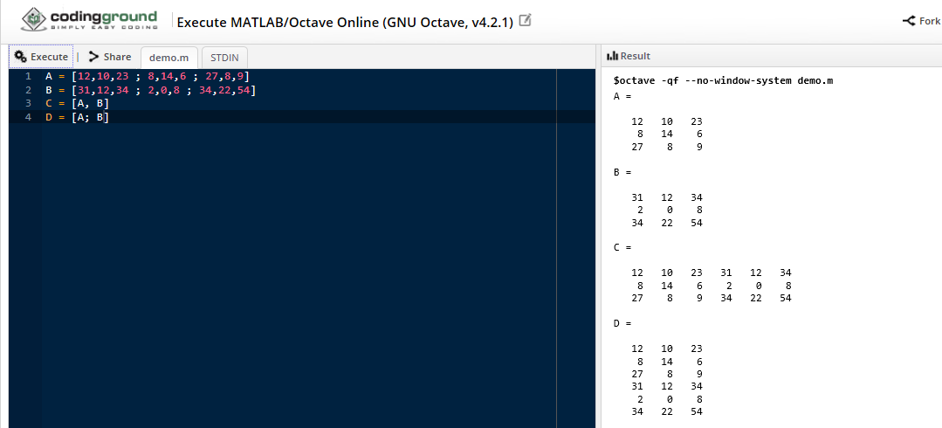

1. **Create a vector of complex numbers.**

Solution: Complex numbers has real as well as imaginary part.

X = [2 3]

Y = [4 5]

Z = complex (X, Y)

Output:

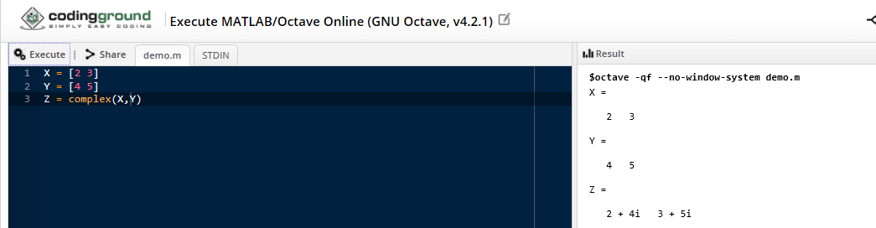

1. **Multiply a row of a matrix with an element of that same matrix.**

Solution: A = [2 3 4;5 6 7;7 8 9]

B = A .*A

Output:

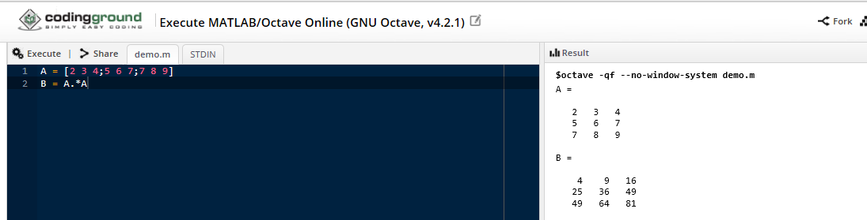

1. **Generate a vector of values ranging from 1 to 500 with 100 elements.**

Solution: The following vector is ranging from 1 to 500 with 100 elements.

X = [1:5:500]

Output:

