**First testing doc, hehe**

This is the first page.

# **Random heading 1 lol**

## **Test the web-app: heading 2**

###### [Slide 2]

This is the second page.

This is just to test sandom spaces

After those random spaces

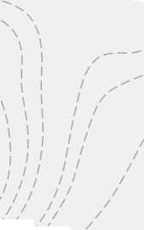

Random sentence blab la bla.

###### [Slide 3]

This is the third page

###### [Slide 4]

This is the fourth page