IT Event & System Monitoring Lab : Supporting evidence
Student Name: Navroop Kaur
Date : 12-02-2026

Overview
This document provides supporting evidence for the Automated Events Troubleshooting project . It demonstrates practical experience with Windows event logs , system monitoring , security events, and performance analysis.

STEP EVIDENCE SUMARRY

Step 1: Triggered system event entries
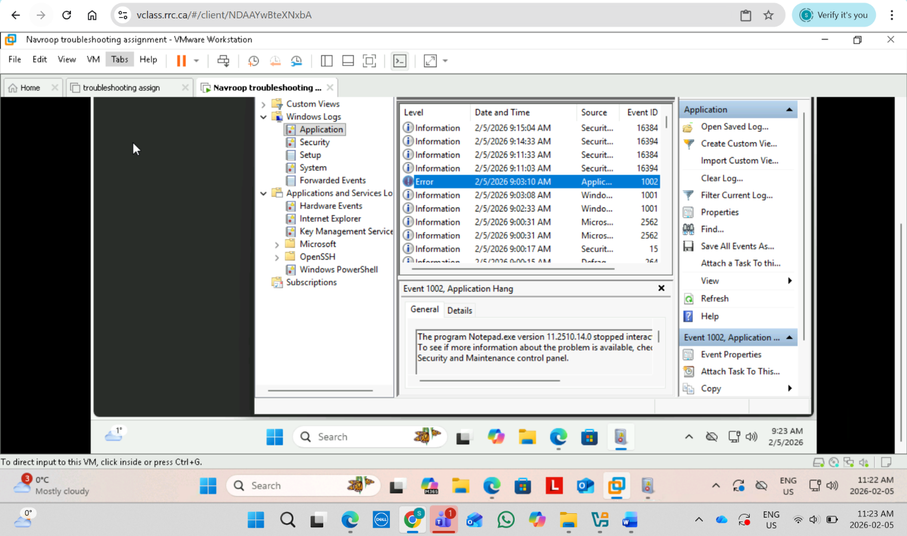

Step 2: Enabled and Disabled WIFI Connection to generate network logs
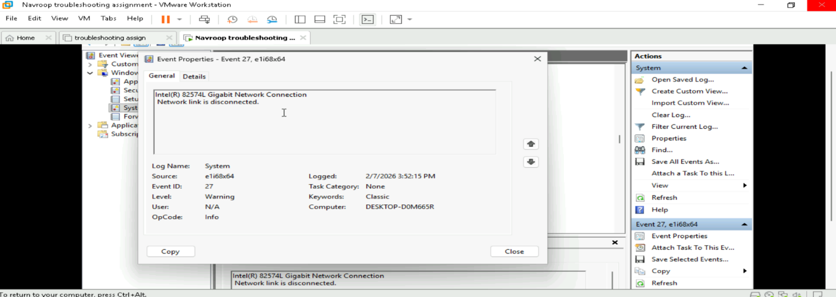
Step 3: Task Manger Monitoring

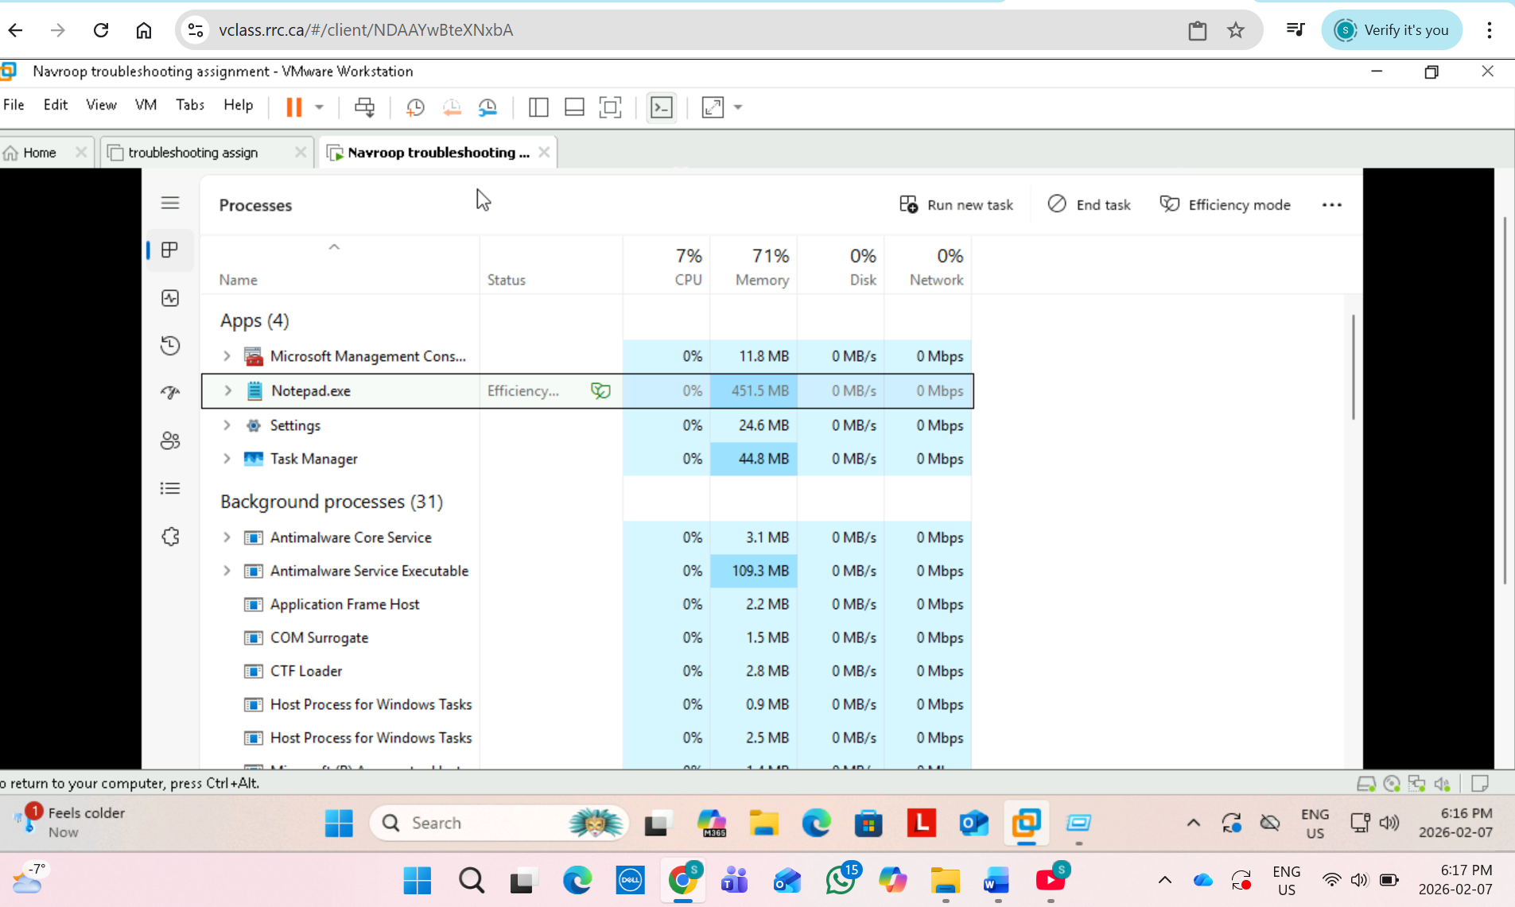
Step 4: Generate Security Events
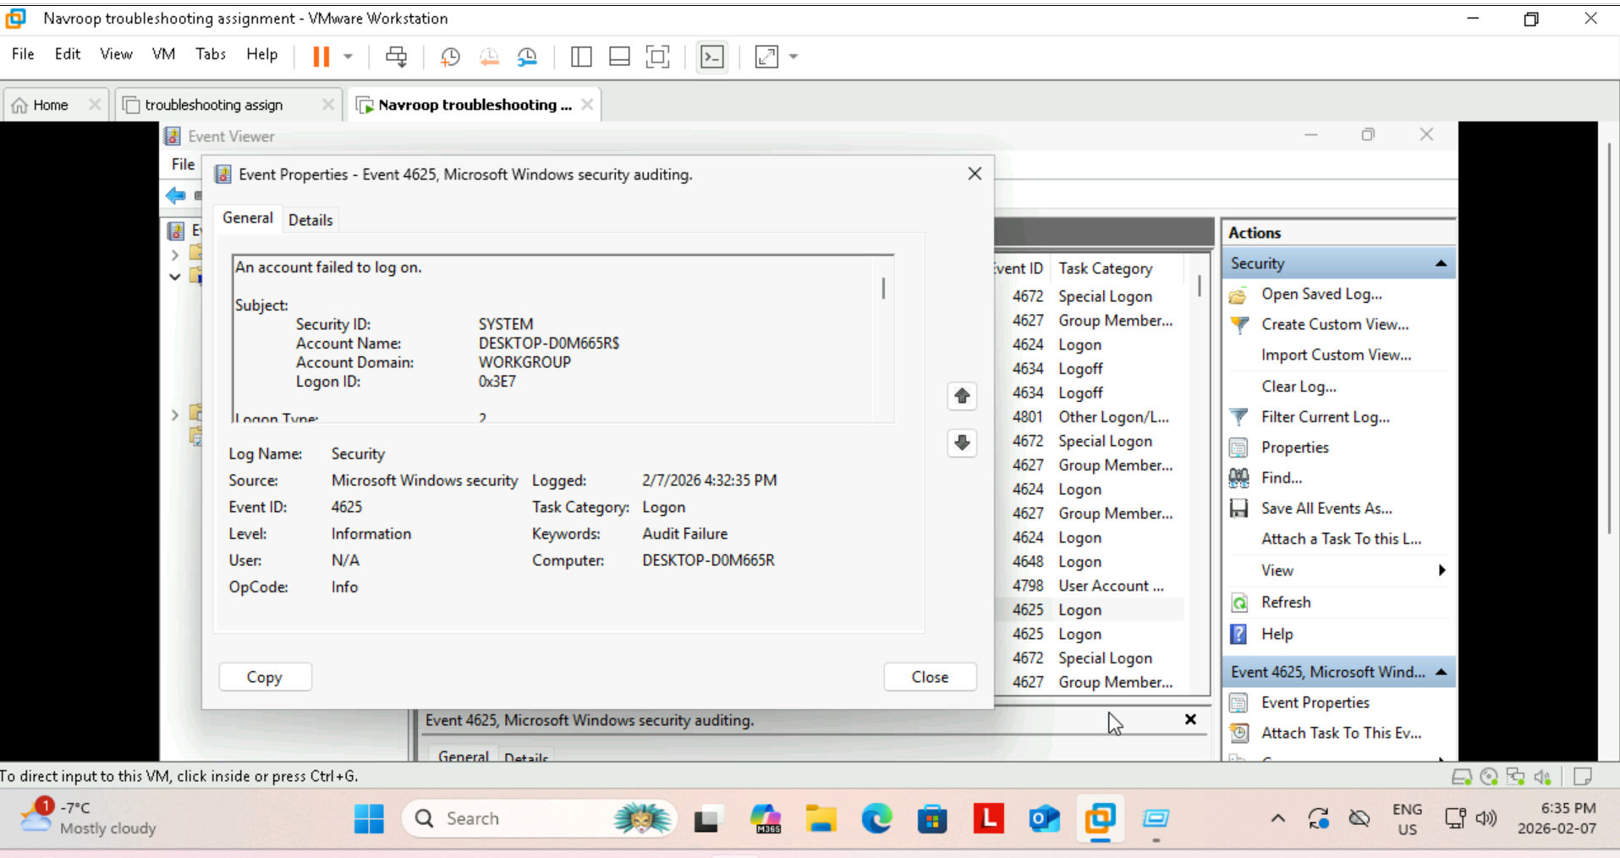
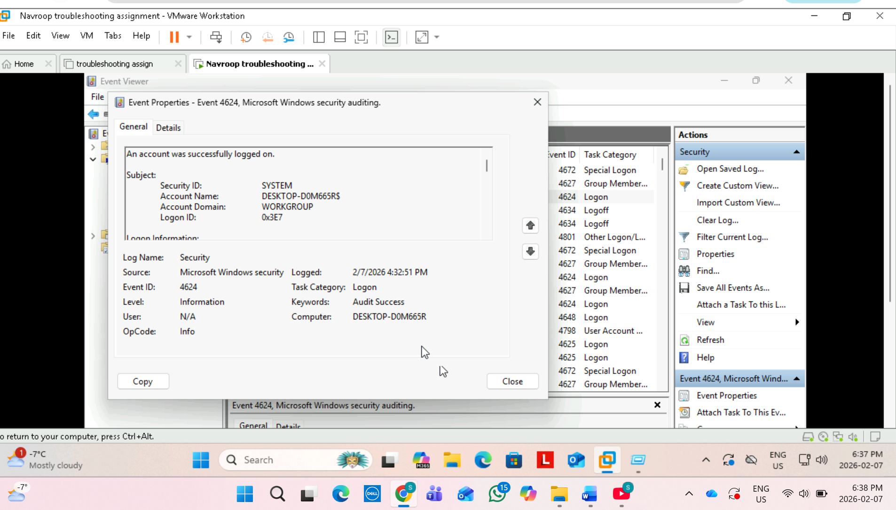
Step 5: Create an alert

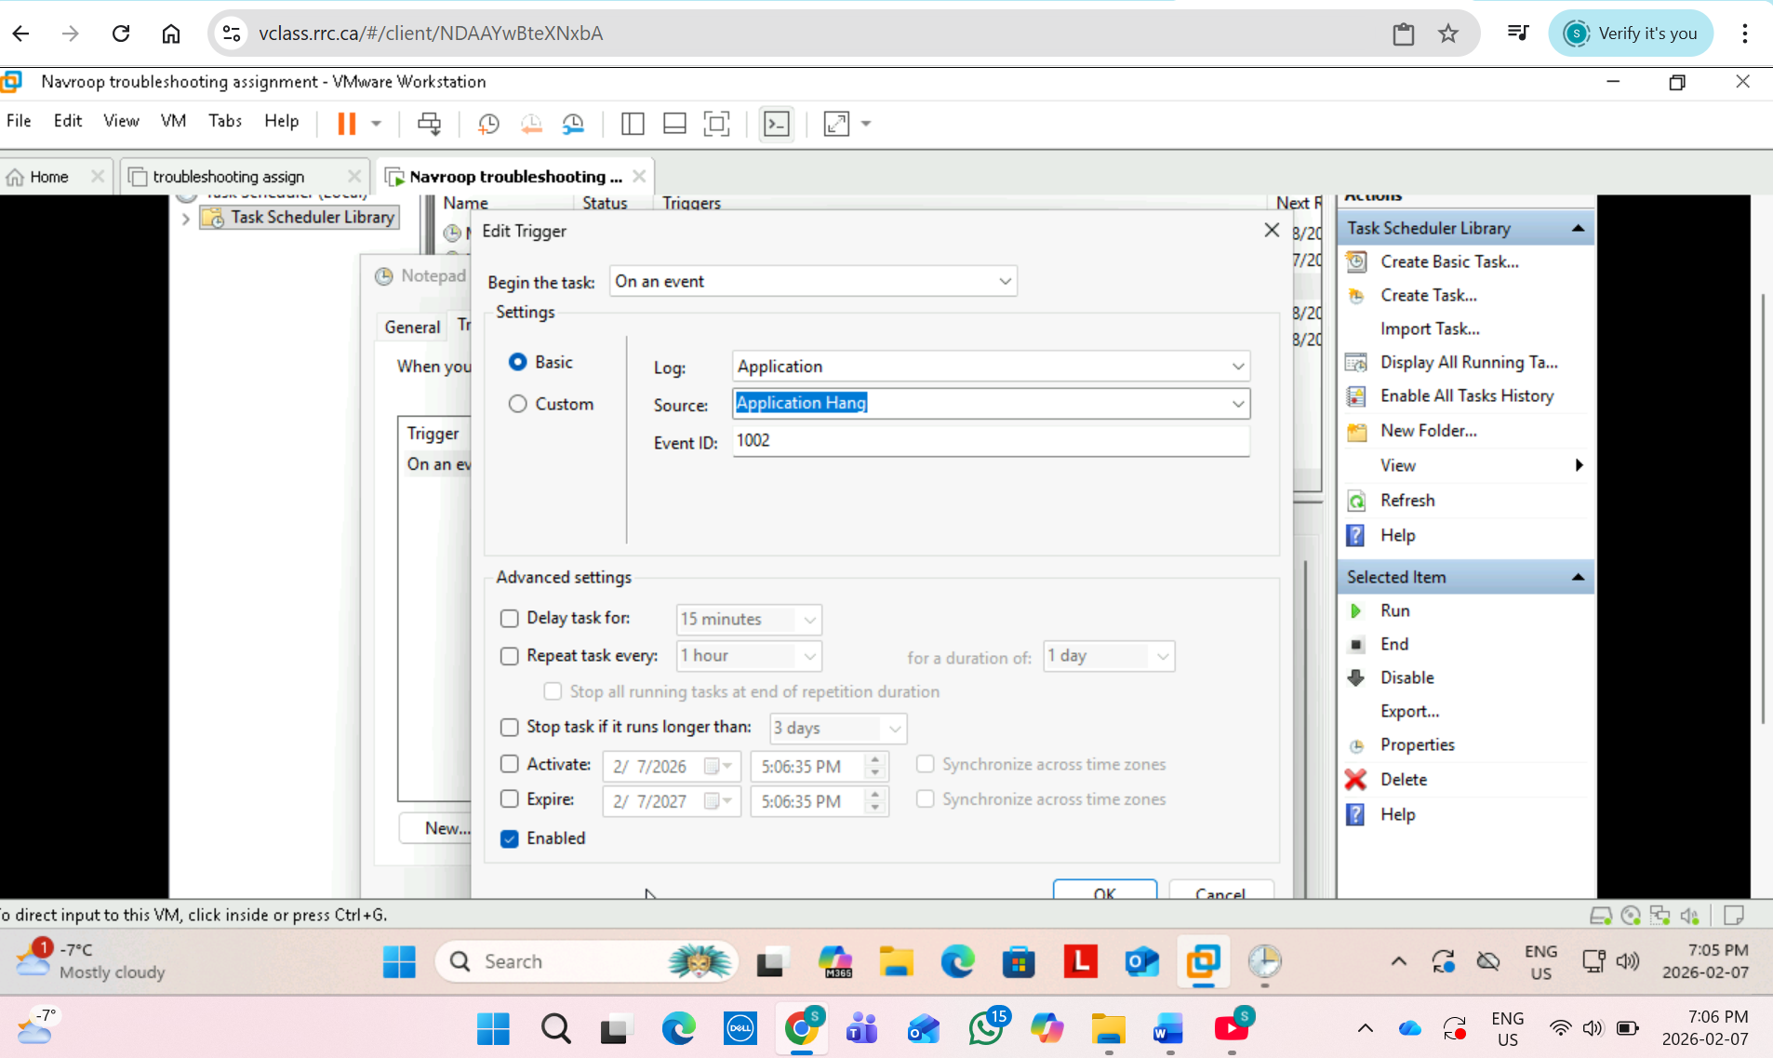
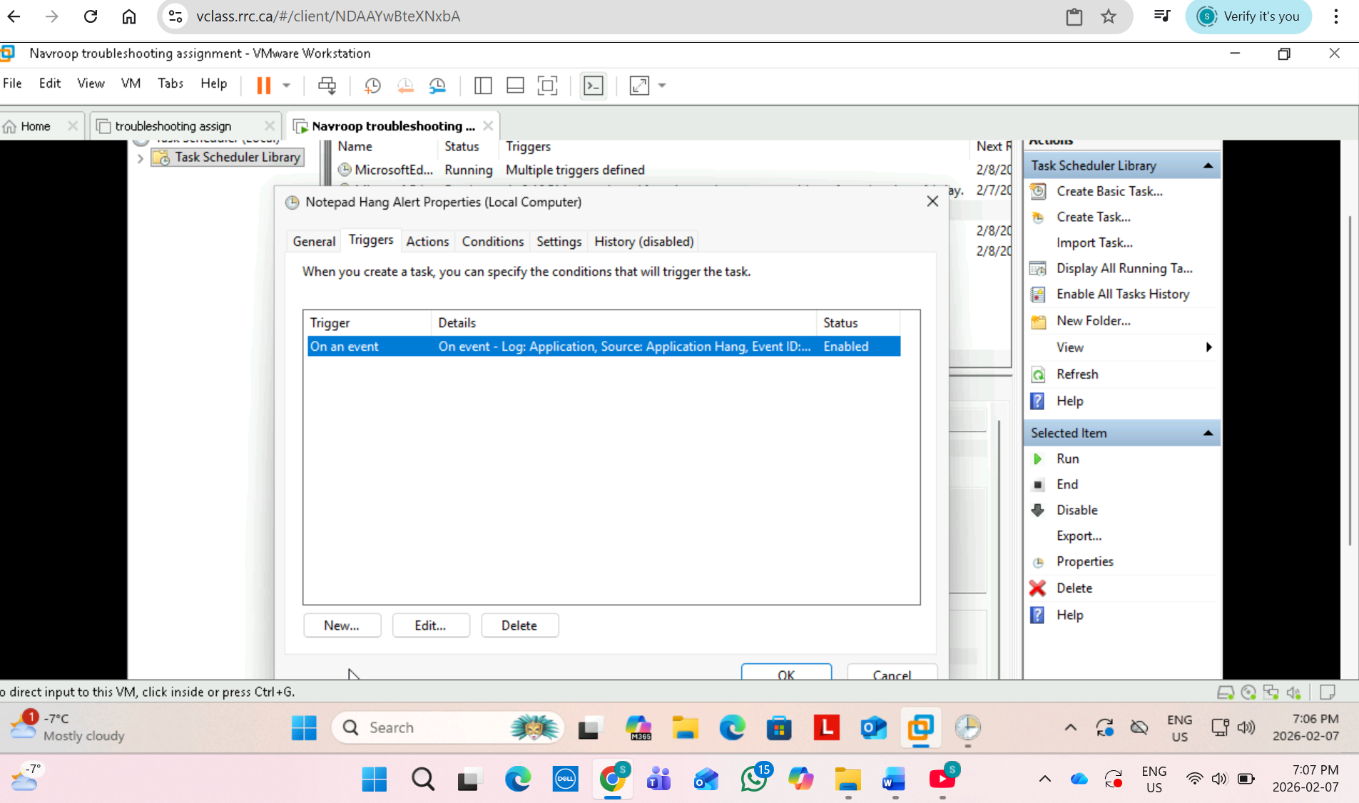

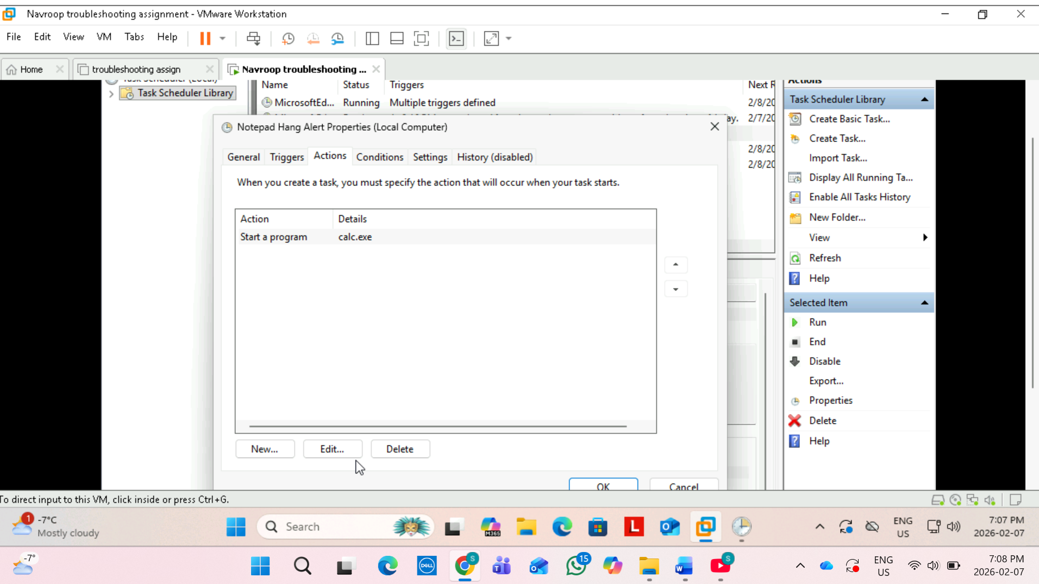

Step 6 : Reliability Monitor Investigation
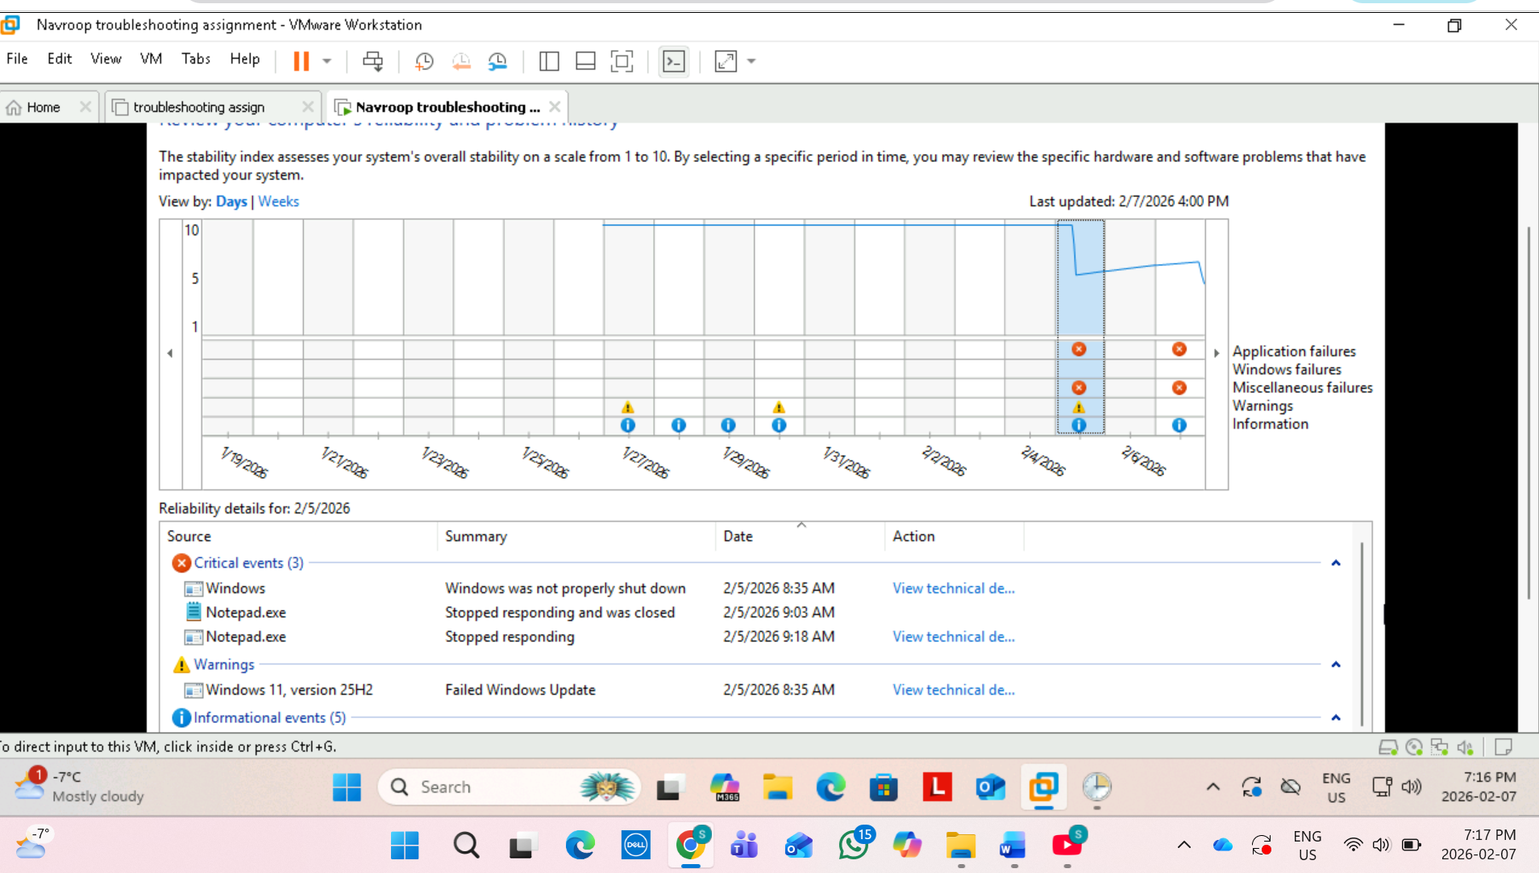
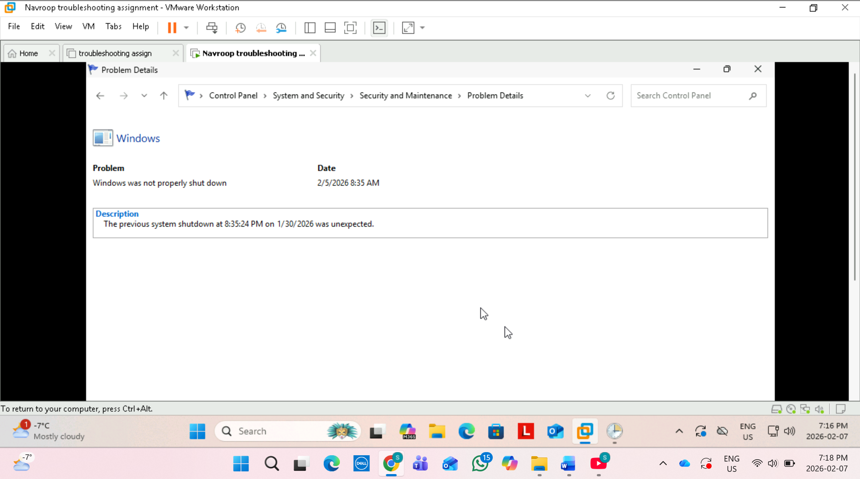

Reliability Monitor recorded a Windows failure on feb 5, 2026 at 8:35AM. The system reported that windows was not properly shut down and the previous shutdown was unexpected. This likely occurred because the virtual machine or computer was turned off without using the normal shutdown process. No other major application events were recorded at that time.
Step 7: Performance Monitor Counters
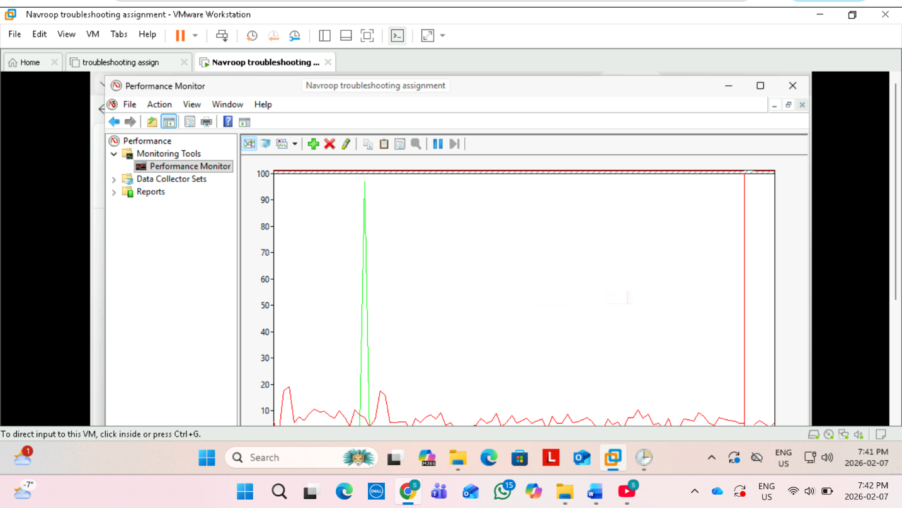

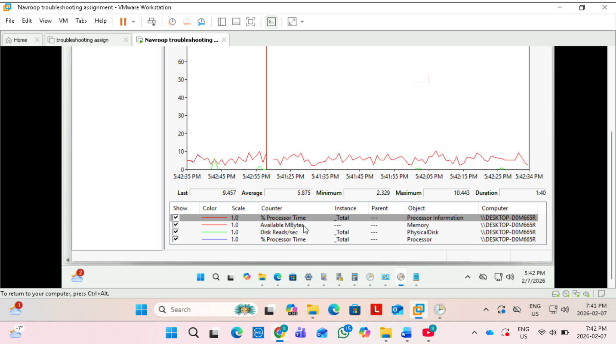

Step 8: Startup Impact Excercise
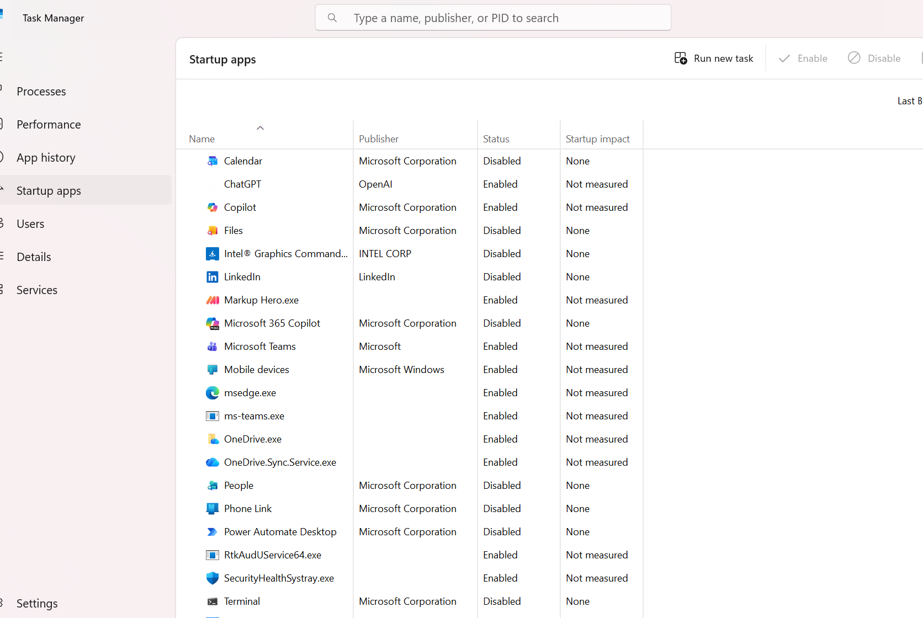

Item | Description | Action (Keep/Disable)
OneDrive.exe | Synchronizes user files and school documents | Keep
Microsoft Edge | Browser preloads at startup and increases boot time. | Disable
Microsoft Teams | Communication app that can be opened manually when needed. | Disable

Step 9: Windows Defender Security logs
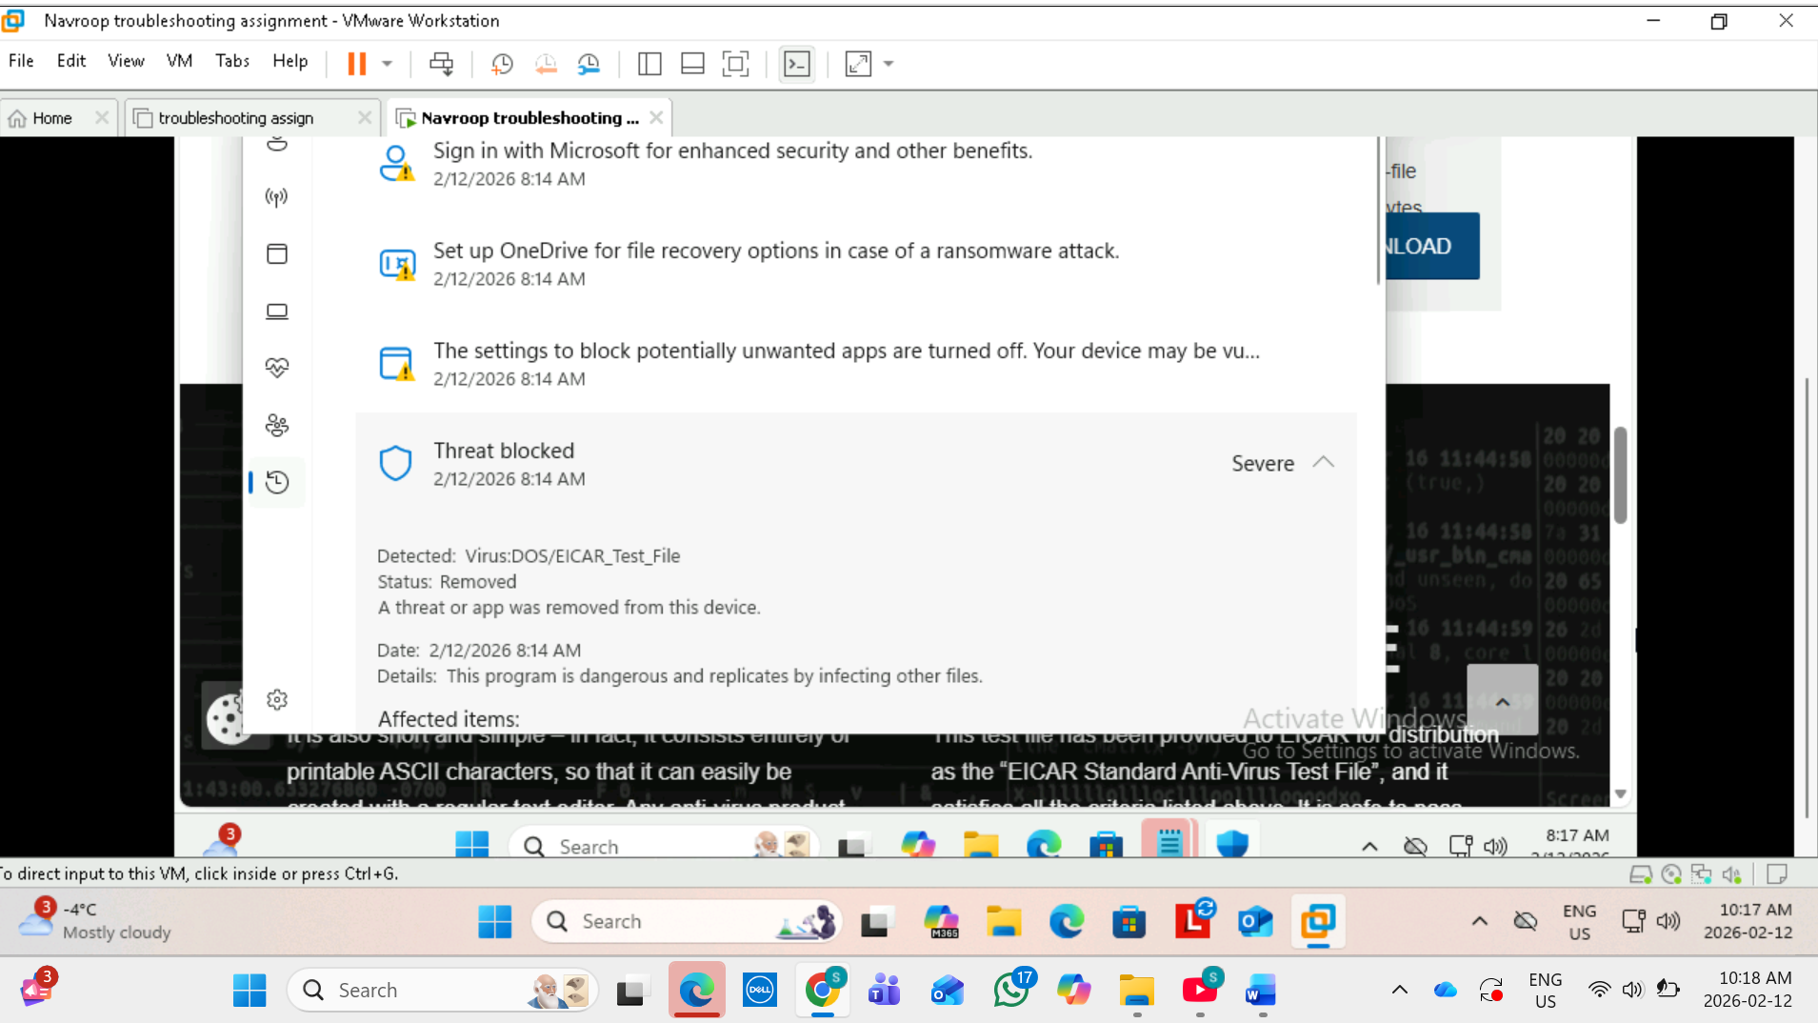

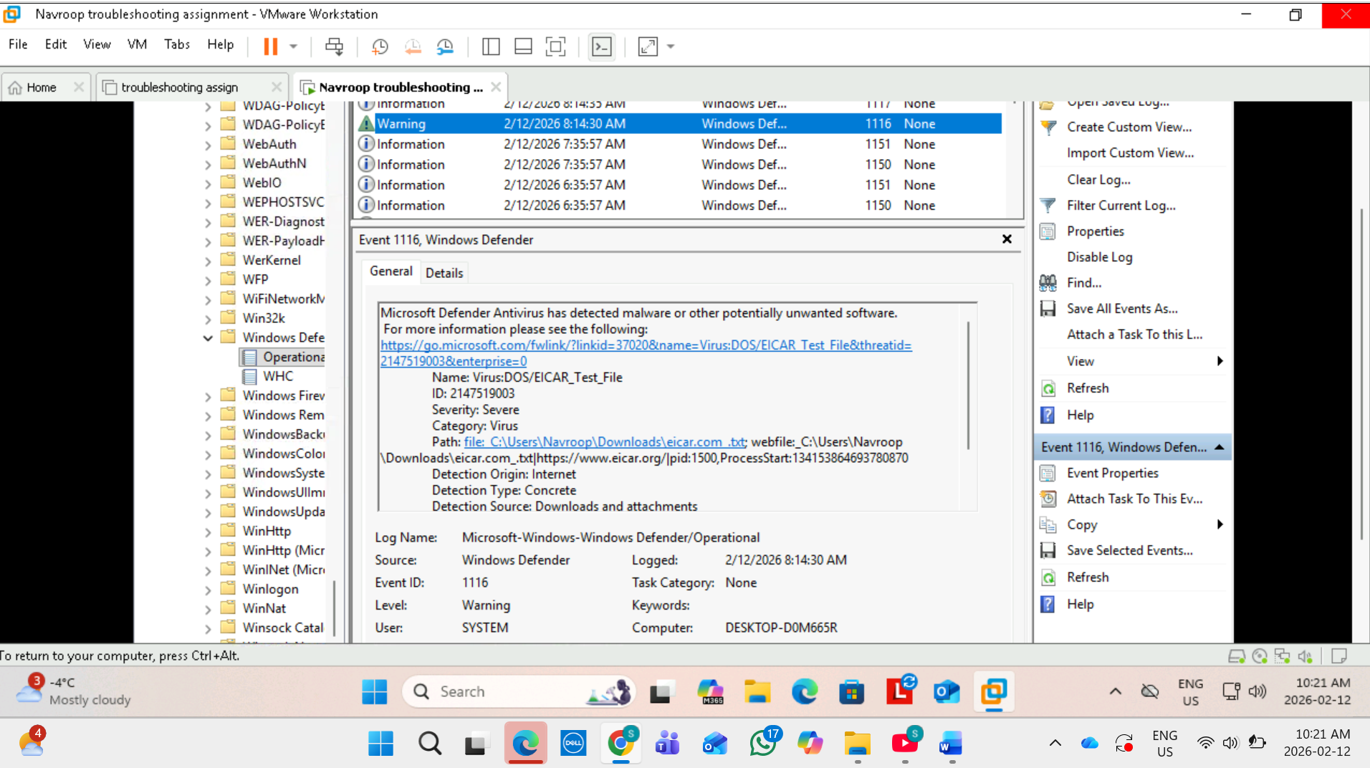
Step 10: Custom log creation
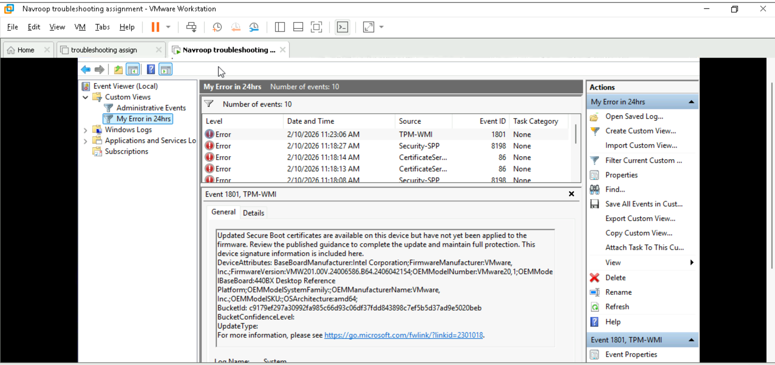

Step 11: Scheduled Task with logging

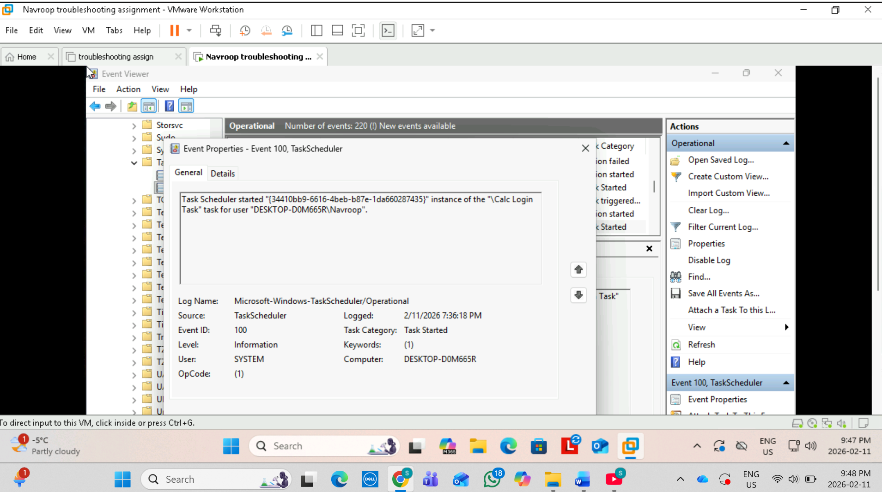

Step 12: Monitoring + Logging
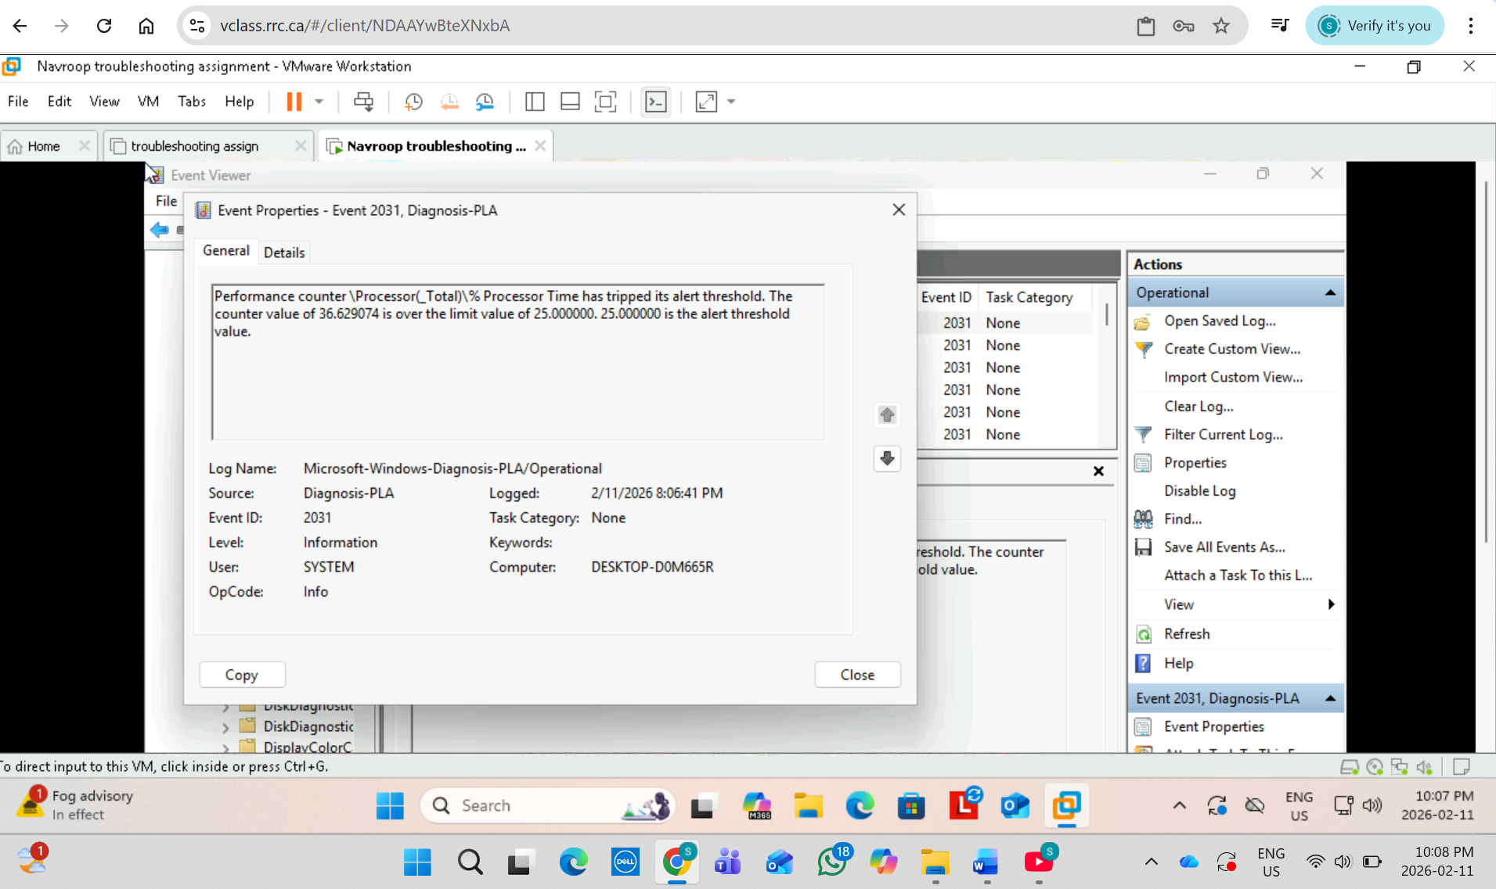
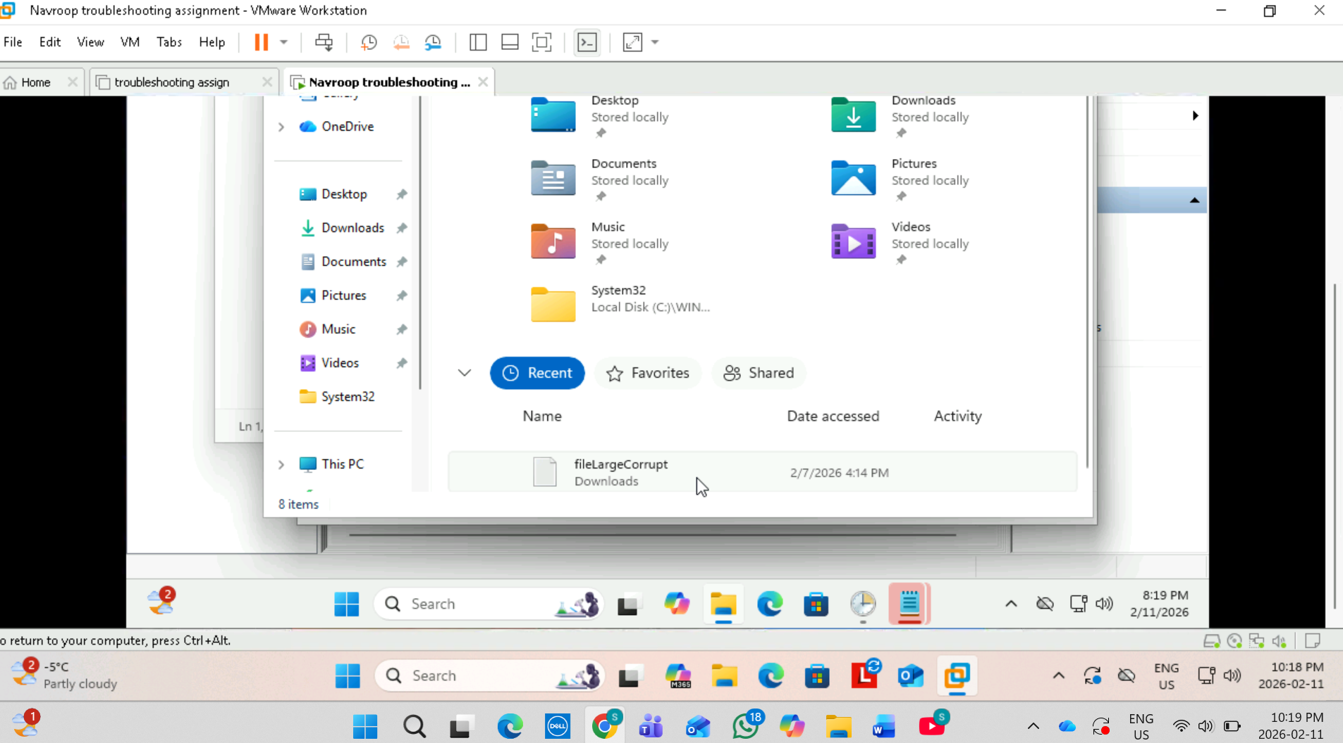
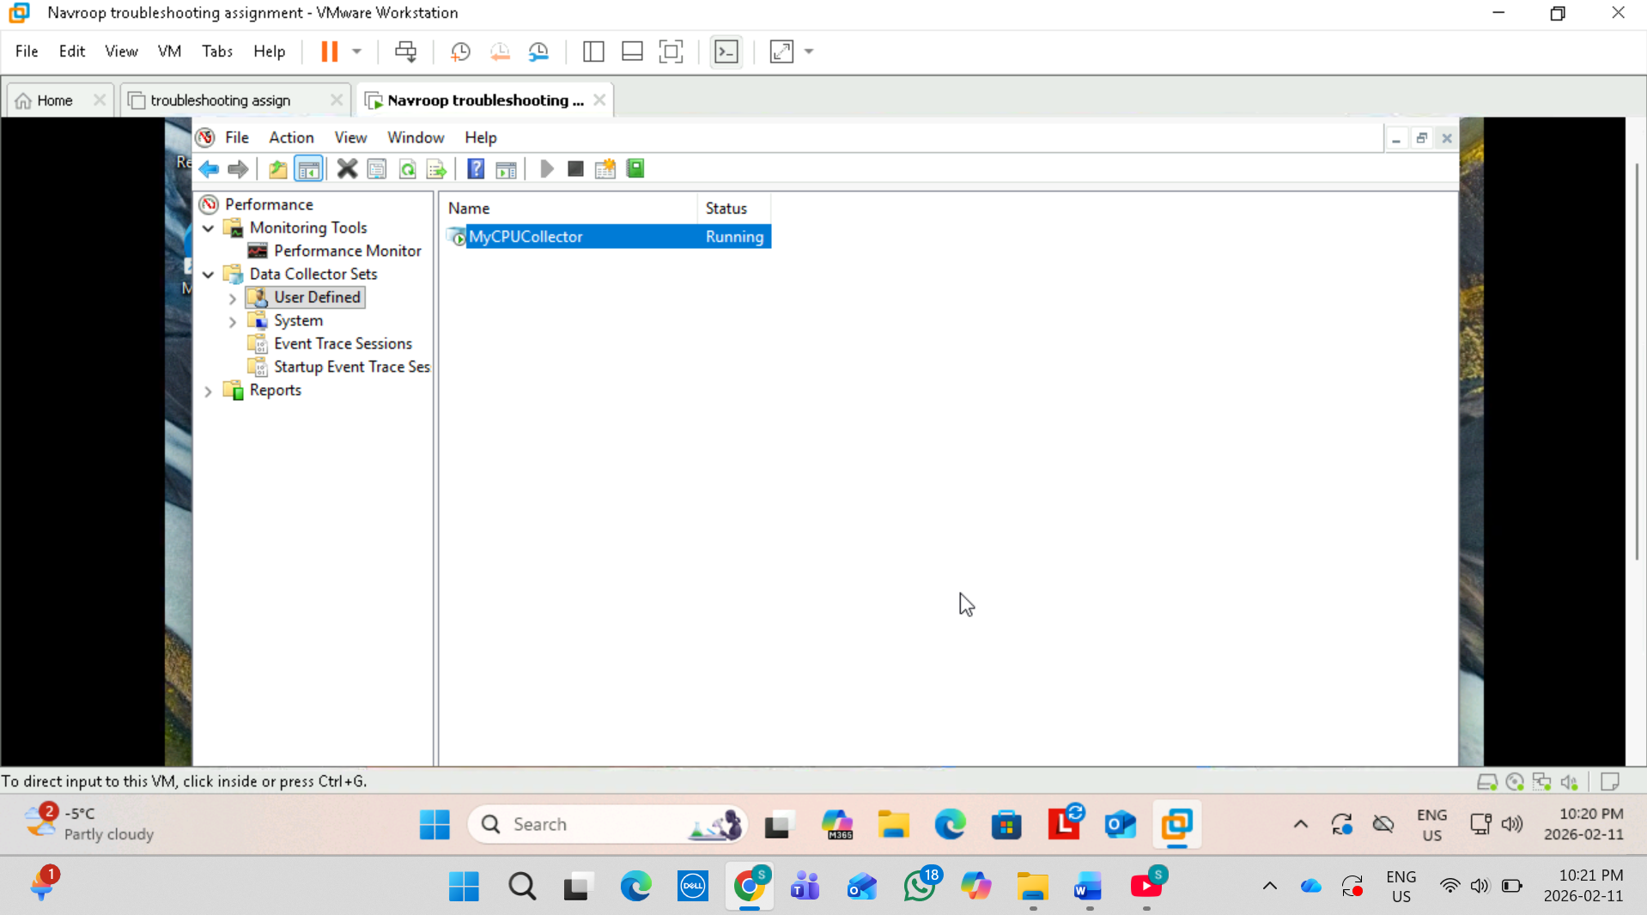
Conclusion
This project improved my understanding of Windows event logs , system monitoring , and troubleshooting workflows. It also strengthened my ability to analyze system behavior and identify potential issues using built in Windows administrative tools.

