WEEKEND CAPSTONE PROJECT – DOCKER
DEPLOY AND MANAGE A COMPANY WEBSITE USING DOCKER
SUBMITTED AS PART OF THE
MASTER CLASS PROGRAM ON CLOUD COMPUTING AND DEVOPS
Submitted By:
Yashdeep Kaur (2302711)
Computer Science and Engineering
DEPARTMENT OF COMPUTER SCIENCE AND ENGINEERING
GURU NANAK DEV ENGINEERING COLLEGE
LUDHIANA, 141006
Submission Date: 20-07-2026

Introduction
This capstone project demonstrates deploying and managing a static company website using Docker instead of installing a web server directly on the host operating system. An Nginx container is pulled, run, customized with company branding, inspected, monitored through logs, and taken through a full lifecycle of stop/start/remove — covering the practical Docker workflow end to end.

Task 1 – Verify Docker Installation
Verified Docker is installed and running, and recorded the Docker version.
docker --version
docker info
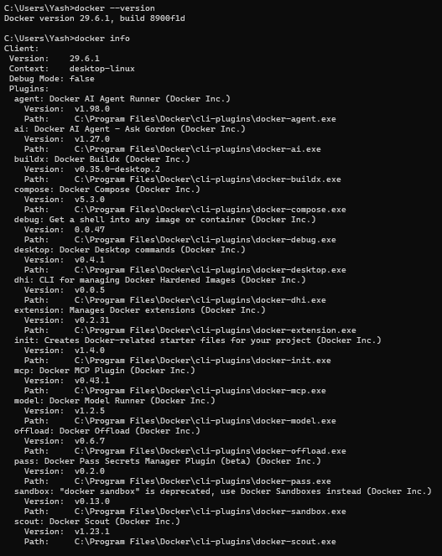
Docker version 29.6.1, build 8900f1d — installation verified.

Task 2 – Download the Web Server Image
Pulled the latest Nginx image from Docker Hub and verified it downloaded successfully.
docker pull nginx:latest
docker images
(Nginx image confirmed present in the local image list — see the Task 10 screenshot, which also lists nginx:latest among local images.)

Task 3 – Deploy the Company Web Server
Created a Docker container named company-webserver from the nginx image, mapping host port 9090 to container port 80, running in detached mode.
docker run -d --name company-webserver -p 9090:80 nginx

Task 4 – Verify Deployment
Displayed all running containers and verified name, ID, image, port mapping, and status.
docker ps
(Container confirmed running — see the Task 9 screenshot, which shows the same company-webserver container Up with port mapping 0.0.0.0:9090->80/tcp.)

Task 5 – Access the Website
Opened the deployed website at http://localhost:9090 and captured the default Nginx page.
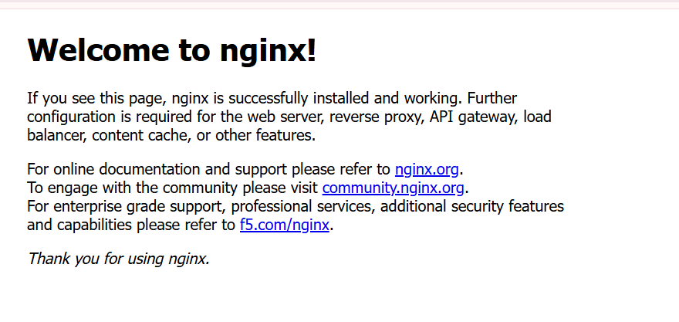
Default Nginx welcome page loaded successfully at localhost:9090.

Task 6 – Customize the Website
Replaced the default webpage inside the container with a custom page containing the company name, student name, roll number, branch, course title, and a welcome message.
docker cp index.html company-webserver:/usr/share/nginx/html/index.html
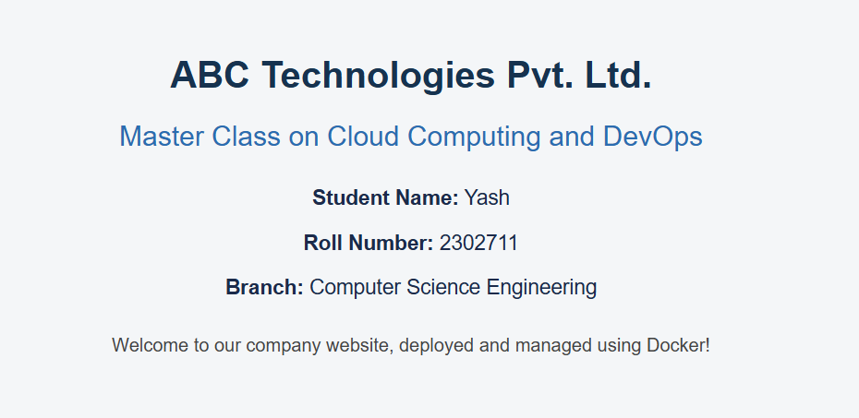
Customized website verified in the browser at localhost:9090.

Task 7 – Inspect the Running Container
Displayed running processes, current working directory, and website files inside the container.
docker exec -it company-webserver bash
pwd
ls /usr/share/nginx/html
cat /proc/1/status | grep Name
docker top company-webserver
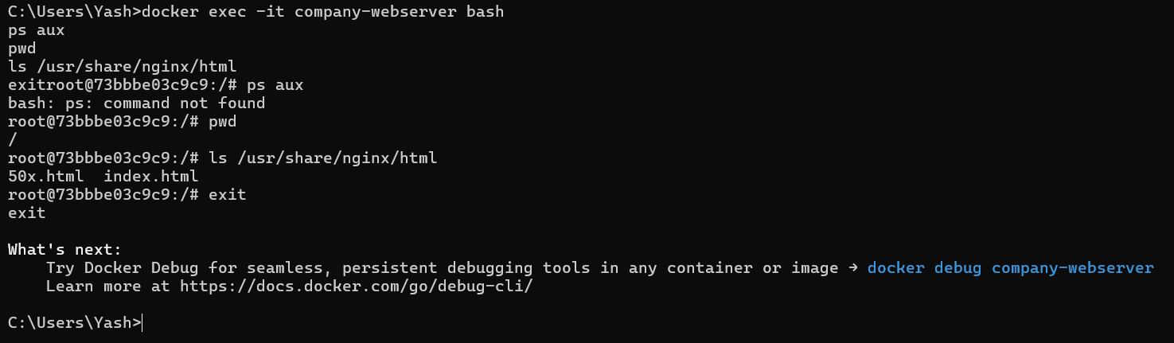
Working directory (/) and website files (index.html, 50x.html).
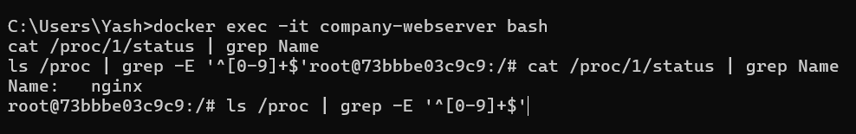
Process name confirmed as nginx (PID 1 inside container).
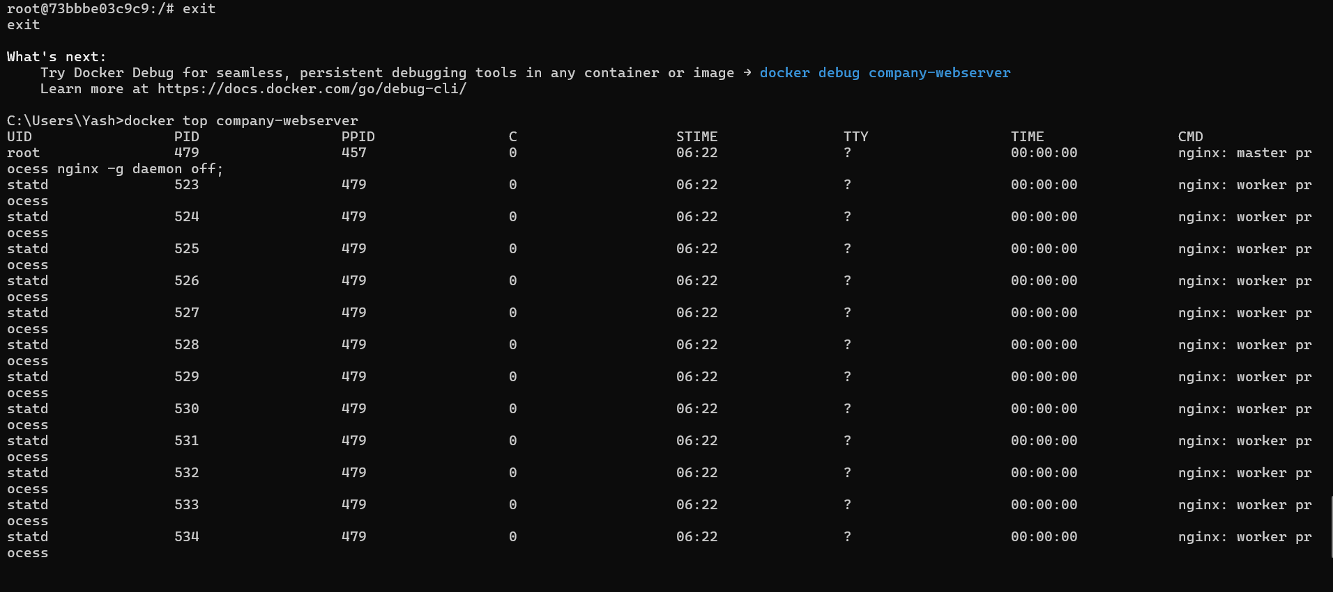
docker top company-webserver — nginx master process and worker processes.

Task 8 – View Docker Logs
Accessed the container logs and refreshed the website several times to observe browser requests appearing in real time.
docker logs company-webserver
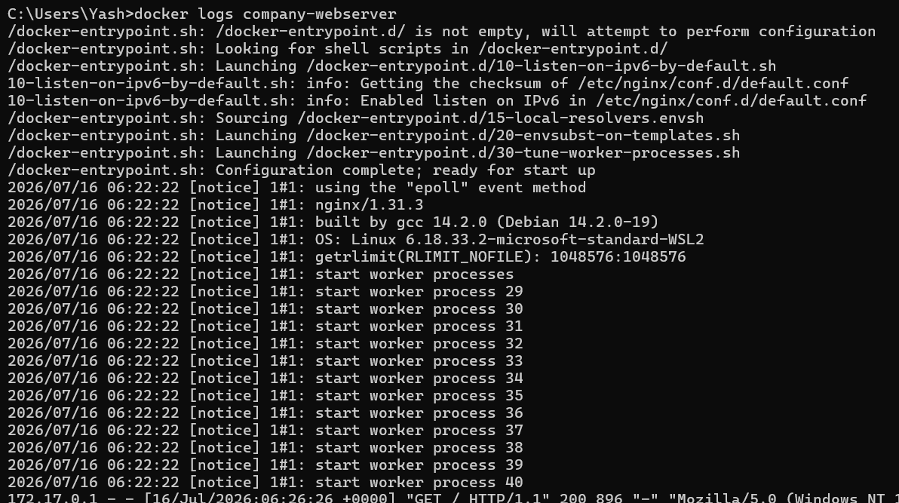
Startup logs followed by browser GET requests with timestamp and status code 200.

Task 9 – Container Management
Stopped the container, verified its status, restarted it, and confirmed the website became accessible again.
docker stop company-webserver
docker ps -a
docker start company-webserver
docker ps
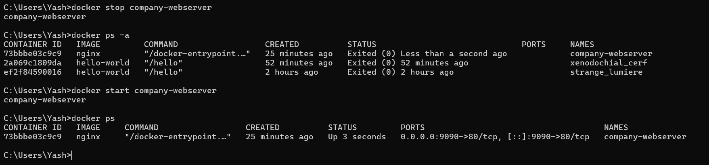
Status changed from Exited(0) to Up after restart; port mapping restored.
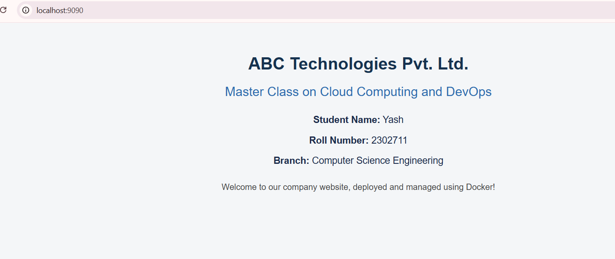
Website confirmed accessible again at localhost:9090 after restart.

Task 10 – Container Cleanup
Stopped and removed the container after the demonstration, then verified the underlying image still exists on the system.
docker stop company-webserver
docker rm company-webserver
docker images
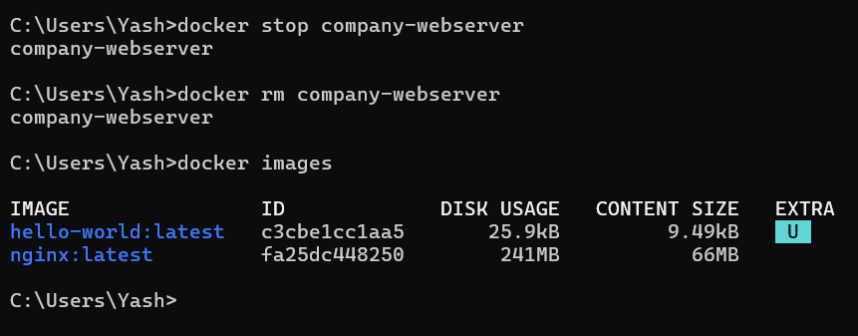
Container removed successfully; nginx:latest image remains available locally.

Conclusion
This capstone project provided hands-on experience deploying and managing a static company website using Docker instead of installing a web server directly on the host operating system. Through the exercise, key skills were reinforced: pulling images from Docker Hub, configuring host-to-container port mapping, running containers in detached mode, and accessing and customizing website content inside a running container. Inspecting the container with commands such as docker top and docker exec clarified how nginx's master and worker processes operate, while docker logs showed how every browser request is recorded in real time. Finally, managing the full container lifecycle — stop, restart, and remove — demonstrated that a Docker image persists independently of any container built from it, which is central to how Docker separates reusable images from disposable container instances. Overall, this project strengthened practical understanding of container-based deployment, a core skill for an entry-level DevOps engineer.

