Website Version Control using Git & GitHub
Capstone Activity – 1 (Beginner Level)
Master Class on Cloud Computing and DevOps

Student Details
- Name: Yash
- Institution: Guru Nanak Dev Engineering College (GNDEC), Ludhiana
- Role: Junior Web Developer, ABC Technologies Pvt. Ltd. (scenario)
Objective
To learn the complete Git workflow — creating a repository, making commits, branching, merging, pushing to and pulling from GitHub — by building a simple company website.
Tools Used
- Git (version control)
- GitHub (remote repository hosting)
- Visual Studio Code (editor and integrated terminal)
Repository Link
https://github.com/kauryashdeep31-gif/company-website
Steps Performed
1. Repository Initialization
Created a project folder named company-website and initialized it as a Git repository using git init.
2. Creating and Committing index.html
Created index.html containing the company name, a welcome message, and developer details. Staged the file with git add and committed it with a descriptive commit message.
3. Connecting to GitHub
Created a new empty repository named company-website on GitHub. Linked the local repository to it using git remote add origin, renamed the default branch to main, and pushed the initial commit using git push -u origin main.
4. Branch Creation
Created a new branch named feature-about using git checkout -b feature-about to develop the About Us feature in isolation from the main branch.
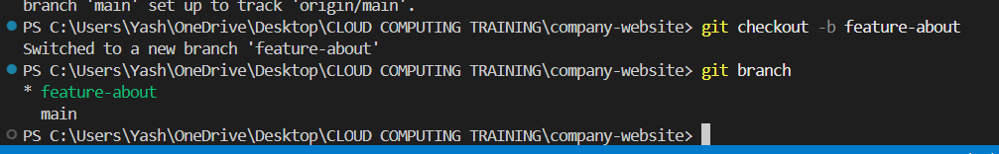
Figure 1: Branch feature-about created and checked out
5. Developing the About Us Section
Added an About Us section to index.html containing the company introduction, vision, and mission. Committed the change on the feature-about branch.
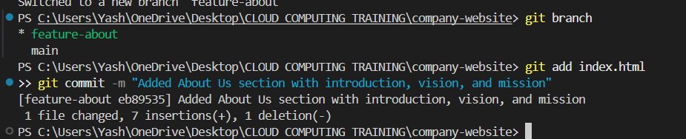
Figure 2: Commit of the About Us section on feature-about
6. Merging the Feature Branch
Switched back to the main branch and merged feature-about into it using git merge feature-about. The merge completed as a fast-forward update.
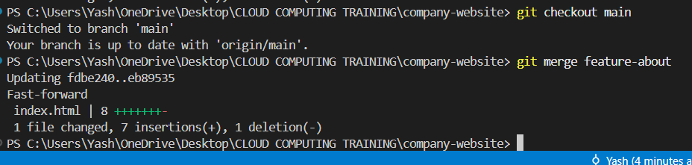
Figure 3: Fast-forward merge of feature-about into main
7. Pushing Updates to GitHub
Pushed the updated main branch to GitHub using git push origin main, making the merged About Us section visible in the remote repository.
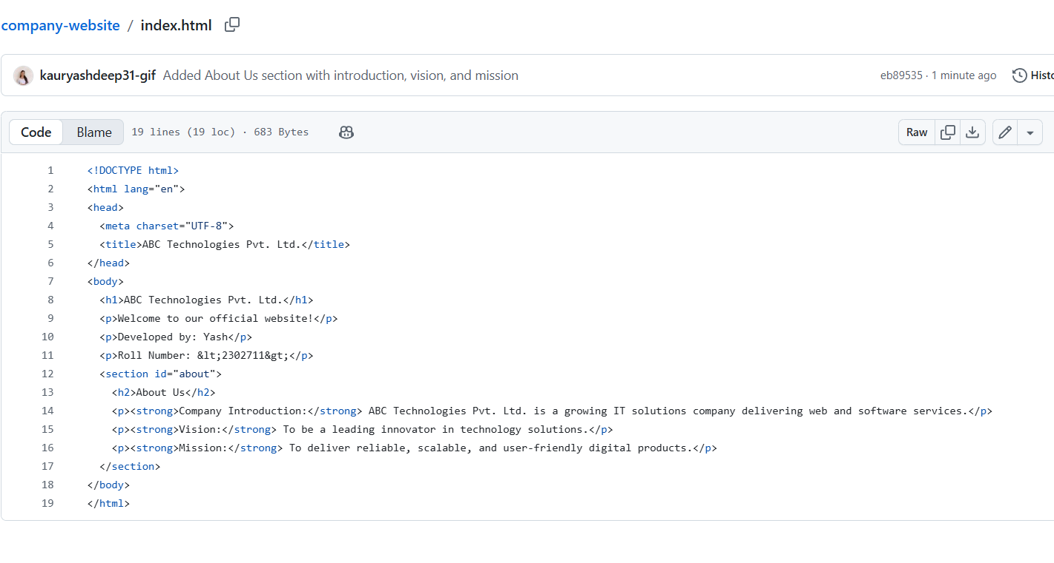
Figure 4: index.html on GitHub showing the merged About Us section
8. Editing README.md on GitHub
Directly on GitHub, added a README.md file containing the line: "Project developed during the Master Class on Cloud Computing and DevOps." This change was committed straight to the main branch on GitHub, without editing it locally.
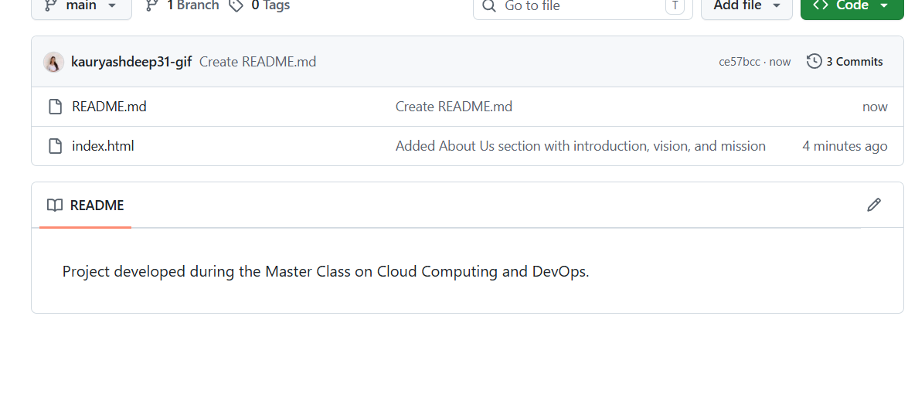
Figure 5: README.md created and committed directly on GitHub
9. Pulling Changes Locally
Ran git pull origin main on the local machine to fetch and merge the README.md commit made on GitHub into the local repository.
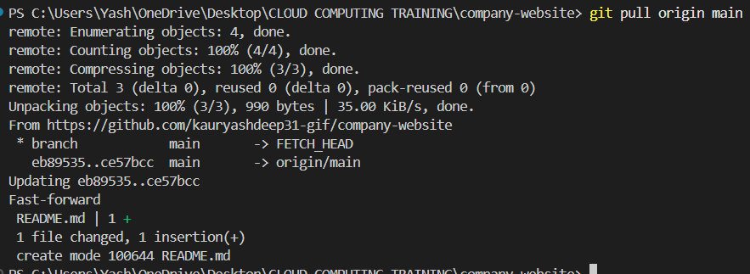
Figure 6: git pull bringing the README.md commit down locally
10. Verifying Commit History
Ran git log --oneline to confirm that all commits — the initial commit, the About Us feature commit, and the README.md commit — were present locally, verifying that the local and remote repositories were fully synchronized.
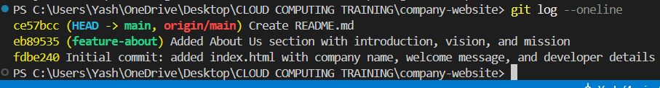
Figure 7: Final commit history verified locally
Expected Deliverables (as per Capstone Activity – 1)
- GitHub Repository Link — provided above
- Screenshot of Branch Creation — Figure 1
- Screenshot of Merge — Figure 3
- Screenshot after Pull Operation — Figure 6
- Screenshot of Commit History — Figure 7
- Source Code — index.html and README.md, pushed to the GitHub repository
- Short Project Report — this document
Learning Outcomes
- Understood how to initialize and manage a local Git repository.
- Learned to create and switch between branches for isolated feature development.
- Practiced merging feature branches back into the main branch.
- Understood the difference between local and remote changes, and how push and pull keep them synchronized.
- Gained hands-on experience with the Git workflow used in real-world collaborative software development.
Conclusion
This activity provided practical, hands-on experience with the core Git and GitHub workflow used in professional web development — from repository setup through branching, merging, and remote synchronization — reinforcing the concepts taught in the Master Class on Cloud Computing and DevOps.

