WEEKEND CAPSTONE PROJECT – 02
CONTAINERIZE YOUR PERSONAL PORTFOLIO WEBSITE
SUBMITTED AS PART OF THE
MASTER CLASS PROGRAM ON CLOUD COMPUTING AND DEVOPS
Submitted By:
Yashdeep Kaur (2302711)
Computer Science and Engineering
DEPARTMENT OF COMPUTER SCIENCE AND ENGINEERING
GURU NANAK DEV ENGINEERING COLLEGE
LUDHIANA, 141006
Submission Date: 20-07-2026

1. Project Scenario
As a Junior DevOps Engineer at GNDEC, Ludhiana, the task was to deploy the completed Personal Portfolio Website (HTML, CSS, JavaScript) without installing Apache or MySQL directly on the host operating system. Instead, the full application environment — a web server container and a database container — was built and managed entirely through Docker, demonstrating service isolation while allowing both containers to work together.

2. Docker Environment
- Container 1 — Apache Web Server (portfolio-apache): hosts the personal portfolio website
- Container 2 — MySQL Database Server (portfolio-mysql): simulates the backend database

3. Task-by-Task Execution

Task 1 — Verify Docker Installation
Confirmed the Docker CLI and Docker Desktop engine were installed and running using docker --version and docker info.
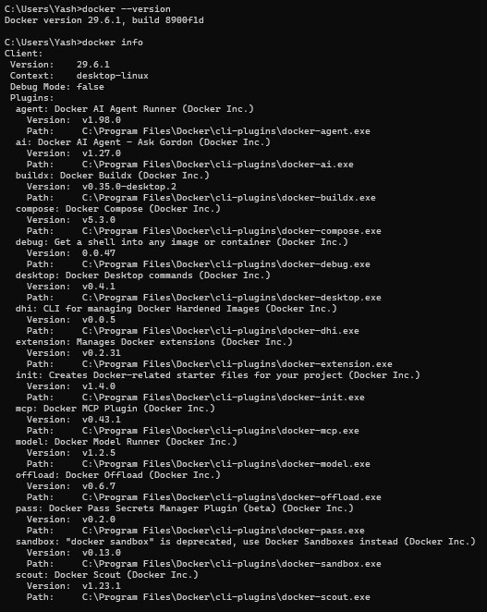
Docker version 29.6.1, build 8900f1d — installation verified.

Task 2 — Download Required Docker Images
Pulled the official Apache HTTP Server (httpd) and MySQL images from Docker Hub.
docker pull httpd
docker pull mysql
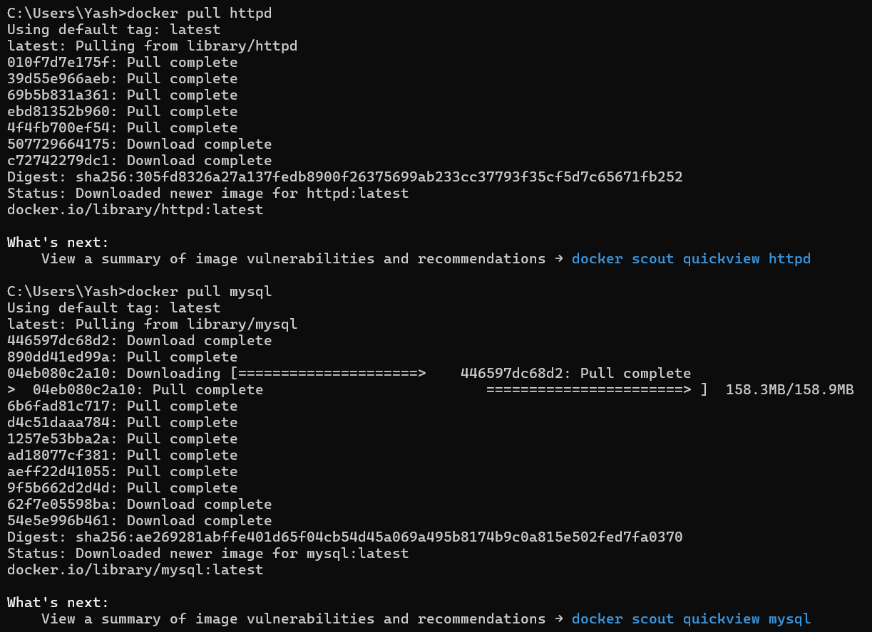
httpd and mysql images pulled successfully from Docker Hub.

Task 3 — Create and Run the Apache Container
Created the Apache container in detached mode, with a meaningful name, port mapping 8080→80, and the project folder mounted directly into Apache's document root so it serves the portfolio files.
docker run -d --name portfolio-apache -p 8080:80 -v
"${PWD}:/usr/local/apache2/htdocs/" httpd
portfolio-apache container started successfully.

Task 4 — Create and Run the MySQL Container
Created the MySQL container in detached mode with the root password configured via an environment variable.
docker run -d --name portfolio-mysql -e MYSQL_ROOT_PASSWORD=YourStrongPassword123
mysql

Task 5 — Deploy the Personal Portfolio Website
With the project folder mounted as Apache's document root, the site is served directly — no separate copy step required. Verified in the browser:
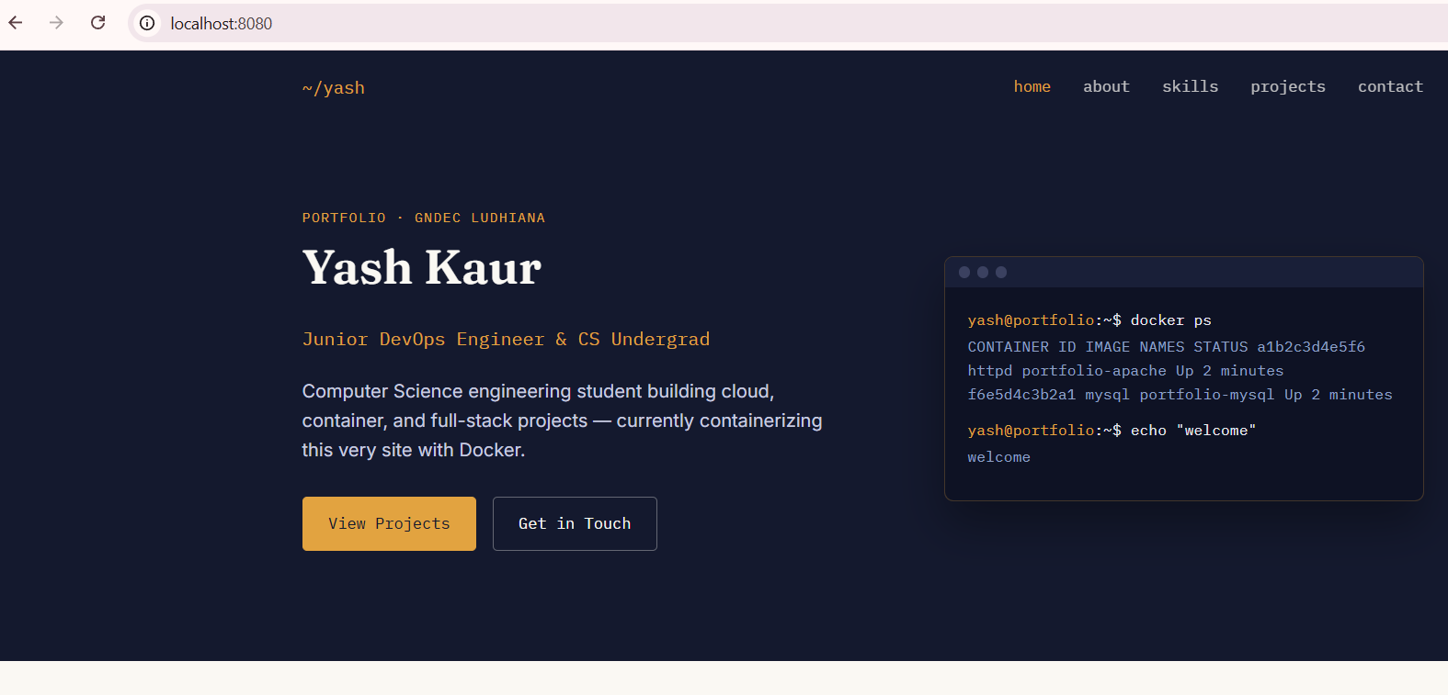
Personal portfolio website served live from the Apache container at localhost:8080.

Task 6 — Verify Both Containers
Used docker ps to confirm running containers, their images, port mappings, and container names.
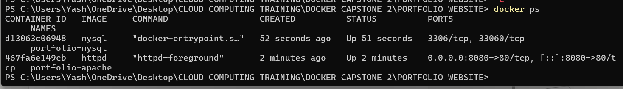
Both portfolio-apache and portfolio-mysql containers confirmed running.

Task 7 — Access the Apache Container
Entered the Apache container with docker exec -it portfolio-apache bash and verified the website files were present in the document root and that the DocumentRoot directive pointed to the correct path.
docker exec -it portfolio-apache bash
ls /usr/local/apache2/htdocs/
cat /usr/local/apache2/conf/httpd.conf | grep DocumentRoot
Output confirmed all site files (index.html, about.html, projects.html, contact.html, skills.html, css/, js/, images/) were visible inside the container, and DocumentRoot resolved to /usr/local/apache2/htdocs.
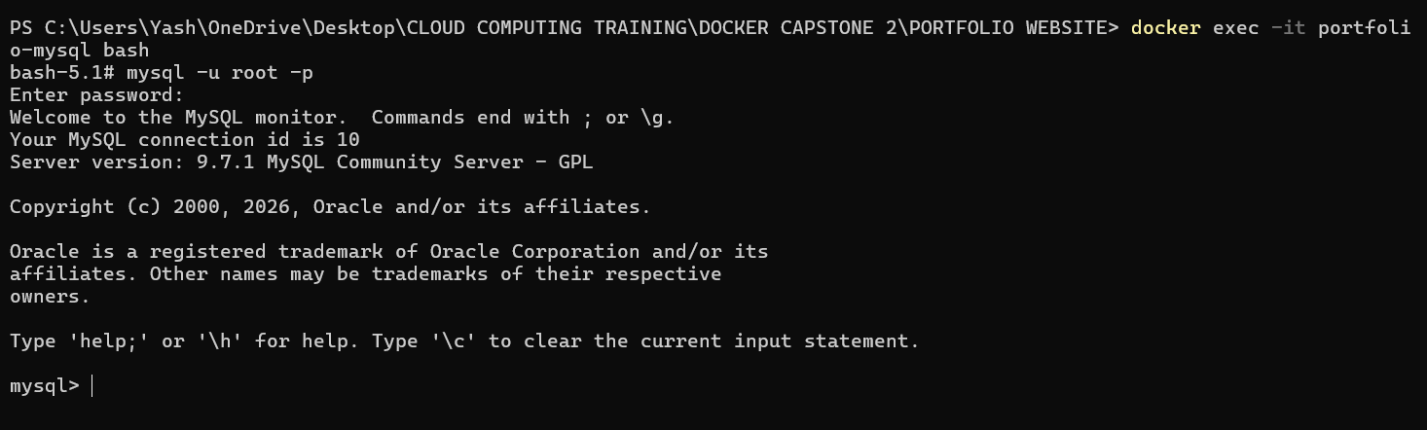
Apache container filesystem check — document root and site files confirmed.
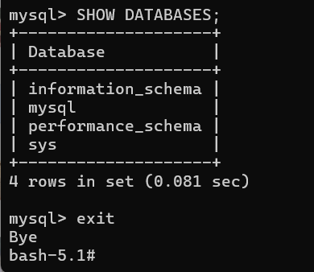
MySQL container shell accessed successfully.

Task 8 — Access the MySQL Container
Entered the MySQL container, logged in with the configured root password, and listed the available databases.
docker exec -it portfolio-mysql bash
mysql -u root -p
SHOW DATABASES;
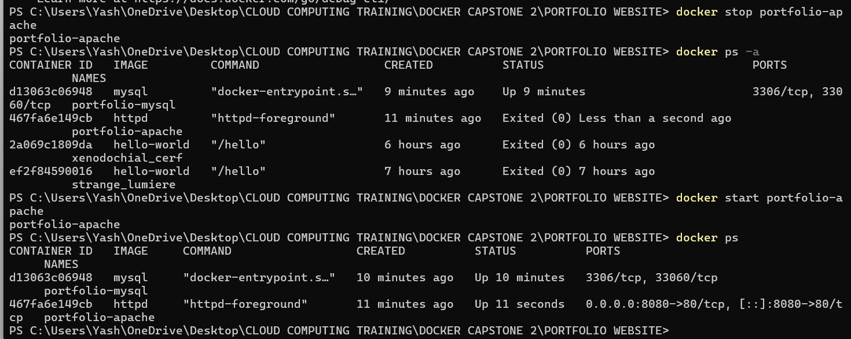
SHOW DATABASES output — default MySQL system databases confirmed.

Task 9 — Demonstrate Container Management
Stopped and restarted both containers independently, confirming each returns to a healthy running state without affecting the other, and that the website remains reachable afterward.
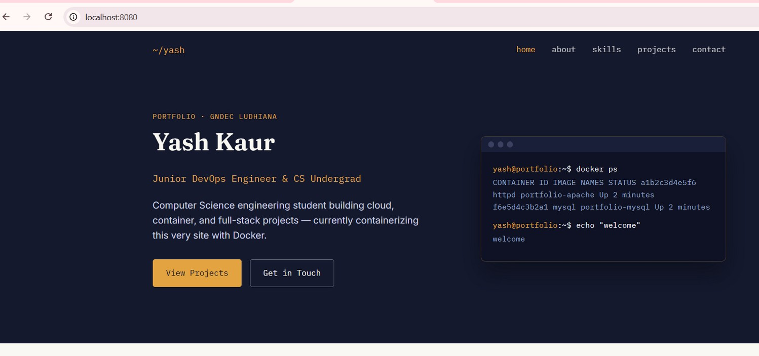
Apache container stopped and restarted — status confirmed via docker ps -a and docker ps.
Website reachable again after restarting the Apache container:
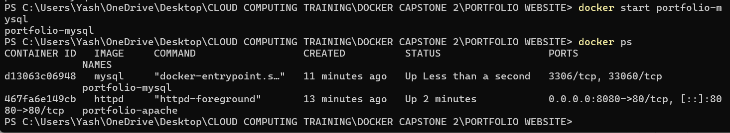
Portfolio website reachable again after the Apache container restart.
MySQL container stopped and restarted independently:
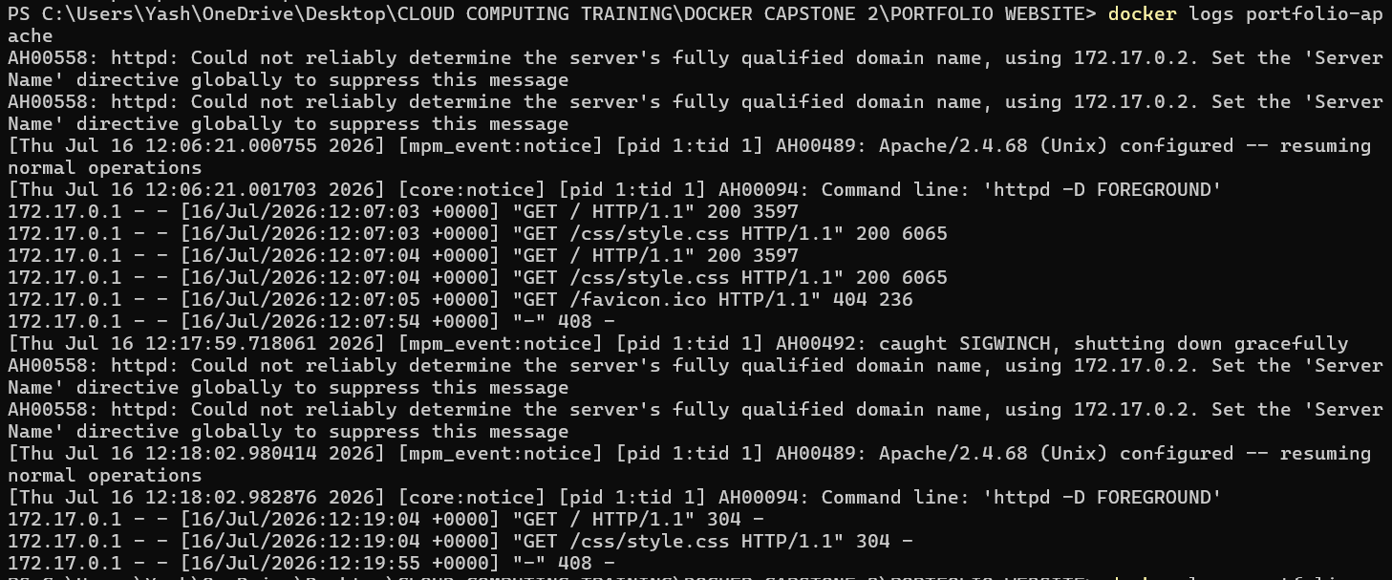
MySQL container restarted independently without affecting the Apache container.
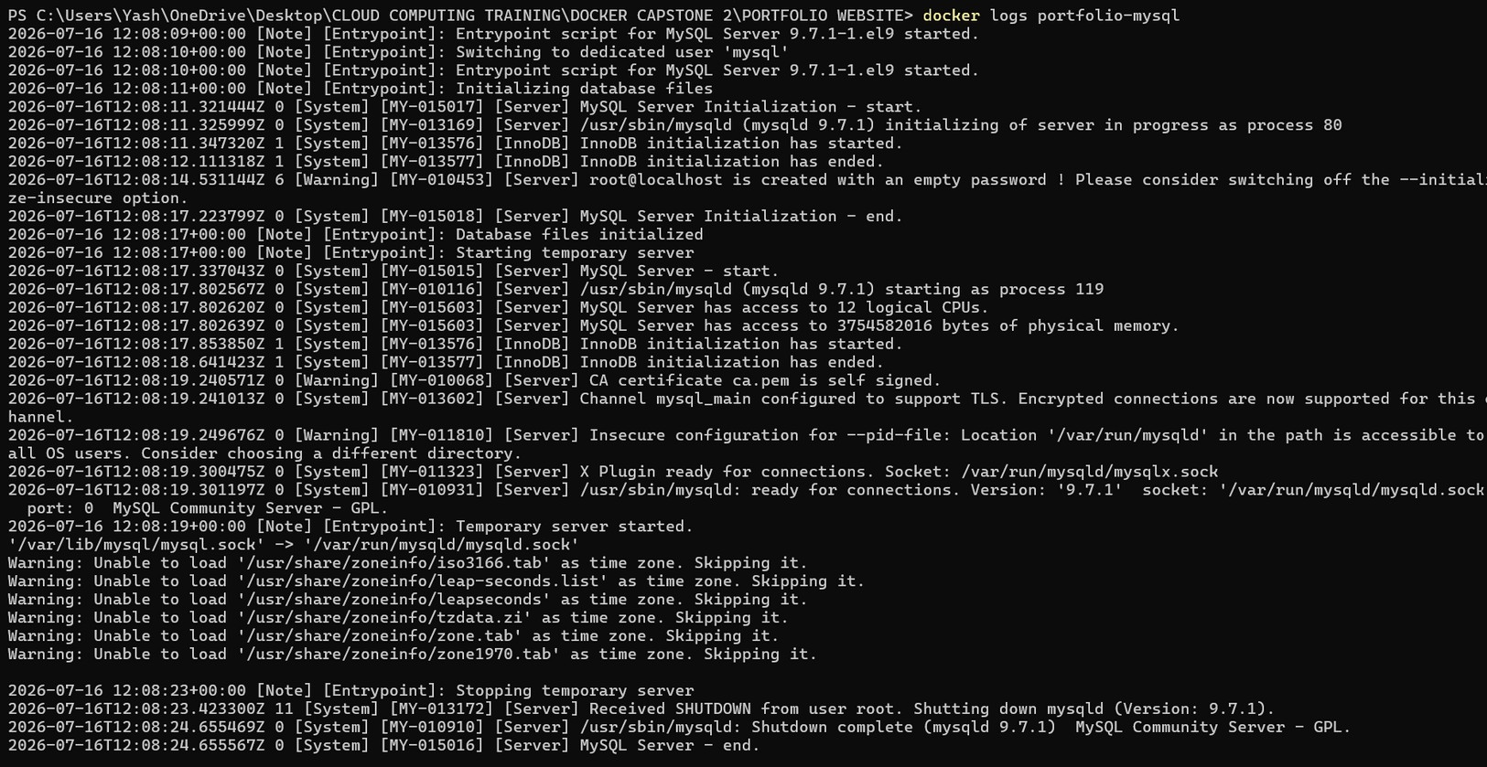
Both containers confirmed healthy and running after independent restarts.

Task 10 — Display Docker Logs
Apache log — shows the httpd startup sequence and every HTTP request made to the site (GET requests for the homepage and stylesheet, response codes), useful for confirming the site is being served and for debugging.
docker logs portfolio-apache
MySQL log — shows the database server's initialization sequence, InnoDB startup, the point at which it becomes ready to accept connections, and the shutdown sequence during container restarts.
docker logs portfolio-mysql

4. Conclusion
Containerizing the portfolio website separated the web server and database into independent, isolated environments without installing either directly on the host operating system. Each service could be stopped, restarted, and inspected on its own without affecting the other, and the entire environment is reproducible on any machine with Docker installed. This mirrors how real-world DevOps teams isolate and manage multi-service applications, and lays the foundation for automating both services together with Docker Compose in the next module.

