MINI PROJECT
BUILD YOUR OWN WEBSITE USING DOCKER
(APACHE + MYSQL + HTML + CSS + JAVASCRIPT — CONTAINERIZED)
SUBMITTED AS PART OF THE
MASTER CLASS PROGRAM ON CLOUD COMPUTING AND DEVOPS
Submitted By:
Yashdeep Kaur (2302711)
Computer Science and Engineering
DEPARTMENT OF COMPUTER SCIENCE AND ENGINEERING
GURU NANAK DEV ENGINEERING COLLEGE
LUDHIANA, 141006
Submission Date: 20-07-2026

1. Project Objective
The objective of this mini project is to build a simple student registration website and deploy it using Docker containers. One container runs Apache with PHP to serve the website and handle server-side logic, and a second container runs MySQL to store the data submitted through the registration form. Docker Compose is used to build, run, and connect the two containers, giving practical, hands-on experience with containerized web application deployment.
- HTML / CSS / JavaScript — builds the front-end (what the user sees and interacts with)
- Apache — serves the website files to the browser
- PHP — bridges the browser and the database (MySQL cannot be reached directly from client-side JavaScript)
- MySQL — stores the data submitted by users through the form
- Docker — packages Apache+PHP and MySQL into containers so the project runs identically on any machine

2. Tools and Technologies Used
Component | Role | Docker Image Used
Apache | Web server (serves the site) | php:apache (Apache + PHP combined)
MySQL | Database (stores form data) | mysql:8.0
HTML / CSS / JS | Front-end of the website | Custom project files
PHP | Connects website to MySQL | Included in php:apache image
Docker Compose | Runs both containers together | Built into Docker Desktop

3. Project Folder Structure
my-website-project/
├── docker-compose.yml
├── apache-php/
│ └── Dockerfile
└── website/
├── index.html
├── style.css
├── script.js
├── db.php
└── submit.php

4. Implementation

4.1 Dockerfile (apache-php/Dockerfile)
Builds a custom Apache+PHP image with the mysqli extension enabled so PHP can talk to MySQL.
FROM php:apache
RUN docker-php-ext-install mysqli
Note: the website folder is not COPYed into the image. Instead it is mounted live via a volume in docker-compose.yml, so changes to the site files are reflected immediately without rebuilding the image.

4.2 docker-compose.yml
Defines and links the two services — the Apache+PHP web server and the MySQL database — along with a named volume so database data survives container restarts.
version: "3.8"
services:
webserver:
build: ./apache-php
container_name: my-apache
ports:
- "8080:80"
volumes:
- ./website:/var/www/html
depends_on:
- database
database:
image: mysql:8.0
container_name: my-mysql
restart: always
environment:
MYSQL_ROOT_PASSWORD: root123
MYSQL_DATABASE: studentdb
MYSQL_USER: student
MYSQL_PASSWORD: student123
ports:
- "3306:3306"
volumes:
- db_data:/var/lib/mysql
volumes:
db_data:

4.3 Front-End Files
website/index.html — the registration form:
<form action="submit.php" method="POST">
<input type="text" name="name" placeholder="Full Name" required>
<input type="email" name="email" placeholder="Email Address" required>
<button type="submit">Register</button>
</form>
website/script.js — client-side validation so the form cannot be submitted with an empty name:
document.querySelector("form").addEventListener("submit", function (e) {
const name = document.querySelector("input[name='name']").value;
if (name.trim() === "") {
alert("Name cannot be empty!");
e.preventDefault();
}
});
website/style.css applies custom styling (card layout, colored button, hover state) so the page does not look like a default unstyled browser form.

4.4 Connecting PHP to MySQL
website/db.php — the database connection file. Note that the host is set to "database", the service name defined in docker-compose.yml, not localhost, since containers communicate with each other by service name:
<?php
$host = "database";
$user = "student";
$password = "student123";
$dbname = "studentdb";
$conn = new mysqli($host, $user, $password, $dbname);
if ($conn->connect_error) {
die("Connection failed: " . $conn->connect_error);
}
?>
website/submit.php — handles the form submission and inserts the data using a prepared statement (safer than directly concatenating form input into the SQL string):
<?php
include 'db.php';
$name = $_POST['name'];
$email = $_POST['email'];
$stmt = $conn->prepare("INSERT INTO students (name, email) VALUES (?, ?)");
$stmt->bind_param("ss", $name, $email);
if ($stmt->execute()) {
echo "Registration successful!";
} else {
echo "Error: " . $stmt->error;
}
$stmt->close();
$conn->close();
?>

4.5 Building and Running
From inside the my-website-project folder:
docker compose up -d --build
This builds the Apache+PHP image from the Dockerfile, pulls the MySQL 8.0 image, creates the network and volume, and starts both containers in the background.
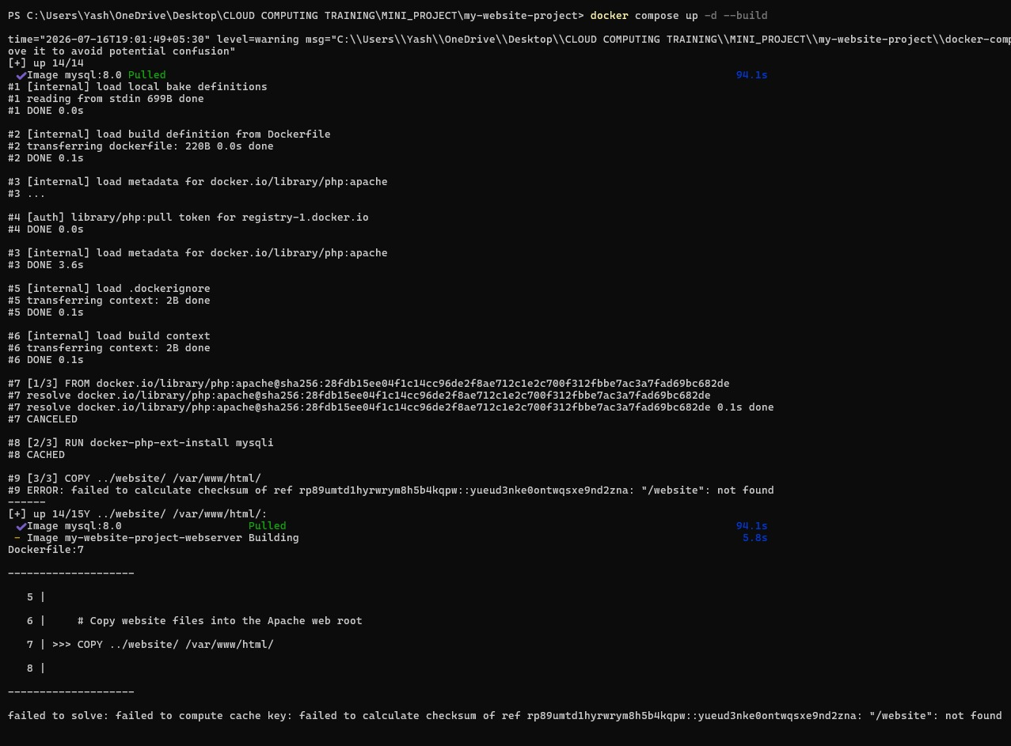
Figure 1: docker compose up -d --build completing successfully — both images built/pulled and both containers started

4.6 Creating the Database Table
Since the MySQL container starts with an empty database, the students table is created manually the first time, using the MySQL shell inside the container:
docker exec -it my-mysql mysql -u root -p
USE studentdb;
CREATE TABLE students (
id INT AUTO_INCREMENT PRIMARY KEY,
name VARCHAR(100),
email VARCHAR(100)
);
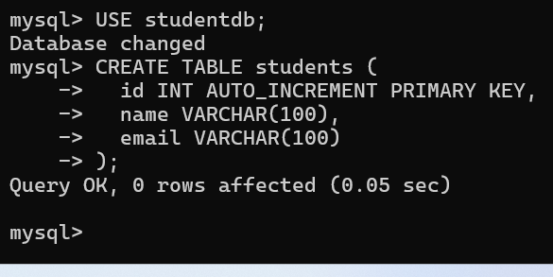
Figure 2: students table created successfully inside the my-mysql container

5. Output and Testing
The website was opened at http://localhost:8080, showing the styled registration form:

Figure 3: Student Registration form running at http://localhost:8080
A test entry was submitted through the form:

Figure 4: Successful form submission — confirmation message returned by submit.php
The data was then verified directly inside the MySQL container:
docker exec -it my-mysql mysql -u root -p
USE studentdb;
SELECT * FROM students;
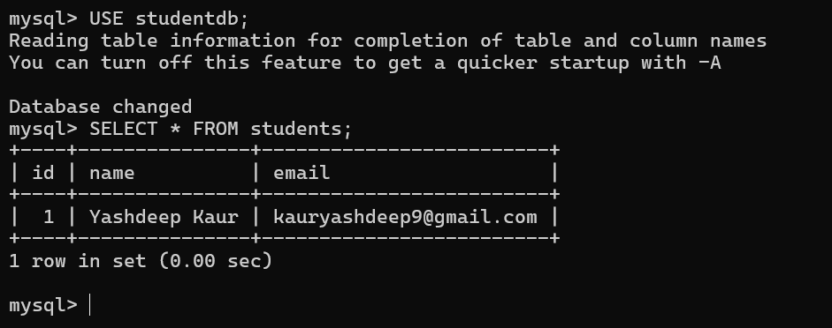
Figure 5: SELECT * FROM students — confirms the submitted record was inserted correctly

6. Guidelines Checklist
- Website loads correctly at http://localhost:8080 — Done
- At least one HTML form that collects user input — Done (name, email)
- CSS applied for reasonable visual styling — Done (card layout, custom colors, hover states)
- At least one JavaScript feature — Done (empty-name validation before submit)
- Form data successfully inserted into MySQL via PHP — Done
- Data verified inside the MySQL container using SELECT — Done
- docker-compose.yml with two services (web server + database) — Done
- Volumes used so database data is not lost on restart — Done (db_data volume)
- Custom Dockerfile used for the Apache+PHP image — Done
- Website files mounted properly into the container — Done (volume mount, not COPY)

7. Conclusion
This mini project provided hands-on experience with containerized web application deployment. It demonstrated how a front-end (HTML/CSS/JS), a server-side language (PHP), a web server (Apache), and a database (MySQL) can be packaged into separate Docker containers and connected using Docker Compose. Key concepts reinforced include inter-container communication using service names instead of localhost, persisting database state using named volumes, and the standard workflow of building custom images, running multi-container applications, and verifying data end-to-end from the browser down to the database.

