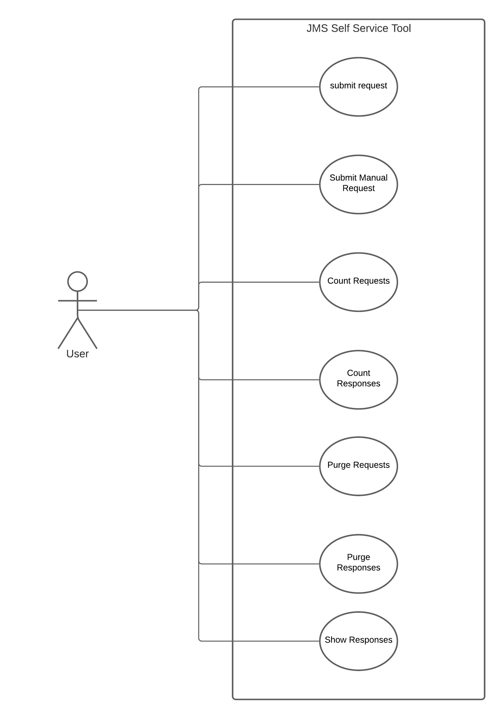
ID | UC_001
User Case: | Submit Request
Actor: | User
Type: | Primary and essential
Description: | User can enter the contract details, select the cycle switches and submit this information to the request queue of the selected environment.

ID | UC_002
User Case: | Submit Manual Request
Actor: | User
Type: | Primary and essential
Description: | User can enter XML message as request message and submit to the request queue of the selected environment.

ID | UC_003
User Case: | Count Requests
Actor: | User
Type: | secondary
Description: | Count of the Requests in the request queue of the selected environment will be displayed

ID | UC_004
User Case: | Count Responses
Actor: | User
Type: | Secondary
Description: | Count of the Responses in the response queue of the selected environment will be displayed

ID | UC_005
User Case: | Purge Requests
Actor: | User
Type: | Secondary
Description: | Clear all the requests from the request queue of the selected env

ID | UC_006
User Case: | Purge Responses
Actor: | User
Type: | Secondary
Description: | Clear all the Responses from the response queue of the selected environment

ID | UC_007
User Case: | Show Responses
Actor: | User
Type: | Secondary
Description: | Table of all the responses present in the response queue for that particular environment will be displayed.

