**Double integrals: Change of Variables**





- Jacobian : functional determinant

**Double integral in polar coordinates**

The change of variable formula can be used to evaluate double integrals in polar coordinates

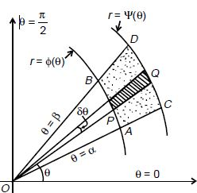 





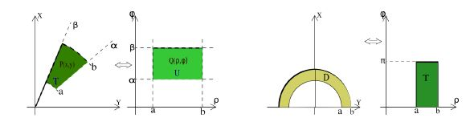

**Applications of double integrals in Geometry**

**The area of the domain**  **is given by:**

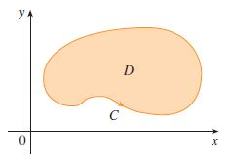 

**The surface area** **of the surface** erected on the domainis 

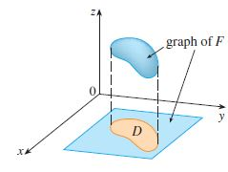

**The volume of the solid** under the surface and above the domain domainis given by:



**Example 0:** Find area of the region bounded by the following curves: 

**Solution**

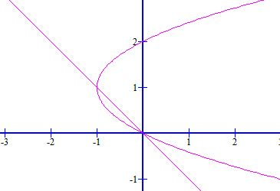



**Example1** Evaluate  , where D is a domain governed by 

**Solution**

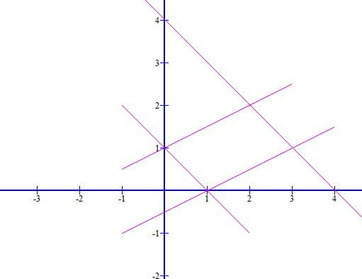 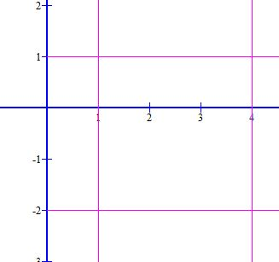

 



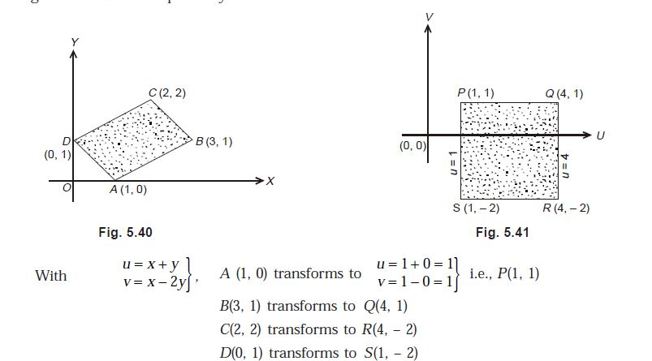

 

 





**Example 2:**

Using changing to polar coordinates, evaluate, when (D) is the unit upper semi-disk governed by: 

**SOLUTION**

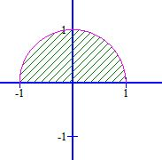 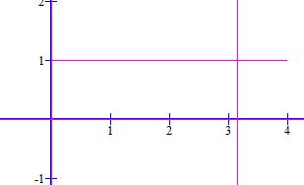 Semi-Disk   Rectangle

 

**Example 3:** Evaluate ,(D) is the region between the two circles

**Solution**

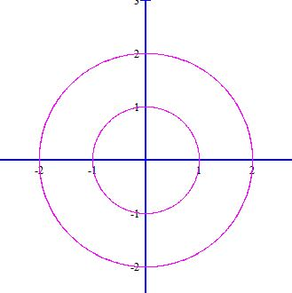 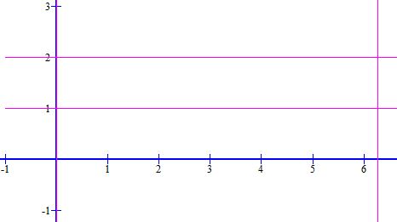

  



**Example4:** Find the volume of the solid bounded by the plane and the paraboloid 

**Solution:**The plane intersects the paraboloid in the circle: . This solid lies under the paraboloid and above the disk the 

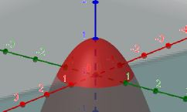 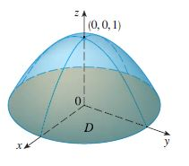

In polar coordinates

Since, the volume is



**Example5:** Find the area of the part of the paraboloid that lies under the plane  .

**Solution**

The plane intersects the paraboloid in the circle.

Therefore the given surface lies above the disk

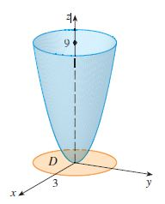

Using formula:

, we get



Using polar coordinates: 



**Example6:** Find the surface area and volume of the sphere **:** 

**Solution:**

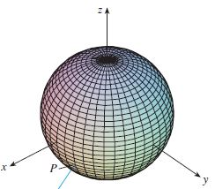

The equation of the upper hemisphere is given by:

It lies above the disk**:** 

Using polar coordinates: 

Therefore, the surface area of the sphere is given by:

The volume of the sphere is given by



**Assignment:**

1.Evaluate: , (D) : **Hint**: 

2.Evaluate: , where (D) :

**Hint**: 