

Research Project Proposal

Topic: MeetUp System

**FACULTY**: Information Technology

**DEPARTMENT**: Software Engineering

Prepared by:

**Names** : MUHORAKEYE Bella Amandine

**Id** : #20803

**Phone** : 0781921606

**Email** : bellamandy45@gmail.com

*Done at Kigali, On 27th January, 2020*

# **Background of the study**

It is quite difficult, in this society, to know and meet a group of people with whom we share the same passion in order to be able to exchange ideas or learn new things together. For example, a person passionate about writing or debating often needs other people passionate about the same thing or need to attend events that would allow him/her to increase his knowledge in this field (in writing or debating).

It is true that sometimes there are workshop or events organized by a group of people to be able to share ideas, learn together and at the same time make connections with people in your field. But the problem is that announcing these events is done via WhatsApp, Facebook, or word of mouth which decreases the chance for some to be aware of it in time and to be able to participate to those events.

# **Project Objectives**

## **General Objective**

The general objective of **MeetUp System** is to develop a web application that will allow people to find other groups of like-minded people in a local area and to be aware of upcoming events on time.

## **Specific Objectives**

Below are specific objectives of the system:

* Help someone to find easily other like-minded people.
* Facilitate people to organize meetings with other people with whom they can share or learn something new.
* To help like-minded people to build something that can be useful
* To help people to put in practice their ideas with other people with whom they share the same passion.
* Contribute to the easy awareness of upcoming meetings in the chosen field.
* To give a chance to a person who has the talent in any field to be able to meet people who have the same talent and be able to develop it together.

# **Problem Statement**

* Wasting talent

There are people who miss a place where they could put their talents into practice and therefore these talents will never be exploited.

* Avoid a lot of free time to young people

Nowadays, due to the fact that it is difficult to find a job after studies, it becomes a problem because many youth spent a lot of time home doing nothing that can improve them or even worse there is a chance that some of them end up ruining their life.

* Lack of awareness of interesting meetings

There are people who would have a lot to share or learn but just miss the opportunity to do so.

# **Proposed Solution**

After analyzing the problem of the current system, the new system proposed following solution:

In the new proposed system:

* There will be an option of creating meetings/event in a specific category/field.
* There will be an option of joining other people.
* There will an option of searching an upcoming event in any field of your choice.
* There will be an option of creating group in any field you are interested in (if not exist) in order to find other people who are interested in the same field and be able to share, to do, or to learn something together.
* All registered users will get an email notifying that a new group has been created.
* There will be an option of searching groups according to your sector.

# **Main Module of the new System**

|  |  |  |
| --- | --- | --- |
| **Input** | **Processes** | **Output** |
| User creates accounts by providing his profile | The application process the request, save the information | Notify if it is all saved or fail to save |
| User login into a system | The application process the request. By checking | Notify if username and password are correct or failed. |
| User create groups | The application process the request from the user | Notify if it is success or failure. |
| User search and select a chosen group | The application process the request from the user | All the information of the chosen group is displayed to the user. |
| User logout in the system | The application process the request, | Notify that you logged out |

# **Requirements**

## **Functional Requirement**

* The system should allow new user to create a new account.
* The system should allow registered user to create a group.
* The system should allow the author of the group to schedule a meeting.
* The system should allow the author of the group to update the meeting schedule.
* The system should notify all registered users about a new group created.
* The system should display all registered groups.
* The system should allow users to view and select a specific group of his/her choice.
* The system should allow users to join an event of his/her interest.
* The system should allow users to search for a group or an event according to a specified sector.
* The system should allow users to search for a group or an event according to the number of people/members who will attend.

## **Non Functional Requirements**

* **Maintainability:**
  + - The system must be easy to maintain when needed
* **Security:**
  + - The system must be able to hide the users sensitive information
    - The password of user must be made of at least 8 characters
    - The system must encrypt user password
    - A user has to login to perform any useful action
* **Operational:**
  + - The system should be able to run on any OS.
* **User friendly:**
  + - The System must be user friendly
    - The system must be easy for a user to use.
* **Privacy:**
  + - The system shall be able to protect the users privacy
* **Availability:**
  + - The system shall have high availability
    - The system shall not have unexpected downtime
    - The system shall have downtime at most 5 hours/month
* **Performance:**
* The system must perform user request within 10 sec.
* The system shouldn’t exceed 20 sec in case of downtime.
* The system must be running 24 hours.
* **Accessibility:**
* The system must be accessible via laptop or any mobile device
* The system must be accessible by authorized user

# **Technologies and Tools**

**Operating System**: Windows (or Ubuntu)

**Programming Languages**: HTML, CSS, JAVA

**DBMS**: MySQL

**Text Editor**: VsCode, Netbeans

**Tools and Designing model**: Enterprise Architecture, Visual Paradigm

# **Work Breakdown Structure**

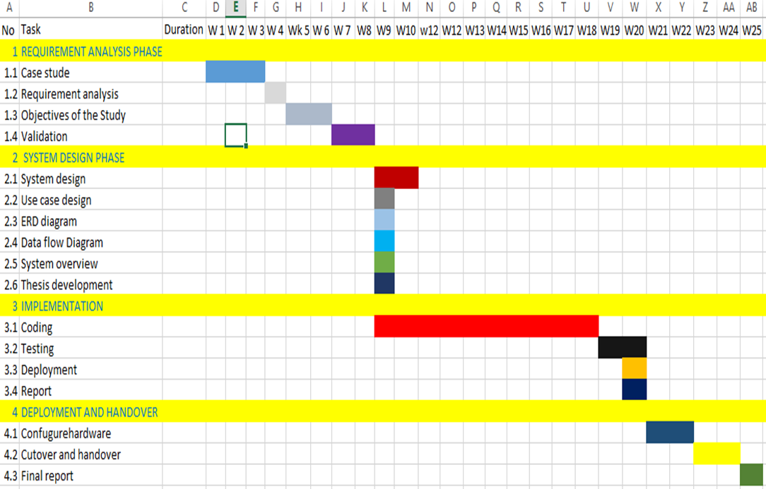

# **Project Plan**

|  |  |  |  |  |  |  |  |
| --- | --- | --- | --- | --- | --- | --- | --- |
| Task Id | Task Names | | Duration | | Status | | |
|  | | | | | | | |
| 1. Requirement Analysis 1.5 months | | | | | | | |
| 1.1 | Analysis Existing System | | 1 Week | | | Open | |
| 1.2 | Description of the Existing System | | 1 Week | | | Open | |
| 1.3 | Analysis a new System | | 1 Week and half | | | Open | |
| 1.4 | Determine project requirement | | 4 Days | | | Open | |
| 1.5 | Meet a Supervisor | | 1 Week | | | Open | |
| 1. System Design 1 month | | | | | | | |
|  | | | | | | | |
| 2.1 | Architecture | | 1 Week | | | Open | |
| 2.2 | Database Design | | 1 Week | | | Open | |
| 2.3 | UI design/ Program Design | | 1 Week | | | Open | |
| 2.4 | Meet a Supervisor | | 1 Week | | | Open | |
|  | | | | | | | |
| 1. System Implementation 1.5 months | | | | | | | |
| 3.1 | Coding | | 3 Weeks | | | Open | |
| 3.2 | Testing | | 1 Week | | | Open | |
| 3.3 | Execution | | 1 Week | | | Open | |
| 3.4 | Meet a Supervisor | | 1 Week | | | Open | |
| 4. Deployment 2 Weeks | | | | | | | |
| 4.1 | | Final report | | 1 Weeks | | | Open |
| 4.2 | | Writing report | | 4 Weeks | | | Open |
| 4.3 | | Meet a Supervisor | | 2 Weeks | | | Open |