INGENII Telecom Agentic
Synthetic Data Generator
High-Level Design (HLD)
Code-aligned architecture with complete implemented API reference
High-level design of the currently implemented backend. The service combines FastAPI, MongoDB, machine-readable telecom standards, deterministic schema compilation, Gemini-based scenario intent interpretation, HITL approval, and deterministic record generation/validation.
Document purpose: design review, implementation walkthrough, API reference, data-flow reference, and production hardening baseline.

Document Structure
- 1. Architecture Principles
- 2. System Context
- 3. Deployment View
- 4. Component View
- 5. Official Standards Ingestion & Registry
- 6. Agentic Scenario Proposal
- 7. HITL Confirmation / Scenario Activation
- 8. Generation Architecture
- 9. Low Balance & Top-up — Source-Locked Architecture
- 10. Implemented API Surface
- 11. MongoDB Logical Data Model
- 12. Caching & Runtime State
- 13. Errors, Health & Observability
- 14. Security & Current Production Gaps
- 15. Scalability & Performance Model
- 16. Traceability & Data Lineage
- 17. End-to-End Reference Flow
- 18. Key Source Files
- Appendix A. Full API Reference (endpoint details in left/right two-column layout)
Architecture diagrams are embedded as rendered images in this Word document. The companion HTML retains interactive Mermaid diagrams and the sticky right-side API reference.

Primary source-of-truth rule: once a scenario is confirmed, its persisted executable variables and metadata are the generation contract. Agentic generation does not send the confirmed schema back to the LLM for reinterpretation.

1. Architecture Principles

Standards-first semantics
TM Forum, MEF and 3GPP machine-readable artifacts supply telecom entity/field meaning, constraints, relationships and provenance.

Policy is separate
telecom_official_generation_v2.json overlays sampling behavior; it is not treated as an official standards definition.

LLM is constrained
Gemini creates scenario intent. Executable schema fields are resolved and compiled against the trusted runtime registry.

HITL is the approval boundary
/scenario/confirm converts a proposal/import draft into the active persisted scenario used by generation.

Generation is deterministic after approval
Agentic scenarios use the confirmed schema directly. Legacy/CSV scenarios retain a LangGraph orchestrated path.

Validation is fail-closed
Type, dependency, formula, temporal and domain-specific checks run before records are accepted by the response contract.

2. System Context
Figure 1. Rendered architecture diagram
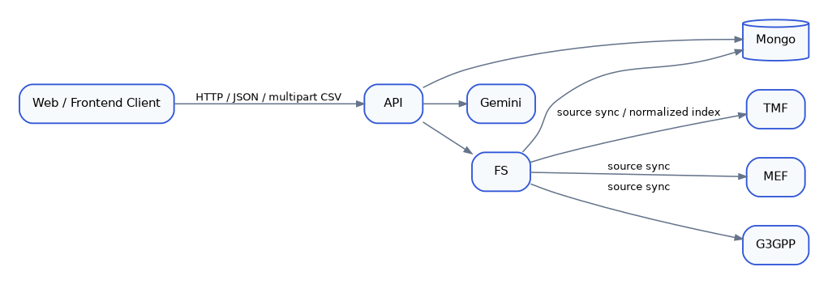

3. Deployment View
Figure 2. Rendered architecture diagram
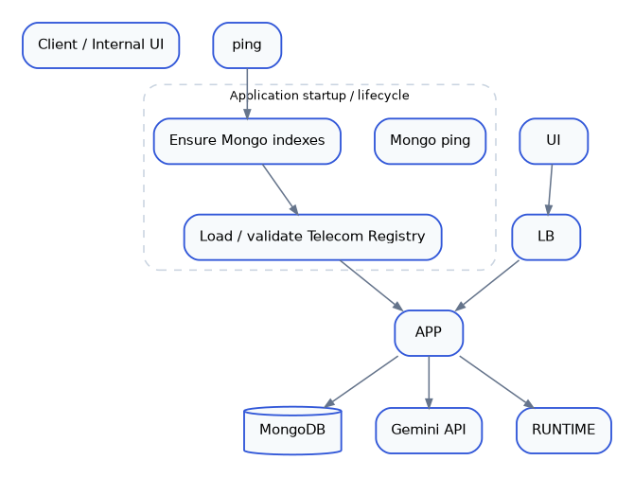
Current deployment posture: runtime caches are process-local and WEB_CONCURRENCY=1 is the example default. Multi-worker / multi-pod deployment should add shared cache/versioning or make persisted scenario versioning the cache invalidation source.

4. Component View
Figure 3. Rendered architecture diagram
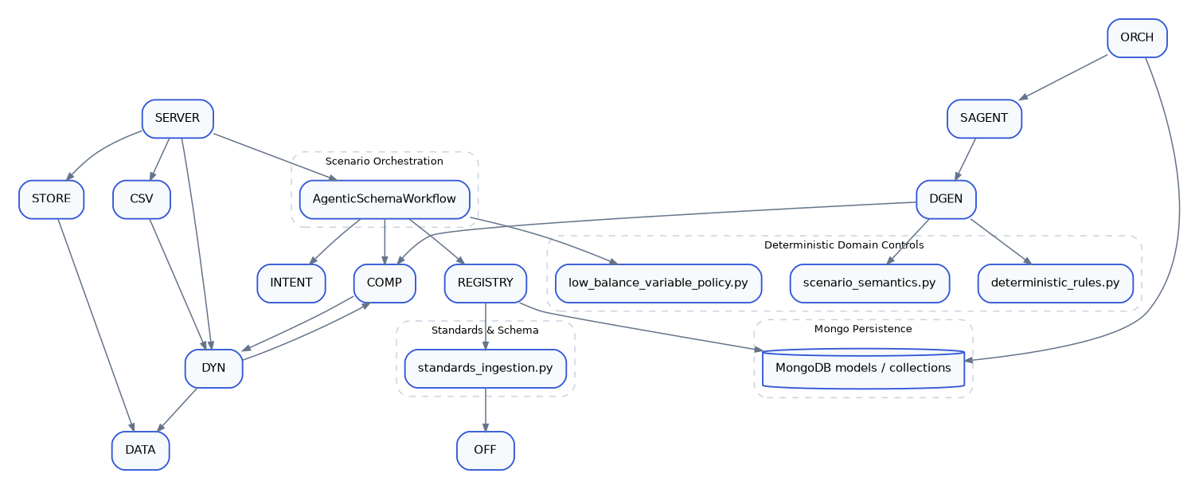

5. Official Standards Ingestion & Registry
Figure 4. Rendered architecture diagram
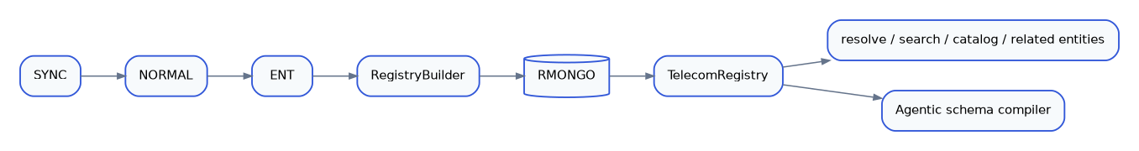

TM Forum
Current manifest includes TMF654 Prepay Balance, TMF629 Customer, TMF666 Account, TMF637 Product Inventory, TMF677 Usage Consumption, TMF676 Payment Management and TMF620 Product Catalog artifacts.

MEF
MEF 125 Subscriber Ethernet and MEF 139 Internet Access product schemas are pinned to Git commits.

3GPP
3GPP TS 32.298 Release 19, v19.4.0 is ingested from the machine-readable ASN.1 package.
The runtime normalized directory is an indexed/cache representation. Source lineage remains attached to registry entities and standards metadata.

6. Agentic Scenario Proposal
Figure 5. Rendered architecture diagram
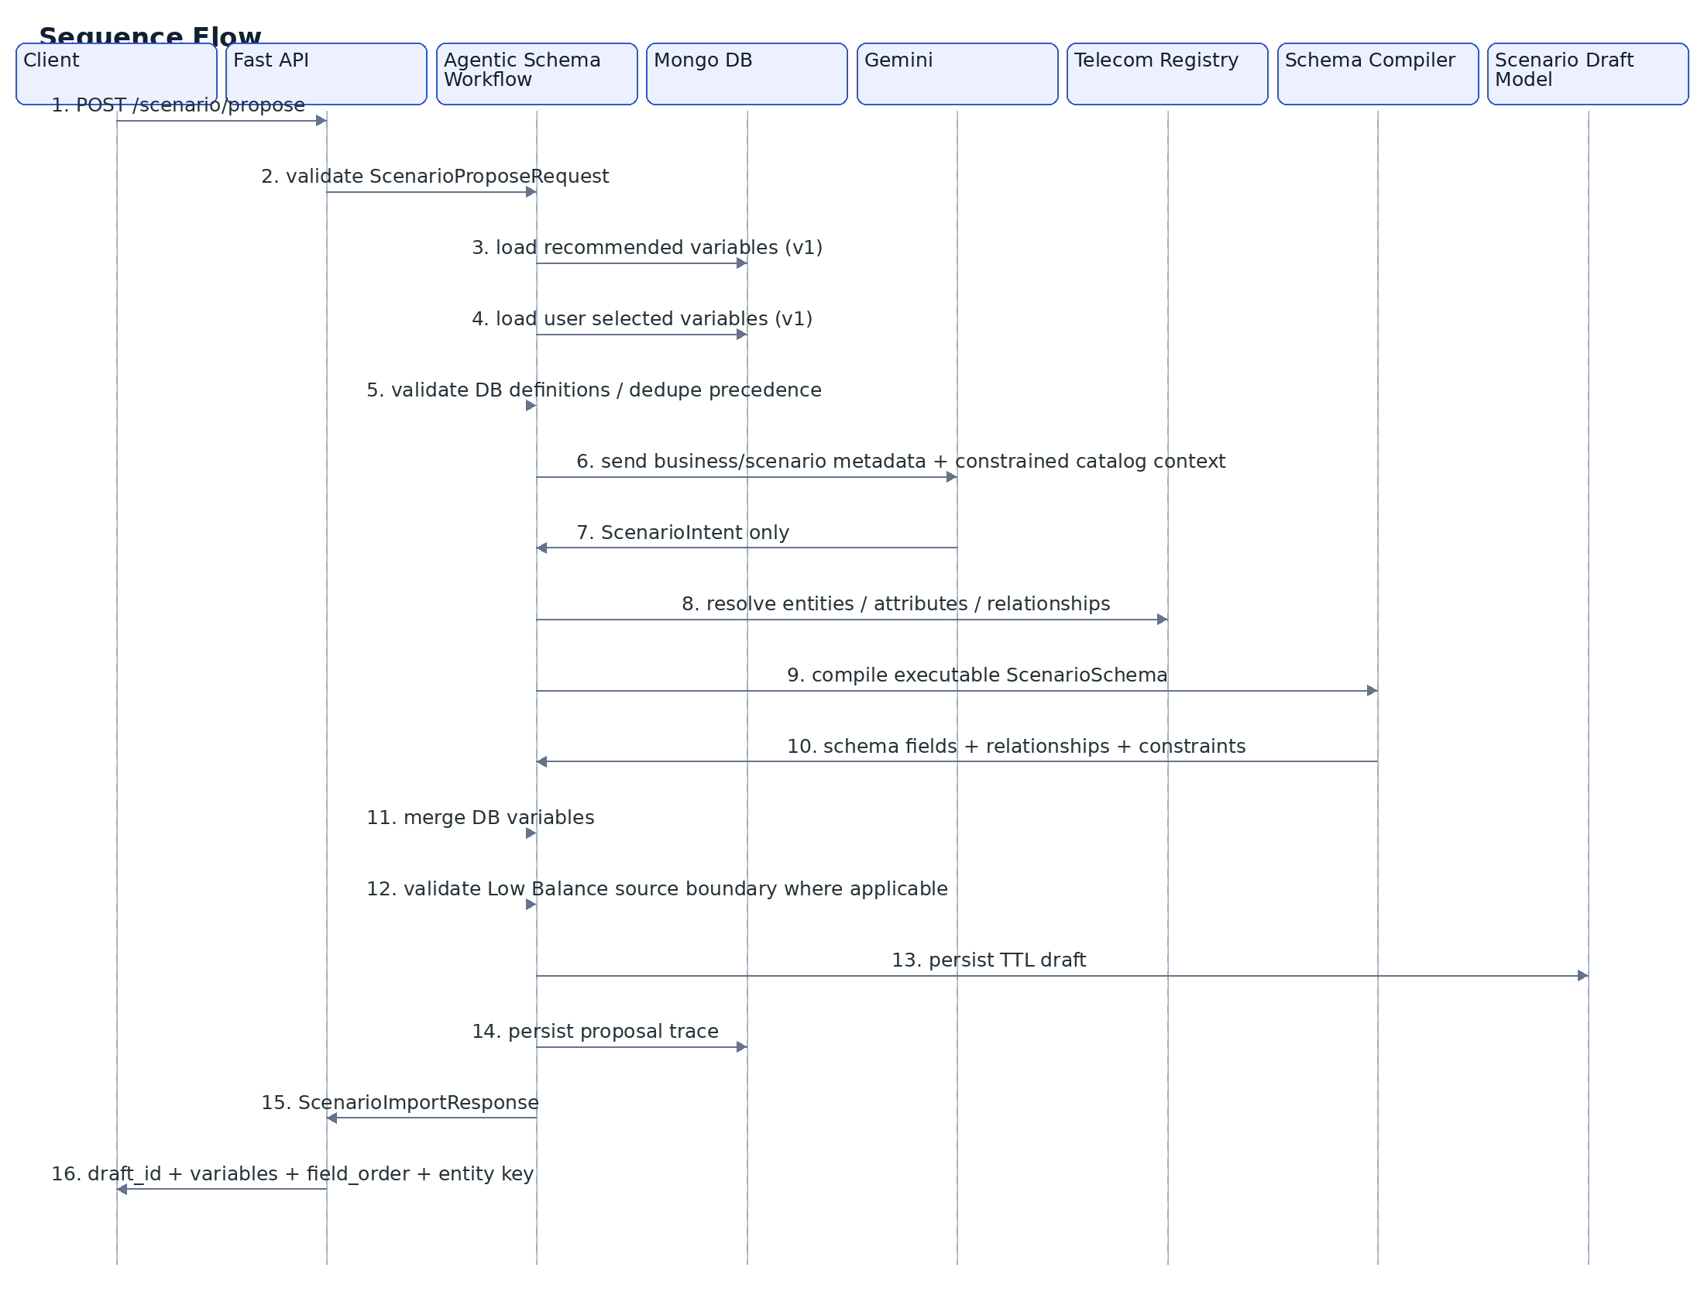

LLM contract
Gemini is typed to ScenarioIntent. It can propose semantic variable ideas, requested entities/relationships, scenario metadata and related intent, but executable telecom fields are resolved by the backend.

Proposal cache
The agentic proposal cache key includes normalized request values, a deterministic hash of Mongo variable definitions and an official source-manifest fingerprint. This reduces stale proposal reuse after source changes.

7. HITL Confirmation / Scenario Activation
Figure 6. Rendered architecture diagram
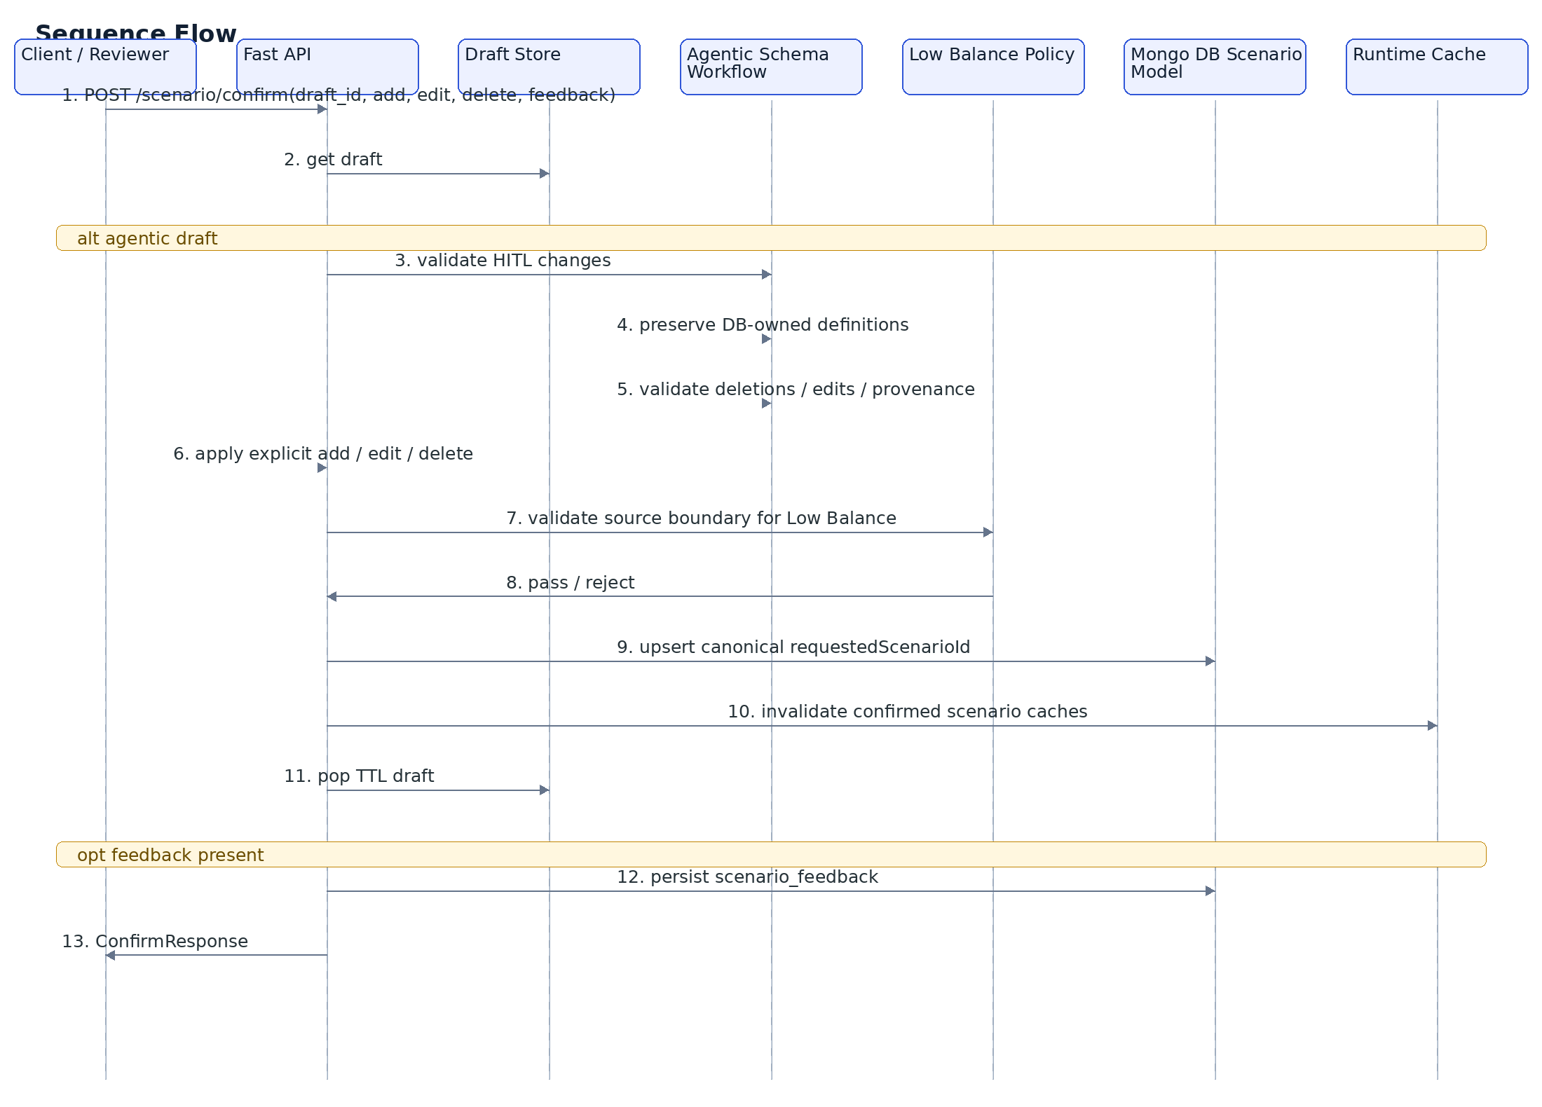
Canonical identifier: requestedScenarioId is the business identifier. Confirmed scenarios are stored using the same value for scenario_id and requested_scenario_id ; reconfirmation updates the active definition for that identifier.

8. Generation Architecture
Figure 7. Rendered architecture diagram
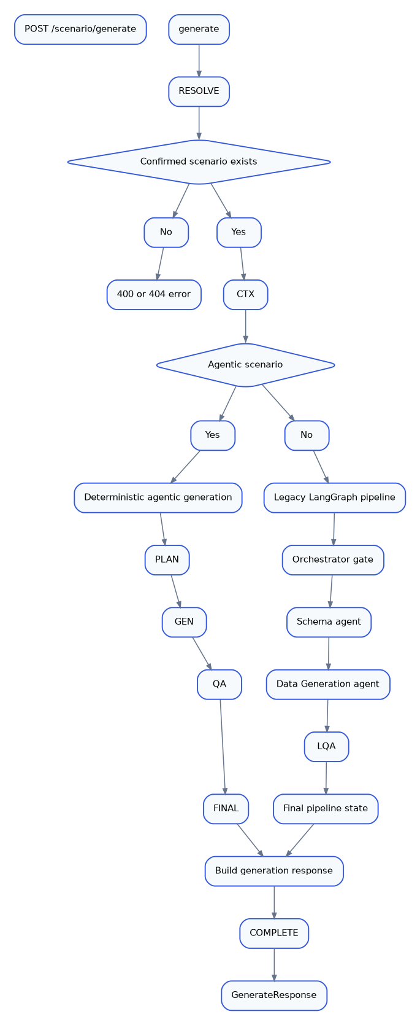

8.1 Transactional generation
Figure 8. Rendered architecture diagram
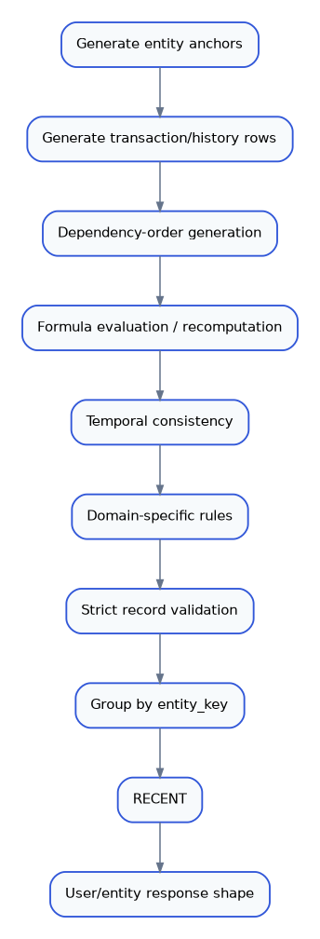

8.2 Aggregational generation
Figure 9. Rendered architecture diagram
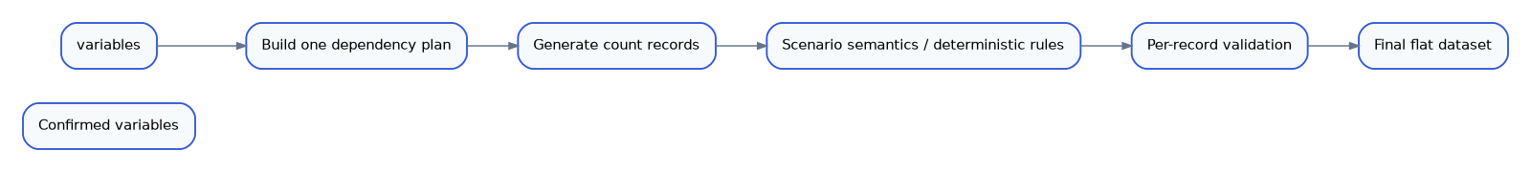

9. Low Balance & Top-up — Source-Locked Architecture
Figure 10. Rendered architecture diagram
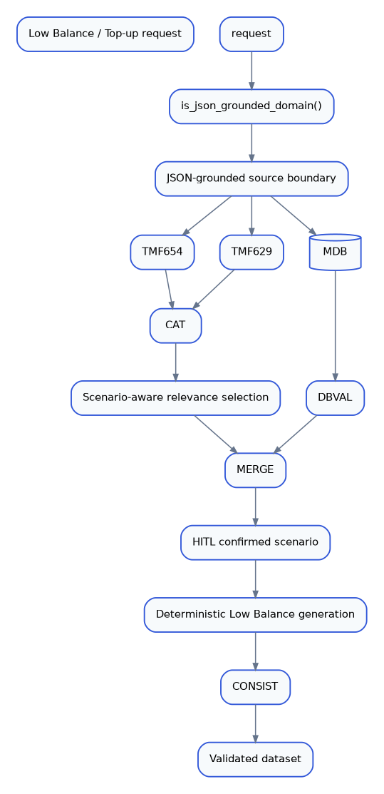
Implemented rule: Low Balance variable selection is restricted to bundled TMF654/TMF629 machine-readable sources plus validated MongoDB variables. CSV cannot introduce a third variable source for this domain.
Source | Allowed role | Boundary
TMF654 v4.0.0 | Official executable telecom fields | Exact scalar leaves selected from bundled Swagger/OpenAPI model.
TMF629 v4.0.0 | Official customer scalar fields | Exact scalar leaves selected from bundled Swagger/OpenAPI model.
MongoDB DB_RECOMMENDED | Application-authoritative variable definitions | Validated before merge; preserved as stored definition.
MongoDB USER_SELECTED | User-selected override | Overrides exact-name DB recommendation.
Gemini | Intent / semantic selection guidance | Cannot invent executable Low Balance variable names.

10. Implemented API Surface
Method | Endpoint | Implemented behavior | Primary persistence / dependency
GET | / | Liveness response. | None
GET | /health | Lightweight liveness response independent of external providers. | None
GET | /ready | Readiness based on Telecom Registry health. | MongoDB registry
POST | /scenario/variables/recommend | Persist scenario-level recommended variables for a scenario version. | scenario_variables
GET | /scenario/{requestedScenarioId}/variables/recommended | Read enabled recommended variables. | scenario_variables
POST | /scenario/variables/user | Persist user-selected / overridden variable definitions. | scenario_user_variables
GET | /scenario/{requestedScenarioId}/variables/user/{userId} | Read active user variables plus persisted selection records. | scenario_user_variables
PATCH | /scenario/{requestedScenarioId}/variables/user/{userId}/{variableKey} | Update one user variable definition; state becomes OVERRIDDEN . | scenario_user_variables
DELETE | /scenario/{requestedScenarioId}/variables/user/{userId}/{variableKey} | Mark user variable as deleted / inactive. | scenario_user_variables
POST | /scenario/import-csv | Parse CSV schema definition and create an explicit draft. Transactional imports require an entity key. Low Balance is rejected on this path. | scenario_drafts
POST | /scenario/confirm | HITL approval/edit boundary. Persists active confirmed scenario and invalidates runtime caches. | scenarios , optional scenario_feedback
POST | /scenario/propose | Agentic telecom scenario proposal using Gemini intent + official registry resolution + Mongo variable merge. | scenario_drafts , scenario_proposals , registry
POST | /scenario/generate | Synchronous dataset generation against confirmed scenario; supports transactional or aggregational modes. | Confirmed scenarios + registry/compiled schema

10.1 Main JSON contracts

POST /scenario/propose
{
"requestedScenarioId": "LB-01",
"scenarioType": "Low Balance & Top-up",
"industryType": "Telecom",
"domain": "prepaid",
"businessScenario": "...",
"typeOfData": "transactional",
"country": "IN",
"entityKey": "customer_id",
"useCase": "prepaid top-up",
"userId": "optional"
}

POST /scenario/confirm
{
"draft_id": "draft-...",
"add": [],
"edit": [],
"delete": [],
"feedback": "optional"
}

POST /scenario/generate
Alternatively a confirmed draftId may resolve the active requested scenario.
{
"requestedScenarioId": "LB-01",
"count": 35,
"recordsPerUser": 10
}

POST /scenario/variables/recommend
{
"requestedScenarioId": "LB-01",
"scenarioVersion": 1,
"variables": [{"name": "...", "dtype": "...", "gen": "..."}],
"userId": "optional"
}

ScenarioProposeRequest
requestedScenarioId, scenarioType, industryType, domain, businessScenario, typeOfData, country, optional entityKey, useCase, optional userId. Unknown JSON keys are rejected.

ConfirmRequest
draft_id plus optional add, edit and delete changes and optional feedback. Agentic drafts use the validated HITL boundary.

GenerateRequest
requestedScenarioId or confirmed draftId; count 1..5000; recordsPerUser 1..10.

ErrorResponse
All normalized API errors follow success=false and an error object containing stable code, human-readable message, optional details, and request_id.

10.2 Canonical JSON Models
Method | Endpoint | Request | Success | Errors
GET | / | Path / query / none | 200 | 500 only for unexpected server failures.
GET | /health | Path / query / none | 200 | 500 only for unexpected server failures.
GET | /ready | Path / query / none | 200 | 503: telecom standards registry is not ready
POST | /scenario/variables/recommend | Body / form-data | 200 | 400: invalid variable definition
GET | /scenario/{requested_scenario_id}/variables/recommended | Path / query / none | 200 | 422: invalid scenarioVersion
POST | /scenario/variables/user | Body / form-data | 200 | 400: invalid user variable definition
GET | /scenario/{requested_scenario_id}/variables/user/{user_id} | Path / query / none | 200 | 422: invalid scenarioVersion
PATCH | /scenario/{requested_scenario_id}/variables/user/{user_id}/{variable_key} | Body / form-data | 200 | 404: variable not found
DELETE | /scenario/{requested_scenario_id}/variables/user/{user_id}/{variable_key} | Path / query / none | 200 | 404: variable not found
POST | /scenario/import-csv | Body / form-data | 200 | 400: invalid CSV, invalid transactional entity key, Low Balance source-locked rejection
POST | /scenario/confirm | Body / form-data | 200 | 400: invalid HITL/source contract
POST | /scenario/propose | Body / form-data | 200 | 400: invalid scenario/proposal
POST | /scenario/generate | Body / form-data | 200 | 400: missing/unknown scenario, draftId mismatch, generation/validation issue

10.1 API Contract Matrix
Full endpoint documentation: use the sticky API Reference panel on the right for the complete request/response contract, parameter rules, error behavior and dependency mapping for every implemented endpoint.

11. MongoDB Logical Data Model
Figure 11. Rendered architecture diagram
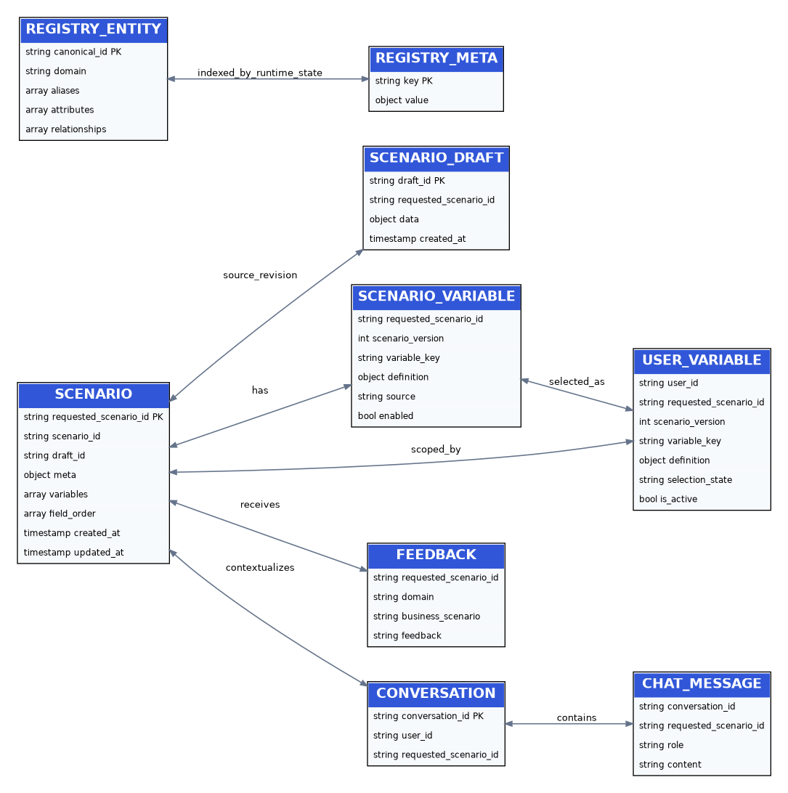
Collection | Purpose | Key indexes / identity
scenarios | Active confirmed scenario definition. | Unique requested_scenario_id ; compatibility scenario_id .
scenario_drafts | Temporary proposal/import state. | Unique draft_id ; TTL on created_at .
scenario_variables | Scenario-level DB recommended variables. | requested_scenario_id + scenario_version + variable_key .
scenario_user_variables | User-specific selection/override state. | user_id + requested_scenario_id + scenario_version + variable_key .
scenario_proposals | Proposal trace/payload keyed by request. | Unique request_id ; scenario/version/time indexes.
scenario_feedback | HITL feedback for future proposal context. | Scenario/time/domain indexes.
registry_entities | Normalized standards entities. | Unique canonical_id .
registry_standards | Standards/artifact metadata. | Unique artifact_id .
registry_meta | Runtime registry fingerprint/bootstrap metadata. | Unique key .
conversations / chat_messages | Conversation context for scenario interactions. | Conversation/scenario/time indexes.

12. Caching & Runtime State
Figure 12. Rendered architecture diagram
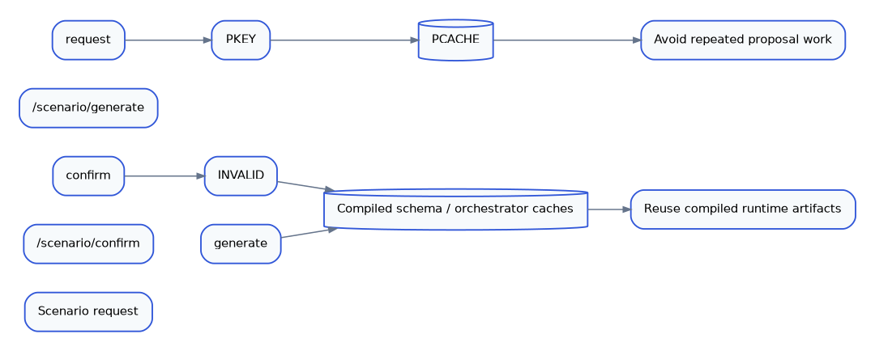

Proposal cache
Bounded + TTL-backed. Keyed by normalized proposal input, Mongo definition fingerprint and standards-manifest fingerprint.

Compiled schema cache
Bounded process-local cache keyed by requested scenario identifier. Explicit invalidation occurs after confirmation.

Orchestrator cache
Used by the legacy LangGraph path to avoid repeated validation calls for the same scenario context.

13. Errors, Health & Observability
Figure 13. Rendered architecture diagram
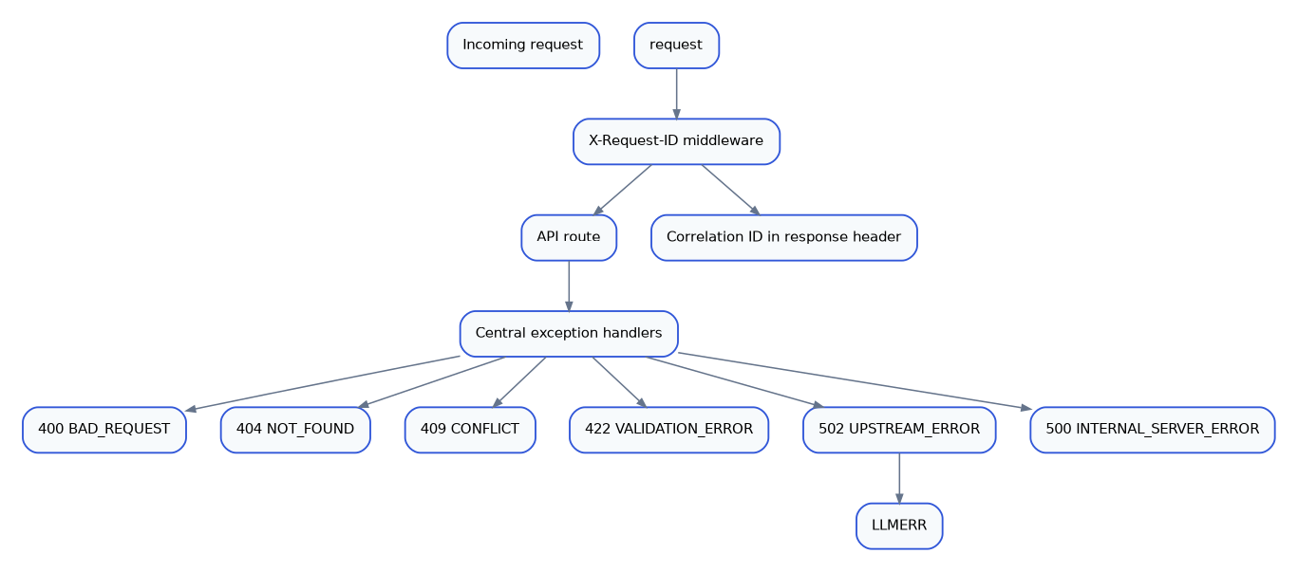

Health model
/health is lightweight liveness. /ready checks the Telecom Registry. Application startup also pings MongoDB, ensures indexes and validates registry readiness before serving.

Correlation
Each request receives a bounded X-Request-ID. The same identifier is returned in the response header and is available to canonical error responses.

14. Security & Current Production Gaps
Current implementation gap: request models currently accept userId as a client-provided value and there is no authentication/authorization dependency protecting scenario or user-variable endpoints. The HLD documents this explicitly rather than presenting it as already implemented.
Concern | Status | Current behavior | Recommended hardening
Authentication | Gap | No auth middleware/dependency in server.py . | Add OIDC/JWT or platform identity and enforce it at route boundaries.
Authorization / tenant isolation | Gap | Scenario/user ownership is not cryptographically tied to the caller. | Derive user/tenant identity from authenticated claims; authorize every read/write.
HITL parameter semantics | Hardening | Existing agentic edit validation blocks structural/provenance violations but should be strengthened with generator-specific semantic parameter validation. | Validate min/max, weights, buckets, precision, references and date/range semantics before persistence.
Scenario concurrency | Hardening | Active scenario is replaced on reconfirmation. | Add immutable scenario revision + definition hash / optimistic concurrency.
Shared cache invalidation | Hardening | Caches are process-local. | Use revision/hash-aware keys or shared cache for multi-worker deployment.
Generation scale | Hardening | /scenario/generate is synchronous. | Introduce an asynchronous job path for very large datasets.

15. Scalability & Performance Model
Figure 14. Rendered architecture diagram
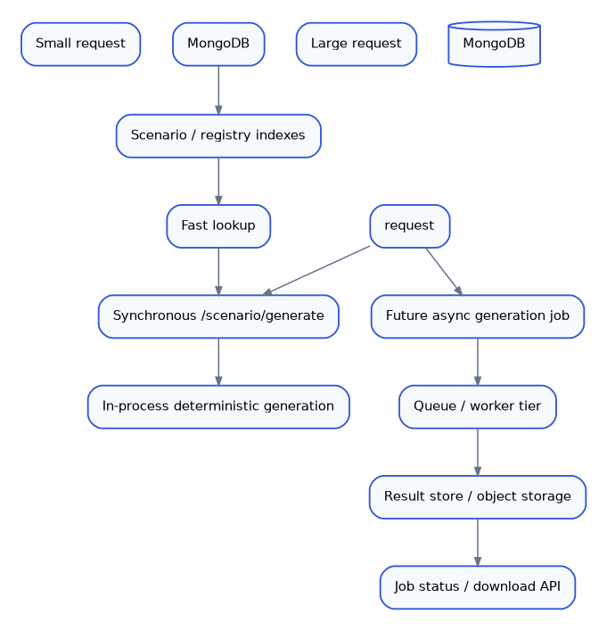
The current public contract permits up to 5,000 transactional users/entities and 1–10 returned history rows per user. The internal deterministic agent contains a wider defensive bound, so the API boundary should remain the canonical business limit.

16. Traceability & Data Lineage
Figure 15. Rendered architecture diagram
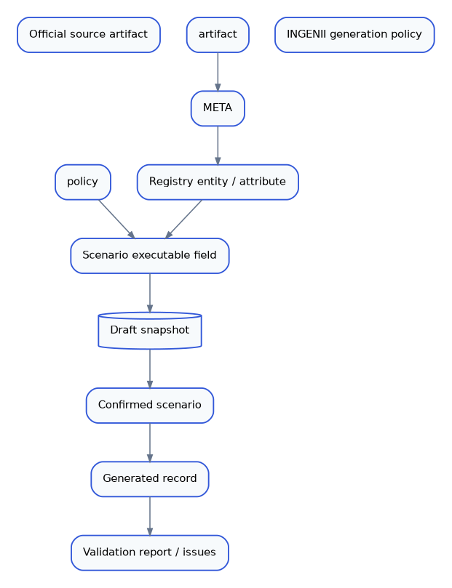
Layer | Authority | What is persisted / resolved
Official semantics | TM Forum / MEF / 3GPP machine-readable artifacts | Entity, attribute, type, enums, relationships, source lineage.
Generation behavior | INGENII profile or explicit DB variable definition | Generator, parameters, dependencies and formulas.
Scenario selection | Business request + backend registry/compiler | Scenario-specific executable field set and order.
Approval | HITL / /scenario/confirm | Confirmed variable contract and scenario metadata.
Acceptance | Deterministic validation | Formula, type, temporal and domain consistency before response.

17. End-to-End Reference Flow
Figure 16. Rendered architecture diagram
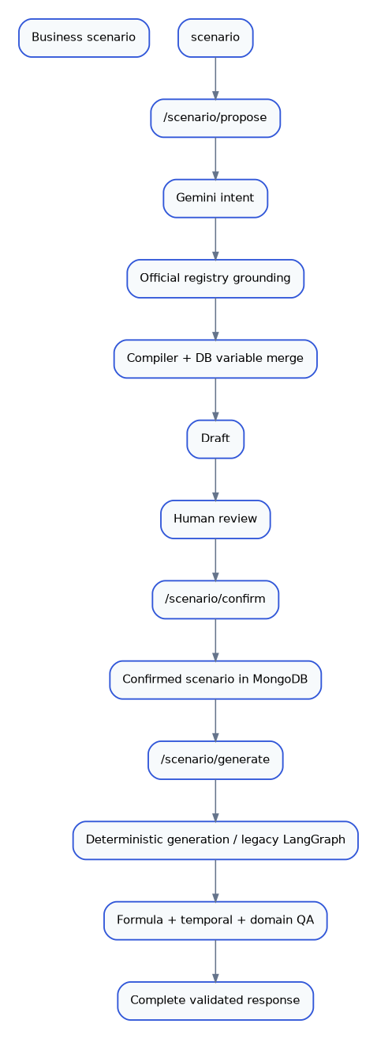

18. Key Source Files
Path | Responsibility
server.py | FastAPI application, routes, request/response models, middleware and API-level orchestration.
core/agentic_workflow.py | Agentic proposal pipeline, registry grounding, Mongo variable merge, HITL validation and proposal persistence.
agents/intent_agent.py | Gemini scenario intent extraction.
agents/schema_compiler.py | Deterministic executable schema compilation and field expansion.
agents/data_generation_agent.py | Generator implementations, dependency order, formulas, timestamps, Low Balance consistency, QA and strict validation.
core/generation_service.py | Generation entry service and response shaping/grouping.
core/dynamic_scenarios.py | Draft/confirmed scenario resolution and legacy compatibility repair.
core/compiled_schema.py | Compiled scenario cache and transactional user/history field inference.
core/telecom_registry.py | Standards registry access, search, relationship expansion and policy application.
core/standards_ingestion.py | TM Forum OpenAPI, MEF JSON/YAML Schema and 3GPP ASN.1 normalization.
core/low_balance_variable_policy.py | Low Balance source restrictions, semantic dedupe and DB variable validation.
core/csv_scenario.py | CSV schema parsing, generator normalization, bucket/weight parsing and executable coercion.
core/pipeline.py | Legacy/CSV LangGraph pipeline: Orchestrator → Schema → Data Generation.
core/runtime_cache.py | Bounded process-local schema/orchestrator/proposal caches.
models/ | MongoDB persistence models and index creation.
resources/telecom/standards/official_sources.json | Official source manifest.
resources/telecom/generation_profiles/telecom_official_generation_v2.json | INGENII generation-policy overlay.

Appendix A. Full API Reference
This appendix mirrors the sticky API reference on the right side of architecture.html. Each endpoint is documented with purpose, authentication posture, request contract, success response, errors, and implementation dependencies. The current implementation does not enforce authentication/authorization.

A.1 Common HTTP Contract
Common HTTP contract X-Request-ID is generated when absent, bounded to 128 safe characters, and returned in the response header. Authorization is accepted by CORS but authentication/authorization is not currently enforced . Canonical errors use {success:false,error:{code,message,details,request_id}} .

A.2 Endpoint-by-Endpoint Documentation
GET  /  Service root / liveness | API details  AUTHENTICATION  None enforced in current implementation  REQUEST  No body, path, or query parameters.  SUCCESS RESPONSE  200: {"success": true, "status": "ok"}  ERRORS  500 only for unexpected server failures.  PERSISTENCE / DEPENDENCIES  None

GET  /health  Lightweight liveness probe | API details  AUTHENTICATION  None enforced in current implementation  REQUEST  No body, path, or query parameters.  SUCCESS RESPONSE  200: {"status": "ok"}  ERRORS  500 only for unexpected server failures.  PERSISTENCE / DEPENDENCIES  None; does not depend on external providers.

GET  /ready  Deployment readiness probe | API details  AUTHENTICATION  None enforced in current implementation  REQUEST  No body, path, or query parameters.  SUCCESS RESPONSE  200: {"status":"ready", "registry":{"standards":<n>, "entities":<n>}}  ERRORS  503: telecom standards registry is not ready; 500: unexpected server failure.  PERSISTENCE / DEPENDENCIES  TelecomRegistry + MongoDB-backed registry collections.

POST  /scenario/variables/recommend  Persist selected scenario-level recommended variables | API details  AUTHENTICATION  No authentication/authorization dependency is currently enforced.  REQUEST  Content-Type: application/json  {  "requestedScenarioId": "LB-01",  "scenarioVersion": 1,  "variables": [{"name":"customer_id","dtype":"string","gen":"prefixed_int"}],  "userId": "optional"  }  SUCCESS RESPONSE  200: {"success":true,"requestedScenarioId":"LB-01","scenarioId":"LB-01","scenarioVersion":1,"saved":1}  ERRORS  400: invalid variable definition; 422: request validation error; 500: persistence failure.  PERSISTENCE / DEPENDENCIES  Mongo collection: scenario_variables.

GET  /scenario/{requested_scenario_id}/variables/recommended  Read enabled recommended variables for a scenario version | API details  AUTHENTICATION  No authentication/authorization dependency is currently enforced.  REQUEST  Path: requested_scenario_id (string). Query: scenarioVersion (integer, default 1, >=1).  SUCCESS RESPONSE  200: {"success":true,"requestedScenarioId":"LB-01","scenarioId":"LB-01","scenarioVersion":1,"variables":[...]}  ERRORS  422: invalid scenarioVersion; 500: persistence failure.  PERSISTENCE / DEPENDENCIES  Mongo collection: scenario_variables.

POST  /scenario/variables/user  Persist user-selected or overridden scenario variables | API details  AUTHENTICATION  No authentication/authorization dependency is currently enforced; userId is client-supplied.  REQUEST  Content-Type: application/json  {  "userId":"u-123",  "requestedScenarioId":"LB-01",  "scenarioVersion":1,  "variables":[{"name":"customer_id", "dtype":"string", "gen":"prefixed_int"}]  }  SUCCESS RESPONSE  200: {"success":true,"userId":"u-123","requestedScenarioId":"LB-01","scenarioId":"LB-01","scenarioVersion":1,"saved":1}  ERRORS  400: invalid user variable definition; 422: request validation error; 500: persistence failure.  PERSISTENCE / DEPENDENCIES  Mongo collection: scenario_user_variables.

GET  /scenario/{requested_scenario_id}/variables/user/{user_id}  Read active user variables and persisted records | API details  AUTHENTICATION  No authentication/authorization dependency is currently enforced.  REQUEST  Path: requested_scenario_id, user_id (strings). Query: scenarioVersion (integer, default 1, >=1).  SUCCESS RESPONSE  200: {"success":true,"userId":"u-123","requestedScenarioId":"LB-01","scenarioId":"LB-01","scenarioVersion":1,"variables":[...],"records":[...]}  ERRORS  422: invalid scenarioVersion; 500: persistence failure.  PERSISTENCE / DEPENDENCIES  Mongo collection: scenario_user_variables.

PATCH  /scenario/{requested_scenario_id}/variables/user/{user_id}/{variable_key}  Edit one persisted user variable definition | API details  AUTHENTICATION  No authentication/authorization dependency is currently enforced.  REQUEST  Path: requested_scenario_id, user_id, variable_key. Query: scenarioVersion (integer, default 1). Body: JSON object containing definition fields to merge.  SUCCESS RESPONSE  200: {"success":true,"userId":"u-123","requestedScenarioId":"LB-01","scenarioId":"LB-01","variableKey":"customer_id","updated":true}  ERRORS  404: variable not found; 400: invalid definition; 422: invalid query/body shape; 500: persistence failure.  PERSISTENCE / DEPENDENCIES  Mongo collection: scenario_user_variables; state becomes OVERRIDDEN.

DELETE  /scenario/{requested_scenario_id}/variables/user/{user_id}/{variable_key}  Remove/deactivate one user variable | API details  AUTHENTICATION  No authentication/authorization dependency is currently enforced.  REQUEST  Path: requested_scenario_id, user_id, variable_key. Query: scenarioVersion (integer, default 1). No body.  SUCCESS RESPONSE  200: {"success":true,"userId":"u-123","requestedScenarioId":"LB-01","scenarioId":"LB-01","variableKey":"customer_id","deleted":true}  ERRORS  404: variable not found; 422: invalid scenarioVersion; 500: persistence failure.  PERSISTENCE / DEPENDENCIES  Mongo collection: scenario_user_variables.

POST  /scenario/import-csv  Import an explicit CSV schema and create a reviewable draft | API details  AUTHENTICATION  No authentication/authorization dependency is currently enforced.  REQUEST  Content-Type: multipart/form-data  Required: file (.csv), requestedScenarioId, domain  Optional: typeOfData, industryType, country, businessScenario, businessResponse, expectedOutcome, scenarioType, useCase, label, entityKey.  SUCCESS RESPONSE  200: ScenarioImportResponse = {success, draft_id, scenario_id, requested_scenario_id, journey, description, variables, field_order, typeOfData, entityKey, variableSources}.  ERRORS  400: invalid CSV, invalid transactional entity key, Low Balance source-locked rejection; 413: CSV exceeds MAX_CSV_BYTES (default 10 MiB); 422: multipart/form validation; 500: unexpected server error.  PERSISTENCE / DEPENDENCIES  CSV parser + scenario_drafts; Low Balance rejects CSV as an executable variable source.

POST  /scenario/confirm  HITL approval boundary; persist active scenario definition | API details  AUTHENTICATION  No authentication/authorization dependency is currently enforced.  REQUEST  Content-Type: application/json  {  "draft_id":"draft-...",  "add":[],  "edit":[{"name":"customer_id","changes":{"nullable":false}}],  "delete":[],  "feedback":"optional"  }  SUCCESS RESPONSE  200: ConfirmResponse = {success, scenario_id, requested_scenario_id, scenario_id_reassigned, draft_id, label, journey, description, variables, field_order, typeOfData, entityKey, variableSources}.  ERRORS  400: invalid HITL/source contract; 404: unknown or expired draft; 409: scenario persistence conflict; 422: request validation; 500: unexpected server error.  PERSISTENCE / DEPENDENCIES  scenario_drafts -> scenarios; optional scenario_feedback; invalidates compiled/runtime scenario caches.

POST  /scenario/propose  Create a standards-backed agentic scenario proposal draft | API details  AUTHENTICATION  No authentication/authorization dependency is currently enforced; userId is optional client data.  REQUEST  Content-Type: application/json  {  "requestedScenarioId":"LB-01",  "scenarioType":"Low Balance & Top-up",  "industryType":"Telecom",  "domain":"prepaid",  "businessScenario":"...",  "typeOfData":"transactional",  "country":"IN",  "entityKey":"customer_id",  "useCase":"prepaid top-up",  "userId":"optional"  }  SUCCESS RESPONSE  200: ScenarioImportResponse. The executable variables are compiled from the trusted registry/Mongo definitions; the LLM returns intent only.  ERRORS  400: invalid scenario/proposal; 422: request validation; 502: Gemini upstream failure; 503: workflow configuration/dependency failure; 500: unexpected server error.  PERSISTENCE / DEPENDENCIES  Gemini intent agent + TelecomRegistry + Mongo recommended/user variables + SchemaCompiler + scenario_drafts/scenario_proposals.

POST  /scenario/generate  Synchronously generate the complete validated dataset for a confirmed scenario | API details  AUTHENTICATION  No authentication/authorization dependency is currently enforced.  REQUEST  Content-Type: application/json  {  "requestedScenarioId":"LB-01",  "draftId":"optional-confirmed-draft-id",  "count":35,  "recordsPerUser":10  }  Constraints: count 1..5000; recordsPerUser 1..10.  SUCCESS RESPONSE  200: GenerateResponse = {success, scenario_id, requested_scenario_id, typeOfData, draft_id, scenario_label, fields, total_records, validation_report, records, entityKey, totalCount, recordsPerUser, errors, record_errors}.  ERRORS  400: missing/unknown scenario, draftId mismatch, generation/validation issue; 404: unknown draftId; 422: request validation; 502: legacy external LLM/QA upstream failure; 500: unexpected server error.  PERSISTENCE / DEPENDENCIES  Confirmed scenarios + compiled schema cache + deterministic generator/validators; legacy CSV/explicit scenarios may use LangGraph.

Source alignment
This DOCX mirrors the current architecture.html and includes the implemented API surface, service boundaries, persistence model, agentic/HITL lifecycle, deterministic generation paths, Low Balance source-locking rules, caches, observability, security gaps, scalability considerations, lineage, key source files, and a complete API appendix.

