Michael Kausch 2/14/23

Activity 2 – CMPS 3500 Professor Morales

The purpose of the program is to take user input (up to 15 values), sort them, and then output them to the user. The user also has the option of inputting a -1 as a sentinel value to terminate reading inputs prematurely. The sorting algorithm used is an implementation of the bubble sort using Fortran’s GOTO control of flow statement. The original version of this algorithm that was implemented in spaghetti.f didn’t always sort correctly. I originally believed this to be because of the archaic GOTO statements, but, after testing I believe I figured out that it was due to the un-initialization of the ISTART variable. I forced initialization with the “IMPLICIT NONE” statement and made sure that all variables were correctly initialized and the result was correctly sorted data. See below:

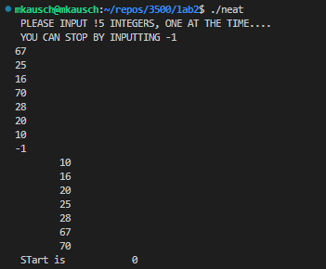

Figure 2:  
 Sort using the same data with the correct value

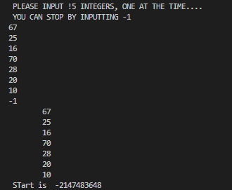

Figure 1:   
Incorrect sort showing the value of the start

The limitations of this code is obviously the readability. It took several hours of parsing through the code in order to discover what the algorithm was doing and it was an algorithm that I have been familiar with now for several years.