

AMERICAN INTERNATIONAL UNIVERSITY–BANGLADESH (AIUB)
Dept. of Computer Science
Faculty of Science and Technology
CSC 2210: OBJECT ORIENTED PROGRAMMING 2
Fall 2025-2026
Section: O
Group No: 05

Project Report On
Project Name: Inventory Management System
Supervised By
Noboranjan Dey

Submitted By:
Name | ID
1. Md. Kauser Islam Robayet | 23-51868-2
2. Sharmin Akter Aziza | 23-52782-2
3. Anik Debnath | 23-51891-2
4. Saiful Islam Sihab | 23-51849-2

CO2: Display and verify the mean of a real-life Project using the concepts of C# Graphical User Interface based environment with database integration to depict a desktop-based application.
Assessment  Criteria | Not Attended/ Incorrect (0) | Inadequate  (1-2) | Average  (3) | Good  (4) | Excellent  (5)
Evaluation Criteria | Evaluation Definition |  |  |  | Total =
Requirement fulfillment | Properly demonstrate a real-life scenario-based project with proper functional requirement identification for the Object-Oriented Programming project development activities.
Validation | Ensuring the ability of students’ proper demonstration on validation forms in their system in terms of dealing with the data.
Verification | Identifying if the students can verify the system data along with proper functional requirements in terms of data flow.

Table of Contents

1. INTRODUCTION 3
2. FEATURE LIST 4
2.1 User 1 4
2.2 User 2 4
2.3 User 3 4
3. ER DIAGRAM 5
3.1 Normalization 5
3.2 Finalization 6
4. UML DIAGRAM 7
4.1 Use Case Diagram 8
4.2 Activity Diagram. 9
5. CONCLUSION 10
6. REFERENCE 10

INTRODUCTION
The Inventory Management System is a comprehensive desktop-based application developed using C# and .NET Framework to streamline and automate inventory operations for businesses of all sizes. In today's competitive market, efficient inventory management is crucial for maintaining optimal stock levels, preventing overstocking or stock outs, and ensuring smooth business operations. This project addresses the challenges faced by businesses in manual inventory tracking by providing a digital solution that centralizes all inventory-related activities.
The system incorporates three distinct user roles: Admin, Customer, and Inventory Manager. The admin has completed administrative control over the system, managing user accounts, overseeing all operations, and generating comprehensive reports. The Customer role facilitates external stakeholders to view available products and place orders. The Inventory Manager focuses on day-to-day inventory operations, including product management, stock updates, and order processing.
This project demonstrates the practical application of Object-Oriented Programming principles, database integration using SQL Server, and GUI development with Windows Forms. By reducing manual errors, improving data accuracy, and enhancing operational efficiency, this system contributes to better business decision-making and customer satisfaction while promoting digital transformation in inventory management practices.

FEATURE LIST
We have three main features in our Inventory Management System. These are

Admin
- Secure Login and Logout
- Access to Admin Dashboard
- Navigation to Customer and Product Management modules
- Can add new products (Product ID, Name, Price, Quantity)
- Can update existing product details
- Can delete products
- Can view all product information
- Can manage customer details
- Has full control over the inventory system

Customer
- Add new customer information
- View customer list in DataGrid View
- Update existing customer records
- Delete customer records
- Search customers by name
- Refresh customer list

Products
- Add new product details
- View product list in DataGrid View
- Update product information
- Delete products
- Search products by product name
- Refresh product list

ER DIAGRAM
The ER (Entity Relationship) Diagram represents the logical structure of the database used in
the Inventory Management System. It visually explains how different entities in the system are related to each other and how data is stored and connected. In this system, the main entities are Admin, Customer, and Product. The admin entity contains information such as Admin ID, Name, and Password. The admin is the main controller of the system and has the authority to manage the overall inventory. Admin is responsible for adding new products, updating existing product information, and removing products that are no longer available. One Admin can manage many products, so there is a one-to-many relationship between Admin and Product. The Product entity includes Product ID, Product Name, Price, and Quantity. This entity holds all the information related to items available in the inventory. It helps the system to track how many products are in stock and their prices. The Customer Entity stores customer-related information such as Customer ID, Name, Address, and Phone Number. Customers interact with the system mainly by purchasing products. The relationship between Customer and Product is many-to-many because one Customer can purchase many products, and one product can be purchased by many customers. To manage this relationship properly in a database, an intermediate table such as Sales or Orders is usually created.

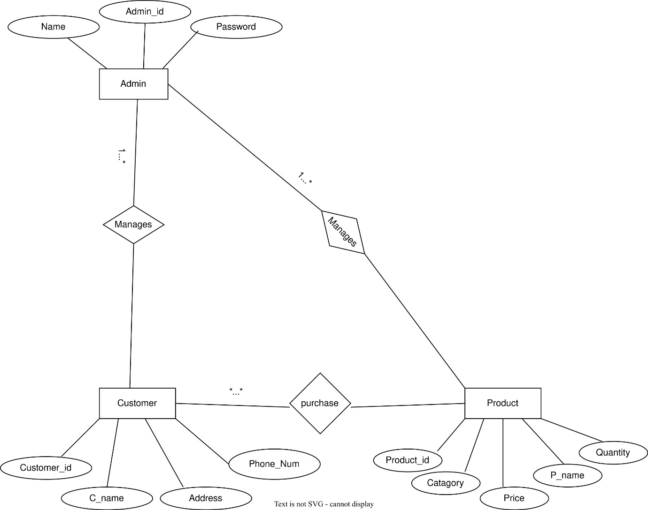

Normalization
Manages ( 1 to many)
UNF
Admin_ID, Admin_Name, Password,
Customer_ID, Customer_Name, Address, Phone_Number
1NF
Admin_ID, Admin_Name, Password
Customer_ID, Customer_Name, Address, Phone_Number
2NF
Admin Table:
Admin_ID (PK), Admin_Name, Password
Customer Table:
Customer_ID (PK), Customer_Name, Address, Phone_Number
Manages Table:
Admin_ID (FK), Customer_ID (FK)
Manages ( 1 to many)
UNF
Admin_ID, Admin_Name, Password,
Product_ID, Product_Name, Price, Quantity
1NF
Admin_ID, Admin_Name, Password
Product_ID, Product_Name, Price, Quantity
2NF
Admin Table:
Admin_ID (PK), Admin_Name, Password
Product Table:
Product_ID (PK), Product_Name, Price, Quantity
Manages Table:
Admin_ID (FK), Product_ID (FK)
Purchases (many to many)
UNF
Customer_ID, Customer_Name, Address, Phone_Number,
Product_ID, Product_Name, Price, Quantity
1NF
Customer_ID, Customer_Name, Address, Phone_Number
Product_ID, Product_Name, Price, Quantity
2NF
Customer Table:
Customer_ID (PK), Customer_Name, Address, Phone_Number
Product Table:
Product_ID (PK), Product_Name, Price, Quantity
Purchase Table:
Purchase_ID (PK), Customer_ID (FK), Product_ID (FK)

Finalization
Final Tables:
Admin:
Admin_ID (PK), Name, Password
Customer:
Customer_ID (PK), Customer_Name, Address, Phone_Number
Product:
Product_ID (PK), Product_Name, Price, Quantity

UML DIAGRAM

Use Case Diagram
The Use Case Diagram shows how users interact with the Inventory Management System and what functionalities are available to them. It focuses on system behavior from the user’s perspective rather than internal system structure. There are two main actors in this system: Admin and Customer.
The admin is the most powerful user of the system. First, the Admin must log in using a valid Username and Password. After successful login, the admin can perform various operations such as adding new products to the system, updating products information like price or quantity and deleting products that are no longer needed. The admin can also manage customer information if required. Besides this, the admin can view the list of all products and monitor the inventory status. After Completing all tasks, the admin logs out to ensure system security.
The Customer is another important user who interacts with the system mainly for purchasing products. The Customer can view the list of available products, select products according to their needs and purchase them. After purchasing, the system generates a bill showing product details, quantity, and total price. Finally, the Customer logs out.
The Use Case Diagram helps to clearly understand what services the system provides
and who can use those services, making it very useful during system design and
development.
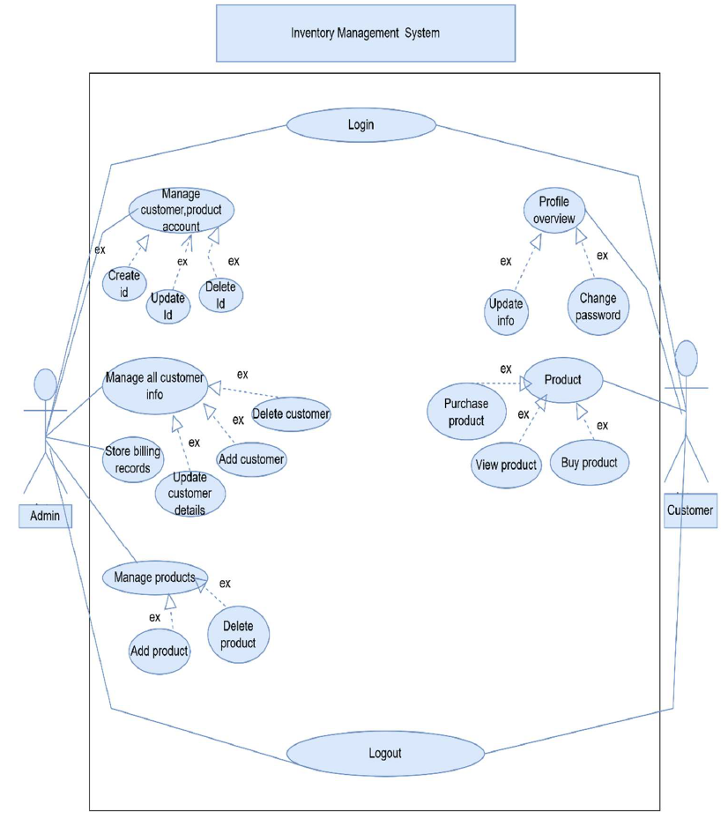

Activity Diagram.
The Activity Diagram represents the workflow of the Inventory Management System. It shows the step-by-step flow of activities performed by different users and how actions move from one stage to another. The system operation begins with the Login process. When a user enters the system, it first checks whether the user is an Admin or a Customer. If the user is an Admin, then the admin can perform multiple activities such as adding new products, updating products, information, deleting products, and managing customer data. The admin can also view inventory reports to understand stock levels and system status. After finishing these activities, the admin logs out, which ends the session securely. If the user is a customer, then the Customer can browse through the available products, select desired products, and proceed to purchase them. During the purchase, the system calculates the total price and generates a bill. After completing the transaction, the Customer logs out.
This Activity Diagram clearly explains how different actions are performed in a sequence and
how the system flows from one task to another, helping developers and users understand the
system’s operational behavior.
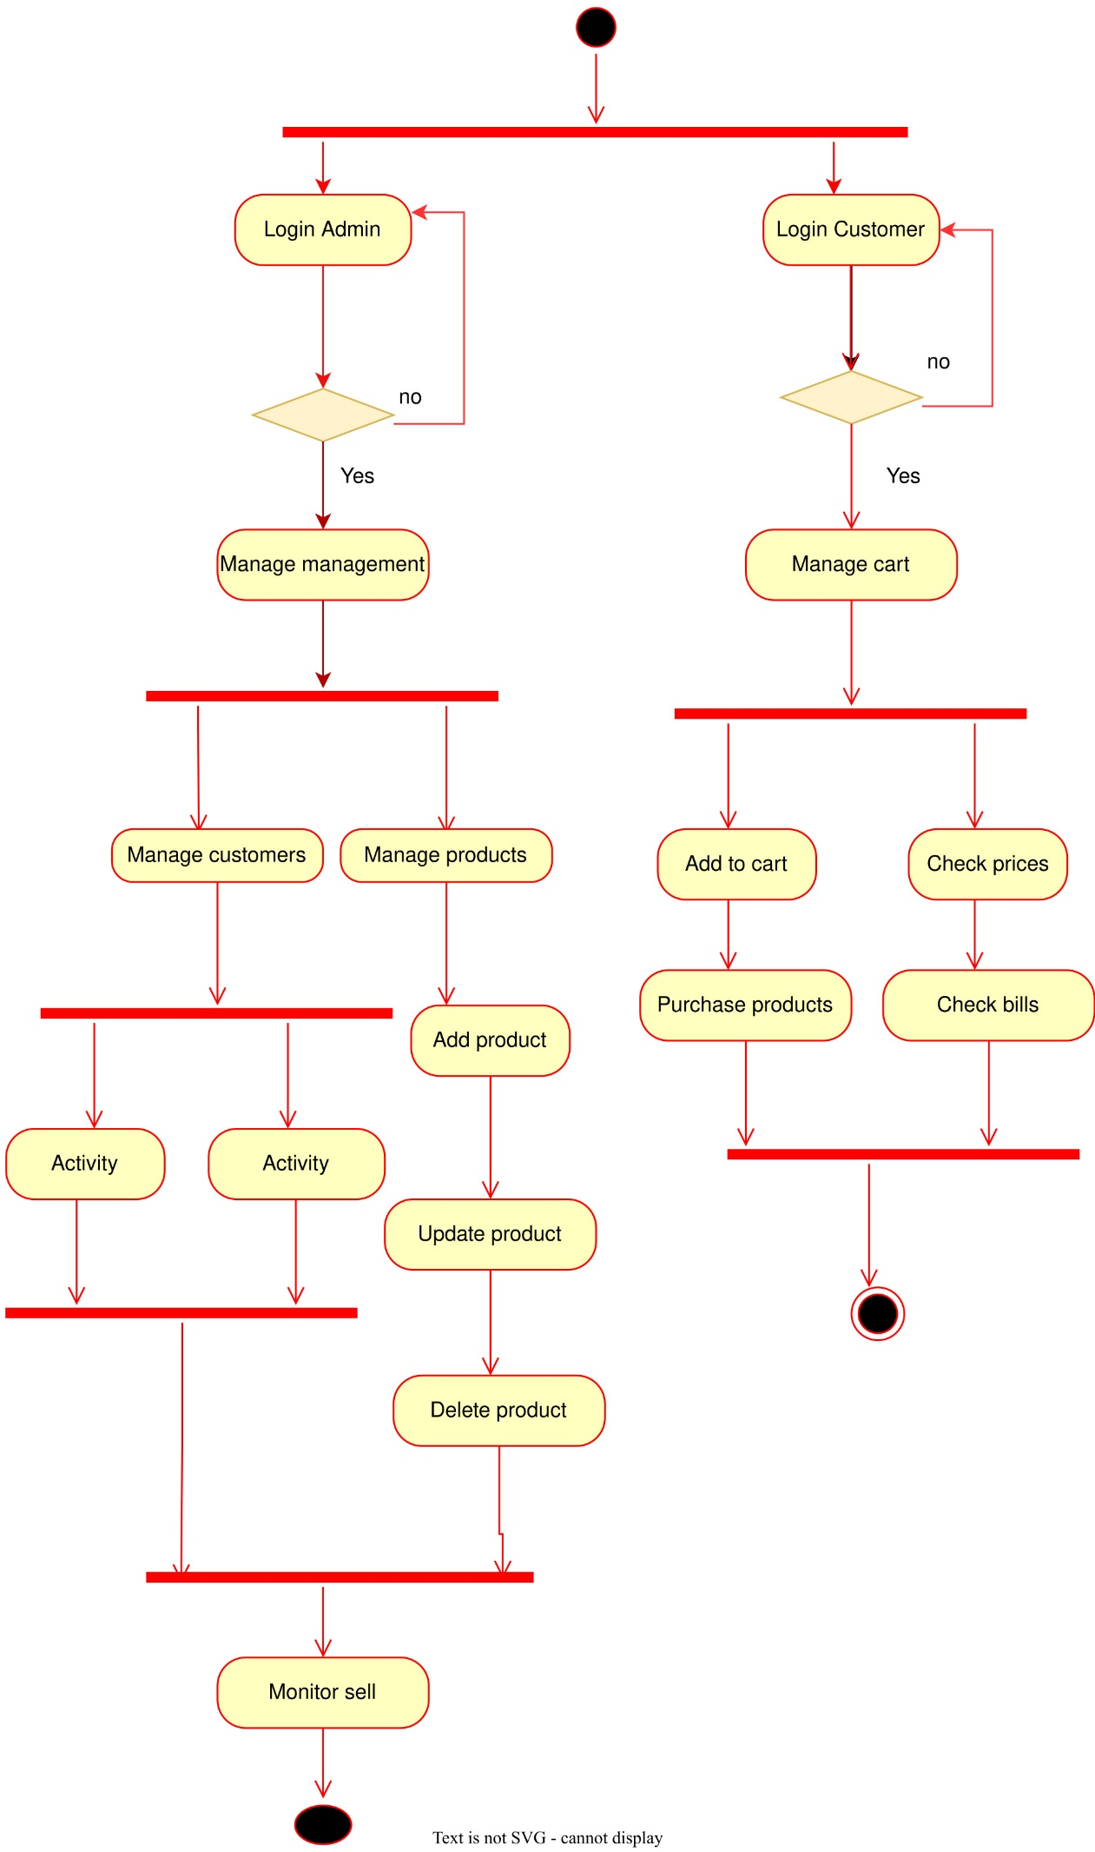

CONCLUSION
The Inventory Management System successfully demonstrates the application of Object-Oriented Programming concepts in developing a practical, real-world solution for business inventory management. Through this project, we have created a comprehensive system that addresses the critical needs of modern businesses in maintaining efficient inventory control. The implementation of three distinct user roles (Admin, Customer, and Inventory Manager) with appropriate access levels ensures secure and organized system operation. The use of proper database normalization techniques up to 2NF has resulted in an efficient database design that minimizes redundancy and maintains data integrity. The graphical user interface developed using C# Windows Forms provides an intuitive and user-friendly experience for all types of users. This project highlights the importance of proper system analysis and design in software development. The ER diagram and UML diagrams created during the design phase provided a clear blueprint for implementation. The system's modular architecture allows for easy maintenance and future enhancements. From a societal perspective, this project contributes to digital transformation in business operations by replacing error-prone manual processes with an automated, accurate system. It helps businesses optimize their inventory levels, reduce operational costs, and improve customer service through better product availability management. The successful completion of this project has provided valuable hands-on experience in full stack application development, database design, and user interface implementation, preparing us for real-world software development challenges.

REFERENCE
- GitHub Link: https://github.com/kauserislam09/InventoryManagementSystem

