Name – Kaushal Oza

Roll no – 40 (A)

SRN – 201900754

**CN ASSIGNMENT 6**

FILE TRANSFER USING SOCKETS.

#include <stdio.h>

#include <stdlib.h>

#include <string.h>

#include <sys/socket.h>

#include <netinet/in.h>

#include <unistd.h> #define PORT 8080 void main() {

int sock = socket(AF_INET, SOCK_STREAM, 0);

int option = 1; struct sockaddr_in address; socklen_t addrlen = sizeof(address); char buffer[1024] = {0}; char source_file[] = "test.txt"; char fname[] = "test.txt"; address.sin_family = AF_INET; address.sin_addr.s_addr = INADDR_ANY; address.sin_port = htons(PORT);

setsockopt(sock, SOL_SOCKET, SO_REUSEADDR, &option, sizeof(option));

if(bind(sock, (struct sockaddr*) &address, sizeof(address)) == -1){ perror("Could not bind to address");

return;

} if(listen(sock, 5) == -

1) {

perror("Error while listening to connections"); return;

} int new_socket = accept(sock, ( struct sockaddr*) & address, & addrlen); if(new_socket == -1){ perror("Error connecting to client");

exit(EXIT_FAILURE);

}else printf("Connected to client\n");// first send the filename if(send(new_socket, fname, sizeof(fname), 0) == -1){

perror("Error while sending file"); return;

}

printf("Sending file %s\n\n", source_file);

FILE* f = fopen(source_file, "r");// send the contents of the file while(fgets(buffer, sizeof(buffer), f)){ printf("Sending %s", buffer);

int sent = send(new_socket, buffer, strlen(buffer),0); if (sent == -1)

perror("Error while sending\n"); else

printf("Successfully sent [%d bytes]\n\n", sent); memset(buffer, 0, sizeof(buffer));

}

printf("File transfer complete\n");

fclose(f); }

**OUTPUT**

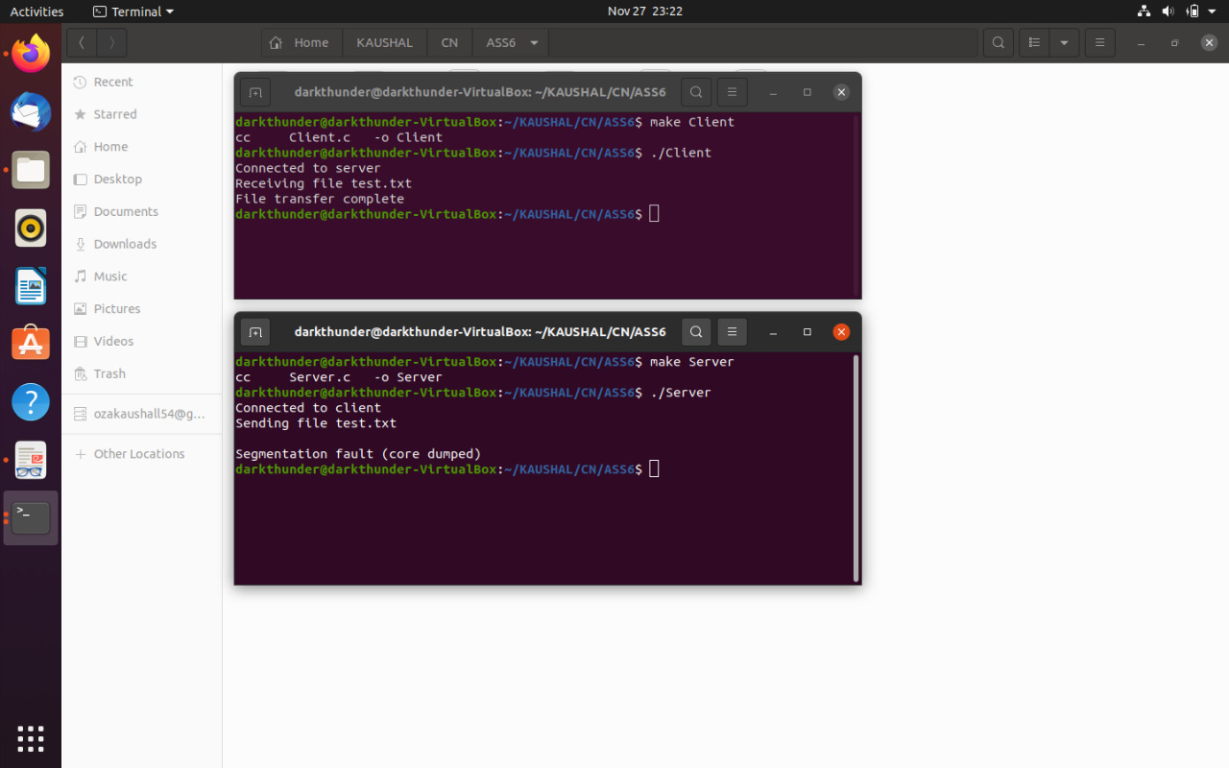

**CLIENT SIDE:**

#include <stdio.h>

#include <stdlib.h>

#include <string.h>

#include <sys/socket.h>

#include <arpa/inet.h>

#include <unistd.h> #define PORT 8080

int main() {

int sock = socket(AF_INET, SOCK_STREAM, 0); long val;

struct sockaddr_in address; char buffer[1024] = {0}; address.sin_family = AF_INET; address.sin_port = htons(PORT);

if(inet_pton(AF_INET, "127.0.0.1", &address.sin_addr) == -1){ perror("Invalid IP value"); exit(EXIT_FAILURE);

} if(connect(sock,(struct sockaddr*) & address, sizeof(address)) == - 1){

perror("Connection Error"); exit(EXIT_FAILURE);

}else printf("Connected to server\n"); // Get file name from server if(read(sock, buffer, sizeof(buffer)) == -1){ perror("Could not read filename from server");

exit(EXIT_FAILURE);

}printf("Receiving file %s\n", buffer);

FILE *f =fopen(buffer, "w");

// printf("%ld", read(sock, buffer, sizeof(buffer))); while((val = read(sock, buffer, sizeof(buffer)))){ if (val == -1) {perror("Error reading the content");

break;

}

printf("Received %s", buffer); for(int i = 0; i < val; i++) fputc(buffer[i], f);

fputc('\0', f);

memset(buffer, 0, sizeof(buffer));

} if (val == 0)

printf("File transfer complete\n"); else

printf("Incomplete Transfer\n");

fclose(f); }

**OUTPUT:**

## 