### INTRODUCTION

The objective of “Employee Management System” is designing a **Scheduling System** for a work centre. **Scheduling** is such a tool with which the process of intimating activities and notifications will be easy and even online in the organization where it is installed. But these task of scheduling the different activities if manually done whether they may be personal or official is time consuming and also may lead to confusion if not properly scheduled.

Scheduling becomes such an easy task such that it reduces much time when compared to previous methods. This enables for the employee to check the task that is assigned to them.

The **Admin** is already having the account on the server and therefore will have login **username and password.** The Admin is allowed to delete employees, set work or task, mark attendance, Add salary and manage leaves etc. The **Employee** will have to register in the database and once registered he/she would be logged in to the system through his/her employee id and password. The employee is allowed to update his/her details, view schedule set by the Admin, view Time Sheet etc**.**

The supervisor which holds the various activities like sending notifications, mark attendance , and deleting the employees and on the other hand employees view their details, view schedule or the notifications or any message form supervisor and view attendance.

### Architecture

**“Employee Management System”** will be adopting **3-Tier Architecture.** The front- end will be HTML pages with Java Script for client side validation where as all business logics will be in Java reside at middle layer. And these layers will interact with third layer of database, which will be MYSQL database. The web server will be Apache Tomcat 8.5. To start working on this project environment required is a server having Tomcat as web server, Oracle as database and Java Runtime Environment (JRE) as development environment.

The system will do the following:

##### Admin:

* + Admin can Add/Edit/delete the employees.
  + Admin can Add/Edit/delete the schedule the work of the employees.
  + Admin can Add/Edit/delete mark the attendance of employees.
  + Admin can Add/Edit/delete Leaves and time sheet of the employee.

##### Employee:

* + Registration according to category (developer, tester and designer).
  + Employee can view his/her schedule set by Admin.
  + Employee can check his/her attendance.
  + Employee can update his/her details.
  + Employee can re-set password.

### ADVANTAGE OF THE SYSTEM

This project offers employees to enter the data through simple & interactive forms. This is very helpful for the client to enter the desired information through so much simplicity. New Employees when registering themselves register according to category wise(i.e. Developer, Tester and Designer).Here, Employee Id is automatically generated once the user got registered. So, user logged in to the system and access to its profile and rights using that Employee Id and password.

The front view of the system consists of two modules i.e. Supervisor and Employee. When clicking on the Employee tab the pop up window would open up and ask for the login, if the employee is not yet register then clicking on **“New User Register Here”,** user can register themselves. After registering they can logged in to the system using password and Employee Id which is automatically generated after registration and access their rights like view schedule, view attendance, update details, view details etc.

Supervisor can logged in to the system using username and password and can set schedule, mark attendance, check category wise description of the employees etc. Hence, the system has various advantages:

* + - Transparency to all the user of system.
    - Less paper use and removal of redundancy.
    - Less prone to errors.
    - The whole system is interactive.[9]

## Efficient Data Maintenance

## Improved Benefits Processing

## Tracking Payroll Expenses

## Internal Recruitment

**Disadvantages-**

## **How Safe is Your Information?**

Your employees entrust you with personal information. Everything from Social Security numbers to private health information and marital status gets stored in your HR management system. Several layers of management may have access to that information. In addition, a non-management employee may engage in identity theft and access a fellow employee's sensitive data. Such a breach of security with your management system can embroil you in legal problems and create poor employee relations.

## **Cost of Setup, Installation, and Training**

One of the disadvantages of these systems is their cost. As a small business owner, you have to do everything you can to rein in expenses, and an HR management system will cost you several thousand dollars for installation, setup, training, and consulting, as well as an intensive time commitment before the system is up and running. You can cut these costs by getting a remotely hosted system, but you’re likely to spend hours on the phone with your remote customer service representative whenever something goes awry, which further cuts into your productivity.

## **Loss of Subjectivity**

Because HR management systems do such a good job of listing employee accomplishments, certifications, and degrees, managers may be tempted to promote based on the objective data your system provides. This may discourage supervisors from taking the time to get to know employees on a personal basis as part of their evaluation of what staff members can contribute to your company. The truth is that a computer can only provide you with measurable factors that don’t always tell the full story.

## **Difficulty of Analysis**

Your system can contain so much data that you may find it difficult to analyze. You may need a separate analysis system just to sort the data into meaningful chunks. For example, if you want to analyze employee turnover in relation to levels of compensation and your system is not sophisticated enough, you may have difficulty generating reports that identify patterns. This could require the help of advanced software outside of your HR management system, which means additional expense.

### CONCLUSION

Overall, the system is useful for all the users to maintain information at various levels. It connects supervisor and employee and thus easy to maintain.

Now supervisor can easily set the schedule or any notifications to the respective employees without having a person to send to employees.

It has been a great pleasure for us to work on this exciting and challenging project. This project proved good for us as it provided practical knowledge of not only programming in J2EE and Oracle Server Developer working of web based application, but also about all handling procedure related with Advance and new technology. It also provides knowledge about the latest technology used in developing web enabled application and client server technology that will be great demand in future. This will provide better opportunities and guidance in future in developing projects independently.

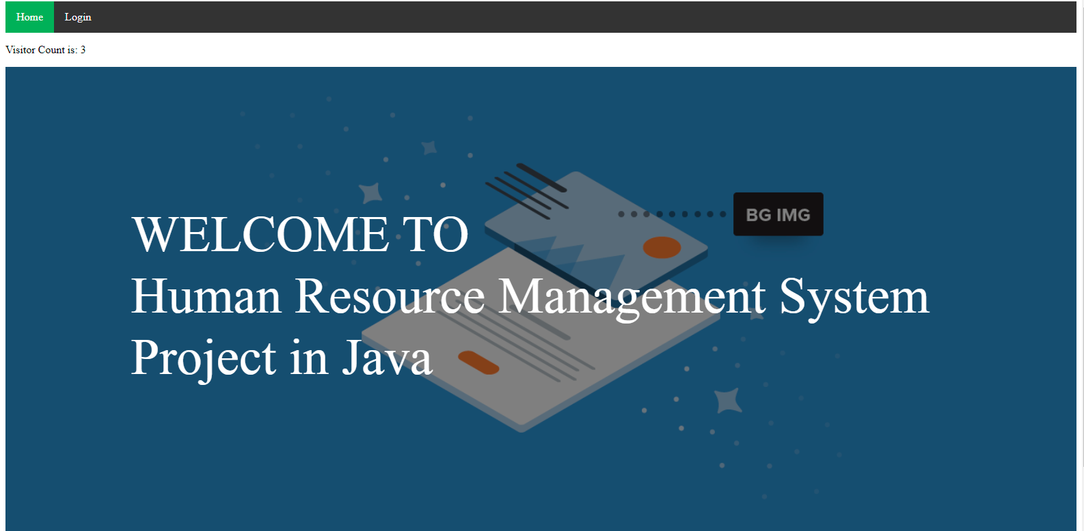

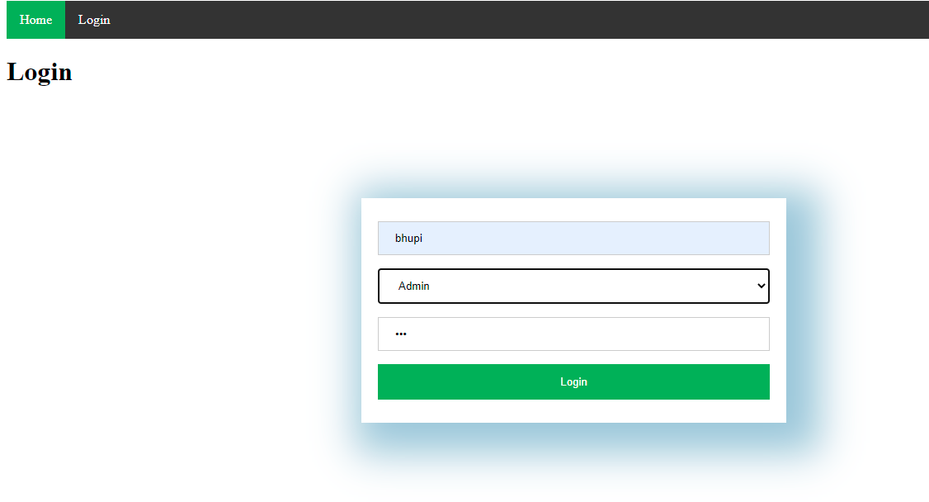

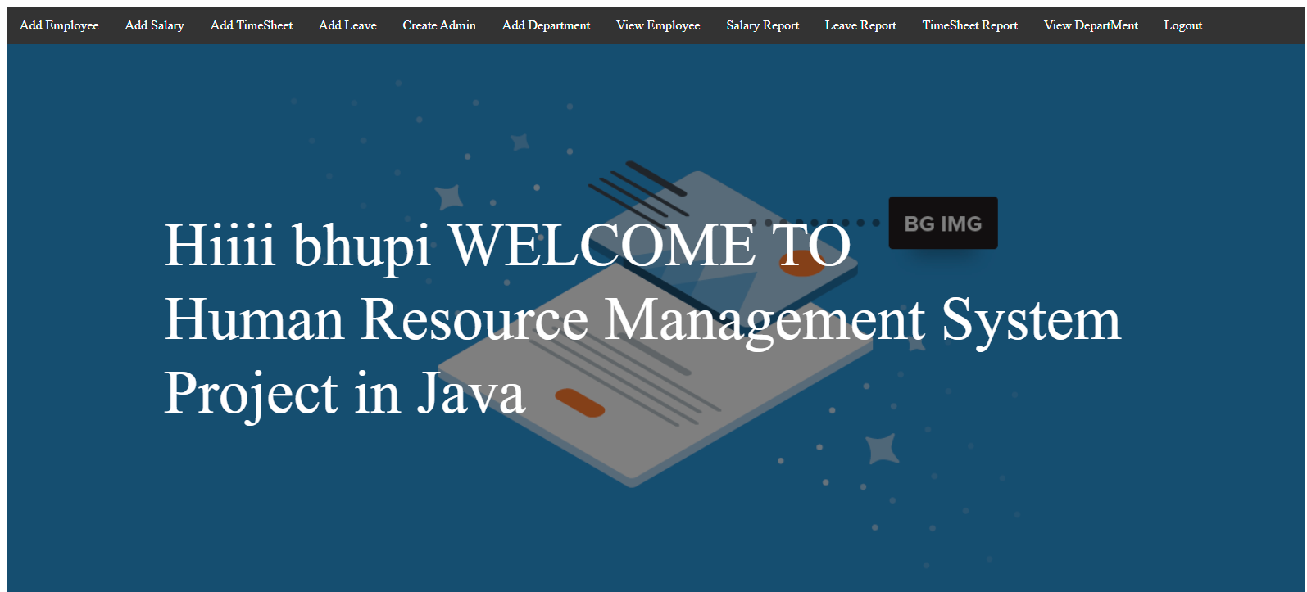

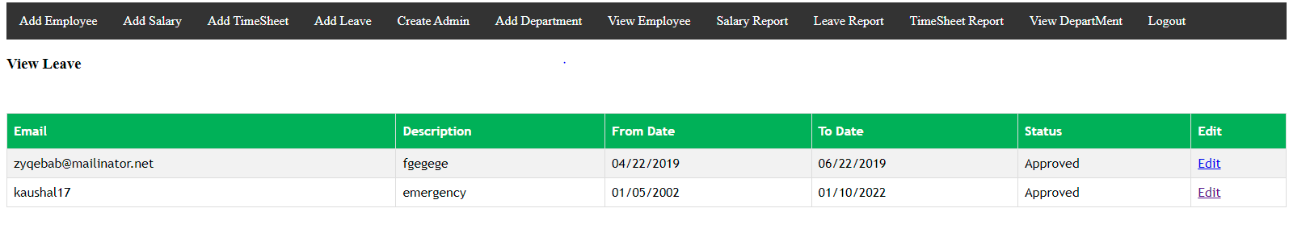

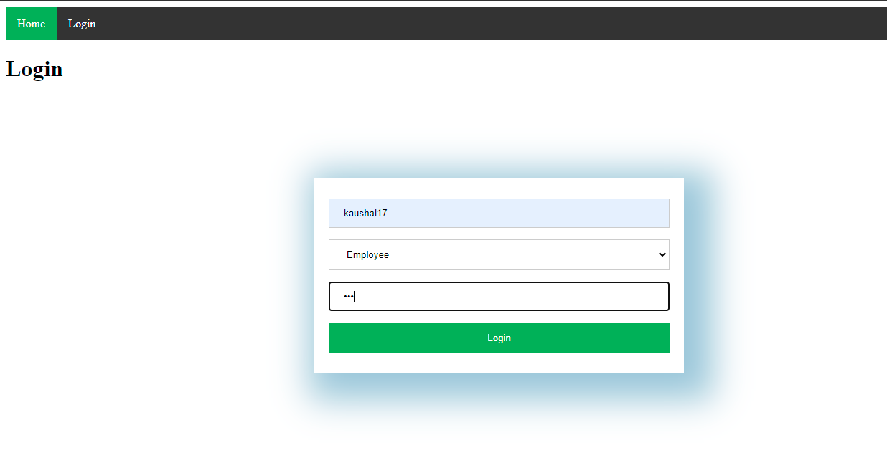

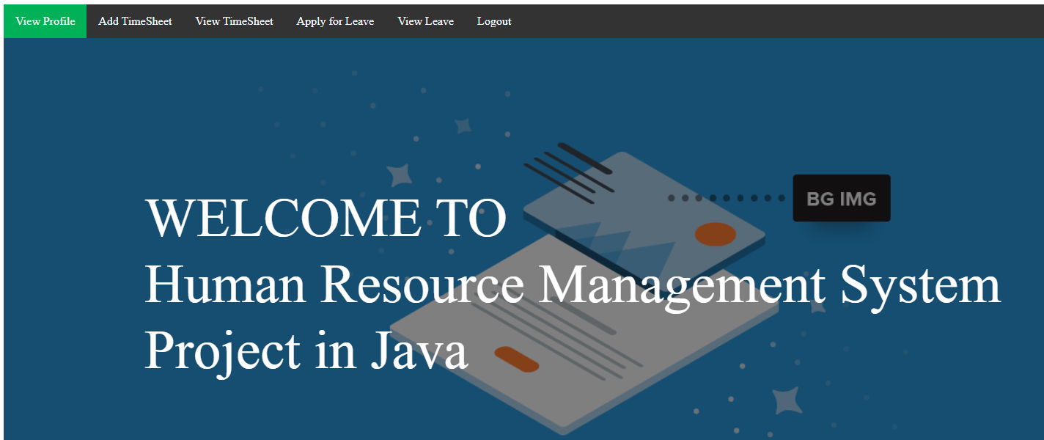

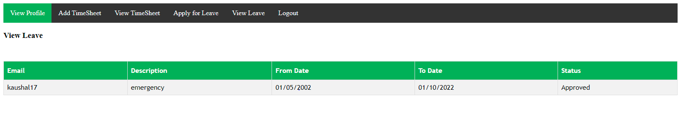

LINK OF THE WEBSITE 🡺 <http://localhost:8080/EmployeeManagementSys/index.jsp>

BY 🡺 KAUSHAL_20CSU051, NISCHAY_20CSU073, LAKSHAY_20CSU051, AMAN_20CSU008