MediMart Online Healthcare Platform
Updated system design and unified project documentation

LJ University
Department of Computer Applications
Master of Computer Application (Integrated)
Prepared for internal project review
Scope covered: Sections 1 to 4.5

Table of Contents
1. Introduction
1.1 Existing System
1.2 Need for the New System
1.3 Objective of the New System
1.4 Problem Definition
1.5 Core Components
1.6 Project Profile
1.7 Assumptions and Constraints
1.8 Advantages and Limitations
2. Project Planning
2.1 Team Details and Roles
2.2 Proposed Timeline
3. Requirement Determination and Analysis
3.1 Requirement Determination
3.2 Targeted Users
4. System Design
4.1 Use Case Diagram
4.2 Class Diagram
4.3 Interaction Diagram
4.4 Activity Diagram
4.5 Data Dictionary
5. Development and later sections retained from the original document

1. INTRODUCTION
MediMart is a Django and MySQL web platform for healthcare commerce and service coordination. The current project combines product discovery, seller offers, prescription review, cart and checkout, payments, invoices, fulfilment, lab bookings, doctor consultations, health records, support, notifications, and guarded AI assistance in one account-based system.
This revision documents the implementation that exists in the repository rather than an ideal future product. Where an external provider or legal process is still required, the workflow is described as a controlled integration boundary instead of being presented as completed functionality.

1.1 Existing System
The existing healthcare purchasing environment is fragmented across pharmacies, laboratories, clinics, courier services, spreadsheets, paper prescriptions, and separate messaging channels. Customers repeat their profile and address information, while operations teams maintain product, licence, prescription, booking, delivery, and refund records in disconnected places.
Typical fragmented workflow:
1. A customer searches for a product or asks a local pharmacy about availability and price.
2. A prescription is shared separately and reviewed manually without a common status history.
3. A lab appointment is booked by phone or through a separate provider with no shared health record.
4. Doctor consultations, payments, follow-ups, and prescriptions are tracked outside the purchasing workflow.
5. Delivery, return, refund, and quality complaints are followed up through calls or messages.

1.2 Need for the New System
- A single account view is needed for products, prescriptions, orders, lab bookings, consultations, records, reminders, and support.
- Regulated medicine sales need explicit safety classification, Schedule H/H1 and controlled-substance flags, pharmacist review, batch traceability, and audit history.
- Customers and staff need clear status transitions for payments, shipments, sample collection, prescription review, returns, refunds, recalls, and disputes.
- Operations need role-scoped workspaces instead of broad, undocumented administrative access.
- Private health files and AI support must be isolated from public catalogue data and protected by ownership and capability checks.

1.3 Objective of the New System
- Provide searchable medicines, healthcare products, equipment, tests, doctors, and health guides.
- Support secure customer registration, multi-identifier login, password reset, MFA, profile, address, dependent, and health-record management.
- Provide a practical product-to-order workflow with offers, cart, coupon, fee breakdown, Razorpay verification, invoices, shipment tracking, returns, refunds, and support.
- Make prescription-required fulfilment dependent on validation, pharmacist or clinical review, approved product mapping, quantity controls, and expiry rules.
- Coordinate lab partners, collection slots, phlebotomists, accession events, structured reports, invoices, refunds, settlements, and disputes.
- Coordinate verified doctor consultations with availability, payment, private messages, follow-ups, clinical notes, and signed e-prescriptions.
- Provide role-based operations CRUD, audit events, notification history, guarded AI search, and privacy-safe account assistance.

1.4 Problem Definition
The problem is to design and implement a secure, maintainable healthcare platform that connects a customer journey with clinical, seller, fulfilment, finance, and support controls. The system must preserve a reliable record of who submitted, reviewed, approved, fulfilled, refunded, or changed a healthcare transaction. It must also make clear which functions are implemented locally and which depend on external payment, courier, laboratory, consultation, storage, email, monitoring, or legal arrangements.

1.5 Core Components
Component | Current Django responsibility | Primary records
Accounts and security | Registration, login identifiers, MFA, profiles, addresses, roles, capabilities, sessions | User, UserProfile, Address, capability overrides
Catalogue and search | Products, categories, brands, variants, images, specifications, clinical profiles, interactions, search analytics | Product, ProductVariant, ProductClinicalProfile, SearchQuery
Seller and compliance | Vendor onboarding, licence evidence, offers, approvals, manufacturer and pharmacy workflows | Vendor, BusinessLicense, VendorProduct
Cart and checkout | Cart, saved items, coupons, checkout totals, payment, invoice, and tax/charge breakdown | Cart, CartItem, Coupon, OrderChargeBreakdown
Prescription safety | Private upload, scan metadata, validation, item mapping, pharmacist review, clarification, partial approval | Prescription, PrescriptionItem, PrescriptionReview
Orders and fulfilment | Order status, batches, warehouses, shipment events, delivery OTP, recalls, returns, refunds, settlements | Order, InventoryBatch, Shipment, ReturnRequest, Refund
Healthcare services | Dependents, health vault, labs, sample chain of custody, consultations, reminders, care plans | LabBooking, LabSampleEvent, Consultation, HealthRecord
Operations and communication | Role-scoped CRUD, support, notifications, blog, doctors, complaints, audit-friendly actions | SupportTicket, Notification, DoctorProfile, QualityComplaint
AI and platform services | Guarded AI search/chat, local account answers, redaction, private media, health checks, APIs | Assistant service logs and application audit records

1.6 Project Profile
Attribute | Current project value
Application type | Server-rendered Django web application with Bootstrap-compatible UI, custom CSS, JavaScript, AJAX catalogue updates, and responsive layouts
Backend | Python Django with separate apps for accounts, products, vendors, cart, orders, prescriptions, healthcare, extras, dashboards, reviews, assistant, and core
Database | MySQL configured through environment settings; migrations define the relational schema
Authentication | Django authentication, username/email/phone identifier login, password hashing, reset/change flows, CSRF, rate limits, optional TOTP MFA
Storage | Public product/profile media plus permission-checked private media for prescriptions, reports, credentials, attachments, and health records
Payments | Razorpay order creation, signature/webhook verification, payment events, reconciliation records, refunds, chargebacks, and credit notes
AI | Single configured provider/model policy with guarded catalogue search, local account-status answers, redaction, safety rules, timeouts, and fallback
Deployment boundary | Local development uses normal MySQL and local services; production requires dedicated credentials, HTTPS, private storage, backups, monitoring, and provider agreements

1.7 Assumptions and Constraints
Assumptions:
- Users provide accurate identity, address, prescription, clinical, and appointment information.
- A trusted administrator assigns professional roles and verifies evidence before public or operational access is granted.
- Pharmacists, doctors, labs, vendors, warehouses, support staff, and delivery staff follow the documented workflow and maintain the required records.
- External services are available only when valid accounts, credentials, webhook configuration, policies, and service agreements are supplied.
Constraints:
- The application does not diagnose patients, replace a pharmacist or doctor, perform laboratory analysis, or guarantee courier fulfilment.
- Government licence verification, live courier allocation, production object storage, SMTP delivery, and production monitoring remain deployment responsibilities unless configured.
- Legal compliance requires review of applicable Indian medicines, privacy, tax, consumer protection, telemedicine, and state-specific rules before production use.

1.8 Advantages and Limitations
Advantages | Limitations and boundaries
One account for commerce, clinical services, fulfilment, and health records | Availability and fulfilment still depend on approved partners and operations staff
Explicit roles, capability checks, review queues, and audit-oriented records | Legal approval and policy configuration are not replaced by software controls
Batch, recall, cold-chain, payment, return, and refund records support traceability | Live integrations need provider credentials, webhooks, agreements, and production monitoring
Private media and guarded AI reduce exposure of sensitive health information | AI remains assistance and search; it must not diagnose or prescribe

2. PROJECT PLANNING

2.1 Team Details and Roles
The application models operational responsibilities as explicit roles. Role assignment is controlled by trusted administrators, while capability checks protect each workspace and sensitive action.
Role | Responsibility | Main workspace
Customer | Shop, upload prescriptions, book healthcare services, manage records, track orders, returns, and support | Customer dashboard
Vendor | Sell approved healthcare products and manage offers and stock | Vendor dashboard
Manufacturer | Submit manufactured equipment/products and required evidence | Vendor dashboard and equipment workflows
Pharmacy | Sell medicines subject to seller and licence review | Vendor dashboard
Pharmacist | Review prescription safety, regulated medicines, substitutions, batches, and dispensing decisions | Operations Center
Phlebotomist | Handle assigned collection, OTP, identity checks, proof, and sample handoff | Operations Center
Doctor | Maintain verified profile, availability, consultations, notes, advice, and signed prescriptions | Doctor dashboard
Delivery staff | Handle assigned deliveries and permitted status transitions | Delivery dashboard
Support staff | Own support tickets, messages, macros, SLA, and escalation | Support/Operations Center
Compliance officer | Review sellers, licences, regulated evidence, and compliance decisions | Operations Center
Catalog manager | Manage catalogue, offers, product publication, categories, and brands | Operations Center
Operations manager | Coordinate users, sellers, clinical, fulfilment, support, finance, and audit | Operations Center
Warehouse manager | Manage warehouses, batches, inventory, shipments, and fulfilment | Operations Center
Admin | Full trusted application operations and Django Admin access | Operations Center and Django Admin

2.2 Proposed Timeline
Phase | Work included | Output
1. Discovery | Stakeholders, role matrix, safety scope, external integration decisions | Approved scope and risk list
2. Analysis and design | Requirements, workflows, data relationships, permissions, UML diagrams | Sections 1 to 4.5 and design baseline
3. Platform foundation | Django apps, MySQL schema, authentication, shared layout, private media | Working application shell
4. Commerce | Catalogue, seller offers, cart, checkout, payments, invoices, returns | Customer purchase workflow
5. Safety and fulfilment | Prescription review, batches, recalls, cold chain, warehouse, delivery | Controlled order operations
6. Healthcare services | Labs, slots, phlebotomy, reports, doctors, consultations, records, reminders | Healthcare workspaces
7. Verification | Unit, integration, accessibility, security, recovery, webhook, and permission tests | Test evidence and fixes
8. Deployment | Production MySQL user, secrets, storage, SMTP, monitoring, backup, restore drill | Release candidate and runbook

3. REQUIREMENT DETERMINATION AND ANALYSIS

3.1 Requirement Determination
Requirements were determined from the actual application routes, Django models, forms, permission helpers, dashboards, services, migrations, and system guide. The analysis separates public discovery from authenticated ownership, clinical approval from catalogue publication, and operational status transitions from customer-facing requests.
Functional requirements:
1. Authentication and identity: register customers and professionals, log in using supported identifiers, reset passwords, enable TOTP MFA, and record security events.
2. Catalogue and seller management: create products, categories, brands, images, variants, clinical details, offers, licences, and publication approvals.
3. Safety controls: classify products, enforce prescription and licence gates, validate prescription fields, review items, record decisions, and prevent recalled or quarantined stock from fulfilment.
4. Cart and checkout: manage quantities, coupons, saved items, addresses, taxes and charges, payment state, invoice, order, and retry behavior without duplicate orders.
5. Fulfilment: allocate warehouse batches, reserve stock, assign delivery, record OTP/proof/events, manage temperature logs, returns, refunds, recalls, reconciliation, and settlement records.
6. Laboratory services: list partners and tests, offer collection slots, book dependents, assign phlebotomists, track accession and chain of custody, publish structured reports, invoice, refund, settle, and dispute.
7. Doctor consultations: list verified doctors, schedule availability, create consultations, collect payment, support private messages and attachments, record clinical notes, follow-ups, and e-prescriptions.
8. Customer health workspace: manage dependents, private records, time-limited sharing, medication reminders, care-plan memberships, notifications, and support.
9. Operations: provide role-scoped CRUD, queues, maker-checker actions where configured, audit history, and dashboards for catalogue, clinical, finance, fulfilment, support, and compliance.
10. AI and public content: provide grounded catalogue/search help, local account answers for the signed-in user, redaction, safety restrictions, health guides, and notifications.
Non-functional requirements:
- Security: Django password hashing, CSRF, session protection, secure cookies, rate limits, private media authorization, capability checks, and TOTP MFA.
- Integrity: database constraints, protected foreign keys, transactional order and inventory operations, idempotent payment events, and immutable order history.
- Usability: responsive navigation, clear status labels, accessible forms, pagination, search, filters, validation feedback, and consistent empty/loading/error states.
- Maintainability: separated Django apps, migrations, reusable templates, services, management commands, test modules, and environment-based configuration.
- Observability and recovery: audit events, health endpoints, logs, payment exception records, backups, restore drills, and production monitoring when deployed.

3.2 Targeted Users
User group | Needs | Allowed outcomes
Customer or dependent owner | Discover products, buy, book tests, consult doctors, store records, manage reminders | Own records, own orders, own bookings, own support and saved items
Vendor, pharmacy, manufacturer | Submit evidence, list approved products, manage offers, stock, and seller orders | Own seller data and permitted offer/fulfilment actions
Pharmacist and doctor | Review or deliver clinical work with credentials and privacy controls | Assigned clinical records, review decisions, consultations, follow-ups
Phlebotomist and delivery staff | Execute assigned field work with proof and status controls | Assigned bookings or shipments only
Support and operations staff | Resolve tickets, approve records, operate queues, and coordinate exceptions | Capability-scoped operational records and audit trail
Compliance, catalogue, warehouse, finance managers | Review evidence, publish products, manage batches, reconcile money and fulfilment | Assigned management sections and maker-checker decisions
Admin | Trusted platform administration and emergency operations | Full application access subject to audit and deployment policy

4. SYSTEM DESIGN
The design uses a layered Django application. Browser requests are routed to app views and forms, business rules are applied in models or services, MySQL stores relational state, private media is delivered through permission-checked views, and external providers are isolated behind payment, email, geocoding, storage, courier, laboratory, consultation, and AI configuration boundaries.
The most sensitive flow is prescription-required checkout. The customer owns the request, the pharmacist or authorized clinical reviewer owns the decision, the order captures the approved item and batch, and the operations layer records the status history and audit context.

4.0 Architecture Layers
Layer | What it does | Examples in this project
Presentation | Receives user actions and displays state | Django templates, Bootstrap-compatible components, custom CSS, JavaScript
Application | Routes requests and enforces workflow permissions | URLs, views, forms, capability checks, dashboards, services
Domain | Applies healthcare, catalogue, payment, fulfilment, and privacy rules | Models, validators, prescription review, order and inventory services
Persistence | Stores relational records and protected files | MySQL, migrations, private media, audit and status histories
Integration | Connects optional external services through controlled boundaries | Razorpay, SMTP, geocoding, courier/lab/consultation APIs, AI provider

4.1 Use Case Diagram
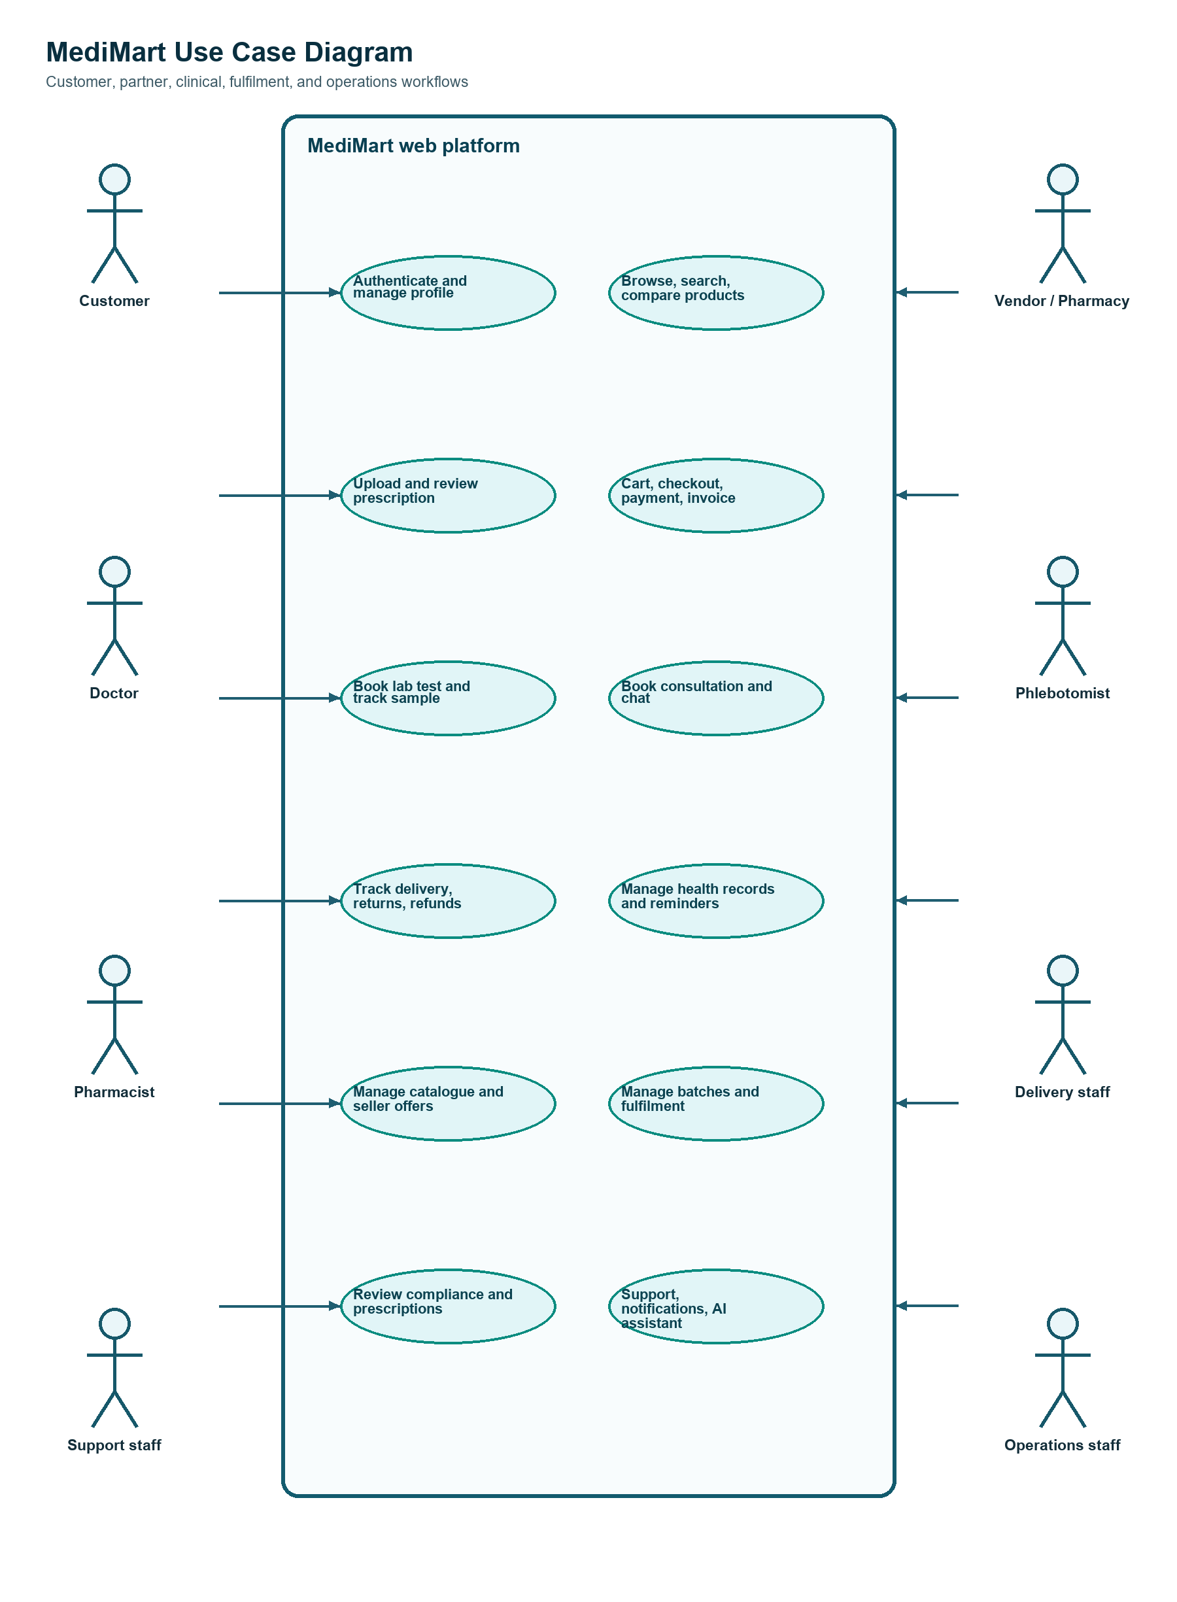
Figure 4.1. MediMart use cases and role boundaries.
Customers authenticate, search, compare, purchase, upload prescriptions, book labs, consult doctors, manage records, and request support. Sellers and partners submit catalogue or clinical evidence. Pharmacists, phlebotomists, delivery staff, and operations roles perform controlled work through assigned dashboards. The system boundary includes safety checks, payments, fulfilment, private records, notifications, and guarded AI support.

4.2 Class Diagram
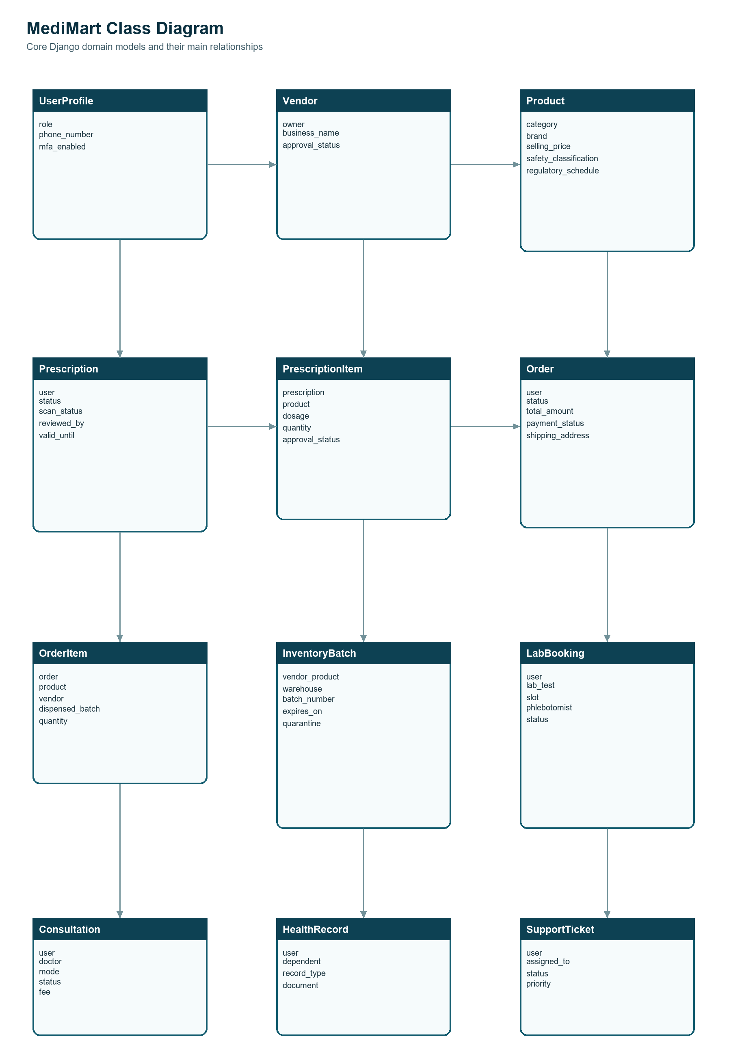
Figure 4.2. Core MediMart domain classes and relationships.
The core relationship starts with UserProfile and extends into Vendor, Product, Prescription, Order, LabBooking, Consultation, HealthRecord, and SupportTicket. PrescriptionItem maps a clinical request to an approved Product. OrderItem stores a historical product and seller snapshot and can point to the dispensed InventoryBatch. LabBooking and Consultation preserve their own service, payment, and operational histories without exposing unrelated customer records.

4.3 Interaction Diagram
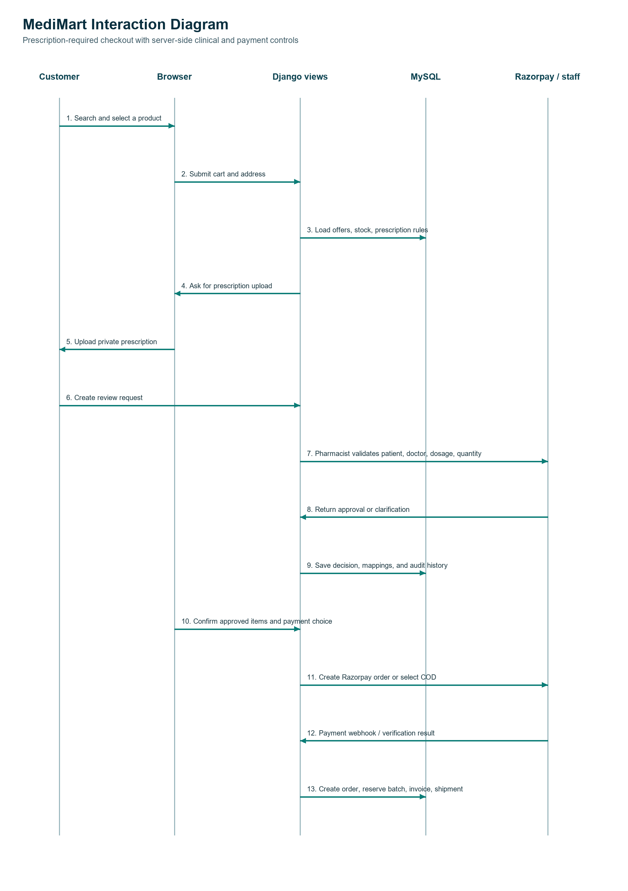
Figure 4.3. Prescription-required checkout interaction sequence.
The browser submits only through server-side Django endpoints. Django validates ownership, product safety flags, prescription requirements, stock, and permissions before writing state to MySQL. A pharmacist or authorized reviewer returns approval or clarification, and the final order is created only after approved item mapping. Razorpay order and webhook events are treated as payment evidence; the order and inventory transaction are then persisted with invoice and fulfilment records.

4.4 Activity Diagram
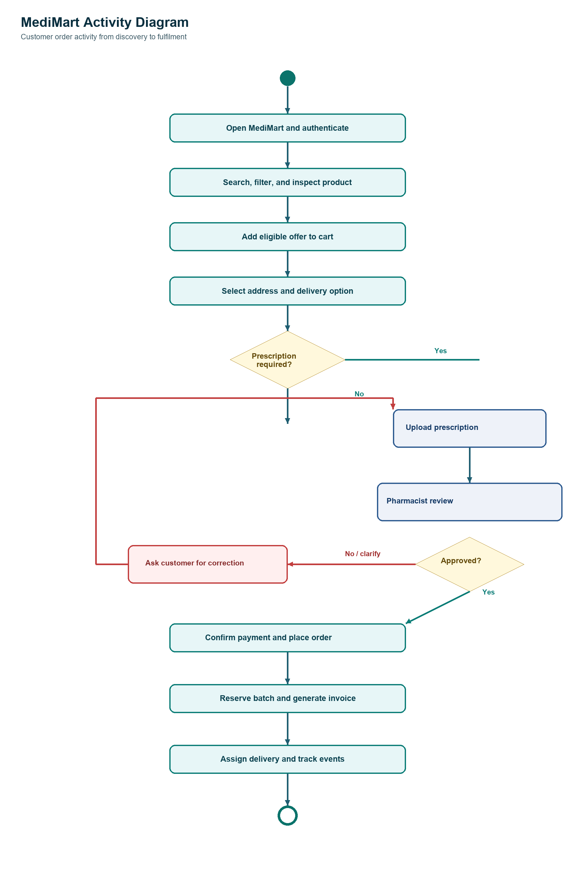
Figure 4.4. Customer order activity with prescription decision.
The activity flow prevents a prescription-required product from bypassing clinical review. A clarification branch sends the customer back to correct or resubmit information. After approval, payment and stock reservation continue into invoice generation, delivery assignment, tracking, and the return/refund path when needed.

4.5 Data Dictionary
The following dictionary summarizes the main implemented Django entities and the fields that define their operational purpose. It is intentionally organized by domain so the relationships in Figure 4.2 remain understandable.

Identity and access
Entity | Important fields | Purpose
UserProfile | user, role, phone_number, location, mfa_secret, mfa_enabled | Application role, profile, location preference, and optional TOTP security state
UserCapabilityOverride | user, capability, is_granted, reason, granted_by | Per-user allow/deny exception to the role capability matrix
Address | user, full_name, phone, address lines, city, state, pincode, coordinates, is_default | Customer and service address with historical and geocoding information

Catalogue and seller
Entity | Important fields | Purpose
Category / Brand | name, slug, image or logo, active state | Catalogue classification and manufacturer/brand identity
Product | sku, category, brand, type, prices, stock, composition, pack_size, safety, schedule, recall, cold_chain | Sellable product master and its safety/publication rules
ProductVariant | product, pack/strength/form attributes, price and active state | Distinct sellable size or formulation
ProductClinicalProfile | dosage, route, therapeutic/chemical class, warnings and storage | Clinical and safe-use context for a product
ClinicalInteraction | product or clinical relation, interaction type, severity, notes | Drug and condition interaction warnings
Vendor | owner, business details, type, approval and active state | Seller or partner organization
BusinessLicense | vendor, licence type/number, document, expiry, review status, reviewer | Evidence and review gate for regulated selling
VendorProduct | vendor, product, price, stock, approval state, licence relation | Seller-specific offer and operational inventory entry

Cart, order, payment, and fulfilment
Entity | Important fields | Purpose
Cart / CartItem | user or session, offer, quantity, timestamps | Single active shopping cart and its quantities
Coupon / CouponUsage | code, discount rule, limits, validity, user/order usage | Controlled discount application and audit
Order / OrderItem | order_number, user, address snapshot, totals, status, payment state, product/seller/batch snapshots | Customer purchase and immutable fulfilment context
Payment / PaymentEvent | method, amount, gateway IDs, signature, captured/refunded amount, payload, event state | Gateway payment lifecycle and webhook evidence
Refund / CreditNote | payment, return request, amount, reason, gateway reference, status | Refund and accounting document trail
Warehouse / InventoryBatch | warehouse, offer, batch number, manufacture/expiry, quantity, quarantine, recall, MRP, supplier, temperature | Batch-level stock, cold-chain, and traceability control
Shipment / ShipmentEvent | order, delivery user, tracking, OTP, proof, status, event note and time | Delivery assignment, tracking, and proof of delivery
ReturnRequest | order item, reason, status, pickup, decision, refund relation | Customer return, reverse pickup, and resolution workflow

Prescription and clinical safety
Entity | Important fields | Purpose
Prescription | user, private file, patient/doctor details, date, validity, status, scan, validation flags, reviewer | Customer-submitted prescription and review lifecycle
PrescriptionItem | prescription, product, dosage, duration, instructions, quantity, approval status, reviewer | Per-medicine approval and fulfilment quantity
PrescriptionReview | prescription, reviewer, decision, pharmacy licence, validation snapshot, notes | Append-only clinical decision history
DoctorProfile / PharmacistProfile | user, registration, credentials, facility, verification state | Verified professional identity and licence context
QualityComplaint | user, product/order, batch, evidence, status, reviewer, resolution | Adverse-event or product-quality complaint workflow

Laboratory, consultation, and health records
Entity | Important fields | Purpose
Dependent | user, name, relationship, DOB, gender, consent, active state | Family member or patient profile
HealthRecord / HealthRecordShare | user, dependent, type, provider, date, private document, purpose, expiry, revoked_at | Private health vault and time-limited sharing
LabPartner / LabBranch | name, city, accreditation, licence, hours, service areas, active state | Approved laboratory and collection location
LabTest / LabCollectionSlot | partner, name, image, sample, preparation, price, SLA, capacity, blackout | Test catalogue and bookable collection capacity
LabBooking / LabSampleEvent | user, dependent, test, slot, phlebotomist, OTP, identity proof, accession, status, event/barcode | Booking, collection, and chain-of-custody history
LabReportValue / LabReferenceRange | test, value, unit, range, abnormal flag, reviewed explanation, age/sex range | Structured report results and non-diagnostic context
LabInvoice / LabRefund / LabSettlement / LabDispute | booking or partner, amounts, status, reviewer, reference, resolution | Lab finance and service exception lifecycle
Consultation / Availability / Payment / Message / FollowUp | user, doctor, mode, status, symptoms, schedule, fee, private message, attachment, follow-up | Doctor consultation, payment, communication, and closure
MedicationReminder / CarePlanMembership | user, dependent, product, schedule, plan, dates, usage, status | Adherence and membership benefit tracking

Communication, content, and trust
Entity | Important fields | Purpose
Notification / NotificationDelivery | recipient, type, title, message, read state, delivery state, timestamps | Short-lived UI notifications with persistent notification center
SupportTicket / SupportMessage | user, order or booking, owner, priority, SLA, status, message, private attachment | Account-based support and escalation
BlogCategory / BlogPost / ContentIssue | title, slug, body, author, publication, issue type and status | Health education content and moderation
Review / HelpfulVote / AbuseReport / SellerReply | order/product, rating, comment, verified buyer, votes, report, reply | Trust and moderated customer feedback
SearchQuery | user/session, query, filters, result count, timestamp | Search analytics and zero-result improvement

5. DEVELOPMENT

5.1 Development Approach
MediMart follows an Agile-oriented development approach in which the system is divided into
manageable modules and implemented incrementally. Frontend, backend, database, and testing
activities are performed in parallel with regular integration checkpoints.
· The project is organized into functional milestones such as requirements, UML / database design, authentication, catalog, cart / order, prescription, lab booking, consultation, administration, and testing.
· Django models and migrations are used to define and evolve the MySQL schema.
· Django views, forms, templates, URL routing, and application services are used to implement business workflows.
· Bootstrap and Tailwind CSS are used for responsive layout and reusable UI components, while JavaScript supports dynamic interactions, validation feedback, filters, and AJAX - style enhancements where implemented.
· Git is used for source-code version control, and testing is performed during development rather than only at the end.

5.2 Coding Standards
Naming Conventions:
· Python Classes / Models: PascalCase (e.g., ProductView, LabBookingService)
· Python Functions / Variables: snake_case (e.g., create_order(), verify_prescription())
· Variables: snake_case, e.g., user_profile, order_total
· Constants: UPPER_CASE (e.g., UPPER_SNAKE_CASE, e.g., MAX_UPLOAD_SIZE)
· HTML / CSS / JS: for CSS: camelCase, for JS variables (e.g., itemQuantity).
Code Style Guidelines:
· Meaningful and descriptive names are used for variables, functions, classes, database fields, and other programming elements to improve code readability and maintainability.
· Functions are kept concise and focused on a single responsibility, ensuring that each function performs one specific task and avoids unnecessary complexity.
· Consistent indentation of 4 spaces is maintained throughout the source code to ensure proper formatting and readability, especially in Python and Django files.
· Comments are added wherever complex logic, important business rules, validation processes, or database operations require additional explanation.
· A clear Separation of Concerns is maintained by keeping presentation, business logic, and data management separate. HTML templates are primarily used for displaying content and do not contain complex business logic.
· Code duplication is minimized by following the DRY (Don't Repeat Yourself) principle. Common functionality is implemented through reusable functions, classes, templates, and components.
· Database tables and Django model classes follow consistent and meaningful naming conventions. Django model classes use PascalCase, such as User, Product, Order, and LabBooking, while database fields use clear and descriptive names.

5.3 GitHub Repository Details
Source code was managed using Git version control hosted on GitHub:
· Repository Name: MediMart
· Branch Structure: 'main' branch for stable production releases; 'test-env' branch for feature integration; dedicated feature branches for module development.
· Collaboration Policy: Mandatory Pull Request reviews before merging code into the 'test-env' branch.

5.4 AI tools/ Libraries/API used (If Any)
This section should list the Artificial Intelligence tools, libraries, frameworks, or APIs
used in the project, if applicable. For each tool, mention its name, purpose, version (if
relevant), and explain how it contributes to the project's functionality, such as automation,
prediction, chatbot development, image processing, recommendation systems, or data
analysis.
Examples:
● AI Tool: ChatGPT – Used for generating content, code suggestions, or documentation.
● Library: TensorFlow / Scikit-learn – Used for machine learning model development.
● API: OpenAI API / Google Vision API – Used to integrate AI capabilities into the application.

5.5 Screenshots & Implementation Details
Definition:
Include screenshots of key screens/modules and explain implementation details.
[SCREENSHOT 1: LOGIN SCREEN]
Description: The entry portal allows multi-role authentication for buyers, sellers, and system
administrators, complete with security controls.
Implementation Details: Built using Django's built-in Authentication views with CSRF tokens.
Form fields enforce client-side validation alongside SHA-256 backend password hashing.
Implementation Details:
● Username field with validation (minimum 5 characters)
● Password field with encryption using SHA-256
● Remember Me checkbox for session management
● Forgot Password link for password recovery

[SCREENSHOT 2: DASHBOARD SCREEN]
Description: Control center for manufacturers to oversee stock inventory levels, evaluate pending
RFQs, and monitor sales metrics.
Implementation Details: Uses Django ORM database aggregations to compute live order metrics.
Features dynamic low-stock alerts and action buttons for rapid quote responses.
Implementation Details:
● Displays key performance indicators
● Shows recent transactions
● Provides quick access to major functions
● Implements role-based access control

[SCREENSHOT 3: MAIN MODULE SCREEN]
Description: Product showcase interface displaying tiered quantity pricing and direct RFQ modal
triggers.
Implementation Details: Employs JavaScript for dynamic price calculations based on volume
inputs. RFQ forms submit asynchronously via AJAX to ensure a seamless user experience.
Implementation Details:
● Form validation for all fields
● Search and filter functionality
● Database transactions for data integrity
● Real-time data processing

6. PROPOSED ENHANCEMENTS
The following enhancements can be considered for future versions of the MediMart platform to
improve its functionality, security, accessibility, and overall healthcare-service experience:
1. Mobile Application Development.
Develop dedicated Android and iOS applications using Flutter to provide users with convenient access to medicines, health products, lab test bookings, doctor consultations, prescriptions, orders, and health records through mobile devices.
2. Integrated Online Payment Gateway.
Integrate secure online payment services such as Razorpay or Stripe to support digital payments for medicine orders, diagnostic tests, and doctor consultations. This can provide users with faster and more convenient checkout options.
3. AI-Based Health Recommendations.
Introduce AI-based recommendation features to analyze user searches, purchase history, and healthcare preferences and provide relevant health products, diagnostic packages, or general health-related recommendations. Such features would be designed as assistance and would not replace professional medical advice.
4. Real-Time Notifications and Communication.
Implement real-time notifications through email, SMS, or push notifications for order updates, prescription verification, lab appointment reminders, consultation schedules, report availability, and other important account activities.
5. Advanced Security and Privacy Features.
Strengthen the protection of sensitive healthcare information by introducing enhanced authentication, secure file storage, improved access controls, activity monitoring, regular security audits, and additional privacy mechanisms for prescriptions, reports, and consultation records.
6. Performance and System Scalability.
Improve system performance and scalability through database optimization, caching, efficient queries, indexing, pagination, optimized file handling, and improved server configuration. These enhancements will help MediMart support a larger number of users, products, bookings, and healthcare records efficiently.

7. CONCLUSION
MediMart is a web-based healthcare platform that combines medicines, health products, prescription management, diagnostic test booking, doctor consultation, and health-record management in one system. It makes healthcare services more organized, convenient, and accessible for users.
The platform supports user registration, product search, cart management, prescription upload, medicine ordering, order tracking, lab-test booking, doctor consultation, and health-record viewing. It also provides separate functions for administrators, pharmacies, laboratories, and doctors.
MediMart is developed using Python Django, MySQL, HTML, Bootstrap, Tailwind CSS, and JavaScript. Django manages the application and database operations, while MySQL stores important information such as users, products, orders, prescriptions, bookings, consultations, and health records.
The project follows an Agile development approach that includes planning, design, development, testing, and documentation. Security, usability, performance, and data accuracy are also considered during development.
MediMart is an academic project and does not replace professional medical advice, laboratory services, or medicine dispensing. Future improvements may include mobile applications, online payments, AI-based recommendations, real-time notifications, and stronger security.
Overall, MediMart provides a useful foundation for a centralized digital healthcare platform that brings several healthcare services together in one application.

8. BIBLIOGRAPHY
The following official documentation and online technical resources were referred to during the analysis, design, development, and documentation of the MediMart project:
Django Software Foundation. https://docs.djangoproject.com/
Python Software Foundation. https://docs.python.org/
Oracle Corporation. https://dev.mysql.com/doc/refman/8.4/en/
Bootstrap Team. https://getbootstrap.com/docs/
Tailwind Labs. https://tailwindcss.com/docs
GitHub, Inc. https://docs.github.com/
Django Software Foundation. https://docs.djangoproject.com/en/6.1/topics/security/

