**(Industrial Project Synopsis)**

(Project Semester Jan-June 2022)

**“Internship at Microsec.ai Security”**

Submitted in for the partial fulfilment of the degree

by

**Shubham Kumar**

**Student Reg. no: 18BCON459**

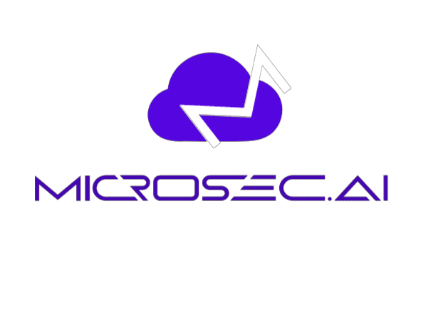



*Under the Guidance of:*

**Ms. Sushama Tanwar Mr. Jayant Byadwal**

Assistant Professor – I CEO at Microsec.ai Security

Department of CSE Technical Expert

Faculty Internship Guide Industry Guide

Department of Computer Science and Engineering

JECRC UNIVERSITY, JAIPUR

(2022)

**DECLARATION**

I hereby declare that the projects entitled **Cloud Security Software** is authentic record of my own work carried out at Microsec.ai Security as requirements of Six months of industrial project for the award of degree of B.tech from JECRC University, under the guidance of Mr. Jayant Byadwal and Ms. Sushama Tanwar, during 10 Jan 2022 to June 2022.

Shubham Kumar

18BCON459

Certified that the above statement made by the student is correct to the best of our knowledge.

**Ms. Sushama Tanwar**  **Mr. Jayant Byadwal**

Assistant Professor – I CEO at Microsec.ai Security

Faculty Internship Guide Industry Guide

**List of Content**

**Nomenclature Page no.**

* Page Title 37
* Declaration 38
* Abstract 40
* Overview of project 41
* Technology used 42
* Feasibility Study 44
* Conclusion 45

**Abstract**

Included in this paper are accounts of my Internship undertaken in the fulfilment of my B.Tech CSE degree from JECRC University. The Internship is with Microsec.ai Security Jaipur Rajasthan.

In this Internship I have learnt all the languages used in Backend development of the web application as well as at the Server side development of the websites. Some of them can be Python lang, Fast API, Bitbucket, Cloud Computing, DBMS

I have been working on our own company product. So included all the links and sample images for the same and gained. Leadership, confidence, determination. Increased technical knowledge while implementing those ideas.

**Overview**

**Microsec.ai Security:**

Microsec is backed by top venture funds, industry luminaries, and strategic partners. The Microsec.ai solution is an agentless, runtime Cloud Native Application Protection Platform (CNAPP) created to secure and protect multi-cloud IaaS and PaaS environments, containers, and data in one unified solution.

* One-click discovery and real-time visibility
* Cloud security posture management (CSPM) with runtime monitoring
* Cloud workload protection platform (CWPP) with self-healing micro segmentation
* Data loss prevention (DLP)

As an agentless solution, Microsec.ai delivers value in minutes. The only Cloud Native Application Protection Platform (CNAPP) to operate in runtime with east-west traffic control and DLP, Microsec.ai secures and protects multi-cloud IaaS and PaaS environments, containers, and data in one unified solution.

Full data loss prevention (DLP) capabilities automatically protect sensitive data at rest, and in motion. Network and architecture graph dashboards show resource relationships, sensitive data, traffic, vulnerabilities, misconfigurations, and compliance posture in context with instant click-to-fix capabilities. Microsec.ai performs cloud security posture management (CSPM) and cloud workload protection (CWP) automatically and continuously protects cloud native applications and data through ML-based detections and responsive policies.



Microsec.ai was founded by industry veterans Mitthan Meena and Deena Thomchick who were instrumental in the development of one of the most successful Cloud Access Security Broker (CASB) solutions on the market. In Microsec.ai, they plan to deliver protection for IaaS environments that’s even more dynamic and comprehensive than CASB for Software as a Service.

**Technology Used**

**Python language:**

Python is a high-level, general-purpose programming language. Its design philosophy emphasizes code readability with the use of significant indentation. Its language constructs and object-oriented approach aim to help programmers write clear, logical code for small- and large-scale projects.

**Bitbucket:**

Bitbucket is our Git repository management solution designed for professional teams. It gives you a central place to manage git repositories, collaborate on your source code and guide you through the development flow.

**VSCode:**

Visual Studio Code is a streamlined code editor with support for development operations like debugging, task running, and version control. It aims to provide just the tools a developer needs for a quick code-build-debug cycle and leaves more complex workflows to fuller featured IDEs, such as Visual Studio IDE.

**Fast API:**

Fast API is a modern, fast (high-performance), web framework for building APIs with Python 3.6+ based on standard Python type hints.

**PostMan:**

Postman is an application used for API testing. It is an HTTP client that tests HTTP requests, utilizing a graphical user interface, through which we obtain different types of responses that need to be subsequently validated.

**MySQL:**

MySQL is a relational database management system based on SQL – Structured Query Language. The application is used for a wide range of purposes, including data warehousing, e-commerce, and logging applications. The most common use for MySQL however, is for the purpose of a web database.

**Docker:**

Docker is an open-source containerization platform. It enables developers to package applications into containers—standardized executable components combining application source code with the operating system (OS) libraries and dependencies required to run that code in any environment.

**Virtual Machines**:

A Virtual Machine (VM) is a compute resource that uses software instead of a physical computer to run programs and deploy apps. One or more virtual “guest” machines run on a physical “host” machine.

**Feasibility Study**

System testing is the stage of implementation, which is aimed at ensuring that the system works accurately and efficiently before live operation commences. Testing is the process of executing the program with the intent of finding errors and missing operations and also a complete verification to determine whether the objectives are met and the user requirements are satisfied. The ultimate aim is quality assurance.

Tests are carried out and the results are compared with the expected document. In the case of erroneous results, debugging is done. Using detailed testing strategies a test plan is carried out on each module. The various tests performed in “Network Backup System” are unit testing, integration testing and user acceptance testing.

**Unit Testing:**

The software units in a system are modules and routines that are assembled and integrated to perform a specific function. Unit testing focuses first on modules, independently of one another, to locate errors. This enables, to detect errors in coding and logic that are contained within each module. This testing includes entering data and ascertaining if the value matches to the type and size supported by java. The various controls are tested to ensure that each performs its action as required.

**Integration Testing:**

Data can be lost across any interface, one module can have an adverse effect on another, sub functions when combined, may not produce the desired major functions. Integration testing is a systematic testing to discover errors associated within the interface. The objective is to take unit tested modules and build a program structure. All the modules are combined and tested as a whole. Here the Server module and Client module options are integrated and tested. This testing provides the assurance that the application is well integrated functional unit with smooth transition of data.

**User Acceptance testing:**

User acceptance of a system is the key factor for the success of any system. The system under consideration is tested for user acceptance by constantly keeping in touch with the system users at time of developing and making changes whenever required.

**Conclusion**

* From this Internship of 3 months till now, I get to know about the company environment like how the company works on such kind of projects.
* I learnt about different tools and technology which are use to develop any product.
* Using my theoretical knowledge, I got the chance to implement them practically with live projects.
* I can able to get improve my logics much better than before.
* I get Hands on experience with Python technology and worked on different cloud.
* I am now able to work on both frontend and backend for the web Applications.
* I learnt about how to handle huge amount of data from any client or company.
* How Vm works on clouds and how it will be implemented using codes, I get hands on experience on it.
* Till now this internship has been an excellent and rewarding experience for me and I hope I could continue this way. I can conclude that there has been a lot I've been learning from my work at Microsec. The technical aspects of the work I've done are not flawless and could be improved provided enough time.