1. service cloudera-scm-server status
2. su
3. service cloudera-scm-server status
4. Go to the **Launch Cloudera Express**
5. Copy the sudo /home/cloudra/ cloudra-manager –force --express

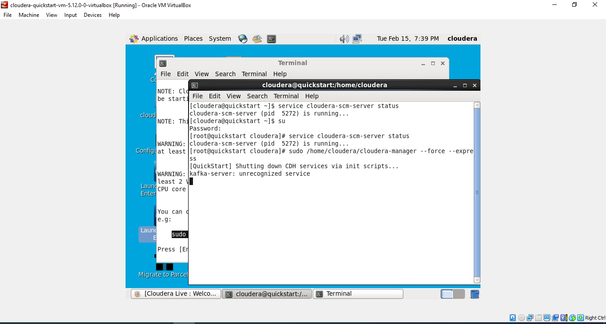

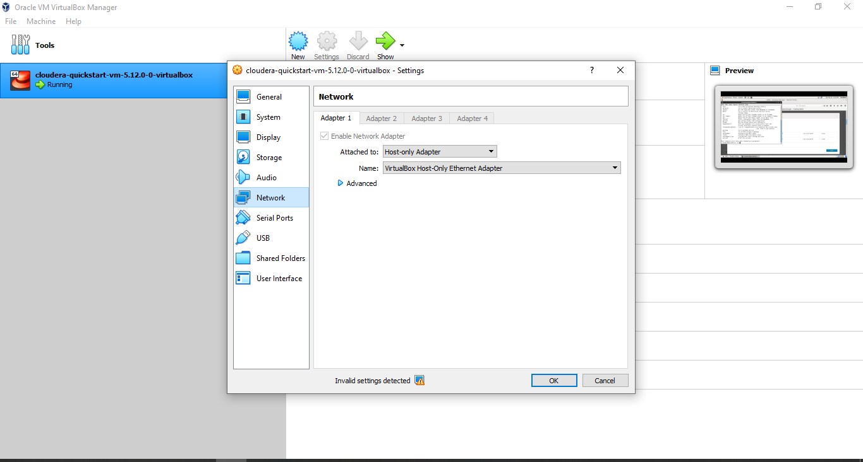

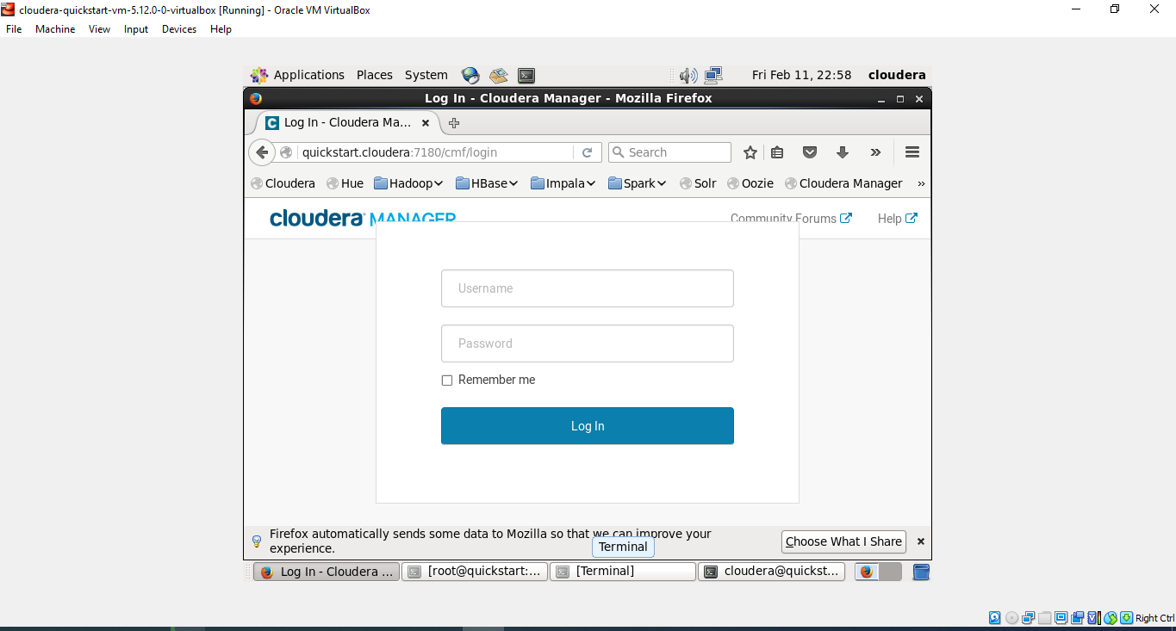

Usrname: cloudera

Password: cloudera

1) Hadoop Version

->hadoop version

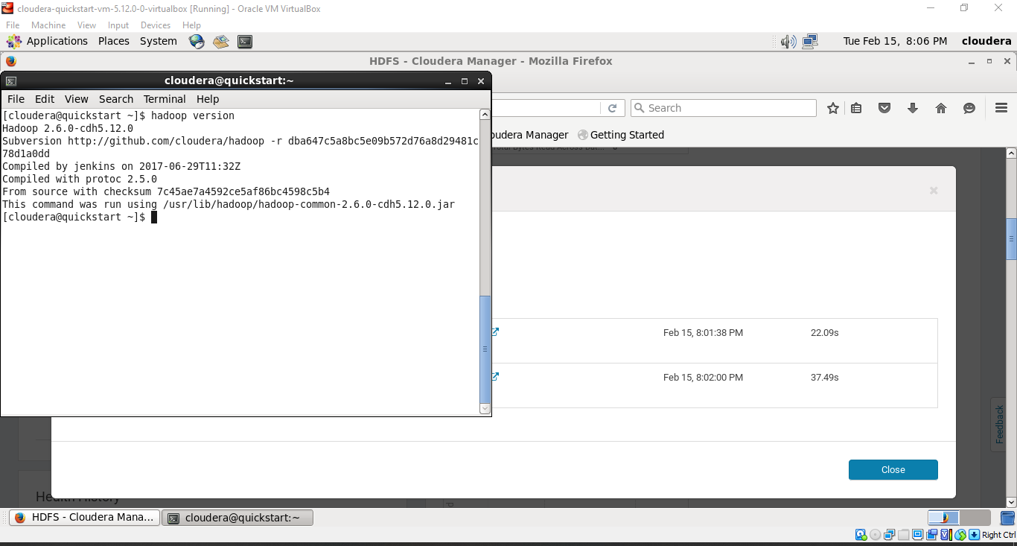

2) LS Command

->hdfs dfs -ls /

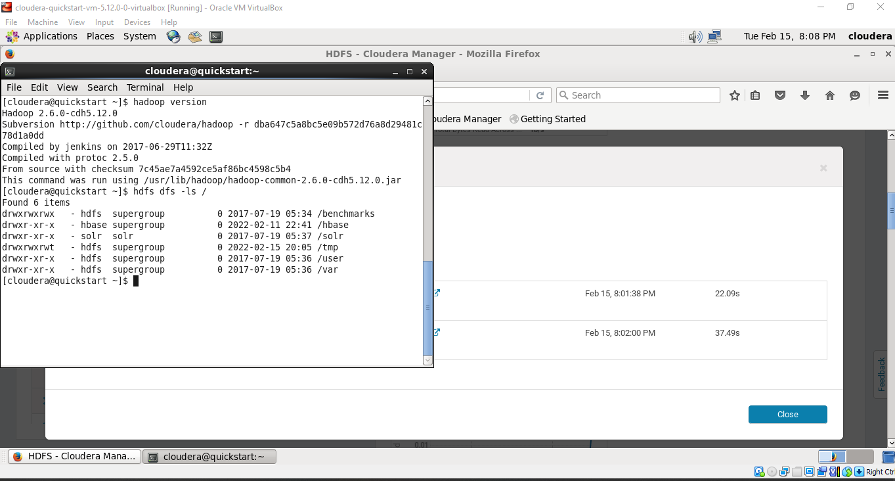

->hadoop fs -ls /

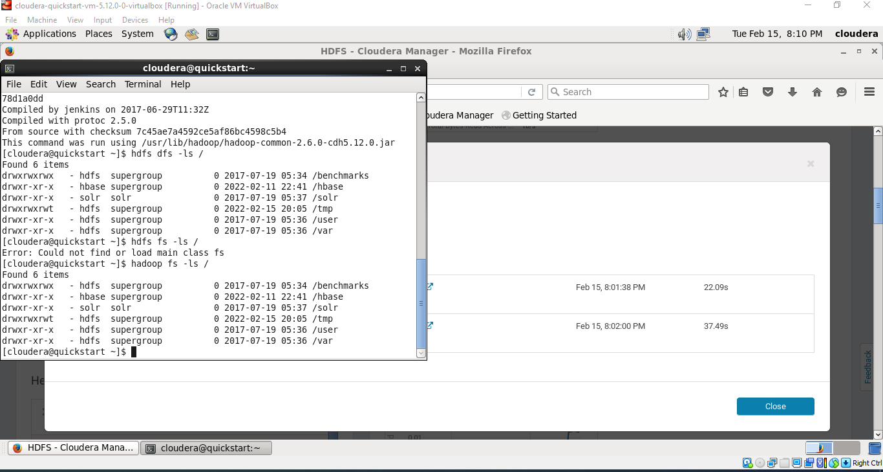

2) MKDIR Comman

Usage: hdfs dfs –mkdir /directory_name

If not created then use this command-> **Sudo -u hdfs hdfs dfs -mkdir /dir_name**

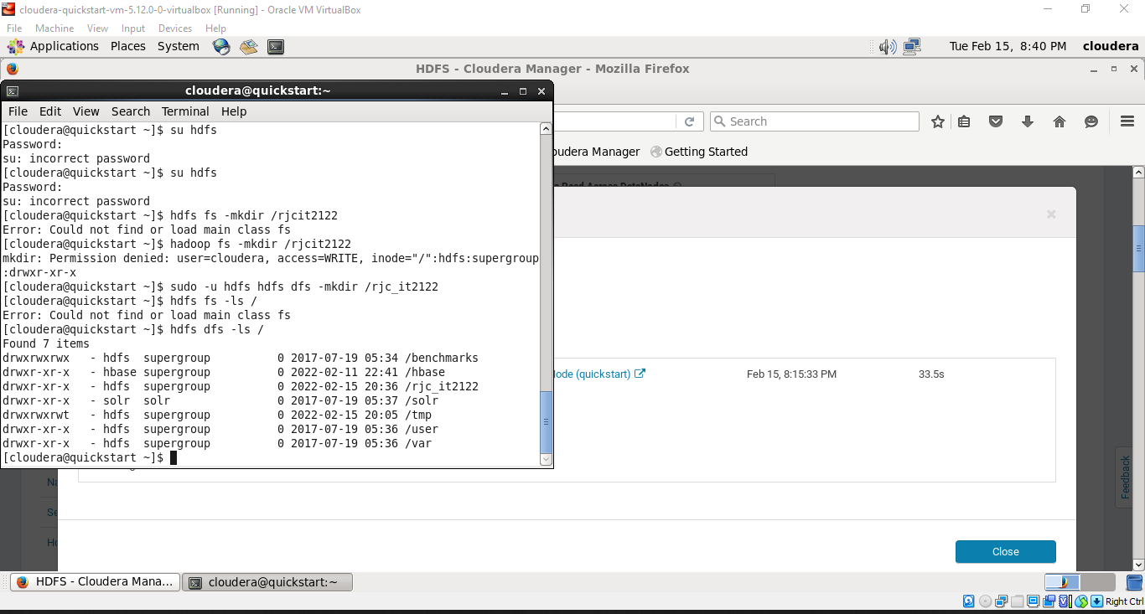

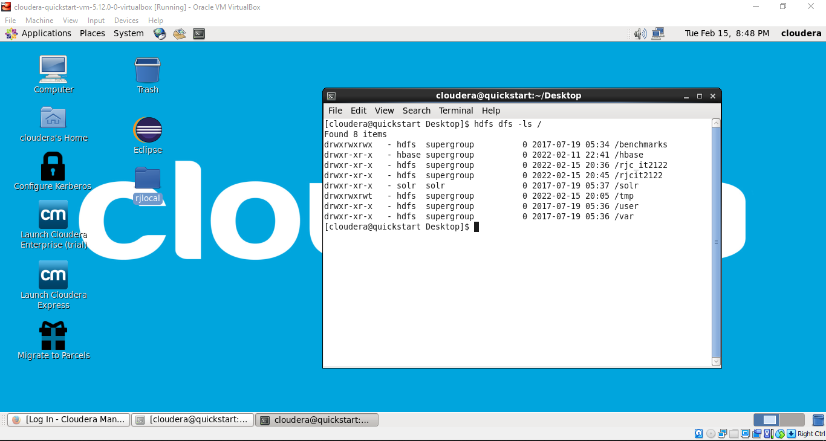

Create folder and file on desktop

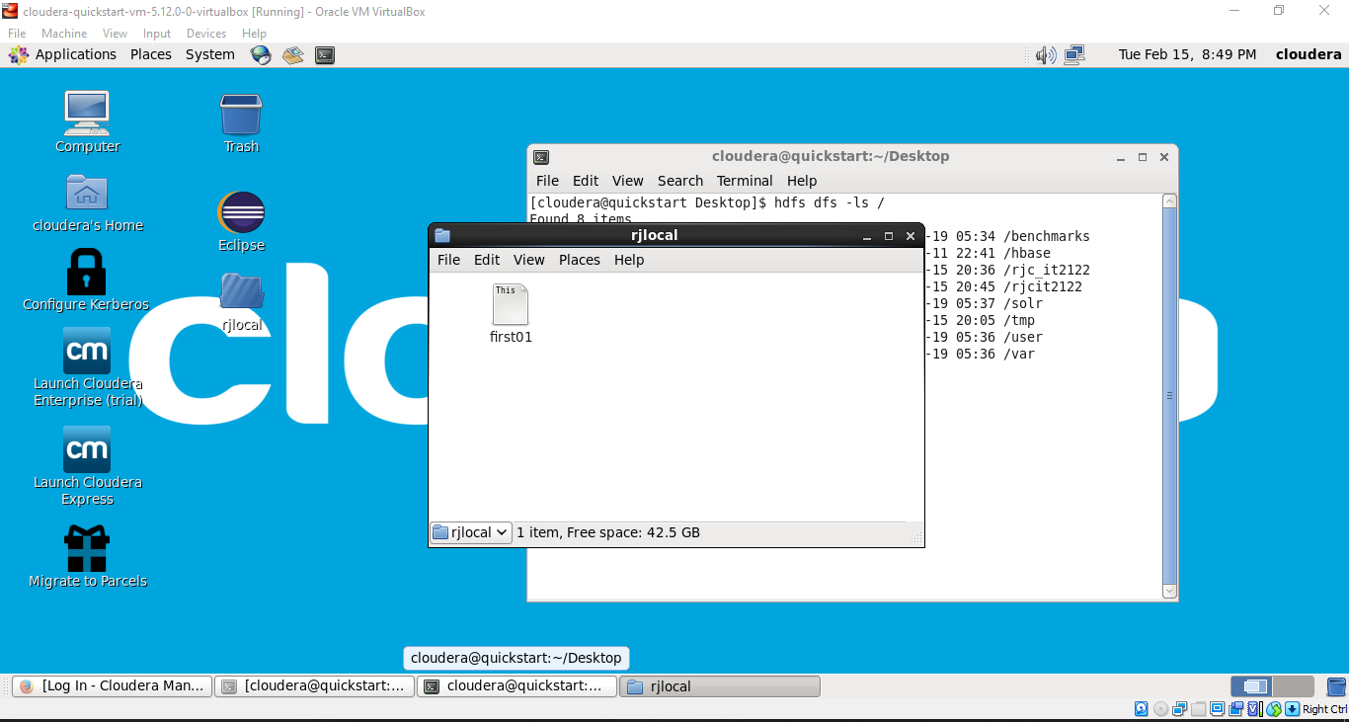

->hdfs dfs -copyFromLocal /home/cloudera/Desktop/dir_name /file_name

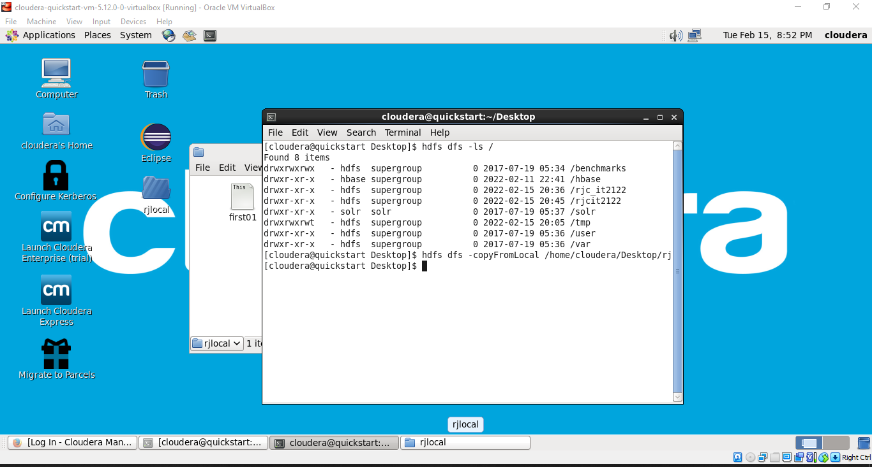

**If getting any error due to permissions**

**=>>>>>>>export HADOOP_USER_NAME=hdfs**

**Put Command -> hdfs dfs -put /home/cloudera/Desktop/dir_name /file_name**

