**Hive command**

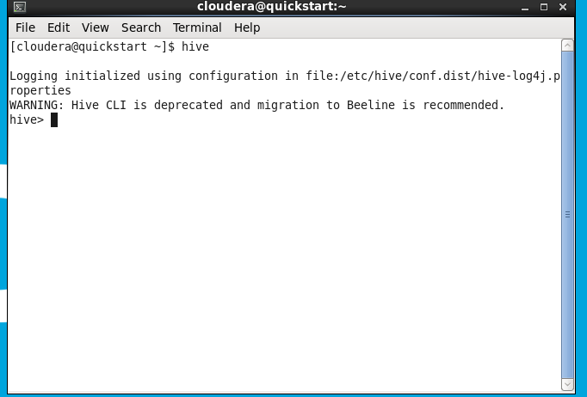

**Show databases;**

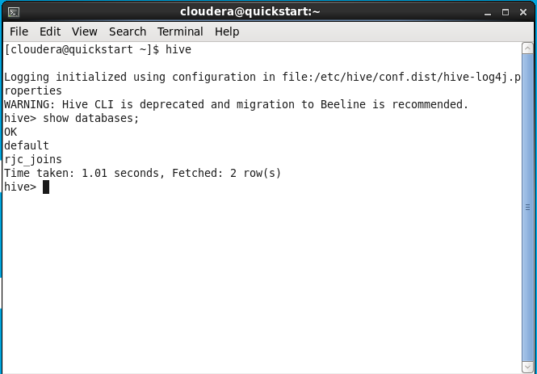

**Create database RJC;**



**Use rjc;**

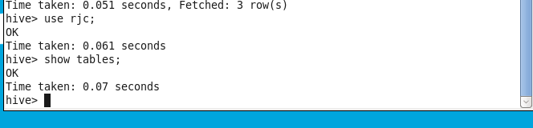

**drop rjc;**



**Create database RJC;**



**Use rjc;**



**create table employee**

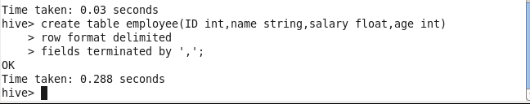

**describe employee;**



**describe formatted employee;**

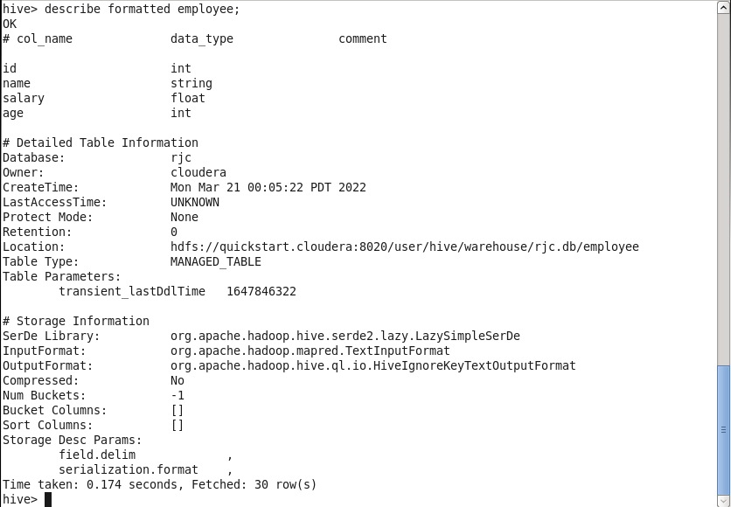

**create external table emloyee2**

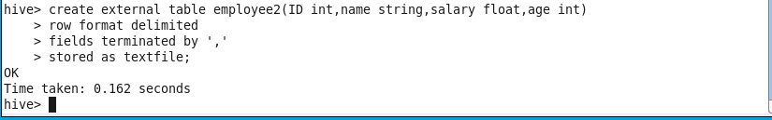

**describe employee2;**

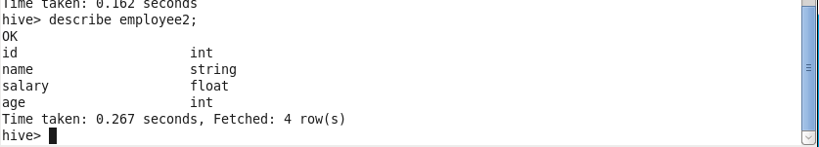

**describe formatted employee2;**

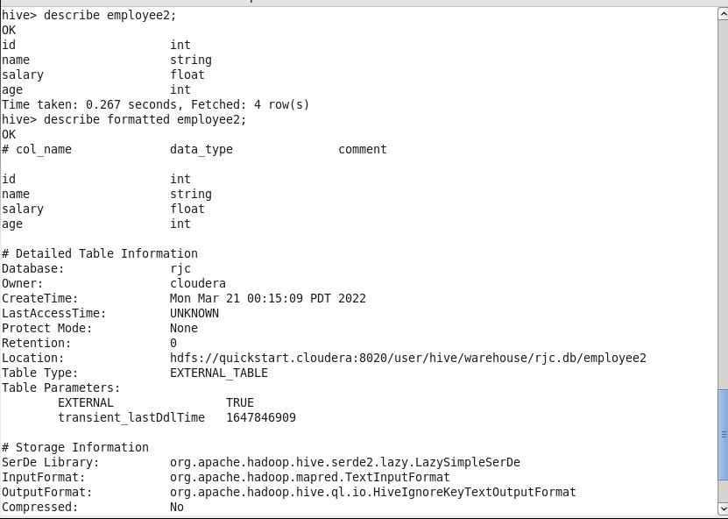

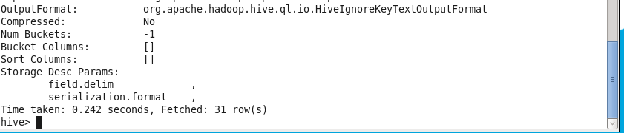

**Open the browser**

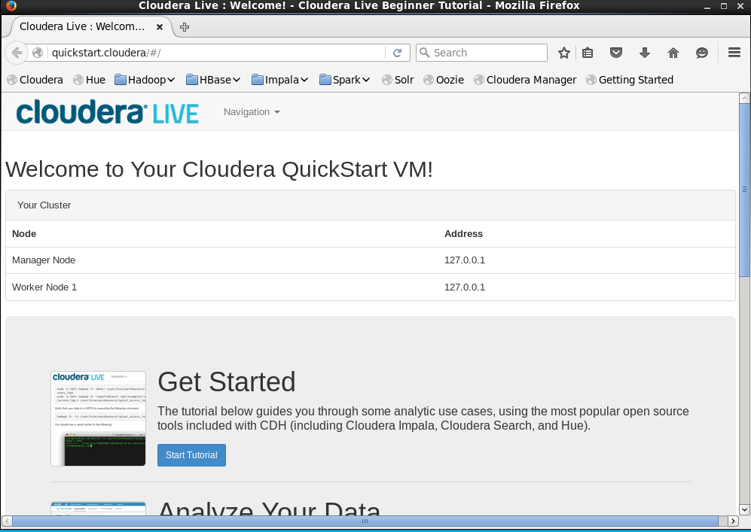

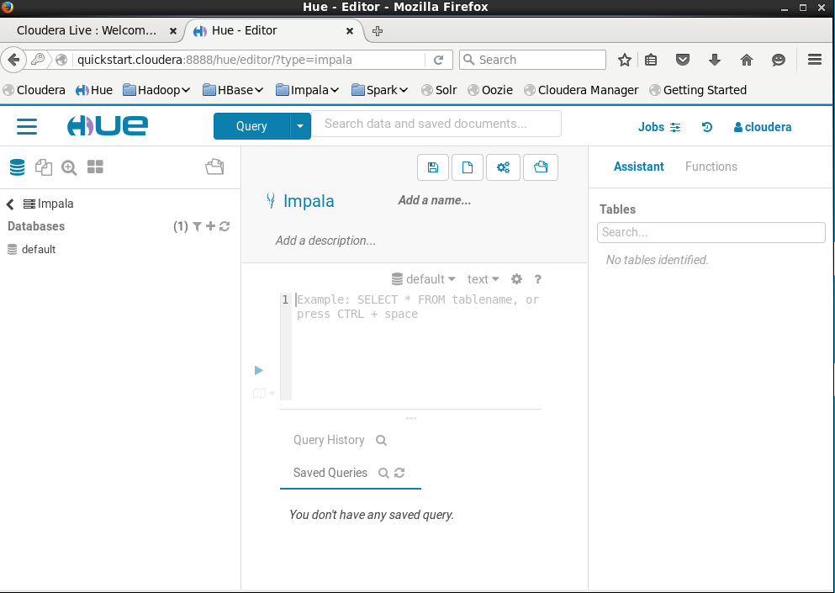

Show databases

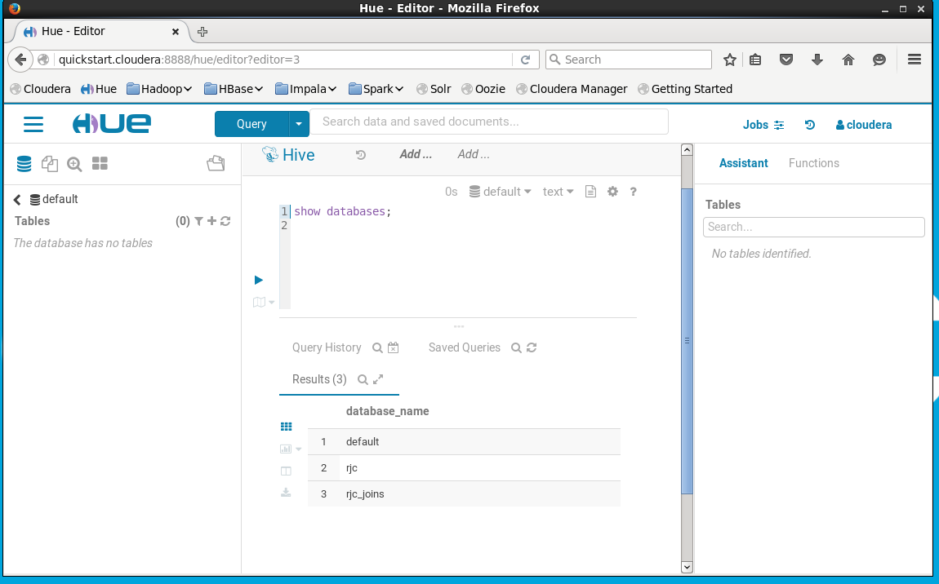

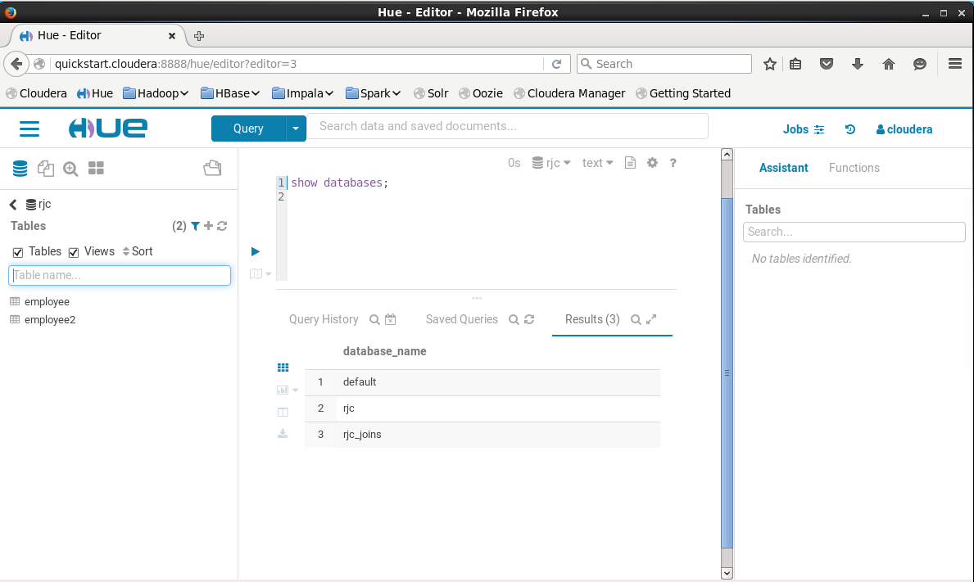

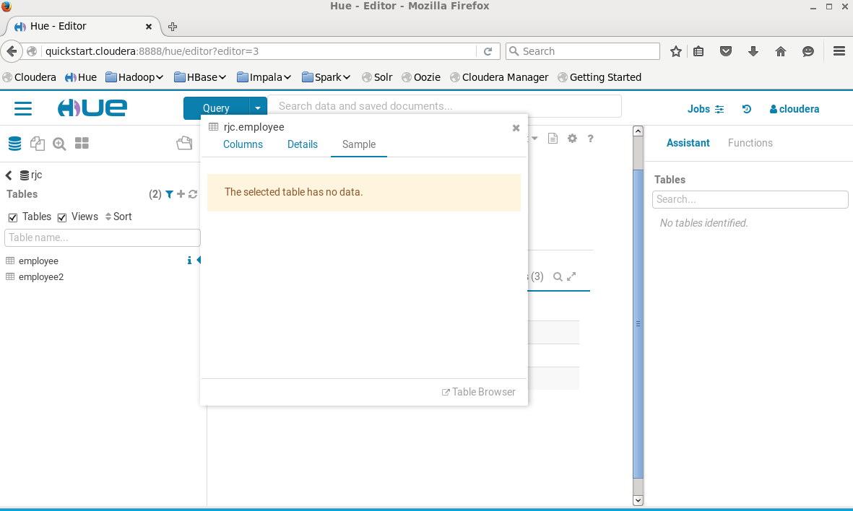

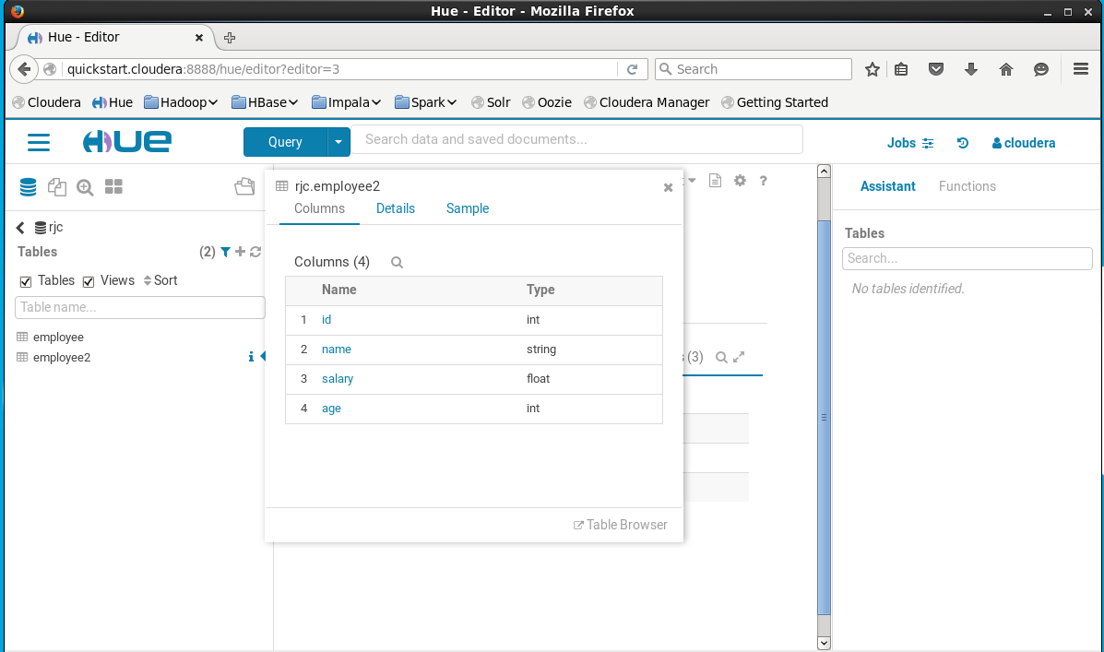

Create employee3

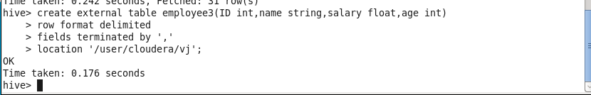

Describe employee3

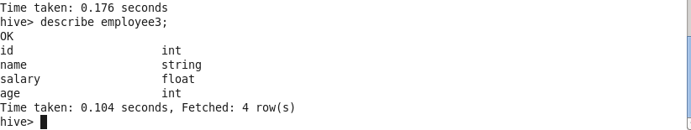

Now refresh browser ,employee3 is also generated in rjc database.

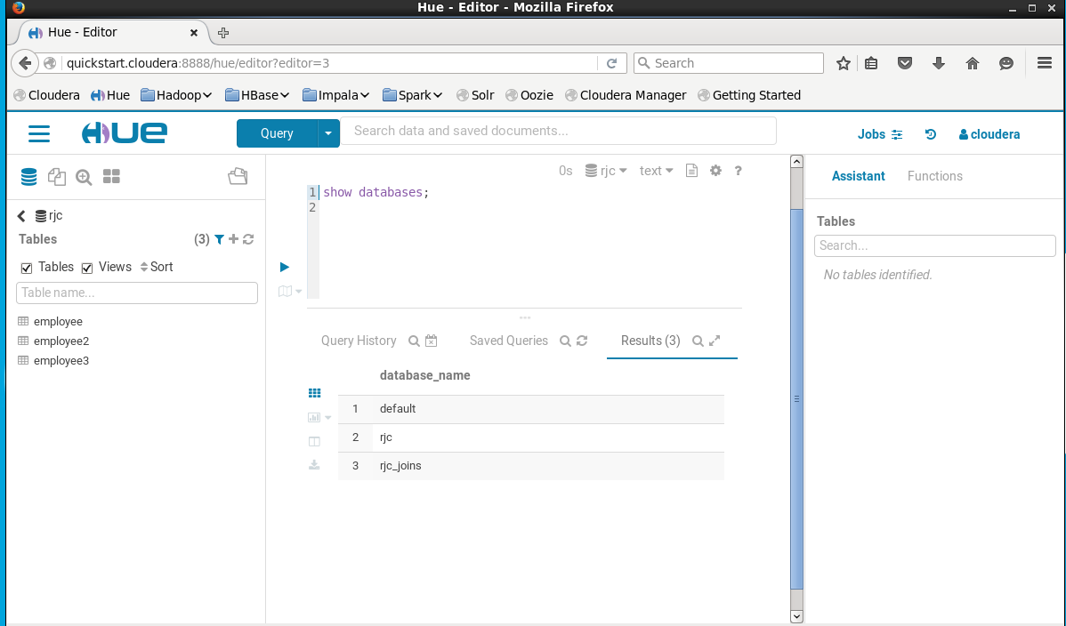

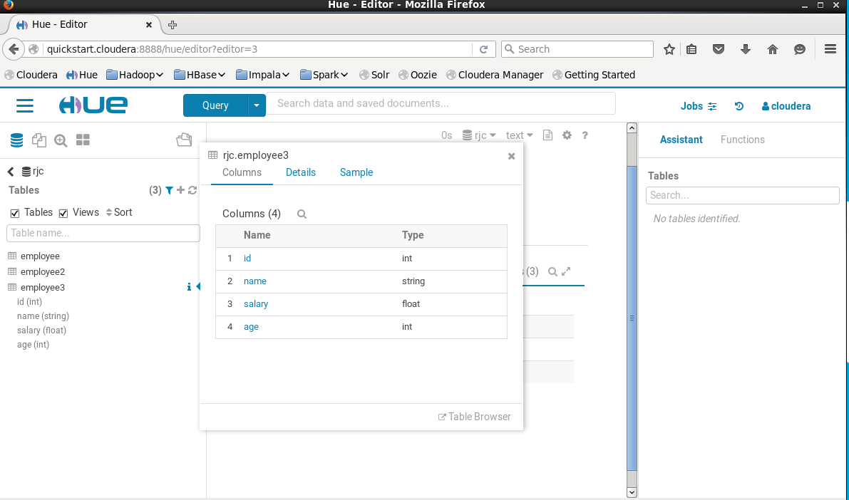

Listing out all tables

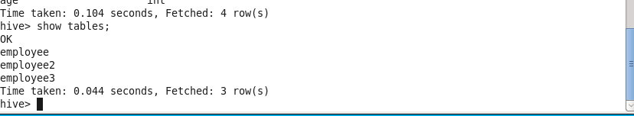

Alter table



Show tables after altering



describe emptable;

Alter table emptable add columns (surname string);

describe emptable;



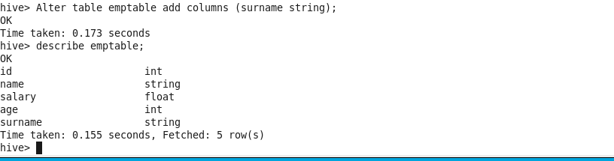

Alter table emptable change name first_name string;

describe emptable;

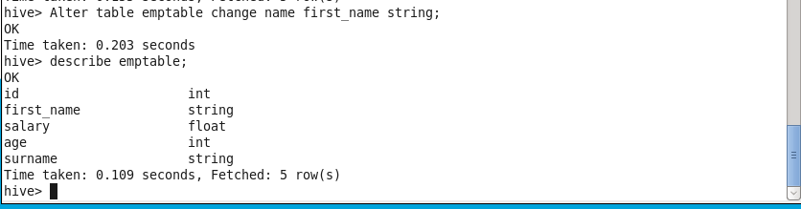

**Loading the data in the table**

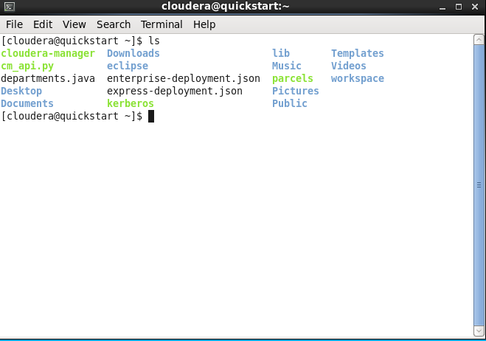

gedit command





Inset data in student.csv file

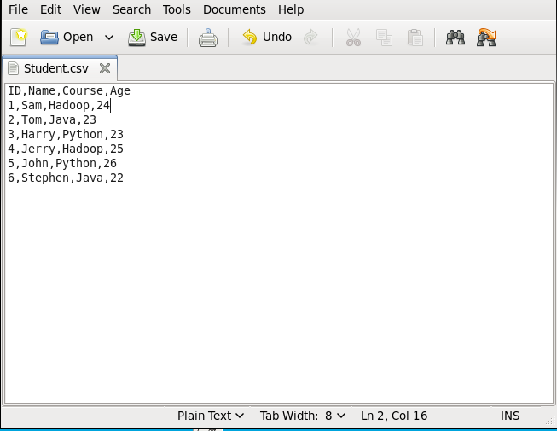

**create database rjcstudent;**

**show databases;**

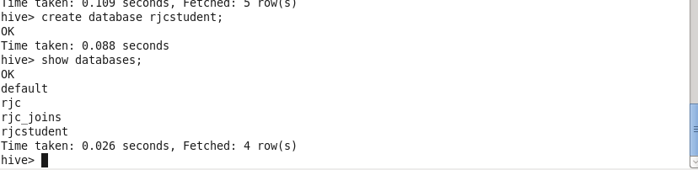

**Use rjcstudent;**



Use rjcstudent;

Create table student

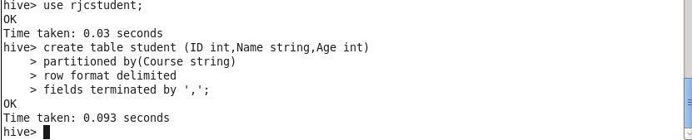

Describe Student



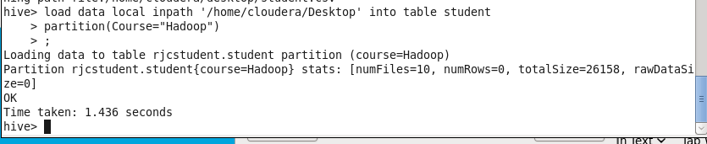

Select * from Student

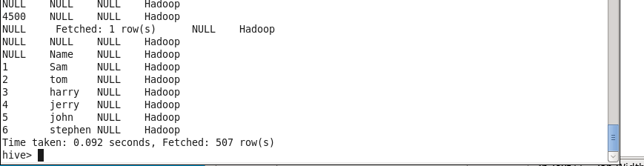

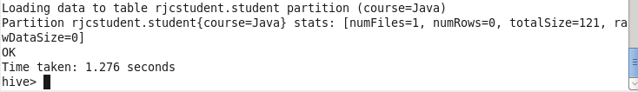

Again Create Table Student

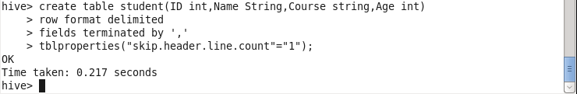

Select * from student



Gedit employee.csv



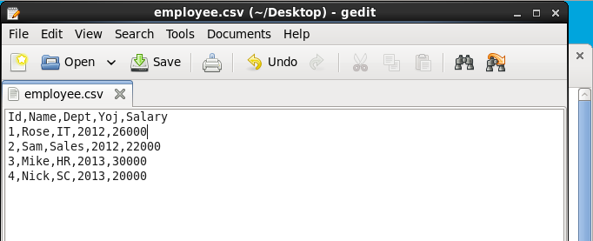

Create database hiveeql



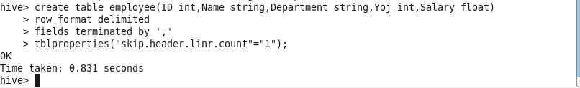

**Describe employee**

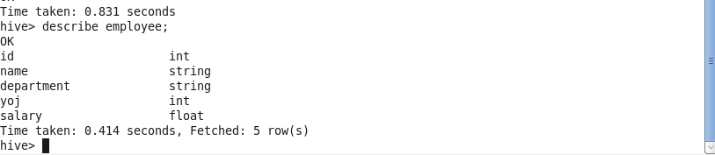

**Select * from employee**

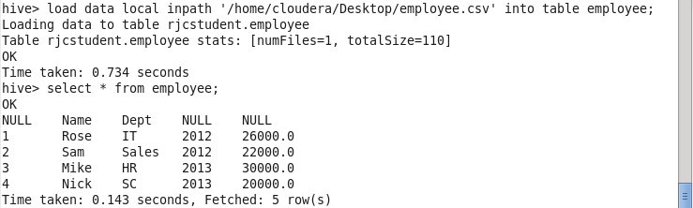

**select * from employee where salary >=25000;**

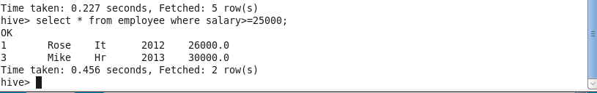

**select * from employee where salary <=25000;**

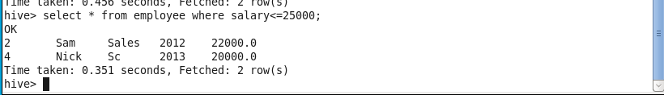

**Aggregating**

**41.Arithmetic operations:**

select ID, name, salary + 5000 from employee;

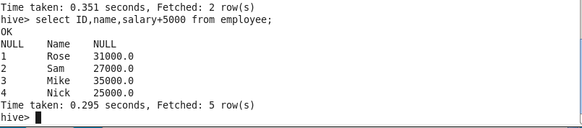

**select max(salary) from employee;**

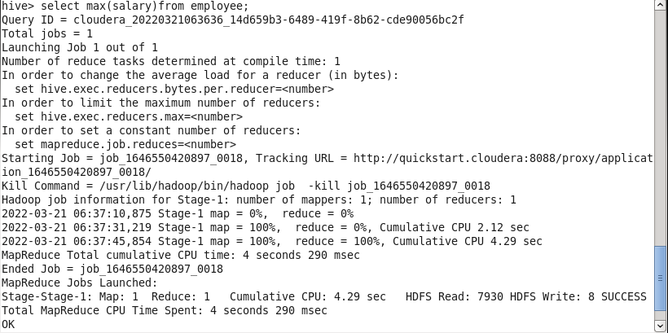

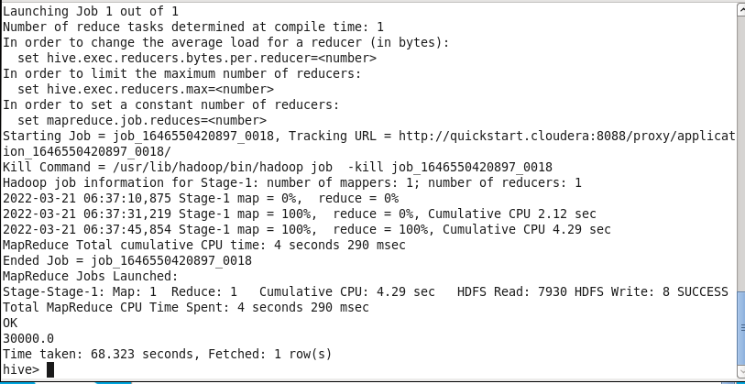

**select min(salary) from employee;**

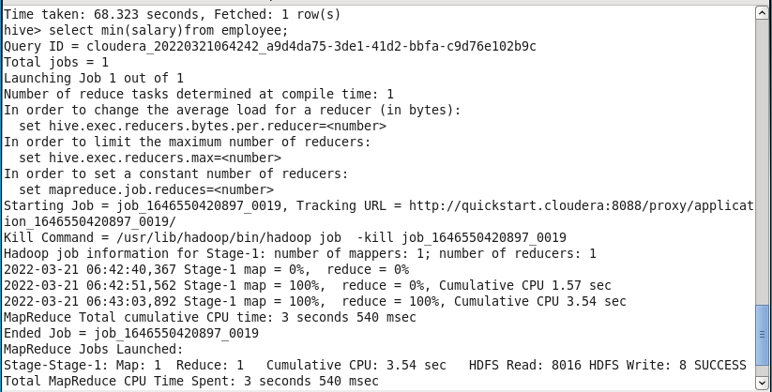

**Select ID, name, sqrt(salary) from employee;**

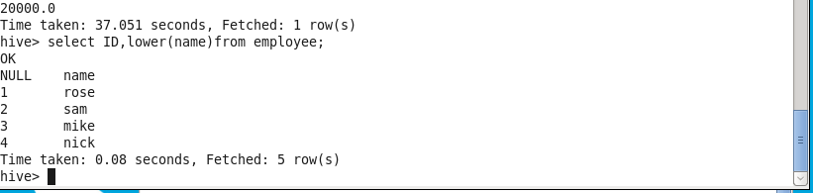

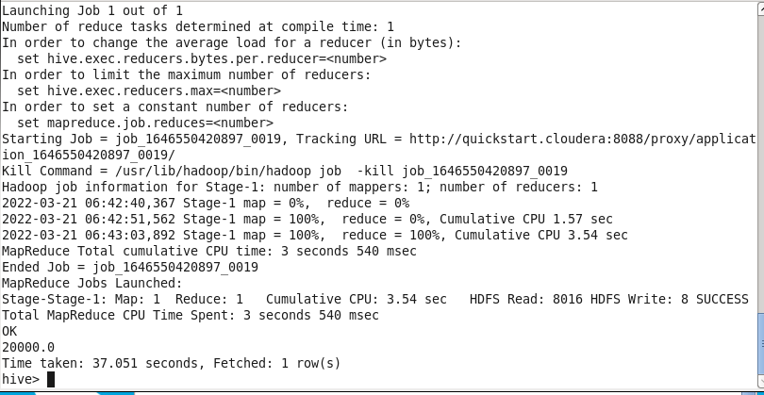

**Select ID, name, sqrt(salary) from employee;**

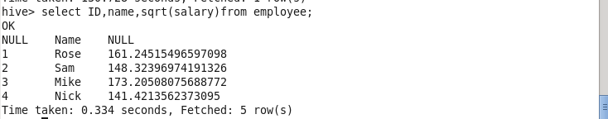

**select ID, upper(name) from employee;**



**select ID, lower(name) from employee;**

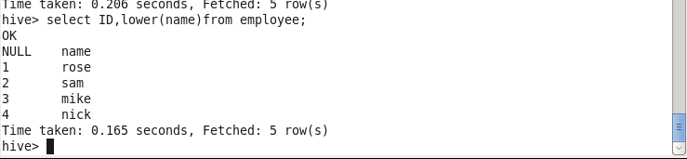

**Creating a new table as empgroup.**

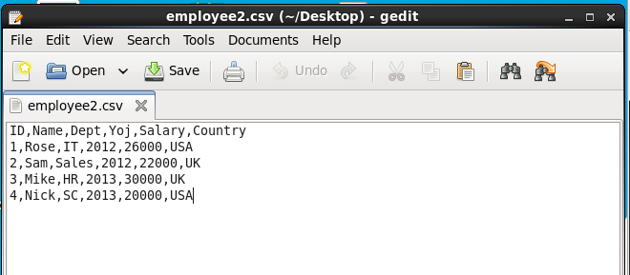

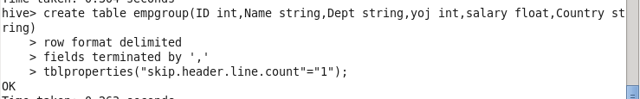

select * from empgroup;

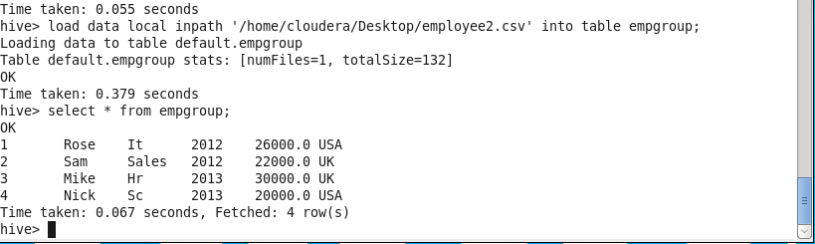

**Groupby clause**

select country, sum(salary) from empgroup group by country;

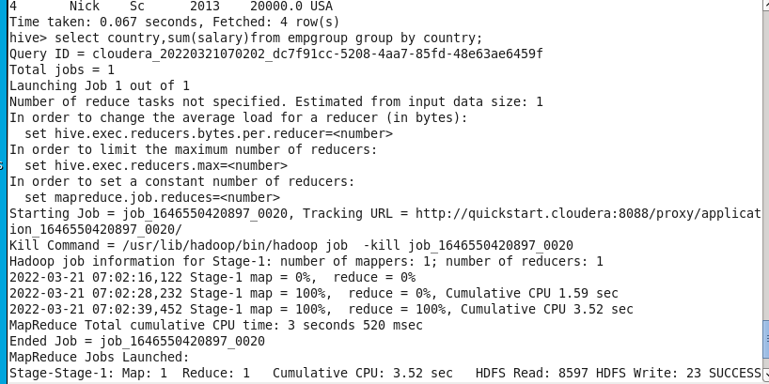

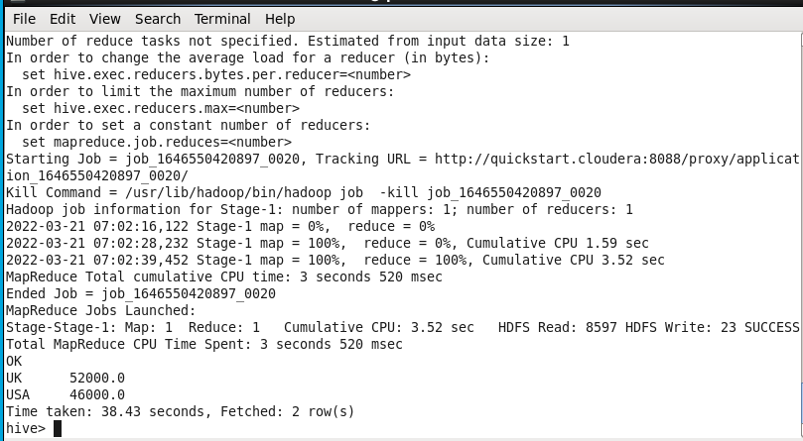

**Groupby clause along with the having clause**

select country, sum(salary) from empgroup group by country having sum(salary)>50000;

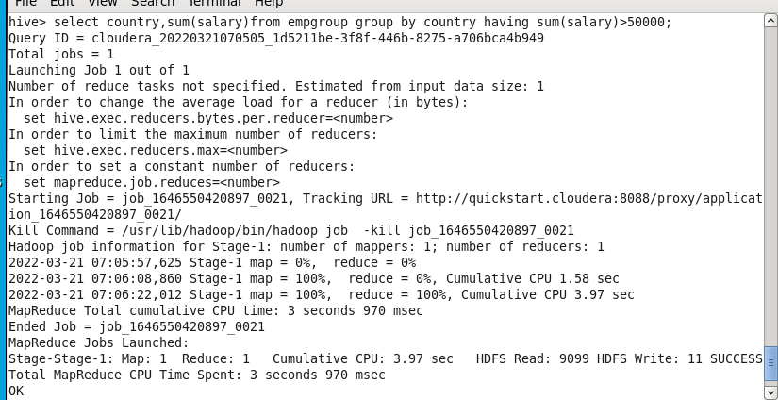

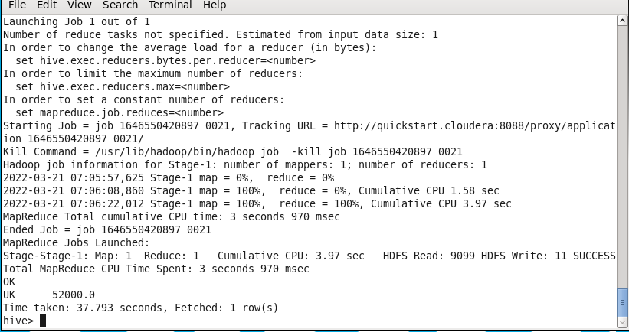

**Sorting : Order by**

**Select * from empgroup order by salary desc;**

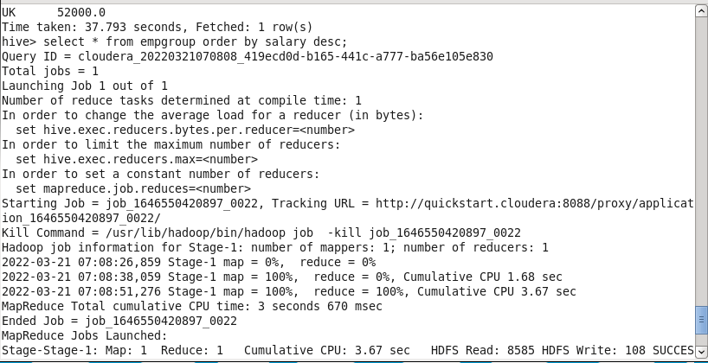

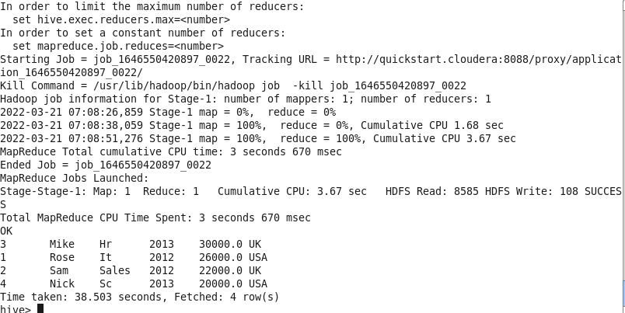

**Select * from empgroup sort by salary desc;**

