



Report By: Kaushal Ghimire

UoN ID: 20416226

Name of File: CSY2028_assignment_technical_report_Kaushal_ghimire.docx

Word Count:1479

Fafa

**Table Of Content**

1. Introduction
   1. Introduction Task
   2. Aims and Objective
2. Implemented Features Checklist
3. Table of Testing Features
4. Testing screenshot
5. References
6. INTRODUCTION
   1. **Introduction to the task**

This is the report of assignment csy2028 (web programming) which was given to the student of Level 5 student as the assignment 1. The assignment is the making an e-newspaper (website) of local newspaper of Northampton by implementing some features using PHP programming language.

* 1. **Aims and objective**

Aims:

In this assignment, the main aim of this project is to design and develop a E-newspaper with some basic and advance functionalities.

Objectives:

1. To add news categories and assign post to it.
2. To edit and delete the existing post or categories.
3. To make visible all the news in the home page with the recently posted post.
4. To make categories in drop down menus using html and css.
5. To make clickable category link, for displaying all post related to that category.
6. To make to add a comment to the post for only subscribed of Logged user.
7. To allow to upload an image to a post and profile image.
8. To make a comment approve disapprove functionalities.
9. To make social media buttons for sharing the posts, and allow user to search the post title.
10. To make An Administration area.
11. To make a secure login and signup system with password hashing function.
12. Implemented Features Checklist

This is the table of the features and functionalities that are implemented to the e-newspaper.

|  |  |  |  |
| --- | --- | --- | --- |
| **Newspaper**  **Functionality** | **Completed?**  **(yes/no/partially)** | **Relevant files containing code for the this features** | **Any comments (e.g. usernames/passwords, known bugs/issues) or URL if different to filename.** |
| Subscriber/Administrator login | yes | Login.php | Administrator Login:  *Email:*  [*admin@gmail.com*](mailto:admin@gmail.com)  *password: admin*  News Post admin:  [rame@gmail.com](mailto:rame@gmail.com), pass: rame |
| Subscriber register/signup | yes | Register.php |  |
| Check registered or login Input credentials | yes | authenticationController.php |  |
| Add admin | yes | Add_admin.php |  |
| Delete admin | yes | Delete.php |  |
| Edit admin | yes | Edit_admin.php |  |
| View admin | yes | view_admin.php |  |
| Add categories | yes | Add_category.php |  |
| Edit category | yes |  |  |
| Delete category | yes | Delete.php |  |
| Add new post | yes | Create_post.php |  |
| Delete post | yes | edit_view_delete_post.php |  |
| Edit post | yes | Edit_post.php |  |
| View post | yes | View_all_post.php |  |
| Post comment | yes | Post_comment.php |  |
| Update account | yes | Update_account.php |  |
|  | yes |  |  |
| View all post | yes | view_all_post.php |  |
| View latest post | yes | Latest-article.php |  |
| View popular post | yes | Index.php |  |
| View profile | yes | View_profile.php |  |
| View user comment | yes | View_user_comment.php |  |
| Delete comment | yes | Post_comment.php |  |
| Approve comment | yes | Post_comment.php |  |
| Single post view | yes | Single_post_view.php |  |
| Share post | yes | Share.php |  |
| Category post view | yes | Category_post_view.php |  |
| Author post view | yes | Author_post.php |  |
|  |  |  |  |

1. Table of testing of Features

|  |  |  |  |  |
| --- | --- | --- | --- | --- |
| **SN** | **Implemented features** | **Expected Outcomes** | **Actual Outcomes** | **Remarks** |
| 1. | Login and register page input field credential check up | Empty field and wrong credentials should through warning. | Empty field and wrong credentials through warning. | An expected outcome is same as actual outcomes. |
| 2. | Displaying popular post in index/home page | Post having highest views should display. | Post having highest views displayed. | An expected outcome is same as actual outcomes. |
| 3. | Display post related to a particular author when clicked on author name. | Related particular author’s post should display. | Related particular author’s post displayed. | An expected outcome is same as actual outcomes. |
| 4. | Display post related to a particular category when clicked on category name. | Related particular category’s post should display. | Related particular category’s post displayed. | An expected outcome is same as actual outcomes. |
| 5. | Show Category Drop down menu list with all the category item and follow No.4. | Category should be in Drop down menu list and follow No.4 | Category is in Drop down menu list and followed No.4 | An expected outcome is same as actual outcomes. |
| 6. | Views increase by 1 when the post page is refreshed. | Views should be increased by 1 when the post page is refreshed. | Views increased by 1 when the post page is refreshed. | An expected outcome is same as actual outcomes. |
| 7. | Search input field search the post by title name. | Search input field should search the post by title name. | Search input field searched the post by title name. | An expected outcome is same as actual outcomes. |
| 8. | Login and register button dis-appear and display Logout button when logged in. | Login and register button should dis-appear and Logout button should display when logged in. | Login and register button dis-appeared and Logout button displayed when logged in. | An expected outcome is same as actual outcomes. |
| 9. | Comment Box not display when logged-off, but display when logged on. | Comment Box should not be displayed when logged-off, but should display when logged on. | Comment Box does not displayed when logged-off, but displayed when logged on. | An expected outcome is same as actual outcomes. |
| 10. | Posted Comment goes to post admin for approval. And display when approved. | Posted Comment should go to post admin for approval. And display when approved. | Posted Comment goes to post admin for approval. And displayed when approved. | Expected outcomes matched with actual outcomes. |
| 11. | User reply comment by clicking reply button | User should reply comment by clicking reply button | User cannot able to reply comment by clicking reply button | Expected outcomes does not matched with actual outcomes. |
| 12. | Post share to social media when clicked to Facebook or Twitter Icon. | Post should share to social media when clicked to Facebook or Twitter Icon. | Post shared to social media when clicked to Facebook or Twitter Icon. | Expected outcomes matched with actual outcomes. |
| 13. | All news navigation link display all news in the website | All news navigation link should display all news in the website | All news navigation link displayed all news in the website | Expected outcomes matched with actual outcomes. |
| 14. | News poster admin, create article to a particular category. | News poster admin should able to, create an article to a particular category. | News poster admin is able to create an article to a particular category. | Expected outcomes matched with actual outcomes. |
| 15. | News poster admin, edit, delete and view all his/her posted article. | News poster admin should able to, edit, delete and view all his/her posted article. | News poster admin is able to, edit, delete and view all his/her posted article. | Expected outcomes matched with actual outcomes. |
| 16. | Display all approved and not approved comment related to a particular news poster admin. | Should Displayed all approved and not approved comment related to a particular news poster admin. | Displayed all approved and not approved comment related to a particular news poster admin. | Expected outcomes matched with actual outcomes. |
| 17. | News poster admin approves or delete his post’s comment. | News poster admin should approve or delete his post’s comment. | News poster admin can approve or delete his post’s comment. | Expected outcomes matched with actual outcomes. |
| 18. | Display all comment, commented by a user when clicked to username. | Should Display all comment, commented by a user when clicked to username. | Displayed all comment, commented by a user when clicked to username. | Expected outcomes matched with actual outcomes. |
| 19. | Admin view and edit their profile picture and details. | Admin should view and edit their profile picture and details. | Admin viewed and edited their profile picture and details. | Expected outcomes matched with actual outcomes. |
| 20. | Administrator add new administrator, news poster admin, subscriber user. | Administrator should add new administrator, news poster admin, subscriber user. | Administrator added new administrator, news poster admin, subscriber user. | Expected outcomes matched with actual outcomes. |
| 21. | Administrator view, edit and delete admin, news-poster admin and subscriber. | Administrator should view, edit and delete admin, news-poster admin and subscriber. | Administrator viewed edited and deleted admin, news-poster admin and subscriber. | Expected outcomes matched with actual outcomes. |
| 22. | Administrator add , edits and delete category | Administrator should add , edits and delete category |  | Expected outcomes matched with actual outcomes. |
| 23. | Administrator view all the posts | Administrator should view all the posts | Administrator viewed all the posts | Expected outcomes matched with actual outcomes. |

1. **Testing screenshot**
2. Some screenshot of tested output is below:

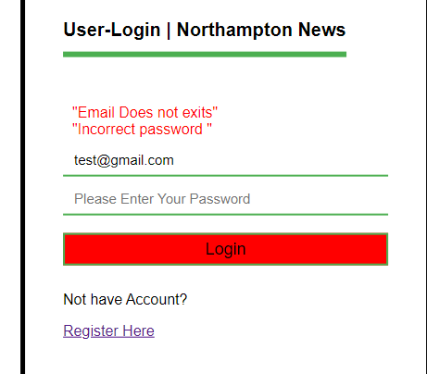

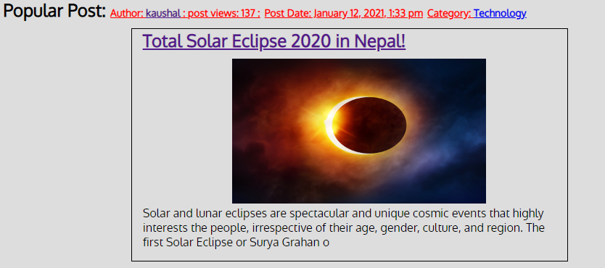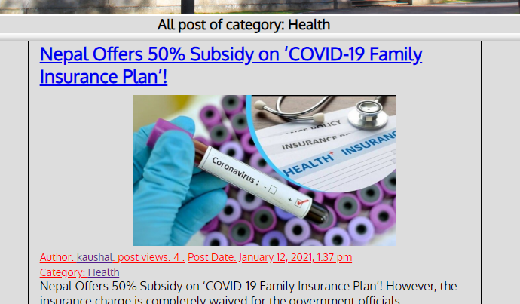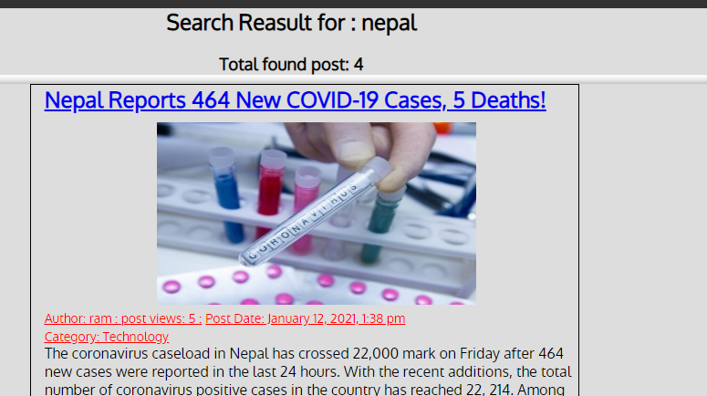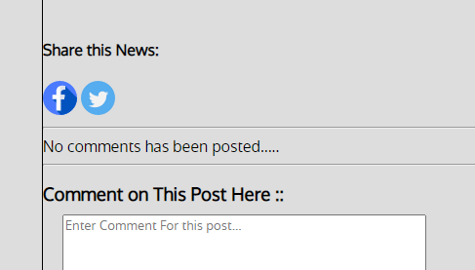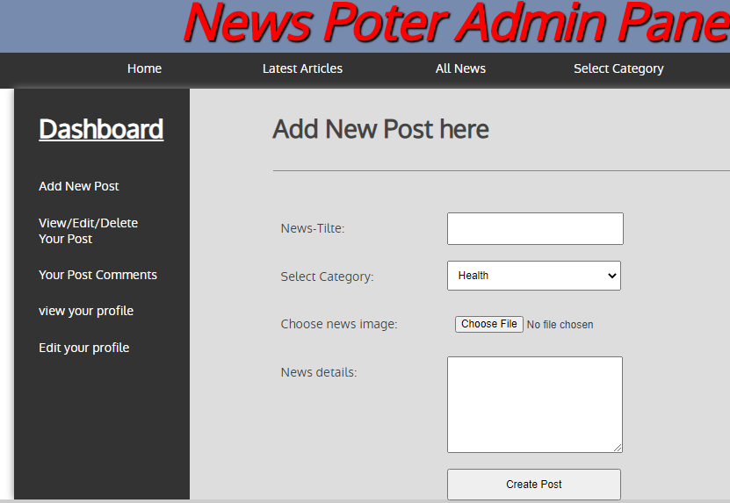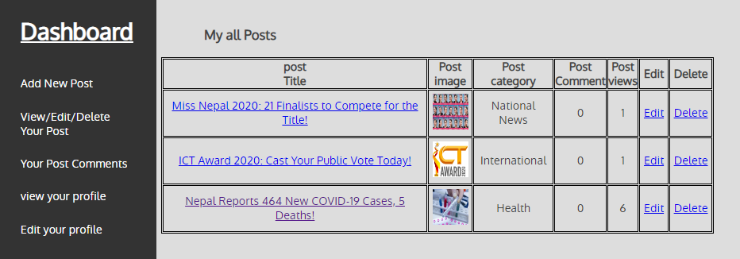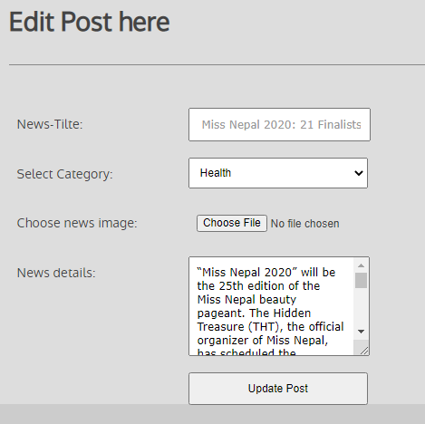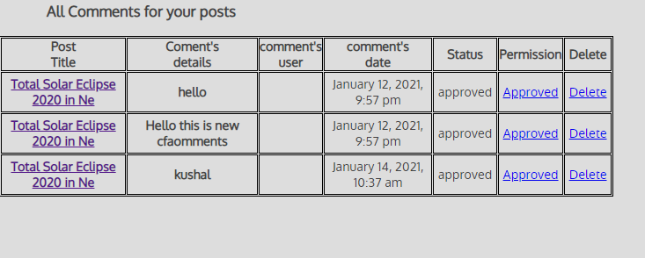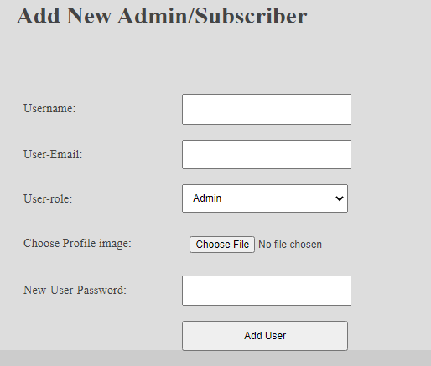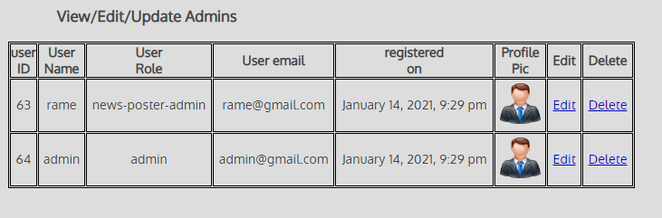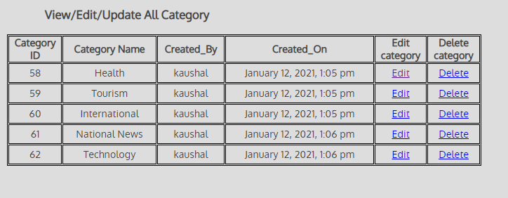

**5. References**

1. Udemy.com (2010). *The Complete Web Development Course with PHP, PDO _ MySQL* [Online].Available at: https://www.udemy.com/course/the-complete-web-development-course-with-php-pdo-mysql/ [Accessed 19 Dec 2020].
2. Stackoverflow.com (2011). *How To echo alert before header redirects to another page*[Online].Available at: https://stackoverflow.com/questions/55648560/php-how-to-echo-alert-before-header-redirects-to-another-page/55648833 [Accessed 23 Dec 2020].
3. Nile.northampton.ac.uk (2020). *Blackboard Learn* [Online]. Available at: https://nile.northampton.ac.uk[Accessed 20 Dec 2020].
4. Stackoverflow.com (2011). *Using href links inside option tag* [Online].Available at: https://stackoverflow.com/questions/2000656/using-href-links-inside-option-tag [Accessed 23 Dec 2020].
5. Stackoverflow.com (2011). *Php form on submit stay on same page* [Online].Available at: https://stackoverflow.com/questions/17333901/php-form-on-submit-stay-on-same-page [Accessed 23 Dec 2020].
6. Stackoverflow.com (2011). *How to display datetime to type this format datef-j-y-gi-a*[Online].Available at: https://stackoverflow.com/questions/13305169/how-to-display-datetime-type-to-this-format-datef-j-y-gi-a [Accessed 23 Dec 2020].
7. YouTube (2010). User Profile Picture Uploader Tutorial | HTML, PHP, MySQL[Online] Available at https://www.youtube.com/watch?v=mgnWYBaJuUk&feature=youtu.be&list=LLDMRTm_MH4c_958yiy_ZYzg [Accessed 2 Jan 2020].
8. W3schools.com (2011). *Html table* [Online].Available at: https://www.w3schools.com/html/html_tables.asp [Accessed 2 Jan 2020].
9. Flaticon.com (2011). *https://www.flaticon.com/svg/static/icons/svg/1312/1312139.svg* [Online].Available at: https://www.flaticon.com/svg/static/icons/svg/1312/1312139.svg [Accessed 29 Dec 2020].
10. Flaticon.com (2011). *https://www.flaticon.com/svg/static/icons/svg/145/145812.svg* [Online].Available at: https://www.flaticon.com/svg/static/icons/svg/1312/1312139.svg [Accessed 29 Dec 2020].