**KCC INSTITUTE OF TECHNOLOGY & MANAGEMENT**



**SYNOPSIS**

DAILY.SHOP

AN ECOMMERCE WEBSITE

**By**

**KISHOR KUMAR**

**Index**

|  |  |  |
| --- | --- | --- |
| S.no | **Tittle** | **Page.no** |
| 1. | Introduction | 2 |
| 2. | Objectives | 3 |
| 3. | System modules and features | 4-9 |
| 4. | Technologies used | 10 |
| 5. | Benefits of the project | 11 |
| 6. | Future enhancements | 12 |
| 7. | Conclusion | 13 |

**Introduction**

In the modern digital world, eCommerce platforms play a vital role in enabling seamless shopping experiences for consumers.

Daily.Shop is a dynamic and feature-rich eCommerce website designed to facilitate online shopping by connecting users with various shops and suppliers. This platform allows customers to explore products, place orders, and provide feedback, while also enabling shop owners and suppliers to manage their inventory and sales efficiently.

The project aims to create a scalable and user-friendly system that enhances the online shopping experience while ensuring smooth operational management through an admin panel. Daily.Shop integrates multiple modules, including User, Shop, Supplier,

Feedback, and Admin, each serving a specific function to ensure seamless interaction between different stakeholders.

**Objectives**

* To develop a fully functional eCommerce platform that connects customers with shops andsuppliers.
* To provide a user-friendly interface for customers to browse and purchase products efficiently.
* To enable shop owners and suppliers to list and manage their inventory, process orders, and trackdeliveries.
* To implement a feedback system that allows users to rate products and services for continuousimprovement.
* To provide an admin dashboard for monitoring and managing platform activities, including users,transactions, and feedback.
* To ensure security and efficiency in online transactions by implementing authentication,authorization, and payment integration.

**System Modules and Features**

**A. User Module**

* User Registration & Login: Customers can create an account using their email, phone number, orsocial media.
* Product Browsing & Search: Users can explore products using category filters, search functionality,and recommendations.
* Shopping Cart & Checkout: Users can add products to their cart, review their selections, andproceed with checkout.

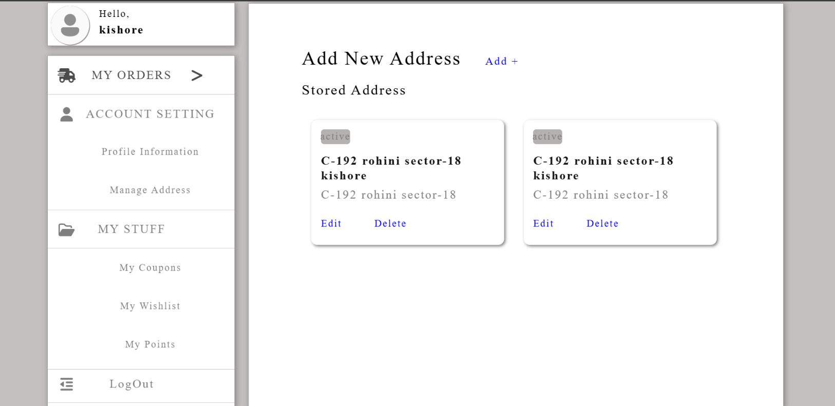

* Order Management: Users can track their order status, view past orders, and cancel orders ifneeded.
* Payment Integration: Secure online payments using debit/credit cards, UPI, and digital wallets.
* Wishlist & Favorites: Users can save products for future purchases.

**B. Shop Module**

* Shop Registration & Login: Shop owners can register and authenticate their accounts.
* Product Listing & Management: Add, update, and remove products with images, descriptions, andpricing.

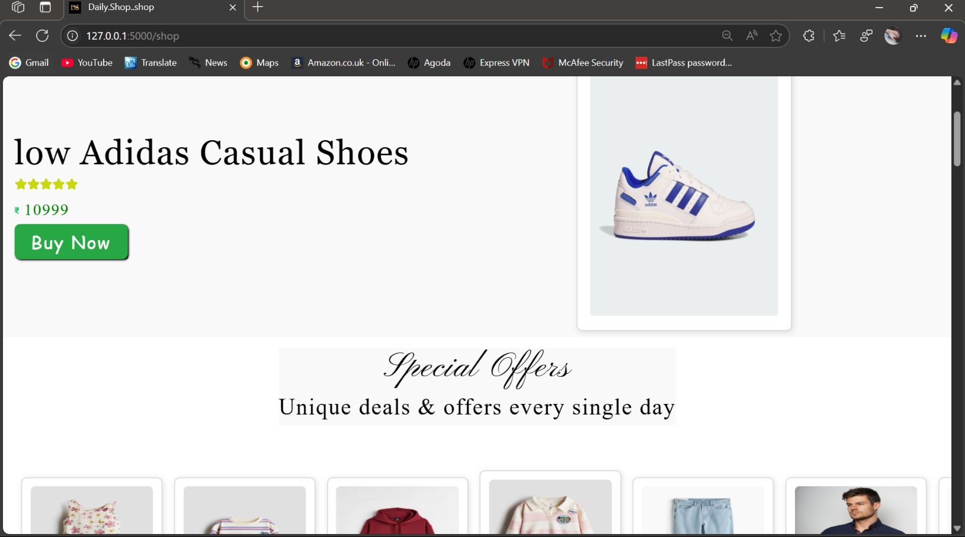

* Order Processing: Shops receive orders, confirm availability, and process shipments.
* Stock Management: Automated alerts for low inventory levels.
* Sales Reports: View sales performance, revenue tracking, and analytics.

**C. Supplier Module**

* Supplier Registration & Authentication: Secure login for verified suppliers.
* Inventory Management: Suppliers can list available stock and update quantities.
* Order Handling: Suppliers receive requests from shops and process bulk deliveries.
* Shipping & Logistics: Suppliers coordinate deliveries with courier services.

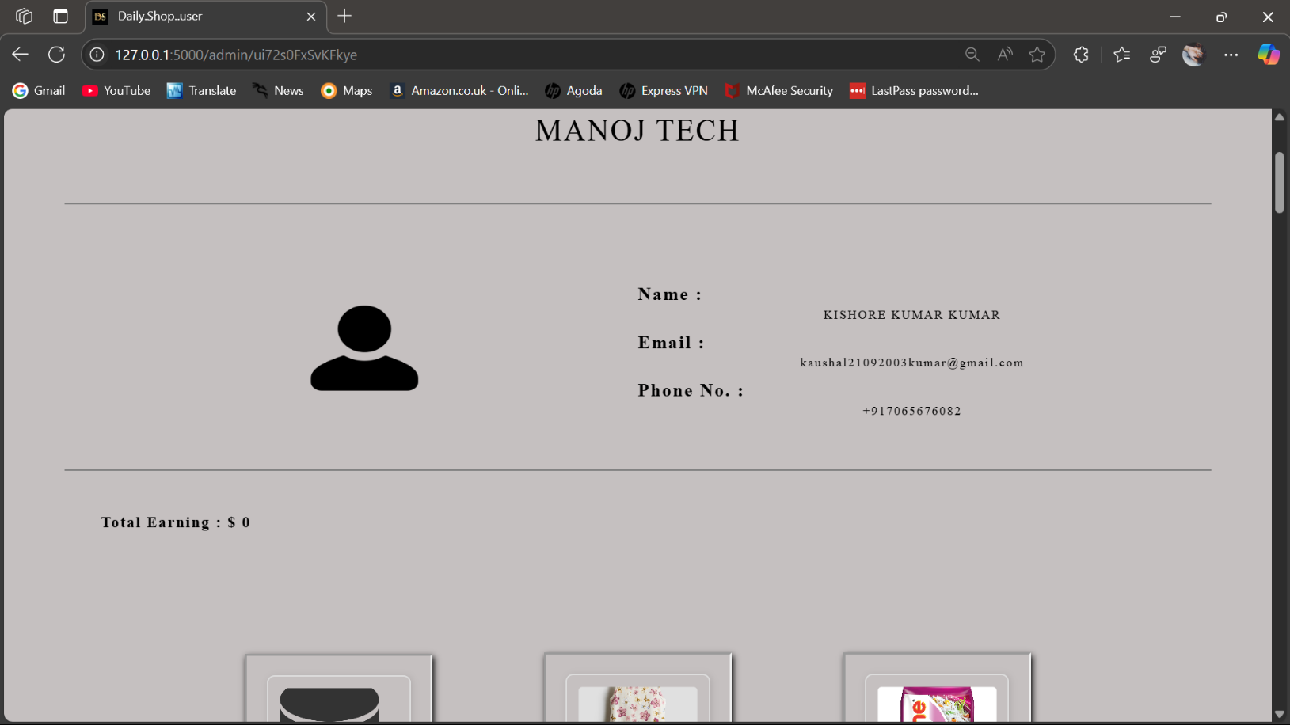

**D. Feedback Module**

* Customer Reviews & Ratings: Users can rate products and leave reviews.
* Complaint & Resolution System: Users can report issues, which are addressed by the admin.
* Shop & Supplier Ratings: Shops and suppliers receive ratings based on customer satisfaction.

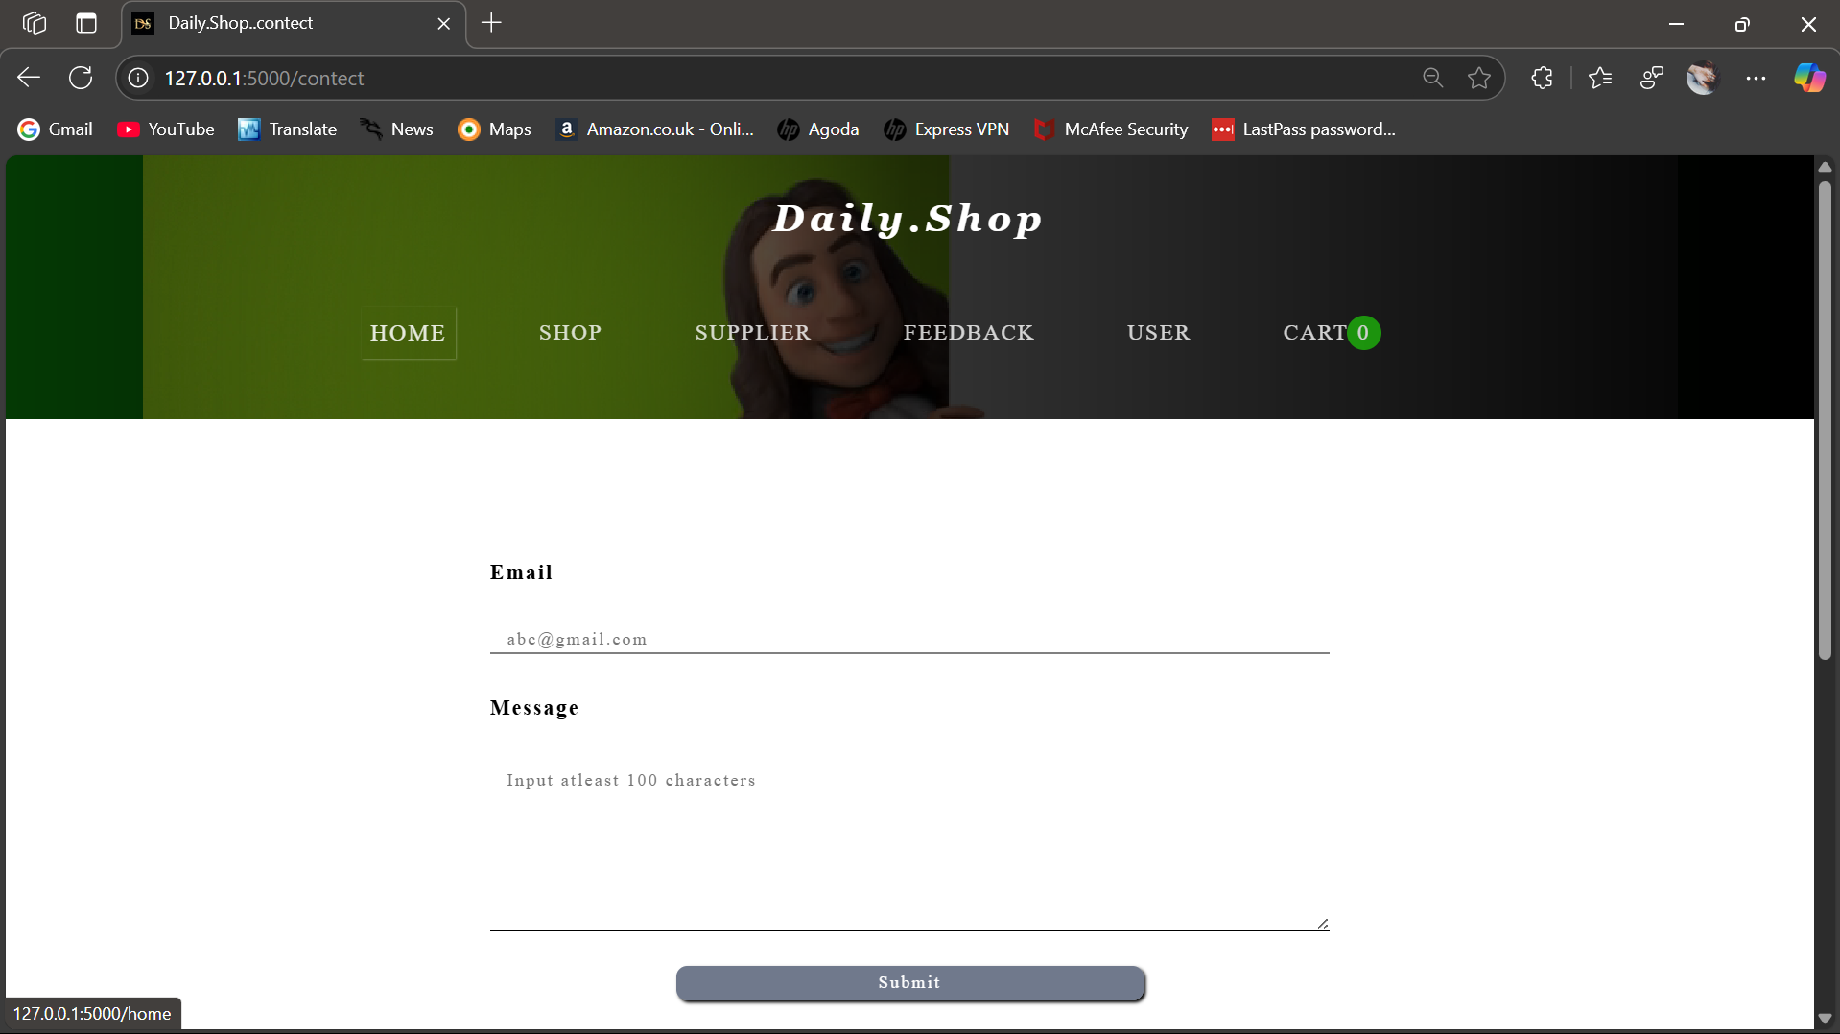

**E. Admin Module**

* User & Shop Management: The admin can verify, activate, or suspend user and shop accounts.
* Order & Transaction Monitoring: Track real-time transactions and resolve disputes.
* Feedback & Complaint Handling: Admins can respond to customer complaints and managereviews.
* Data Analytics & Reporting: Generate reports on sales, user activity, and trends.

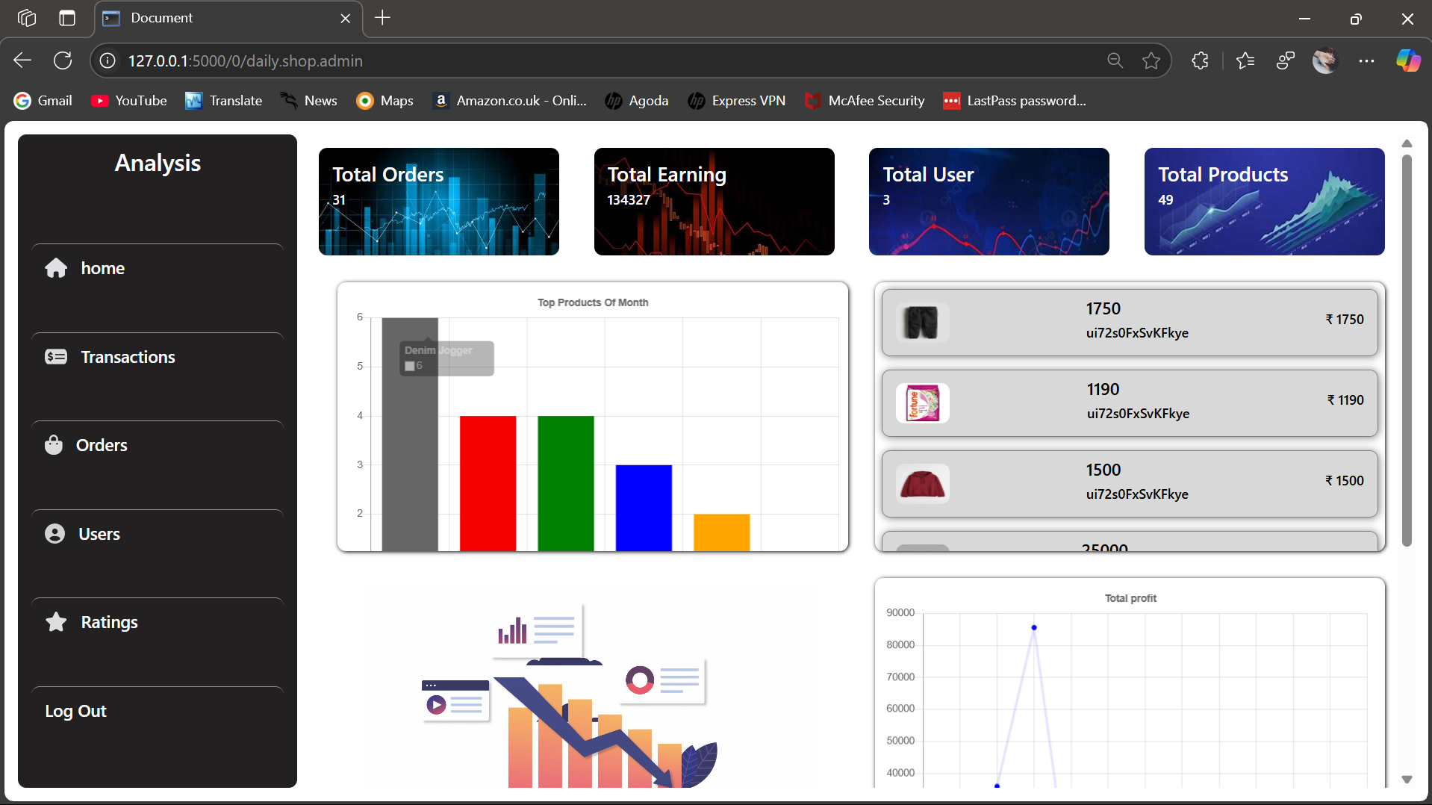

**Technologies Used**

**Frontend Technologies:**

* HTML, CSS, JavaScript: For designing a responsive and interactive user interface.
* Version : HTML - 5
* Version : CSS – 3
* Version : Java_script – (ES - 14)

**Backend Technologies:**

* Python (Flask) : To handle business logic, database operations.
* Version : 3.1.0

**Database:**

-MySQL : For structured and relational data storage.

* Version: 8.0

**Security & Authentication:**

* SSL Encryption: To secure transactions and user data.

**Payment Gateway:**

* Cash on Delivery: For secure and seamless online payments.

**Benefits of the Project**

An **eCommerce website** offers numerous benefits for businesses and customers alike. Here are some key advantages:

**For Businesses:**

1. **Global Reach** – Sell to customers anywhere in the world, expanding your market beyond local boundaries.
2. **24/7 Availability** – Customers can browse and purchase products anytime, increasing sales opportunities.
3. **Lower Operational Costs** – Reduces the need for physical stores, staff, and utilities, saving money.
4. **Better Customer Insights** – Track customer behavior, preferences, and sales trends through analytics.
5. **Marketing Opportunities** – Use SEO, social media, and email marketing to attract more buyers.
6. **Scalability** – Easily add new products, expand to new markets, and adjust inventory without major costs.

**For Customers:**

1. **Convenience** – Shop from anywhere without traveling to physical stores.
2. **Variety of Choices** – Access a wide range of products that might not be available locally.
3. **Price Comparisons** – Easily compare prices from different sellers to get the best deals.
4. **Time-Saving** – Quick browsing, searching, and ordering save time compared to in-store shopping.
5. **Personalized Experience** – Receive recommendations based on browsing and purchase history.
6. **Secure Transactions** – Safe and multiple payment options (credit/debit cards, PayPal, etc.).

Would you like insights on setting up an eCommerce store or specific platform recommendations? 😊

**Future Enhancements**

AI-based Product Recommendations Using machine learning to suggest products based on userbehavior. Augmented Reality (AR) Shopping Allowing users to visualize products in real time. Multi-Vendor Support Enabling multiple sellers for the same product to increase options. Live Chat Support Providing instant assistance to customers. Mobile App Development Extending the platform to Android and iOS users. As technology evolves, eCommerce websites will continue to improve with advanced features and innovations. **AI-driven recommendations** Personalized product suggestions based on user behavior. **Chatbots & Virtual Assistants** AI-powered chatbots for instant customer support. **Voice Commerce** Integration with voice assistants like Alexa & Google Assistant for hands-free shopping.

**Conclusion**

Daily.Shop is an innovative and user-friendly eCommerce platform that bridges the gap between customers, shop owners, and suppliers.

By integrating a robust feedback system and admin panel, it ensures a smooth and secure shopping experience. With its well-structured modules and scalable architecture, the project holds significant potential for future expansion and improvement in the eCommerce sector.