HUB:

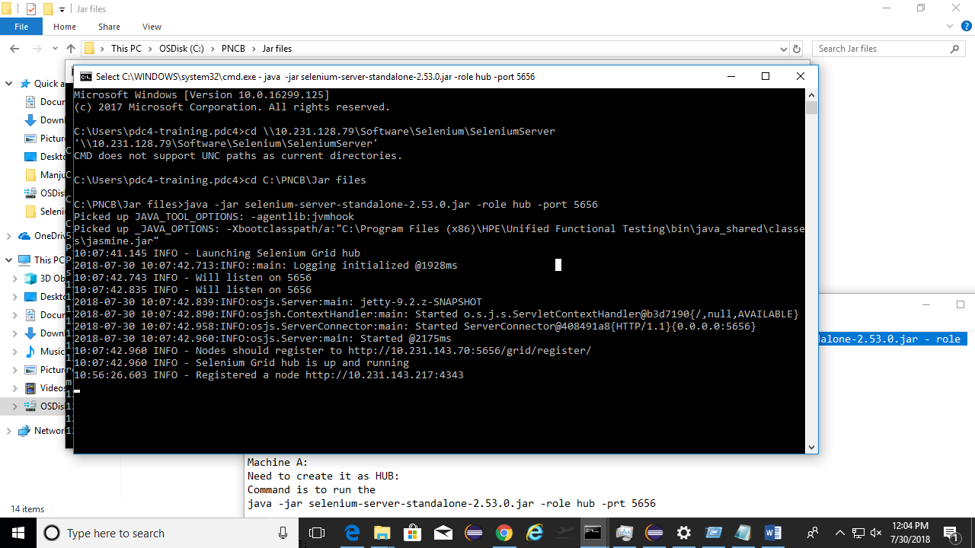

Node:

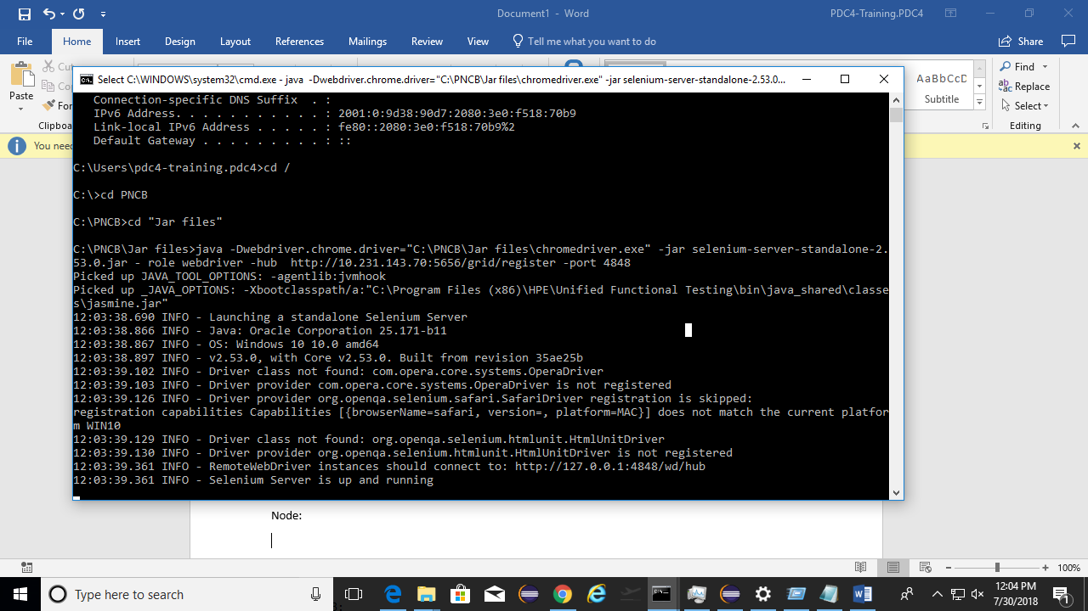

JENKINS:

Step 0: Run the Jenkin Server using below Command:

***Java -jar jenkins.jar -httpPort=8282***

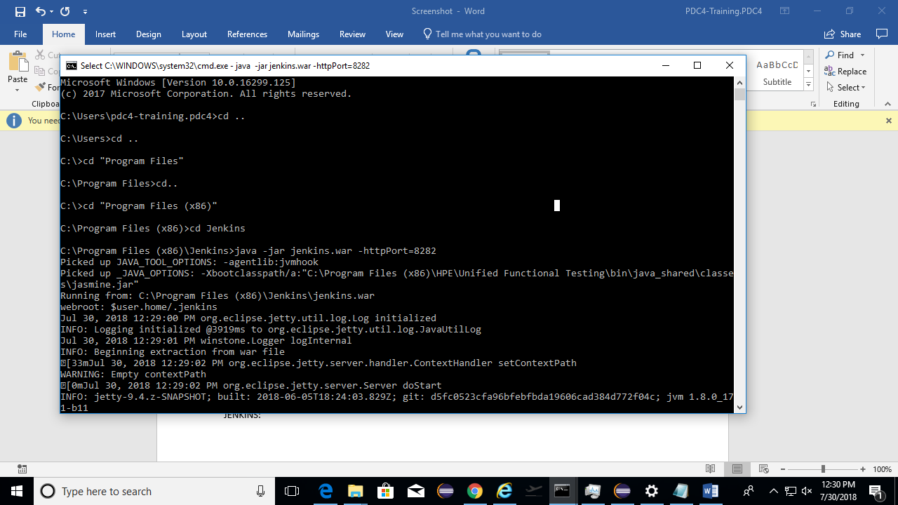

Once the Server is up. Open the Browser and go to the URL: - ***localhost:8282***

Step 1: Install the Plugins:

Add the Cucumber Reporting and TestNG Reporting

Step 2:

**Set the global Variable**

Name*: javaHome*

Java_home: *C:\Program Files\Java\jdk1.8.0_151*

Name: *mavenhome*

Maven_home: *C:\Maven\apache-maven-3.5.2*