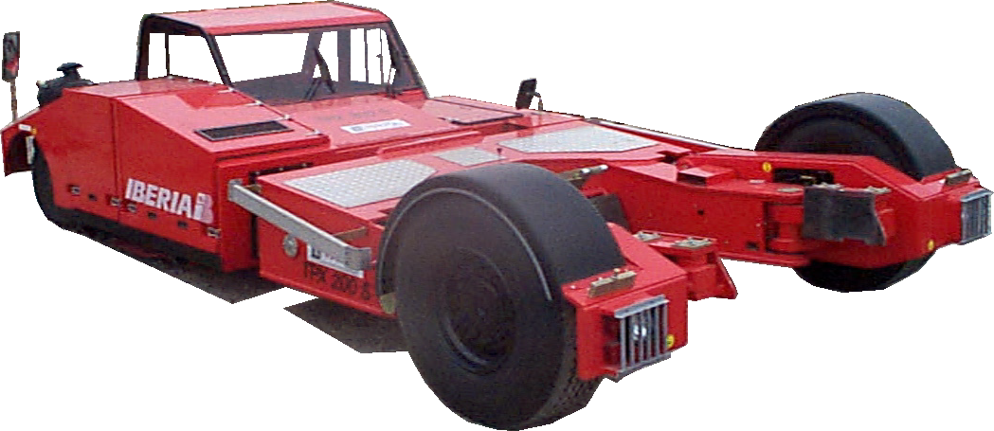

Description
The TPX-200 is a towbarless aircraft towing tractor capable of performing push back operations on all aircraft from B737, B757, A320 up to fully loaded B767 and A300. In addition, maintenance towing is also possible on A330/A340-300, DC9 and MD80 aircrafts.
Its ergonomic design provides increased visibility of landing gear, safer handling and maximum driver comfort. All claw functions are fully automated for ‘foolproof’ execution of lifting and lowering landing gear. TLD’s high standards of build and component quality make the TPX-200 a durable and reliable tractor
Standard Features  - Engine : DEUTZ BF4M1013C diesel engine, 4 cylinders, 115 kW (155 HP) @ 2,300 rpm  - Transmission : Hydrostatic with REXROTH A4VG180 pump and two POCLAIN MS35-2C  (2 displacements wheel motor) on front wheels  - Driveline capability : 8 500 daN (19 000 lbs)  - Maximum nose gear weight : 25 000 kg (55 000 lbs)  Maximum nose gear width : 1 200 mm (47.2")  - Maximum speed : 22 kph (13.7 mph)  - Automatic aircraft selection : Selects appropriate DBP range according to aircraft type  - Brakes (service) : Hydrostatic brakes on front wheels and drum brakes on rear wheels  - Brakes (parking) : Spring applied, hydraulically released wet disk brakes lock front wheels  - Steering : Hydrostatic steering on rear axle | - Emergency equipment : Hand pump and DC pump  - Safety : emergency engine stop push-button  - Tyres : 385/65R22.5 XZA on front  245/70R17.5 on rear  - Fuel tank capacity : 155 liters (41 US Gal)  - Hydraulic tank capacity : 230 liters (61 US Gal)  - Paint : White –RAL 9016  Standard Equipment  - Driving station padded with door cab and tinted windscreen  - Fixed driver station for push-back operation only  - Side mirrors and one driver’s seat  - Gauges :  - Hourmeter  - Fuel level

Indicator lights :  - Engine oil pressure  - Battery charge level  - Coolant temperature  - Hydraulic filter plugging  - Overtorque anomaly  - Aircraft selection indicator light  - Parking brake  - Steering indicator  - Steering wheels position  - Overtorque (Operationnal and safety lights)  - Anomaly buzzer and indicator light  Dimensions AND WEIGHT  - Front track 3 000 mm (118”)  - Rear track 2 260 mm (89”)  - Wheel base 5 150 mm (204”)  - Outside turning radius 7 830 mm (308”)  - Total weight 12 000 kg (26 400 lbs) | ELECTRICAL EQUIPMENT  - 24 VDC electrical system, 2 batteries 95 Ah , 55 A alternator  - Battery master switch  - Head lamps, tail lights, stop lights, reverse lights, front and rear warning lights, front and rear turn signal lamps, buzzer on reverse, flashing beacon  - Control relays and circuit breakers cabinet are conveniently located next to driver’s seat  OPTIONS AVAILABLE  - Cab heater, defroster  - Rear tow hitch for conventional operations  - Rotating warning beacon  - Air conditioner  - Spare wheel and tyre  - Rotating driver’s seat and steering wheel plus secondary dashboard
