QUICK HELP GUIDE - DOCUMENT ARCHIVE

TOOL PURPOSE

Once BAAN have generated the PDF document in the ARCHIVE folder, the only way to get this document was to go through the network, find the file, and finally copy the file. Using this method over a windows network is quite slow. To improve the accessibility and the rapidity of getting these BAAN documents, the document archive feature have been created.

TUTORIAL

We are now going to learn how to get any BAAN document using this tool.

1- First, go to Finance\Archive as bellow:

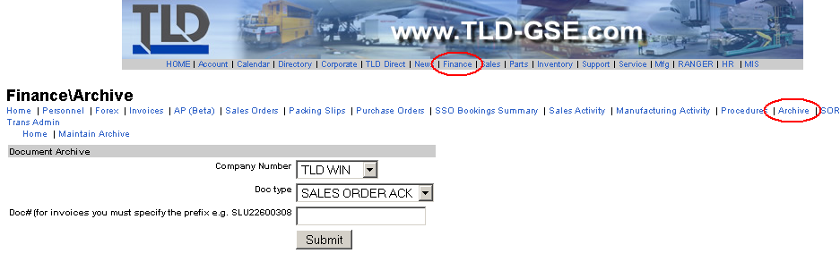
2- Enter the data for each field of the form

- Company number: Your BAAN company where the document have been generated
- Doc type: Type of the document you are looking for
- Doc#: The document number or reference number of the BAAN record

For example, you are in the company 400, you printed out the PO#727953 and you want this document… You have to enter the information bellow and hit submit:
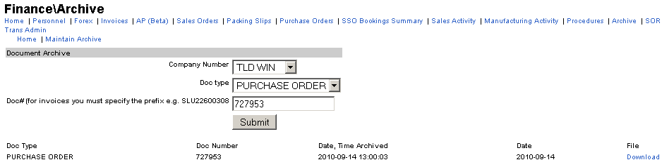
3- Finally, click on the Download link on the right. You should be downloading the PDF BAAN document now.


NOTE: The system may prompt you a box to authenticate asking you a login and a password. The login and password are the windows one. As the online tool is accessing file to the BAAN server, windows system want to make sure you have the permission to access it.
Also make sure you tick the box “save my password” to avoid this prompt box appearing all time you need to get a BAAN document.

WARNING: It may not work for some cases still like in Europe. If so you will need to add a little extra info in front of your login and it will work. This extra information is your windows domain.

- For Europe: TLD_EUROPE
- For America: WINDSOR
- For Asia: DEVTEC

For example, if your windows login is “jeanDupont” and your are in Europe, in the prompt box you will need to put: “TLD_EUROPE\jeanDupont”

