MSG MODULE

INTRODUCTION

MSG is a module that lists all external company electronic messages (usually xml) sent to TLD like SAGE or FEDEX. The goal of this module is to be able to manage these MSG records related to your company such as:
- changing status
- transfer the data to the appropriate module

HOWTO

- Access the module

To access the module, go to FINANCE/MSG like bellow


- Change status

To change the status, you need to view your MSG record and hit the link “status”:
Today there is only 2 status:
- OPEN : the MSG have been received
- CLOSED: the MSG have been reviewed by a TLD user

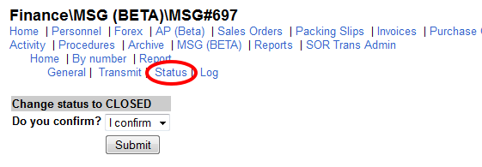
Select “I confirm” and Submit, your MSG record will have now his status CLOSED.

- Transmit the data

To transmit the data of this MSG, select your record and hit the link “transmit”. Regarding the document type of the MSG, the system will give you a new link in order to transmit the data to the appropriate module.

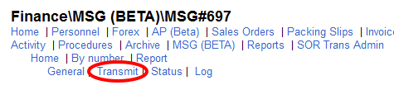
Here is the list of module by document type:

MSG Document type | Module to transmit
SALES ORDER | PARTS/CART

