Procedure – AP Invoices scanning

The following instructions describes the procedure to follow in order to scan AP Invoices and have them be automatically routed thru sequence of approval in our TLD-GSE Intranet.
There are currently two sequence of approval possible:

- First approver(manager) → COO (all Invoices under $5000)
- First approver(manager) → COO → CEO(all Invoices over $5000)

Routing setup :

- in order for the system to properly route the invoices to the first approver, AP need to maintain the list of supplier per approver per company. (one time setup)
to do so, please :

  - Logon to our tld-gse Intranet and go into the “finance” module
  - Hit the link “Maintain Approvers”

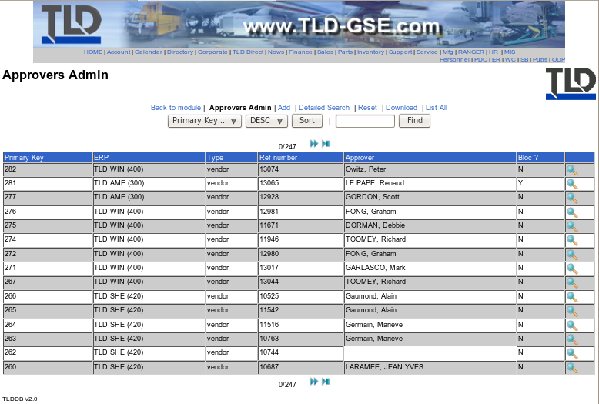

  - hit “add” or “edit” one of the existing entry

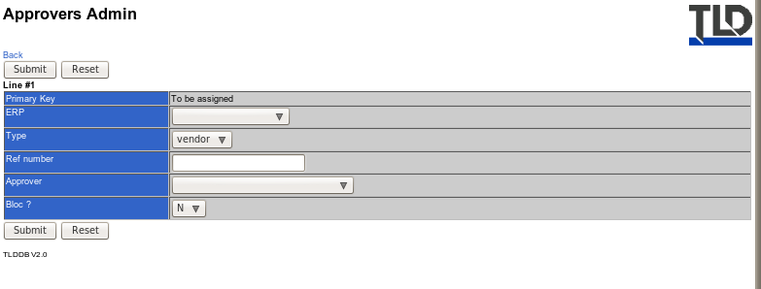

From the Maintain screen your will need to enter/select the following:

  - ERP : Baan ERP number (e.g.: TLD WIN(400), TLD AME(300),..)
  - Type : Type of the routing (Currently only “Vendor” is available, GL Codes and DIM will follow)
  - Ref number : number related to the type selected (e.g.: if type is “Vendor”, then please enter the vendor number, as it is in the ERP System)
  - Approver : person who will received the Invoice first for approval.
  - Bloc? : N by default, this value determine if Yes or No the system should setup a blocking code for the Invoice in baan prior to open the Sequence.
If Y is selected, the system will setup the bloc code “IAP” (Invoice Approval Process) for the concerned document in Baan, this code will be removed automatically at the closing of the sequence.

When the system will proceed the pending Invoices (every hour), it will look into this table and will route the Invoice accordingly.

Note:
If there is not record for a vendor, the system will send out an email to notify the appropriate AP with a link to the form where it can be Added.
The document will not be processed into sequence until the routing for this vendor is setup.

Scanning Setup and Requirements:

this process require the utilization of an appropriate scanner. Here are the minimum specs required for this scanner :

  - Scanning ability to network folder (ability to login to the network if needed)
  - Dual sided scanning (Duplex)
  - Top feeder (no flat scanning allowing only one page at the time)
  - Multi-format/size paper scan
  - Ability to enter the name of the file to be scanned.
  - Ability to setup multiple network folders as scan destination
  - Stand alone scanner (not USB, with its own user interface, no need to install a software !)
  - Network scanner
  - Scan to PDF format

The scanner need to be setup with the different network folders, one folder per type/company# :

eg: folder for the APN files of company 300:
\\baanivc4\online_approvals\invoices\spool\300\APN\

folder for the APN files of company 420: ..\420\APN\
folder for the APW files of company 400: ..\400\APW\

The scanner should be setup with the following quality settings:

- black and white
- between 200 and 300 dpi
- PDF format
Scanning Process:

  - Key the document in Baan, this will give you the baan document number that will be used as name of the scanned file.
  - Place the document in the scanner's feeder
  - Select the destination folder (depending on the document type and company#)
  - enter the name of the document ( same one as in the Baan ERP System)
  - Hit scan
  - While the document is being scanned, Key the second document and so on.
  - Once all documents have been successfully keyed in Baan and scanned, They can then be filed away or destroyed (depending on the local rules for paper original documents)

Note: All scanned documents will be processed by the System on the Hour.

- If the routing is setup the the “Maintain Approvers” table on our tld-gse Intranet, a sequence of approval will be opened and sent to the appropriate person

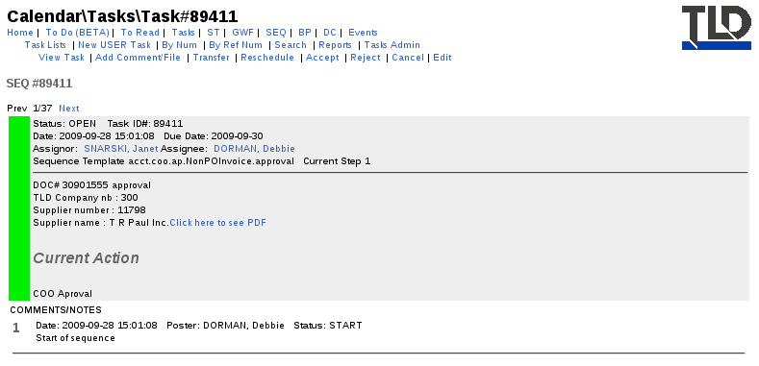

- If the routing is not setup, the AP will receive an email notification to set it up, the document will remain in the spool until the routing is setup.

- Once the sequences have been approved by all, the “IAP” will be removed if setup in the Invoice in Baan and the sequence will close.

