ISR – INTERCO SHIPPING RECORD
GUIDELINE – 02/10/2011

PREAMBLE

The purpose of this document is to provide all TLD employees and managers with the basic guidelines to effectively navigate through the ISR module. The first section of this document provides overall principles while the second part describes details to use the module.

GLOSSARY

Here are some of the TLD acronyms:
- ISR: Interco Shipping Record
- PS: Packing Slip
- PO(L): Purchase Order (Line)
- SO(L): Sales Order (Line)
- BU: Business Unit
- ETA: Estimated Date of Arrival
- UM: Unit of Measurement
- PN: Part Number

INTRODUCTION

GS (Group Sourcing) is the main supplier for all sister company in the TLD world. All shipments are made overseas and, in order to improve communications, follow up, documents validity and transportation process, the module ISR has been created.

PRINCIPLE

After the items are loaded into the container by GS the outbound is released and a packing slip and invoice is printed.

Similar to the tracking module developed for spare parts a web page can be used to link the packing slip number(s) to an ISR number.(note: normally there will be multiple packing slip numbers per container). External files (customs documents, etc) can be scanned and linked to the ISR number.

Because the packing slip number is linked to a sales order line it is possible to get the item number and description as well as the quantity shipped and the date out-bounded.
From the sales order line for orders received through EDI it is possible to get the buying companies purchase order number and line number.

A field can be added to e-vendor open PO lines page to show the ISR linked to the corresponding sales order. Clicking on this link will open the ISR with access to the external docs and the other detail.

USER MANUAL

- Module

The module is located under MFG/PUR/ISR like below:

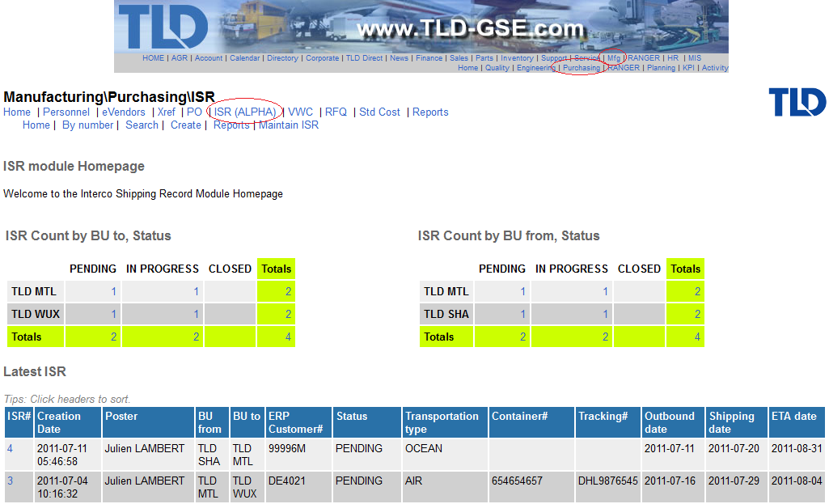

- Create ISR

To create an ISR, hit the link “create”:

Then enter all information needed in the form and submit:
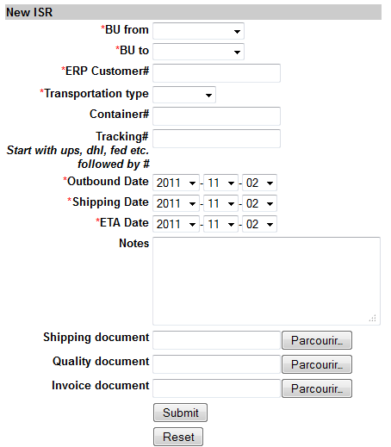

- Packing Slip / ISR lines

Now that you have created your ISR which represent your container, you need to link all packing slip created during the outbound for all items entered in it. We can call them ISR Lines also.

So, once you are viewing your ISR like below, go to the line section:
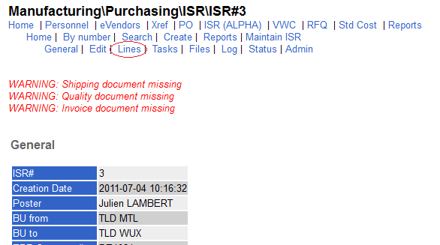

3-a Link packing slip

To add a packing slip to your ISR, click on the “Add line” link and select all packing slip you have created during the outbound.
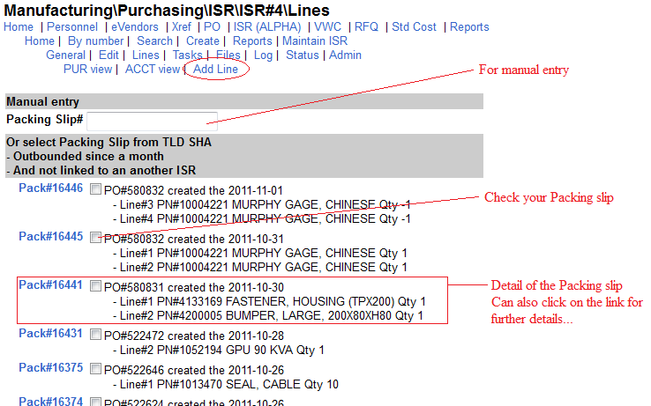

3-b Unlink packing slip

To unlink a packing slip, just hit the link under the column “Unlink Pack”
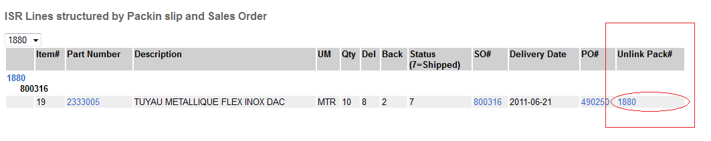
- Status changes

To change the status of the ISR, go to the status section as below:
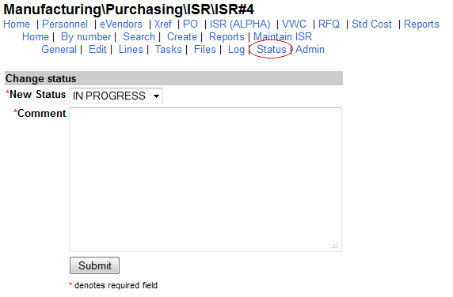

Workflow:

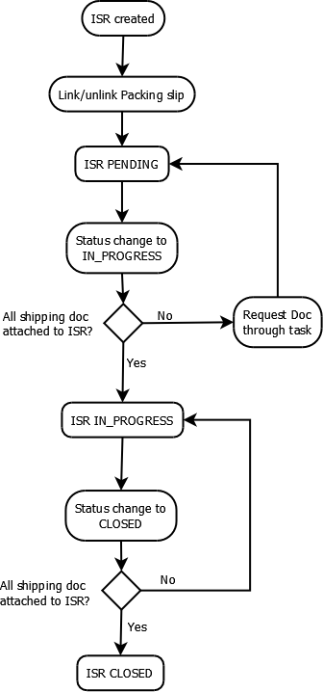

Status definition:

- PENDING: The container is under preparation. The supplier outbound the goods and put it in the container. Finally, he links packing slip to the ISR.
- IN_PROGRESS: All packing slip for all goods entered in the container are linked to the ISR and shipping documents are ready and uploaded. If not, a task has been created to request these documents and upload it ASAP! The container is under transportation (by sea or air).
- CLOSED: The container have been received to the BU who has ordered the good.

