CRAB MODULE HELP

CRAB – something that will bite you in the backside if you don’t fix it.

Overview

The term CRAB was created to describe product quality problems. Another way of thinking of this is as a factory non-conformance, a non-conformance that is created by the production department or manifests itself during the build-test-GT process cycle.

It can also be used to track a unit with special circumstances to ensure it is not GT prior to those circumstances being completed, met or an obstruction cleared. This can be special testing requested or needed for engineering, missing documentation, etc.

The CRAB system was created to track defects
1) discovered in the production process,
2) when the unit is delivered to test or in the testing process, and
3) during the final inspection
in order to reduce or prevent recurrence of these problems. This is analogous to a QCPC or turnback system, which are used in many companies.

Process Steps

The flow of the process is as follows

- Anytime during the build process, Production, Test, Engineering or Quality may write and record a non-conformance.
a. The Group Leader or Foreman opens the shop page in the intranet, selects ER (Equipment Record) to pull up the unit with a non-conformance.
b. Using the lowest tier of blue links, they select the unit CBOM.
i. The person can drill down to a package or specific item and write the CRAB against the item related to the problem.
ii. the person fills in the CRAB form and clicks the submit button to record the non-conformance
c. In the event it involves a material issue, the employee writes and submits an NCR for that item (See NCR Module)
d. the employee repeats this procedure for all non-conformances found during the assembly process whether it is related to refrigeration, electrical, sub assembly or mechanical assembly.
- Unit is delivered to test
- Test begins testing the unit
  - Any non-conformance (internal or external) is recorded in the form
  - Test technicians opens the shop floor homepage and navigates to the unit CBOM
  - The technician begins testing the unit and finds a defect
    - The technician can drill down to a package or specific part to write the CRAB against
    - The technician fills in the CRAB form and clicks submit
  - The technician repeats this procedure for all non-conformances found during test
  - When testing is complete, the technician advises assembly, sends the unit returned to assembly as “ready for touch-up”
- Unit is delivered to production for touch up / final assembly
  - As CRABs are fixed, the employees who fix the CRABs will sign off the individual CRABs
    - Employees will enter their employee number and click the “fixed” button & provide action taken
  - As CRABs are fixed, they are inspected by the Group Leader
    - The Group Leader will log into the ER through the website
    - The Group Leader will click on the CRAB link
    - The Group Leader will click the “Inspection” link
    - The Group Leader will enter his/her employee number
    - The Group Leader will click the submit link
  - When all CRABs are inspected, the Group Leader advise Quality the unit is “ready for inspection”
- Unit is inspected by QA
  - Quality Assurance enters and writes CRABS as found
  - CRABs are fixed and inspected after final inspection, before final run or function check.
  - Quality Assurance reviews the online CRAB list to ensure that all CRABs are closed
  - Quality Assurance confirms the unit is “ready for final run”
- Unit goes to test for final run
  - Any CRABs not able to be inspected during final assembly or QA inspection are inspected at final run (i.e. leaks, where the unit needs to be running to inspect for proper resolution)
  - Test technician signs off CRAB as being inspected
  - Test technician advises unit is “ready for GT” when the final run is complete
- The QAM will review the CRAB list for closure and officially GT the unit after all CRABS are cleared. The system will not allow a GT entry without all CRABS completed and accepted for the specific unit.

Administrative Rights

- The QAM and the PM have admin rights to the entire module.

- Foremen, Group Leaders, Test technicians have access to the module through the website but do not have edit rights
- Direct Employees can only input data

Metrics

Several metrics have been established to monitor and improve product quality to test.

1. CRABs by unit family (i.e. ACU, ASU, GPU)
2. CRABs by department (i.e. Assembly, Electrical, Refrigeration, Purchasing, Sales)
3. CRABs by CRAB code (i.e. 100, 110, etc.)
4. CRABs by model (i.e. ASU-600-270-DDP, ACU-804-CUP, GPU-4090-T-CUP)

These classifications allow us to look at the major groups in manufacturing to target where efforts need to be made to improve product quality. The metrics are taken automatically from the data that is entered at test.

CRABLIST MODULE – WRITING THE CRAB FOR

PRODUCTION, TEST OR INSPECTION

CRABS can only be entered initiated in the shop page – no access for entry is in the website
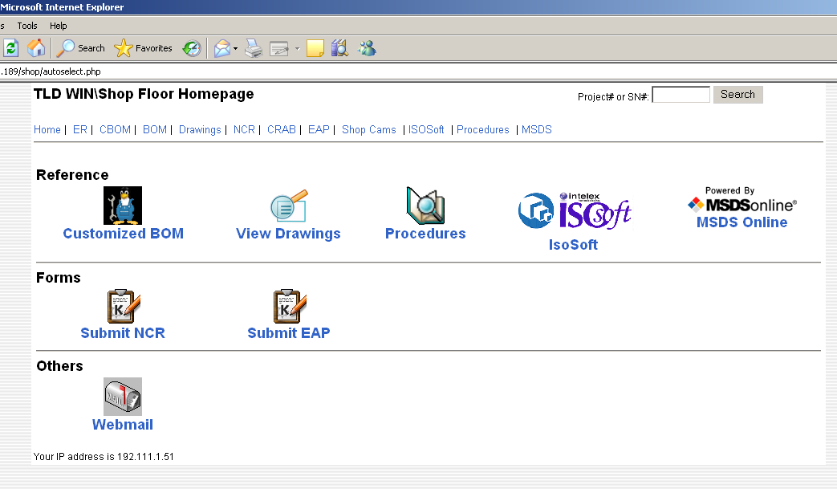

Use the EQUIPMENT RECORD (ER) module link to enter CRABS for the specified unit you are working on.
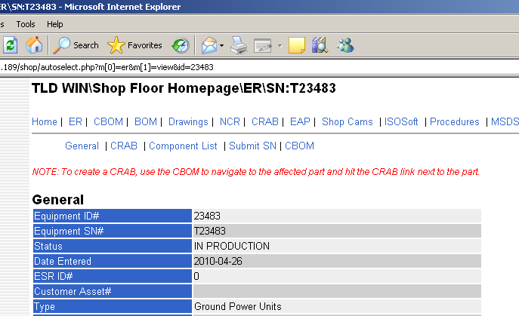

The ER contains all the information for the unit – serial numbers, GT date, Shipping Date, all record files, etc.

To record the crab you need to know what the issue is, and the system, assembly or part that is causing the issue. Select the CBOM on the LOWER BLUE links below the line.

If you do not know the system or part causing the issue, you must find this first to record the CRAB.

Also note, if the part is to be filed as an NCR, file the NCR first because you will need the number to fill out the CRAB.
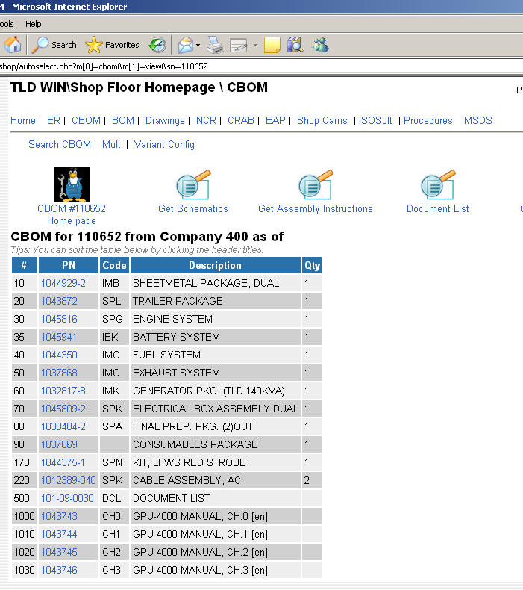

You must select a system package before you can write a CRAB.

For example, if the unit is painted the wrong color, you would select the sheet metal package.
After this entry on the next screen, you may select the sheet metal package by clicking on the word CRAB on the right side of the page.

If it is a particular panel, you would need to continue until you find the panel to which the CRAB applies.

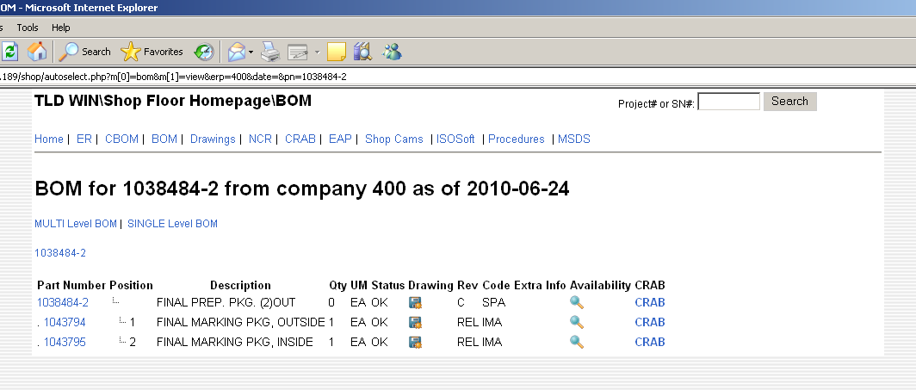

Note after leaving the top level CBOM list, all numbers have CRAB on the right side for you to choose for the issue.

Once you have found the part, assembly or system, select this CRAB link on the right to report it.

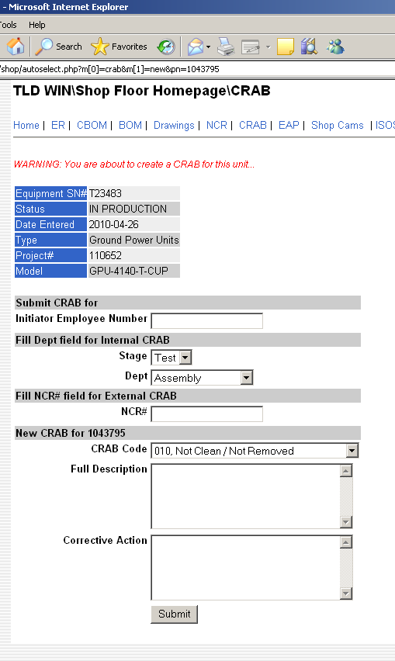

This screen appears after selecting CRAB. Now you will write the CRAB.

You must not only fill out the Full Description, but you also must enter the Corrective Action that is to be taken to resolve the issue. (Either what you do to fix it or what you want done to make it acceptable.)

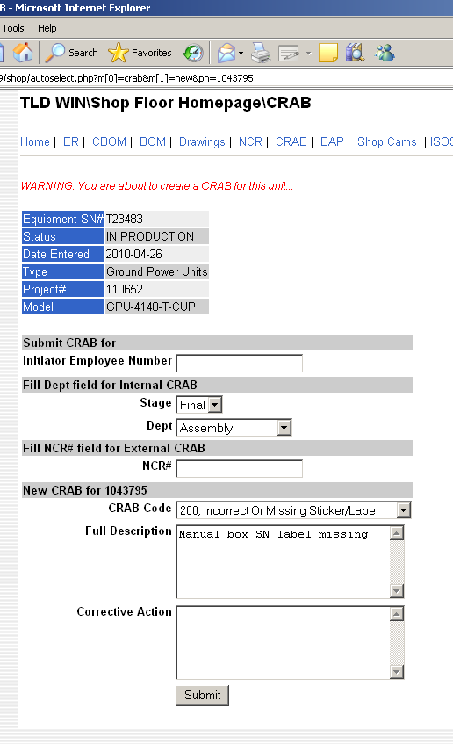
Initiator Employee Number: Fill in your employee assigned number.
Stage: Select if it is in Test or Final (Final Inspection)
NCR: Fill in an NCR number if you have filed an NCR for reporting an issue related to this finding. This is for vendor or supplier issues.
CRAB Code: Select the general issue from the dropdown screen. If it is not listed here, use Miscellaneous.
Full Description: write what was the issue you found, where it was found and any other related information that will help employees find and understand the problem.
Corrective Action: write what you do as you fix the issue or what you need done in order solve the problem

After all of this is filled out, you select the Submit button at the bottom.

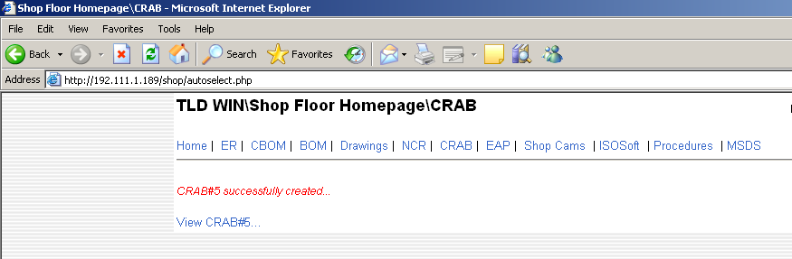

After you select submit, the system will tell you if the CRAB was accepted and recorded.

You may review the crab to check your data if necessary.

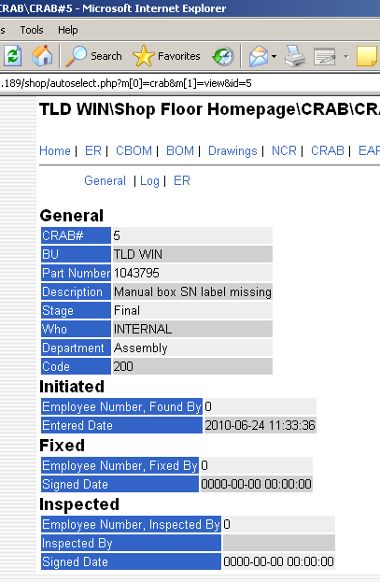

Information is now available to see, get fixed and have it inspected by a supervisor or team leader to complete the finding.
Reporting the CRAB as completed or “FIXED”

Note: All CRABS to be fixed or recorded must be entered through the shop floor page. No entry is available through the website page.
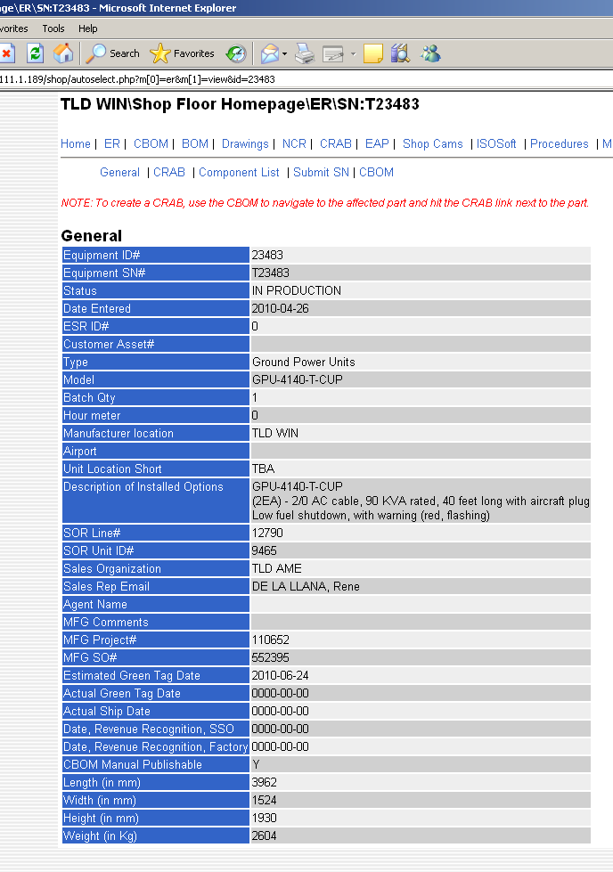

Select the ER on the shop floor homepage on the top line of the blue links and enter the unit serial number

To see and find the CRABS you want to report completed select the blue CRAB link on the bottom line.

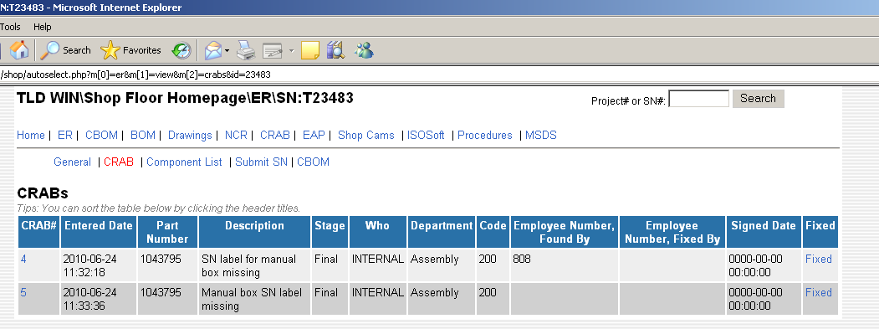

This will provide you access to all CRABS written on this unit, who fixed them.
If you need to go back and “fix” the crab, select the blue link to the right.

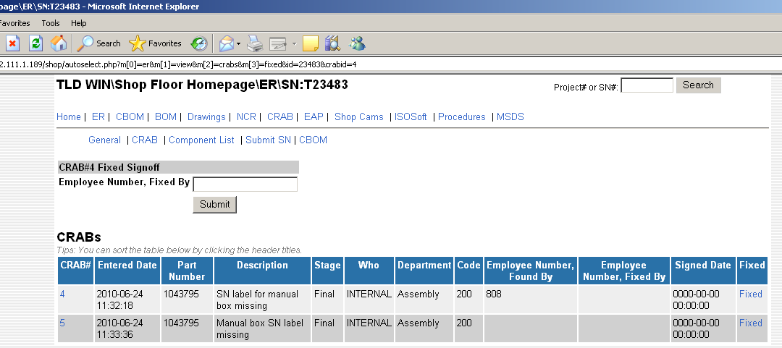
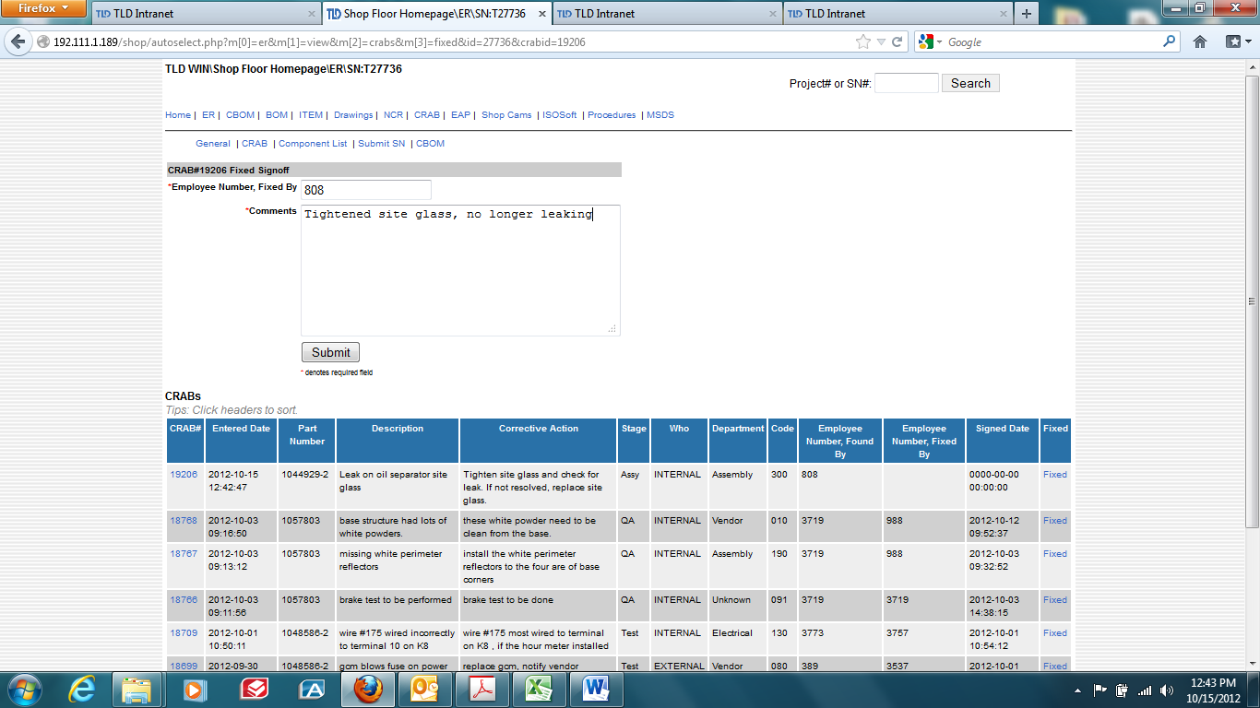

Selecting the link will provide a field to appear at the top of the page to the left.
Enter your employee number, enter the action taken to fix the issue and select the submit button.

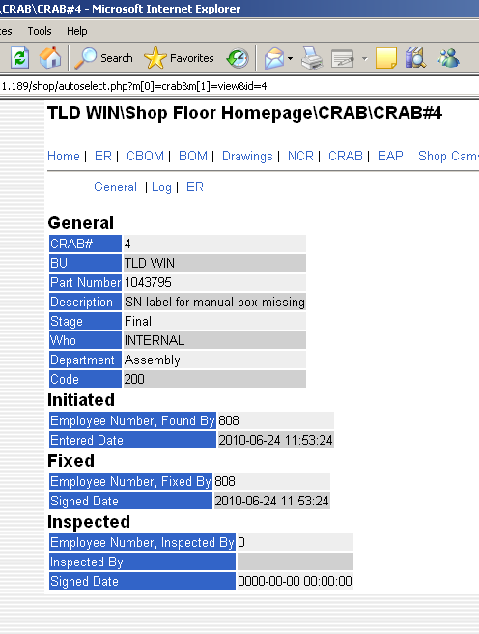

If you select the number to the left, you can see the full reported crab.

This will clear the crab and report it as complete.

After a supervisor checks the work, then enters his approval in the system. Please note: any CRABS left unsigned and unresolved will prevent a GT from being completed. All CRABS absolutely MUST be completed and cleared for a unit to achieve GT status.

CRAB Supervisor Signoff
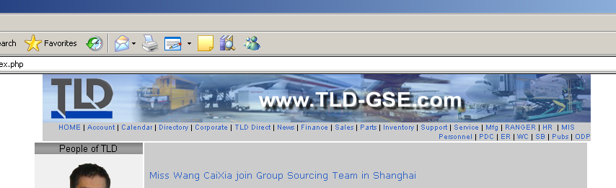

Enter the Website to close out supervisor inspection to confirm all Corrective Actions on the product CRAB list are closed.

Select “SUPPORT” at the top of the page.

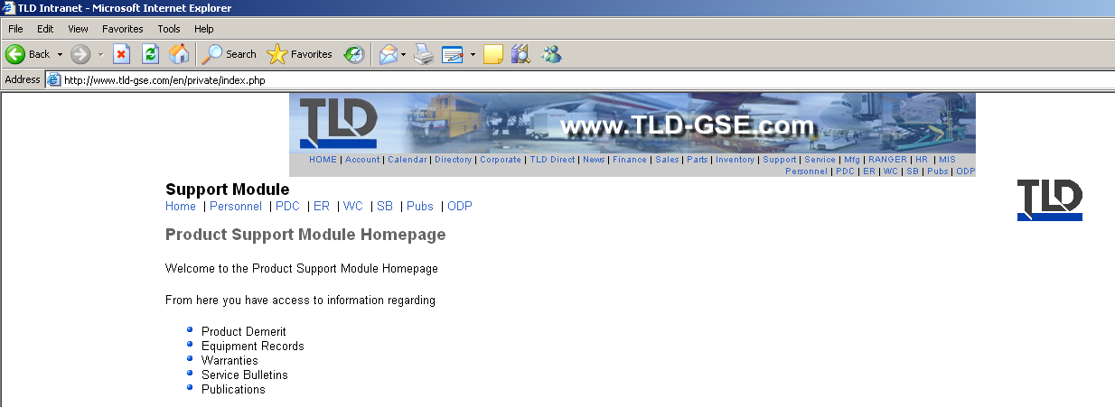

In the Product Support home page select the ER (Equipment Record)

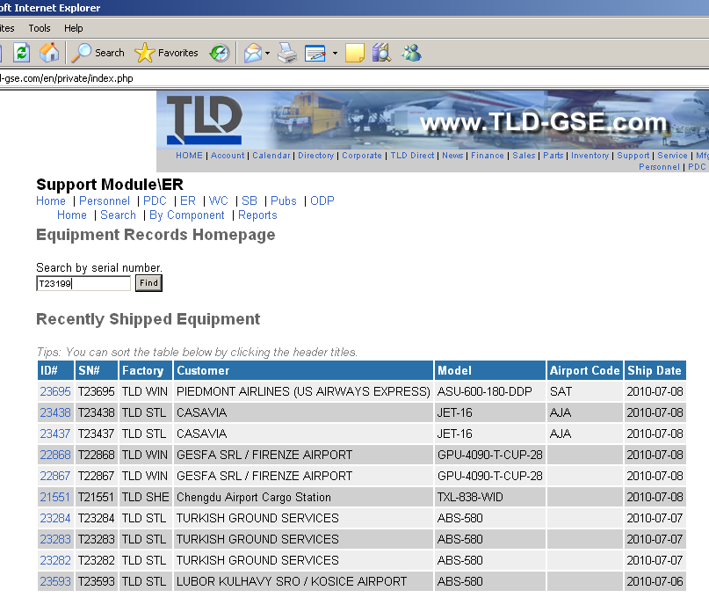

Enter the serial number of the unit you have inspected for CRABS.

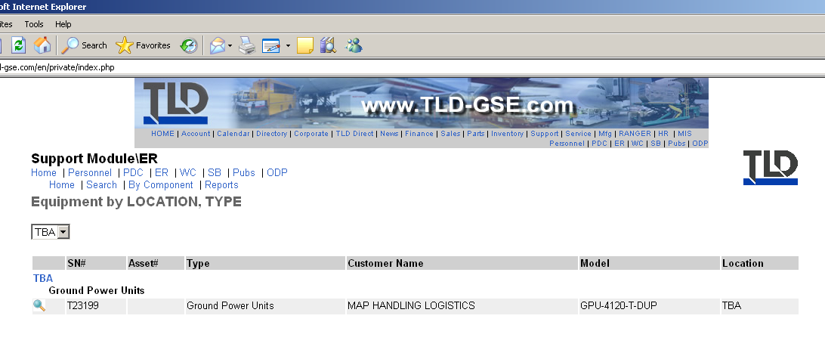

Enter via spyglass link for the unit

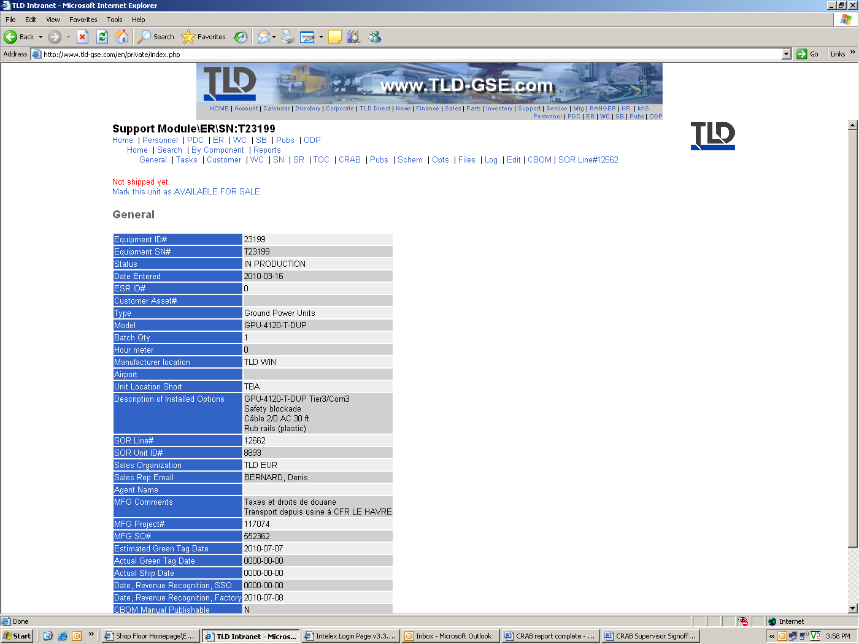

Confirm you are in the correct unit record, then select CRAB

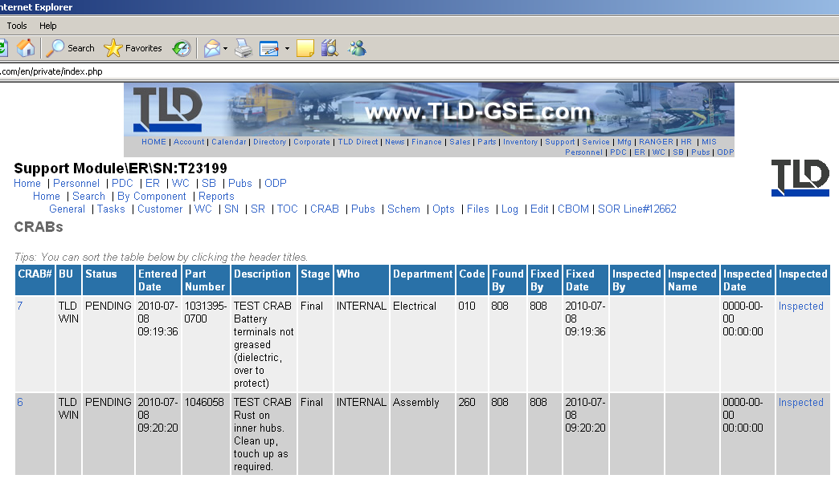

This will take you to the list of CRABs for the unit. It shows these have been fixed, so it is ready to close.

After you have physically checked the unit, select the blue INSPECTED link on the right.

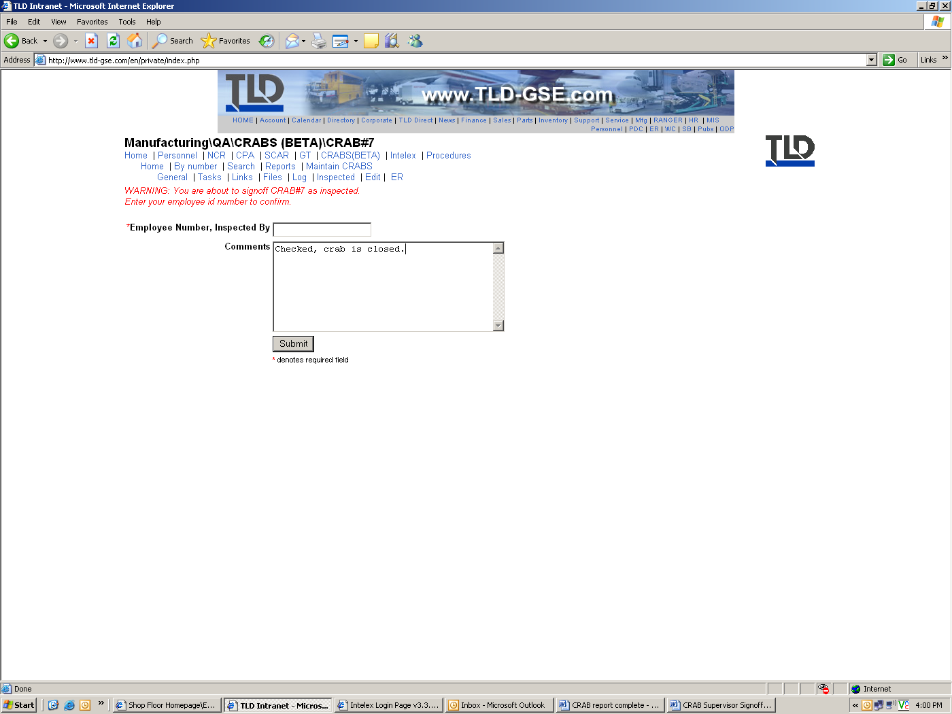
Employee number
Comments
Select SUBMIT button to close

This screen will warn you are about to close a CRAB, a non-conformance with the product.
Enter your employee number, then enter comments, (i.e., brake test passed, item fixed, etc).
Select the SUBMIT button at the bottom to close.

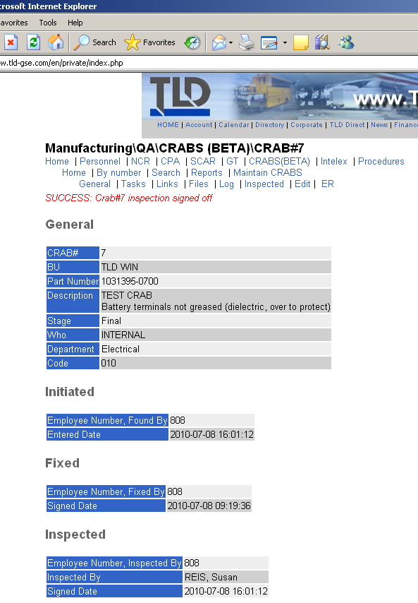

If successful, the screen will say it closed

Select your browser back arrow button and it will return you to the list of CRABS for this unit.

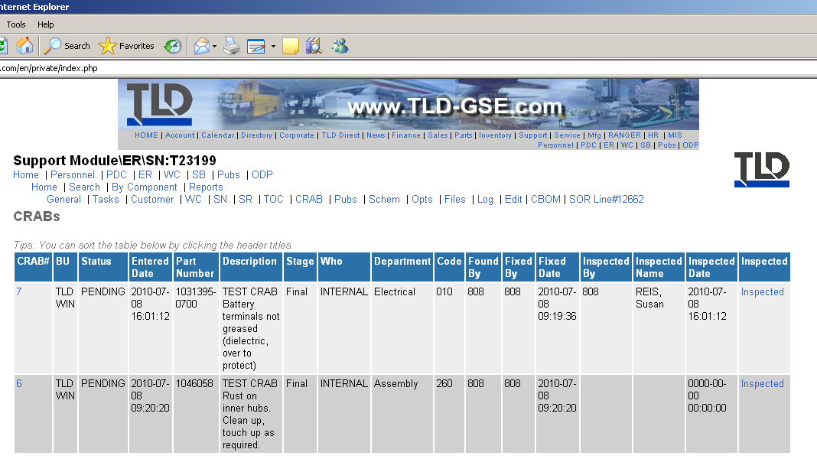

Continue closing CRABS until all are cleared and inspected.

When all CRABS are inspected, responsibility to close the unit then goes to QA.

Log out, you are done.

TLD Shop Employees
How to review unit CRABS and report fixes complete
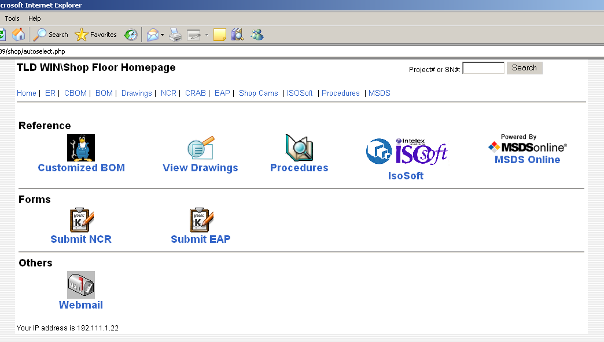

You start by going to the local shop home page for your factory.
Select ER for Equipment Record, to get to the generated CRAB list you are to work & fix.
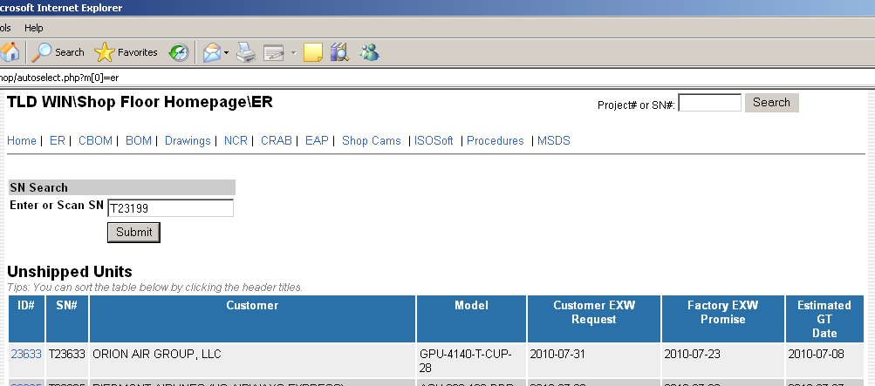

Enter serial number

Enter the serial number including the “T” to go to the Equipment Record (ER) page

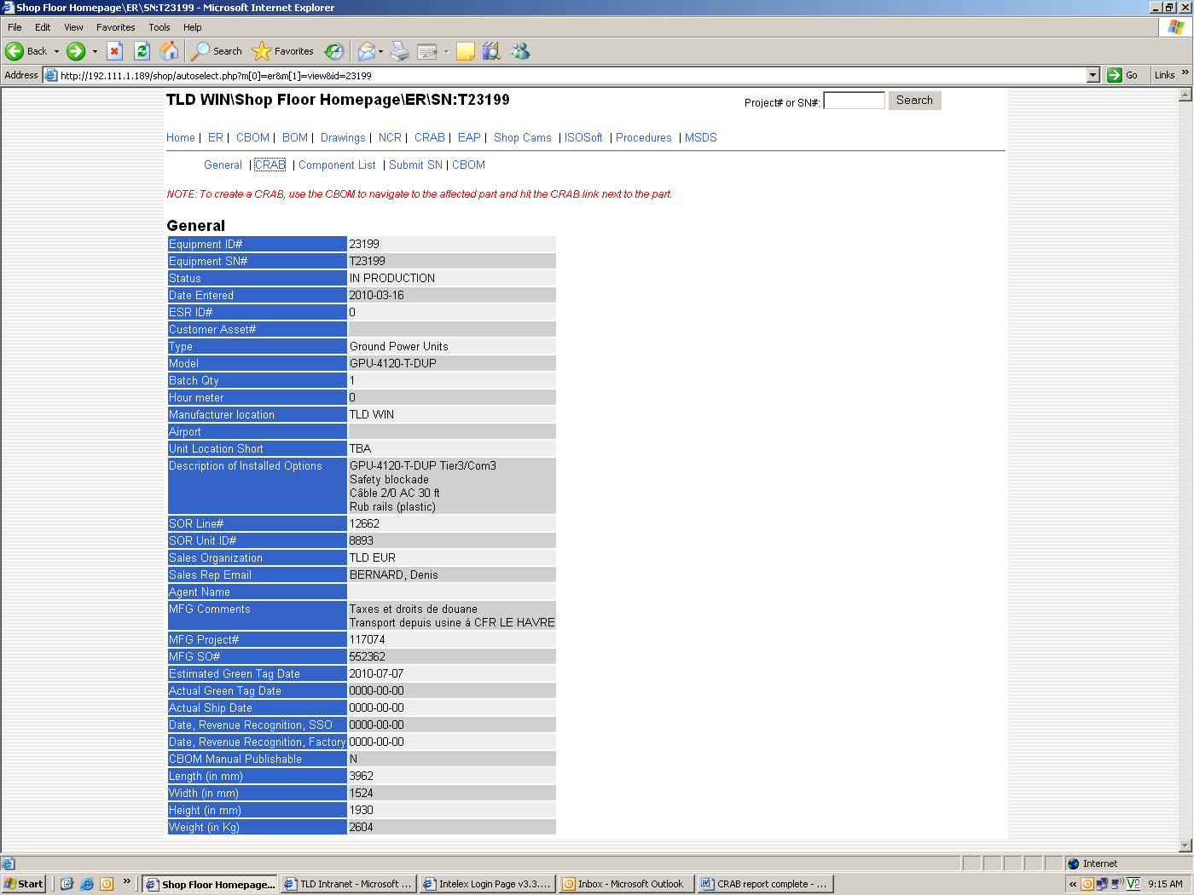
Unit serial number
Use lower line of links to get to CRAB list

Double check and be sure you are in the correct serial number unit.

Select CRAB in the LOWER row of blue links.

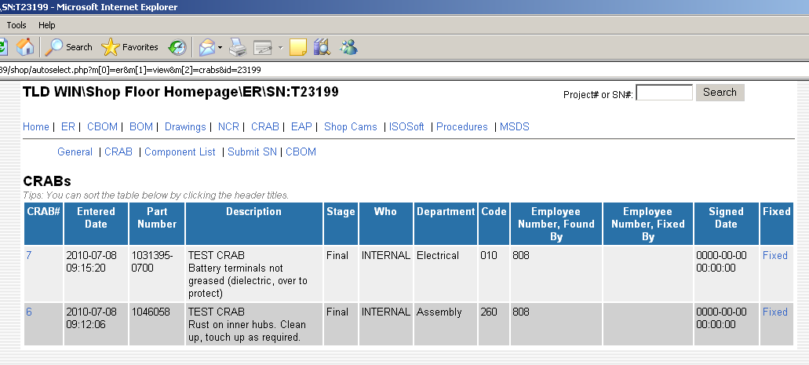

This will list all CRABS open for the unit

Open the CRAB you fixed & report it done and completed. Direction of what has to be done will be listed. Complete the reporting of completing it by selecting the blue FIXED link on the right side

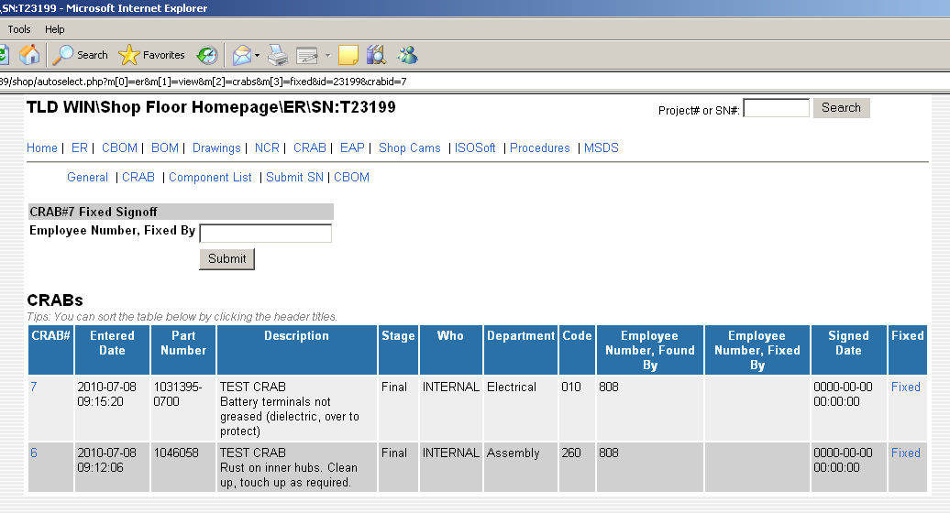

Enter your number in the open field

Enter your employee number in the open field, then select the SUBMIT button under where you entered your number.

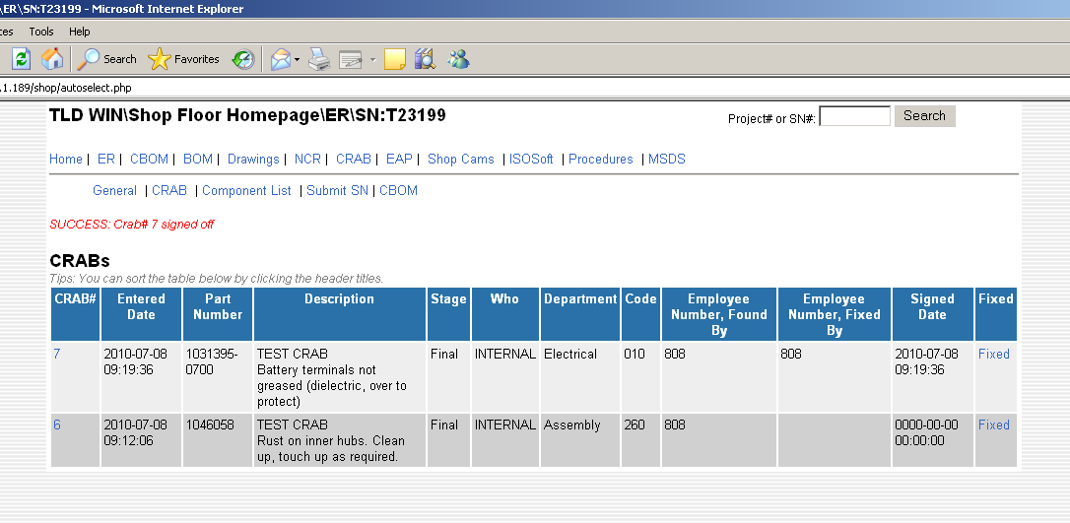

The next screen will tell you if it accepted the entry, and your number will show in the Employee Number, Fixed by field.

If you fixed other CRABS, continue to the next one until you have completed all the ones for the work you performed.

When all CRABS are done, advise your Supervisor you are ready for him/her to inspect your work.

Document History
REV | DATE | DESCRIPTION OF STATUS, CHANGES | REF
Released | 25 Aug 10 | Original Release | RT
A | 4 May 12 | Add ability for Production personnel to record “CRABS”, page 1process overview, pg 2-8 added production and updated notes to be clearer in how to enter the crab and how to report fixing a crab sections. | S.Reis
B | 28 Sept 12 | Add a field for the person “fixing” the unit to make a comment, trained and added engineering to write crabs, updated process in intro area to not mention “buttons” that don’t exist, updated screen shot showing comment field for “fixed by” | S.Reis

