How to Setup Auto Reply for TLD America Email Users
These instructions guide you through the process of setting up an email auto reply. This guide only applies to TLD America personnel with tld-america.com email addresses.

- Open a browser such as Internet Explorer. In the address field type in “http://mail.tld-america.com:20000” (note the colon and number twenty thousand at the end) and hit enter. This will bring you to the login screen shown below.
At the login screen enter the username and password for your email account. Your username is the first half of your email address i.e. everything before the ‘@’ sign.
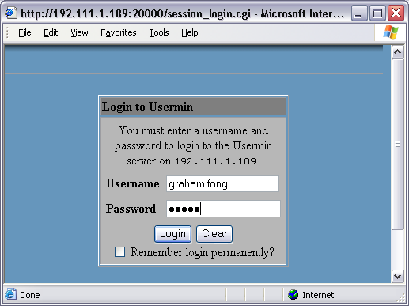
- Once logged in you will see the following screen. Hit the Mail Forwarding link.
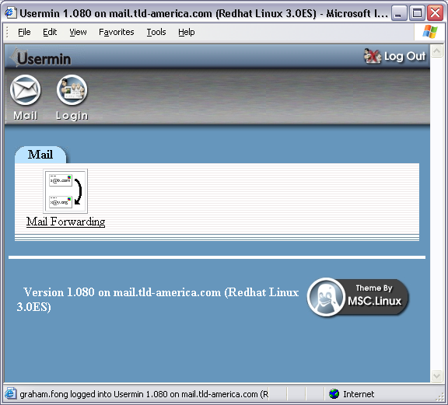
- At the next screen hit the “Add a mail forwarding rule” link.
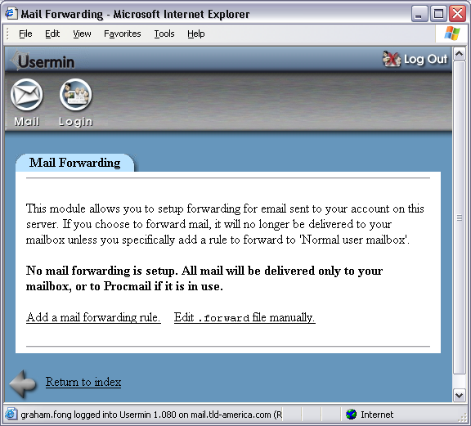
- At the next screen select “Autoreply from file” from the drop down box and type “my_vacation_message” in the empty text field next to it. Hit the Create button.
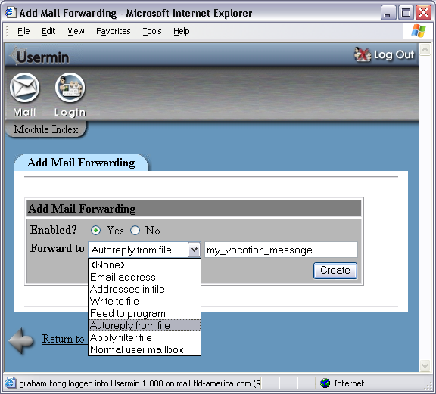
- Once the rule has been added you will be shown the mail forwarding list. Hit the link to the rule you just created.
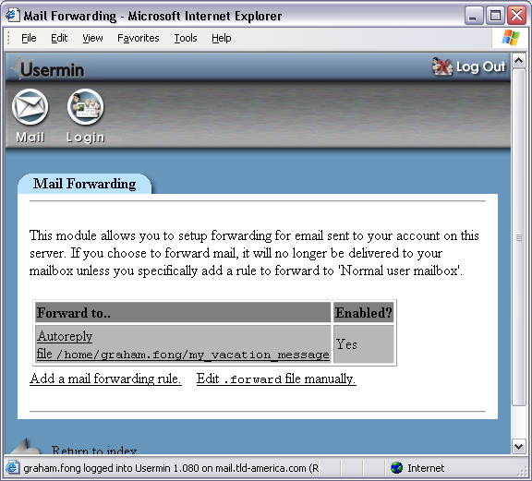
- At the next screen hit the Edit link.
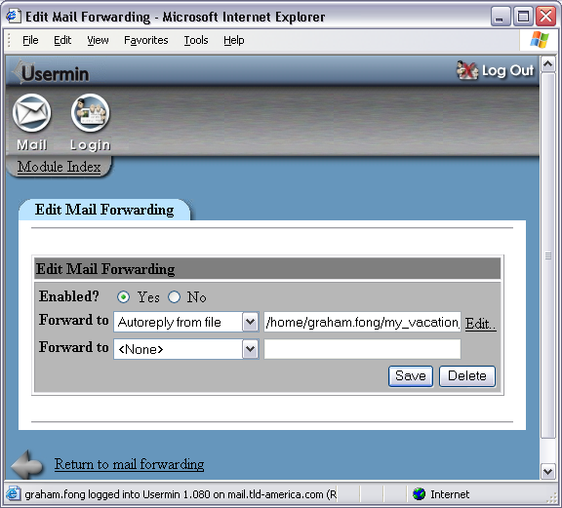
- At the next screen type your message in the large blank box.
You MUST type “From: youremail@address”, replacing ‘youremail@address with your real address, on the first line.
Check the “Track automatic responses….” Checkbox at the bottom of the screen.
Hit Save
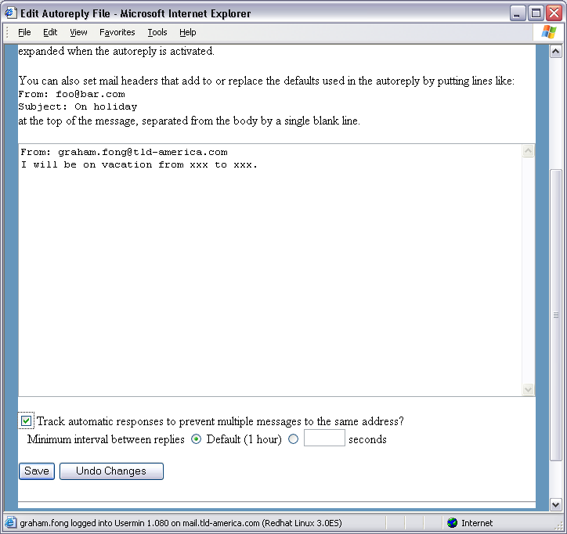
- Once you hit save you will be shown the mail forwarding list. Hit the link to the rule you created.
- At the next screen select “Normal user mailbox” from the drop down box on the SECOND line then hit the Save button.
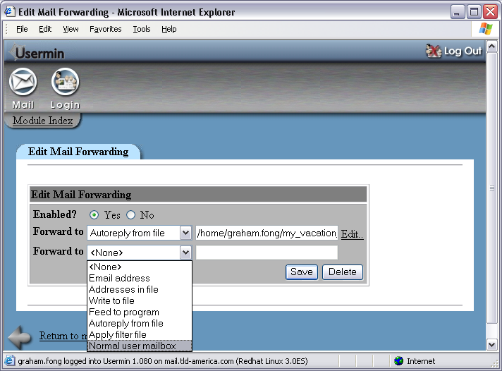
- The mail forwarding list will now show something similar to the screen below with the Enabled field showing Yes. Autoreply is setup at this point.
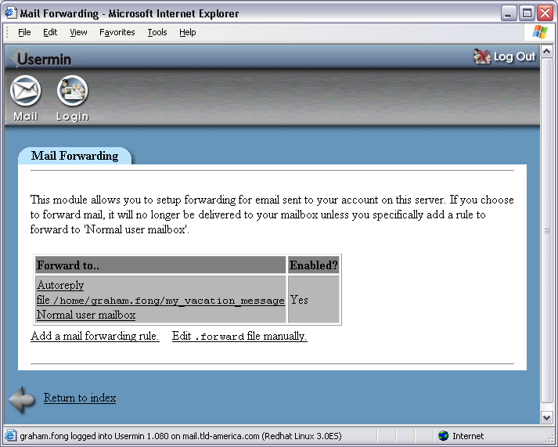
- To stop autoreply hit the link to your autoreply rule in the list.
- Select No in the Enabled? Field then hit Save.
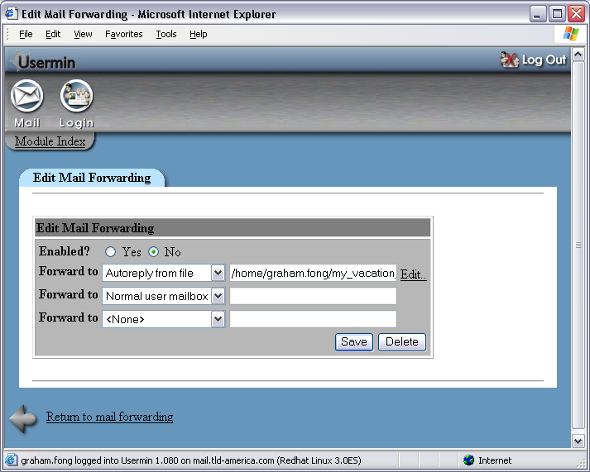
- The mail forwarding list screen will now show a No in the enabled? field. Autoreply is now disabled.
