DOCUMENTATION of MANUAL module

DB STRUCTURE
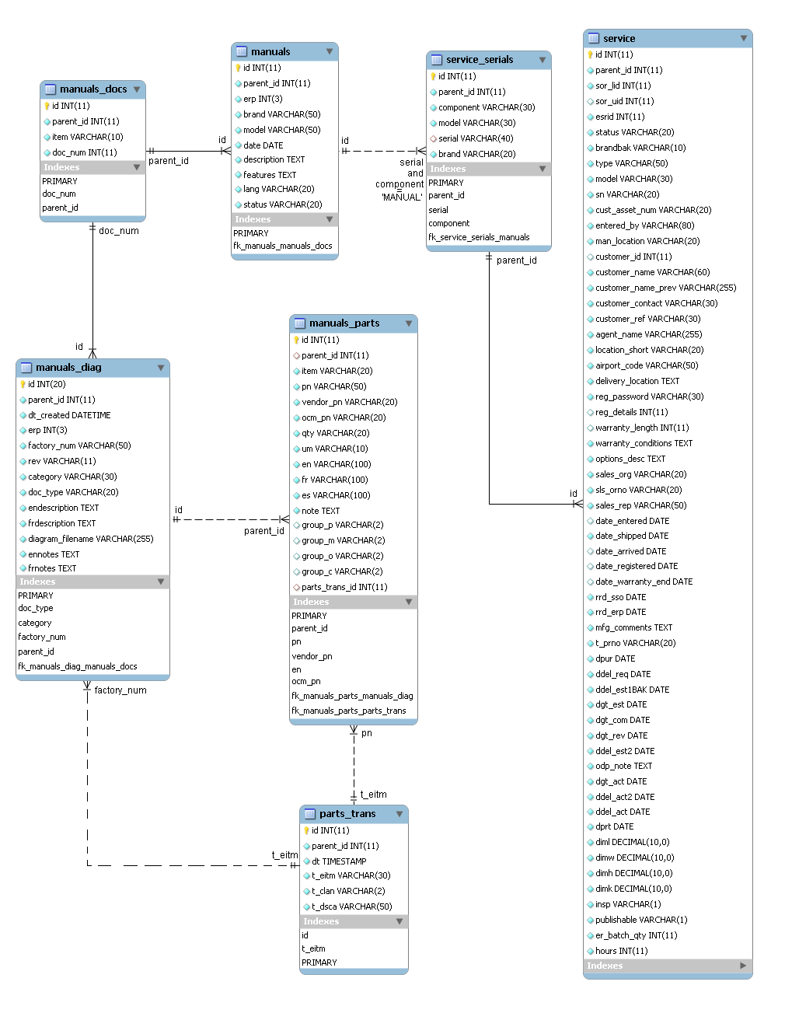

PARTS TRANSLATION

The table containing parts translation is parts_trans.
They have been synchronized entirely from BAAN the February 18, 2011. See script 1 in the glossary for details. In order to maintain translations up to date for all parts, every time the user generate a manual from a CBOM we update this table.

The rule is, for each part:
- update the description if exists for the same language
- insert the part with his language description

Manual generation could be found in the file /product_support/equipment/view.inc.php

PARTS TRANS SYNC

I – ON DUPLICATE KEY UPDATE

SQL:
INSERT INTO parts_trans (dt,t_eitm,t_clan,t_dsca)
VALUES (NOW(),'{$row['t_eitm']}','{$row['t_clan']}','$dsc')
ON DUPLICATE KEY UPDATE t_dsca='$dsc'

Type of action for all parts from BAAN | Total Time in seconds
Insert | 14
Update | 13

II – REPLACE

SQL:
REPLACE INTO parts_trans (dt,t_eitm,t_clan,t_dsca)
VALUES (NOW(),'{$row['t_eitm']}','{$row['t_clan']}','$dsc')

Type of action for all parts from BAAN | Total Time in seconds
Insert | 14
Update | 19

GLOSSARY

I - Scripts

Script 1: Synchronize all parts translations from BAAN to Intranet at once

<?php
include_once("common.inc.php");

$link = mssql_connect(HOST, USER, PASS);
mssql_select_db('baandb', $link);

$query =<<<EOF
select *, ltrim(t_clan) as t_clan
from ttitld890400
where t_dsca<>''
EOF;

$trans = mssql_query($query);

$SQLS = array();
while($tran = mssql_fetch_array($trans)){
if($tran['t_clan'] == 'CH'){
$dsc = iconv("CP936","UTF-8",$tran['t_dsca']);
}else{
$dsc = mysql_real_escape_string(iconv("ISO-8859-1", "UTF-8", $tran['t_dsca']));
}
$SQL[] = "insert into parts_trans set t_eitm='${tran['t_eitm']}', t_clan='${tran['t_clan']}', t_dsca='$dsc';";
}

foreach($SQLS as $SQL){
$e = tldUtils::sqlInsert($SQL);
if(!is_numeric($e)){
echo "<br>IMPORT ERROR for query $SQL<br>RETURN ERROR: $e";
}
}
?>

