HELP GUIDE - SUBMIT NEW DATASHEET

Go to the Support Module and hit the link Start new/update datasheet sequence

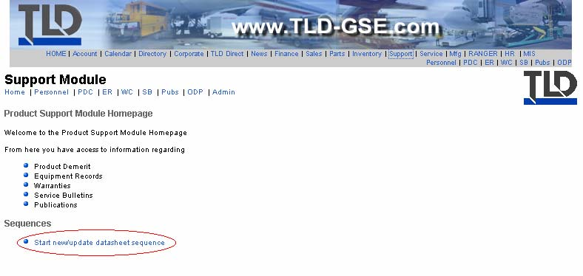
Select the model that refers to your datasheet

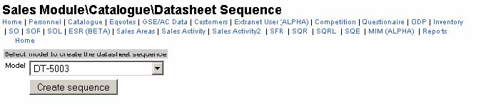
Then, fill in the Update description field. This will be the details attached to the ASM notification once the datasheet will be approved and updated in the intranet.

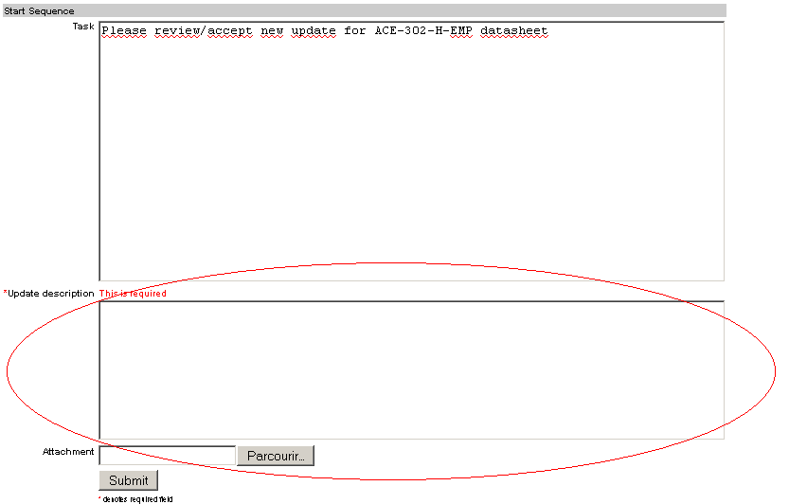

Finally hit the Create sequence button and you will get a confirmation message.
Go the Sequence just created and accept it.

Attach the datasheet to your comment for approval to the COO.

Then, if approved, MIS will add the model in the list and upload all files related to this model to the website.

When the sequence will be closed, an email will be sent to ASM to let them know a new datasheet have been released for a model.

