CRT MODULE - HELP GUIDE

INTRODUCTION

A Customer Relationship Team represents the TLD team for a specific customer with a TLD representative for Sales, Parts and Service department. Also, the CRT allows us to make a link between the customer in BAAN and the customer, called eCustomer, in our INTRANET. That way, we can pull out any baan data, such as sales orders, invoices etc, for a specific customer.

CREATE

Go to SALES/CRT and hit the link “New”.

Step 1:

Select the ERP Company and submit.

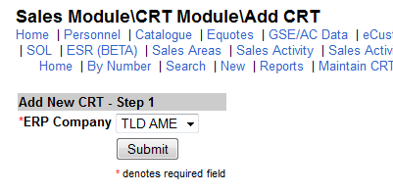

Note: In selecting the erp company here, the system will look for all baan customers and it is “cuno” associated so you do not need to know it or look for it for the next final step.

Step 2:

Fill in the form bellow and submit.

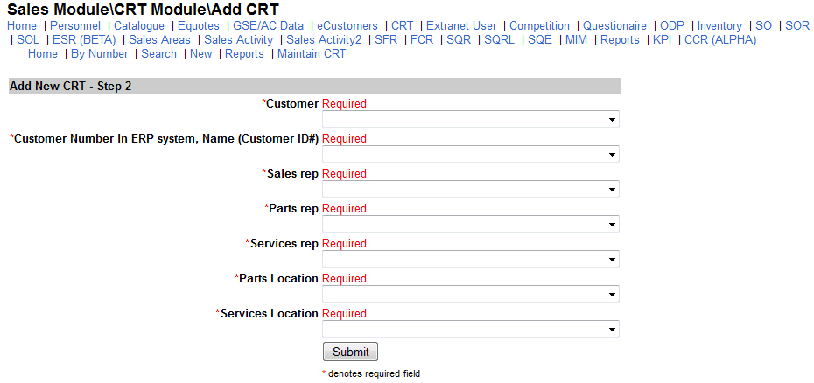
eCustomer (from Intranet)
Baan customer (from BAAN ERP)

Notes: If in the eCustomer field you can not found your customer, you will need to go to SALES/eCustomer and submit a new customer creation request. You will not be able to create a CRT without an eCustomer record.

